**What is javascript?**

JavaScript is a **high-level**, **interpreted** programming language commonly used to create and control **dynamic website content.**

Alongside HTML and CSS, it is one of the core technologies of the World Wide Web.

Here are some key aspects of JavaScript:

1. **Client-Side Scripting:**
   1. JavaScript is primarily used for client-side scripting, allowing developers to create interactive web pages.
   2. This means it runs in the user's browser and can respond to user actions like clicks, form submissions, and other events.
2. **Dynamic Content:**
   1. JavaScript can change HTML content, styles, and attributes on the fly, making web pages more dynamic and interactive.
   2. This includes tasks like updating **the content of a web page without reloading it**, creating interactive forms, and implementing animations.
3. **Libraries and Frameworks:**
   1. JavaScript has a rich ecosystem of libraries (like jQuery) and frameworks (like React, Angular, and Vue.js) that simplify complex tasks and enhance development efficiency.
   2. These tools provide pre-built functions and components that speed up development.
4. **Server-Side Development:**
   1. With the introduction of **Node.js**, JavaScript can also be used for server-side development.
   2. This means developers can use JavaScript to write code that runs on servers, handling tasks like database interactions, server-side logic, and more.
5. **Asynchronous Programming:**
   1. JavaScript supports asynchronous programming through callbacks, promises, and async/await syntax.
   2. This allows developers to write non-blocking code that can handle multiple tasks simultaneously, improving performance and user experience.
6. **Versatility:**
   1. JavaScript is versatile and can be used for various tasks beyond web development, such as game development, mobile app development (using frameworks like React Native), and even desktop applications (using Electron).
7. **Event-Driven:**
   1. JavaScript is event-driven, meaning it can listen for and respond to events (e.g., user clicks, form submissions) in real-time, providing a responsive and interactive experience.
8. **Standardized:**
   1. JavaScript is standardized through the ECMAScript specification, which ensures consistency and compatibility across different browsers and platforms.

Overall, JavaScript is an essential language for modern web development, enabling developers to create rich, interactive experiences on the web.

**Contents of JavaScript**

1. **Introduction to JavaScript**
   * What is JavaScript?
   * Where to use JavaScript (Client-side, Server-side with Node.js)
   * JavaScript Execution Environment (Browser, Node.js)
   * Setting up Development Environment (Browser Developer Tools, Editors like VS Code)
2. **Data Types and Variables**
   * Primitive Data Types (String, Number, Boolean, Null, Undefined, Symbol, BigInt)
   * Complex Data Types (Objects, Arrays, Functions)
   * Variables (let, const, var)
   * Type Conversion and Coercion
3. **Operators**
   * Arithmetic, Comparison, Logical, Assignment, Bitwise Operators
   * Conditional (Ternary) Operator
   * Precedence and Associativity of Operators
4. **Control Structures**
   * Conditional Statements (if, else, switch)
   * Loops (for, while, do-while, for...of, for...in)
   * Iteration Protocols (Iterator, Iterable)
5. **Functions PageNo: 155**
   * Function Declarations and Expressions
   * Function Parameters (default, rest parameters)
   * Return Statements and undefined
   * **Closures** (Lexical Environment, Access to Outer Scope)
   * Arrow Functions (=>)
   * Higher-order Functions (Functions that return or accept functions)
   * **Immediately Invoked Function Expressions (IIFE)**
6. **Objects and Arrays**
   * Object Literals and Constructors
   * Accessing, Adding, and Removing Properties
   * **Object Methods (this keyword)** and Method Binding
   * Arrays: Creating, Accessing, Modifying, Looping through Arrays
   * **Array Methods** (push, pop, map, filter, reduce, find, some, every, etc.)
   * Destructuring Assignment (Objects and Arrays)
   * **Spread Operator** and **Rest Operator**
   * **Shallow Copy vs. Deep Copy** of Objects and Arrays
7. **Prototype and Inheritance**
   * Prototypes and Prototype Chain
   * Inheritance in JavaScript
   * Object.create() and Prototype-based Inheritance
   * **Class Syntax** in ES6+
   * Constructors and super()
   * Inheritance in Classes
8. **DOM Manipulation**
   * Introduction to the DOM
   * Selecting Elements (getElementById, querySelector, querySelectorAll)
   * Modifying Element Content (innerHTML, textContent)
   * Modifying Element Attributes (setAttribute, removeAttribute)
   * Modifying Styles with JavaScript (style object)
   * Event Handling (addEventListener, Event Bubbling, Event Delegation)
   * Creating and Removing Elements (createElement, appendChild, removeChild)
9. **Forms and Input Validation**
   * Handling Forms in JavaScript
   * Retrieving Form Data
   * Validating Input (Basic Validation, Regular Expressions)
   * Preventing Default Form Submissions (preventDefault())
   * Creating Custom Validation Messages
10. **Object-Oriented Programming (OOP)**

* Constructors and Instances
* Class-Based vs. Prototype-Based Inheritance
* Encapsulation, Polymorphism, and Inheritance
* Getters and Setters
* Static Methods
* Composition vs. Inheritance

1. **Asynchronous JavaScript**

* **Callbacks**
* Promises (resolve, reject, then, catch, finally)
* async / await
* Error Handling in Asynchronous Code (try, catch)
* **Fetching Data from APIs** (using fetch and XMLHttpRequest)
* **AJAX** and HTTP Requests (GET, POST, PUT, DELETE)

1. **Error Handling**

* try, catch, finally Blocks
* Throwing Custom Errors
* **Creating Custom Error Types**

1. **JavaScript Modules**

* **ES6 Modules** (import/export)
* Default and Named Exports
* **CommonJS Modules** (used in Node.js)
* Bundling Modules (with tools like Webpack)

1. **Event Loop and JavaScript Engine**

* JavaScript's Single Threaded Nature
* Event Loop (Call Stack, Task Queue)
* **Microtasks** and **Macrotasks**
* Non-blocking I/O with Event Loop

1. **Local Storage, Session Storage, and Cookies**

* **localStorage** and **sessionStorage**
* Storing and Retrieving Data from Browser Storage
* JSON Storage in Local/Session Storage
* **Cookies** and Managing Cookies with JavaScript

1. **Regular Expressions**

* Regular Expressions Syntax (/pattern/flags)
* Commonly Used Methods (test, match, replace, search)
* Validating Patterns in Strings (e.g., emails, phone numbers)

1. **JSON and AJAX**

* Introduction to JSON (JavaScript Object Notation)
* Parsing JSON with JSON.parse()
* Stringifying JavaScript Objects with JSON.stringify()
* AJAX Requests and Interacting with REST APIs

1. **JavaScript Performance**

* Optimizing JavaScript Code (Execution, Memory, Reflows)
* **Debouncing** and **Throttling**
* Managing Heavy Computations in JavaScript (e.g., Web Workers)

1. **JavaScript Design Patterns**

* Singleton Pattern
* Factory Pattern
* Observer Pattern
* Module Pattern
* Revealing Module Pattern

1. **Testing JavaScript**

* **Unit Testing** (Jest, Mocha, Jasmine)
* Writing Testable Code
* Asynchronous Testing

1. **Advanced Topics**

* **Proxies** and Reflect API
* Generators and yield
* Iterators and Iterables
* Symbol and its use cases
* Web Workers for Multithreading
* **WeakMap** and **WeakSet**

1. **JavaScript in Front-End Frameworks**

* Introduction to Modern JavaScript Frameworks (React, Angular, Vue.js)
* Setting up Frameworks with JavaScript
* Component-Based Architecture in Frameworks

**Basics of Javascript**

**1. Syntax and Variables**

**Variables** are used to store data values.

You can declare a variable using **var**, **let**, or **const**.

var name = "John"; // Declares a variable that can be reassigned

let age = 25; // Declares a block-scoped variable that can be reassigned

const pi = 3.14; // Declares a block-scoped variable that cannot be reassigned

**2. Data Types**

JavaScript supports various data types, including:

* **Primitive Types:**
  + String: "Hello"
  + Number: 42
  + Boolean: true or false
  + Null: null
  + Undefined: undefined
  + Symbol: Symbol('id')
  + BigInt: 123n
* **Composite Types:**
  + Object: { name: "John", age: 25 }
  + Array: [1, 2, 3]

**3. Operators**

JavaScript provides various operators:

* **Arithmetic Operators:** +, -, *, /, %
* **Assignment Operators:** =, +=, -=, *=, /=
* **Comparison Operators:** ==, ===, !=, !==, >, <, >=, <=
* **Logical Operators:** &&, ||, !

**4. Control Structures(decisions)**

**Conditional Statements** allow you to execute code based on conditions.

if (age > 18) {

console.log("Adult");

} else {

console.log("Minor");

}

**Loops** allow you to execute code multiple times.

* **For Loop:**

for (let i = 0; i < 5; i++) {

console.log(i);

}

* **While Loop:**

let i = 0;

while (i < 5) {

console.log(i);

i++;

}

**5. Functions**

Functions are reusable blocks of code.

function greet(name) {

return "Hello, " + name;

}

console.log(greet("Alice"));

**6. Objects and Arrays**

**Objects** store key-value pairs.

let person = {

name: "John",

age: 25,

greet: function() {

console.log("Hello, " + this.name);

}

};

person.greet();

**Arrays** store ordered collections of values.

let numbers = [1, 2, 3, 4, 5];

console.log(numbers[0]); // Outputs 1

numbers.push(6); // Adds a new element to the array

console.log(numbers);

**7. Event Handling**

JavaScript can handle events like user actions.

document.getElementById("myButton").addEventListener("click", function() {

alert("Button was clicked!");

});

**8. DOM Manipulation**

JavaScript can manipulate the Document Object Model (DOM) to change the content of a webpage.

document.getElementById("myElement").innerHTML = "New Content";

document.getElementById("myElement").style.color = "red";

**9. Promises and Async/Await**

JavaScript supports asynchronous programming using Promises and the async/await syntax.

* **Promise:**

let promise = new Promise(function(resolve, reject) {

// Some async operation

if (success) {

resolve("Success");

} else {

reject("Error");

}

});

promise.then(function(result) {

console.log(result);

}).catch(function(error) {

console.error(error);

});

* **Async/Await:**

async function fetchData() {

try {

let response = await fetch('https://api.example.com/data');

let data = await response.json();

console.log(data);

} catch (error) {

console.error('Error:', error);

}

}

fetchData();

These basics provide a foundation for learning JavaScript. As you practice and build more projects, you'll become more comfortable with its syntax and capabilities.

**document.querySelector()**

The document.querySelector() method in JavaScript is used to select the first element in the DOM that matches a specified CSS selector.

It allows you to find and manipulate specific HTML elements based on their tag name, class, ID, or other attributes.

**Syntax:**

let element = document.querySelector(selector);

**Parameters:**

* **selector**: A string containing one or more CSS selectors to match the desired element. It can be:
  + **Tag** **name**: "div", "h1", etc.
  + **Class** **name**: ".class-name"
  + **ID**: "#id-name"
  + **Attribute**: "[attribute=value]"

**Example Usage:**

1. **Select an element by class**:

let element = document.querySelector('.myClass');

1. **Select an element by ID**:

let element = document.querySelector('#myId');

1. **Select a nested element**:

let element = document.querySelector('div > p');

1. **Select an input with a specific attribute**:

let element = document.querySelector('input[type="text"]');

**Key Points:**

* **First Match**: It returns only the first element that matches the selector. If no match is found, it returns null.
* **CSS Selectors**: It supports complex CSS selectors, so you can target elements more precisely.

**Example:**

<!DOCTYPE html>

<html>

<head>

<title>querySelector Example</title>

</head>

<body>

<div class="container">

<p id="first-paragraph">This is the first paragraph.</p>

<p>This is the second paragraph.</p>

</div>

<script>

let firstParagraph = document.querySelector('#first-paragraph');

console.log(firstParagraph.textContent); // Outputs: "This is the first paragraph."

</script>

</body>

</html>

In this example, document.querySelector('#first-paragraph') selects the paragraph with the id="first-paragraph" and logs its content.

**Decisions in Javascript**

In JavaScript, decision-making is primarily handled through conditional statements.

These statements allow you to execute different blocks of code based on certain conditions.

The main types of conditional statements in JavaScript are if, else if, else, and switch.

Here’s a detailed look at each:

**1. if Statement**

The if statement is used to execute a block of code if a specified condition is true.

let age = 20;

if (age >= 18) {

console.log("You are an adult.");

}

**2. else Statement**

The else statement is used to execute a block of code if the condition in the if statement is false.

let age = 15;

if (age >= 18) {

console.log("You are an adult.");

} else {

console.log("You are a minor.");

}

**3. else if Statement**

The else if statement is used to specify a new condition if the first condition is false.

let score = 85;

if (score >= 90) {

console.log("Grade: A");

} else if (score >= 80) {

console.log("Grade: B");

} else if (score >= 70) {

console.log("Grade: C");

} else {

console.log("Grade: F");

}

**4. switch Statement**

The switch statement is used to perform different actions based on different conditions. It is a good alternative when you need to compare the same value to several different possible matches.

let day = 3;

let dayName;

switch (day) {

case 1:

dayName = "Monday";

break;

case 2:

dayName = "Tuesday";

break;

case 3:

dayName = "Wednesday";

break;

case 4:

dayName = "Thursday";

break;

case 5:

dayName = "Friday";

break;

case 6:

dayName = "Saturday";

break;

case 7:

dayName = "Sunday";

break;

default:

dayName = "Invalid day";

}

console.log(dayName); // Outputs: Wednesday

**5. Ternary Operator**

The ternary operator is a shorthand for the if-else statement. It is useful for making simple decisions.

let age = 20;

let access = (age >= 18) ? "Granted" : "Denied";

console.log(access); // Outputs: Granted

**Example: Combining Conditions**

You can combine multiple conditions using logical operators like && (AND), || (OR), and ! (NOT).

let age = 25;

let hasPermission = true;

if (age >= 18 && hasPermission) {

console.log("Access granted.");

} else {

console.log("Access denied.");

}

if (age < 18 || !hasPermission) {

console.log("Access denied.");

} else {

console.log("Access granted.");

}

**Summary**

* Use if to specify a block of code to be executed if a condition is true.
* Use else to specify a block of code to be executed if the same condition is false.
* Use else if to specify a new condition to test if the first condition is false.
* Use switch to specify many alternative blocks of code to be executed.
* Use the ternary operator for simple conditional expressions.

Understanding these basic decision-making structures will allow you to write more dynamic and responsive JavaScript code.

**Example 01**

Here's an example program in JavaScript that uses a form to demonstrate decision-making.

This program will validate user input from a form, checking the age and favorite color provided by the user.

Depending on the input, it will display different messages.

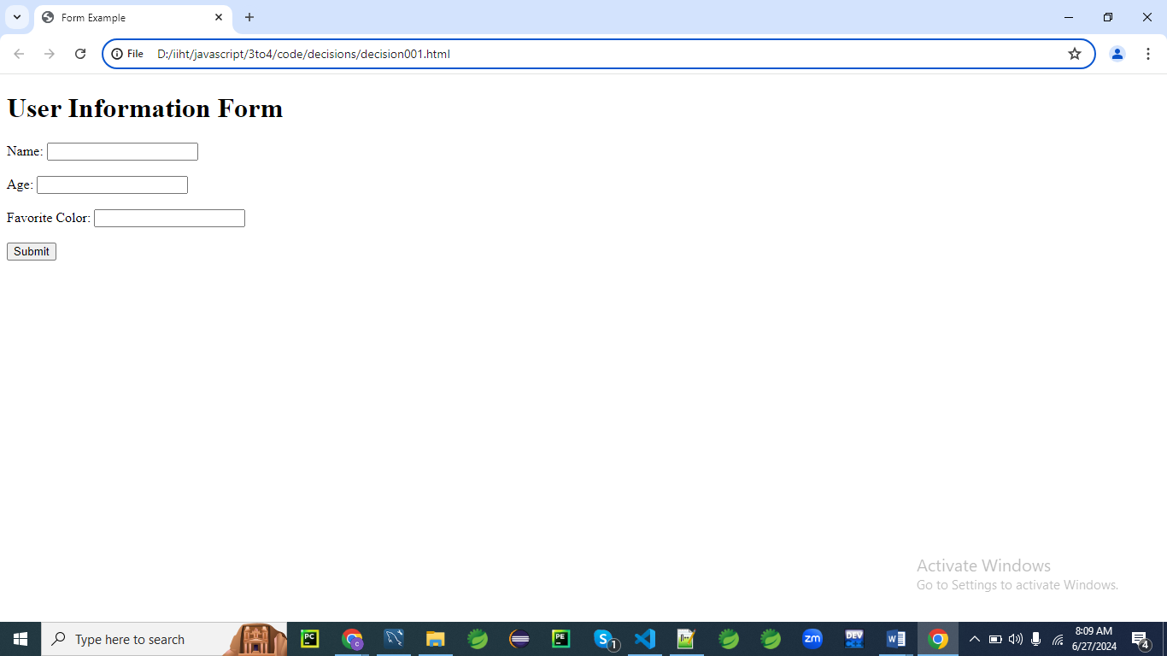

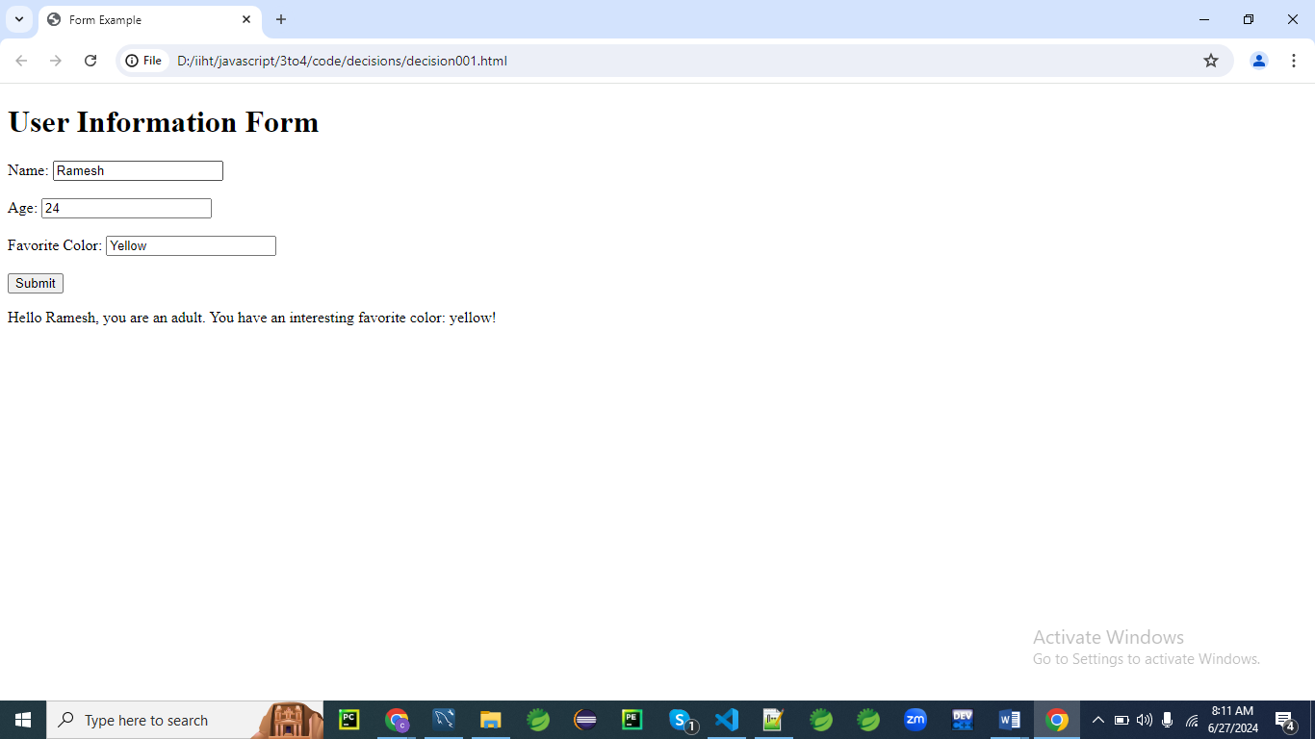

**HTML Form**

First, let's create an HTML form with fields for name, age, and favorite color.

<!DOCTYPE html>

<html lang="en">

<head>

<meta charset="UTF-8">

<meta name="viewport" content="width=device-width, initial-scale=1.0">

<title>Form Example</title>

</head>

<body>

<h1>User Information Form</h1>

<form id="userForm">

<label for="name">Name:</label>

<input type="text" id="name" name="name" required><br><br>

<label for="age">Age:</label>

<input type="number" id="age" name="age" required><br><br>

<label for="color">Favorite Color:</label>

<input type="text" id="color" name="color" required><br><br>

<button type="submit">Submit</button>

</form>

<p id="message"></p>

<script src="script001.js"></script>

</body>

</html>

**JavaScript Code(script001.js)**

Now, let's write the JavaScript code that handles the form submission and includes various decision-making structures.

document.getElementById('userForm').addEventListener('submit', function(event) {

event.preventDefault(); // Prevent the form from submitting the traditional way

// Get form values

let name = document.getElementById('name').value;

let age = parseInt(document.getElementById('age').value);

let color = document.getElementById('color').value.toLowerCase();

// Decision-making logic

let message = '';

if (age >= 0 && age < 18) {

message = `Hello ${name}, you are a minor.`;

}

else if (age >= 18 && age < 60) {

message = `Hello ${name}, you are an adult.`;

}

else if (age >= 60) {

message = `Hello ${name}, you are a senior citizen.`;

}

else {

message = `Invalid age entered.`;

}

// Using switch-case for favorite color

switch (color) {

case 'red':

message += ' Your favorite color is Red!';

break;

case 'blue':

message += ' Your favorite color is Blue!';

break;

case 'green':

message += ' Your favorite color is Green!';

break;

default:

message += ` You have an interesting favorite color: ${color}!`;

}

// Display the message

document.getElementById('message').innerText = message;

});

**Explanation**

1. **HTML Form:**
   * The form contains three input fields: name, age, and favorite color.
   * When the form is submitted, the submit event is triggered.
2. **JavaScript Code:**
   * An event listener is added to handle the form submission.
   * The event.preventDefault() method prevents the form from submitting in the traditional way, allowing us to handle the submission with JavaScript.
   * The values from the form fields are retrieved and stored in variables.
   * Conditional statements (if, else if, else) are used to determine the message based on the user's age.
   * A switch statement is used to add a specific message based on the user's favorite color.
   * The final message is displayed in the paragraph with the id message.

This example demonstrates how to use various decision-making structures in JavaScript to handle and validate form input.

**Example 02**

Here's another example program in JavaScript that uses a form to demonstrate decision-making.

This example will include a login form where the user must enter a username and password.

The program will check the input against predefined values and display appropriate messages based on the validity of the credentials.

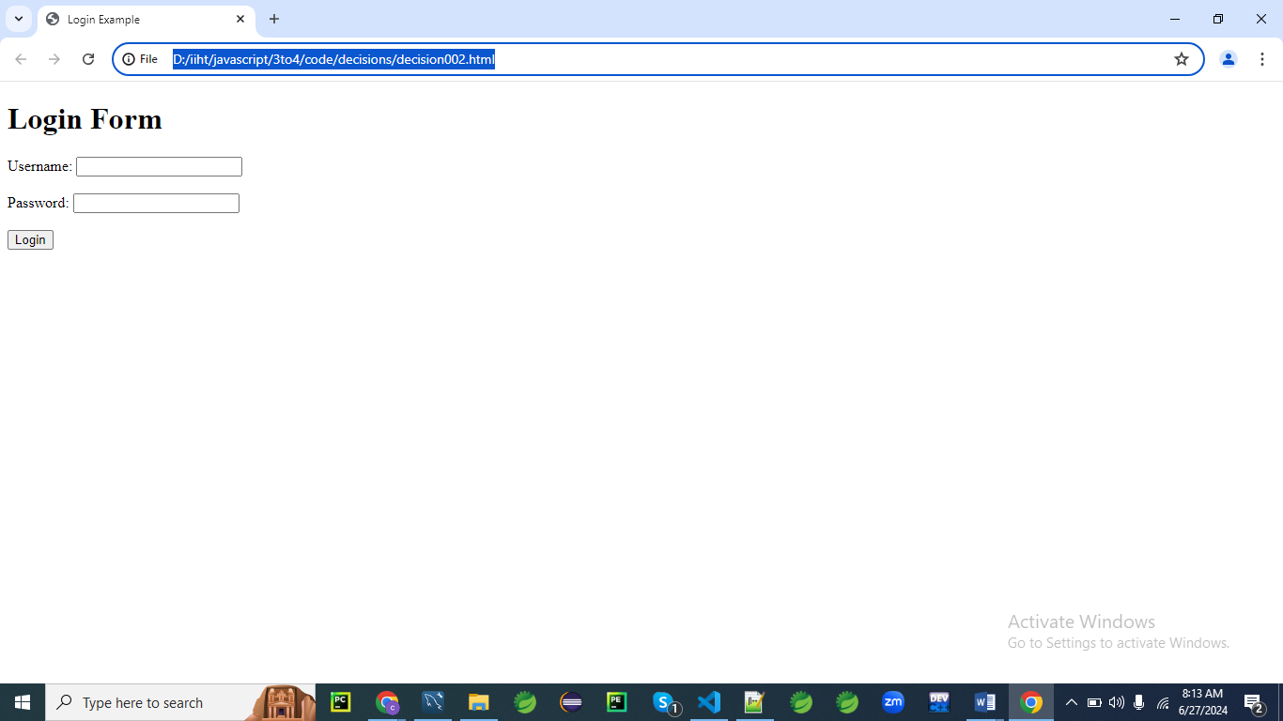

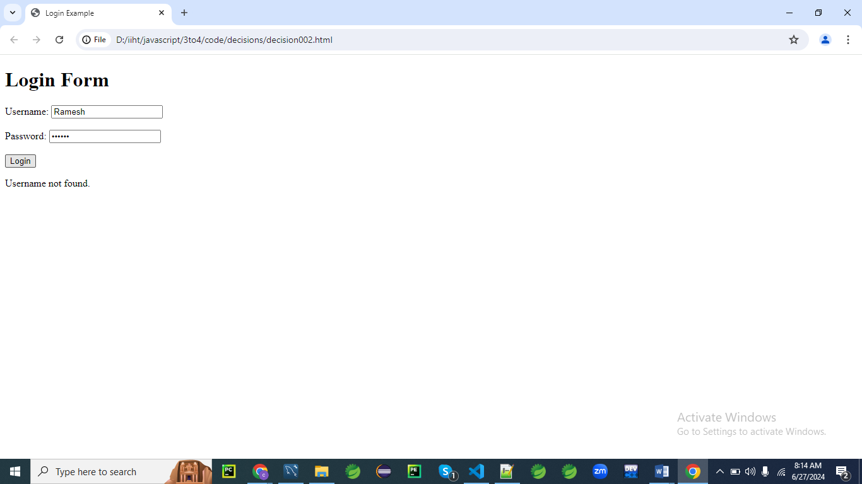

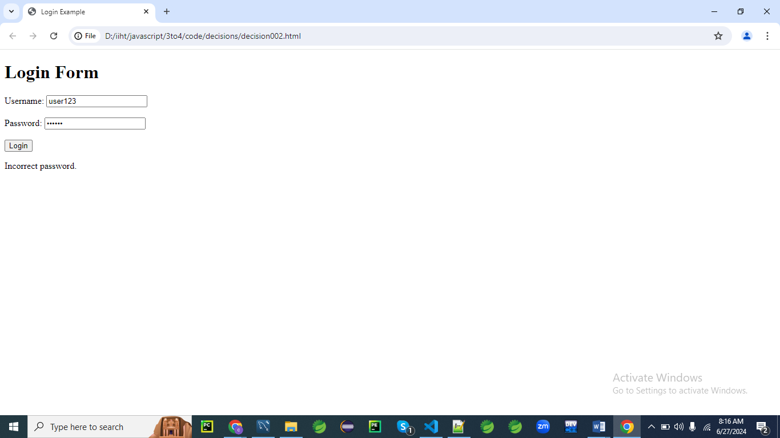

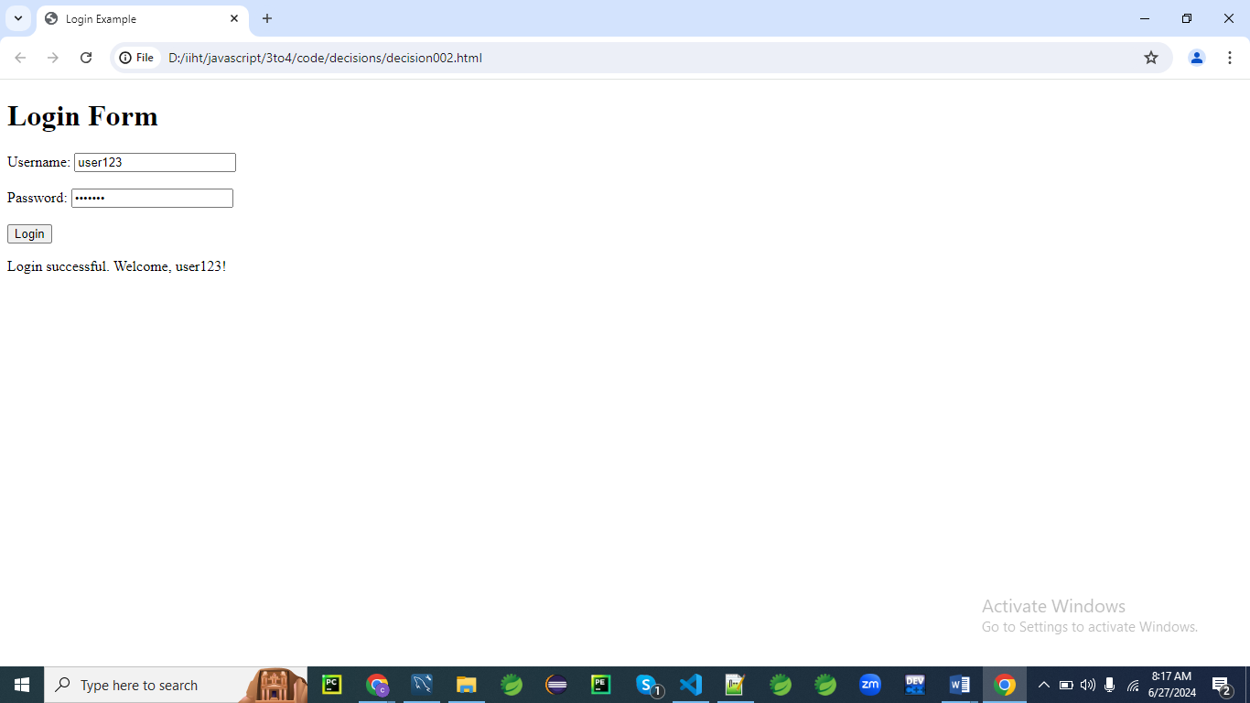

**HTML Form**

First, let's create an HTML form with fields for username and password.

<!DOCTYPE html>

<html lang="en">

<head>

<meta charset="UTF-8">

<meta name="viewport" content="width=device-width, initial-scale=1.0">

<title>Login Example</title>

</head>

<body>

<h1>Login Form</h1>

<form id="loginForm">

<label for="username">Username:</label>

<input type="text" id="username" name="username" required><br><br>

<label for="password">Password:</label>

<input type="password" id="password" name="password" required><br><br>

<button type="submit">Login</button>

</form>

<p id="message"></p>

<script src="script002.js"></script>

</body>

</html>

**JavaScript Code**

Now, let's write the JavaScript code that handles the form submission and includes various decision-making structures.

document.getElementById('loginForm').addEventListener('submit', function(event) {

event.preventDefault(); // Prevent the form from submitting the traditional way

// Get form values

let username = document.getElementById('username').value;

let password = document.getElementById('password').value;

// Predefined valid credentials

let validUsername = "user123";

let validPassword = "pass123";

// Decision-making logic

let message = '';

// Check if the username is correct

if (username === validUsername) {

// Check if the password is correct

if (password === validPassword) {

message = "Login successful. Welcome, " + username + "!";

} else {

message = "Incorrect password.";

}

} else {

message = "Username not found.";

}

// Display the message

document.getElementById('message').innerText = message;

});

**Explanation**

1. **HTML Form:**
   * The form contains two input fields: username and password.
   * When the form is submitted, the submit event is triggered.
2. **JavaScript Code:**
   * An event listener is added to handle the form submission.
   * The event.preventDefault() method prevents the form from submitting in the traditional way, allowing us to handle the submission with JavaScript.
   * The values from the form fields are retrieved and stored in variables.
   * Predefined valid credentials are defined for comparison.
   * Conditional statements (if, else) are used to validate the username and password.
     + First, the username is checked. If it matches the predefined valid username, the password is checked next.
     + If both the username and password are correct, a success message is displayed.
     + If the username is correct but the password is incorrect, an appropriate error message is displayed.
     + If the username is incorrect, a different error message is displayed.
   * The final message is displayed in the paragraph with the id message.

This example demonstrates how to use nested decision-making structures in JavaScript to handle and validate login credentials

**Example 03**

Let's create a more comprehensive example program in JavaScript that demonstrates a variety of decision-making structures.

This example will be a simple quiz application where users can answer multiple-choice questions, and the application will provide feedback based on their answers.

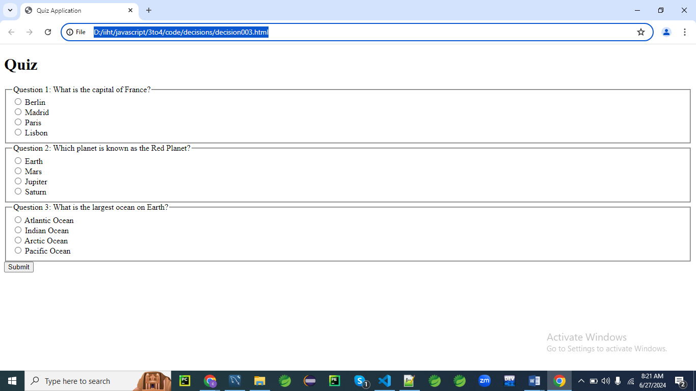

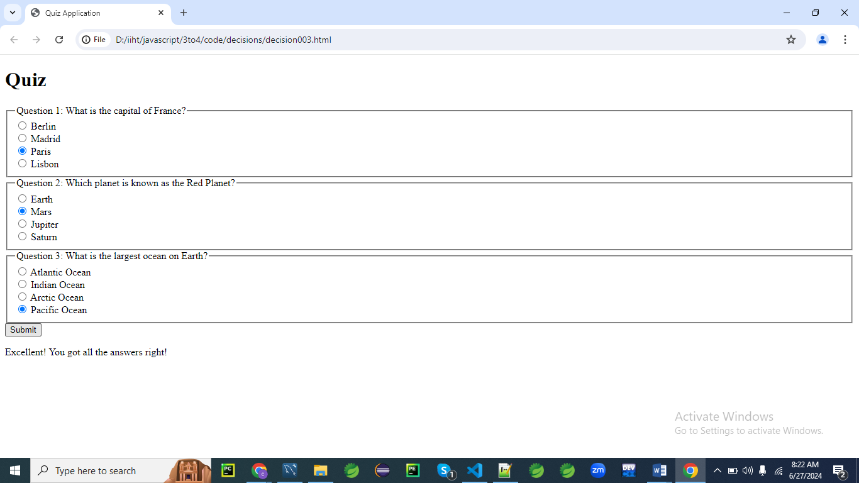

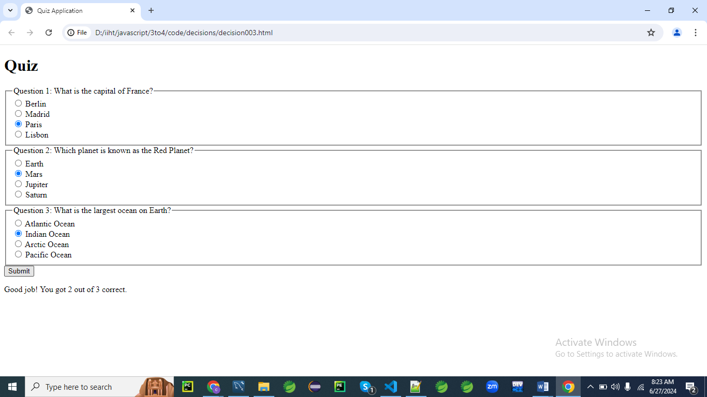

**HTML Form**

First, let's create an HTML form for the quiz with multiple-choice questions.

<!DOCTYPE html>

<html lang="en">

<head>

<meta charset="UTF-8">

<meta name="viewport" content="width=device-width, initial-scale=1.0">

<title>Quiz Application</title>

</head>

<body>

<h1>Quiz</h1>

<form id="quizForm">

<fieldset>

<legend>Question 1: What is the capital of France?</legend>

<label>

<input type="radio" name="q1" value="Berlin" required> Berlin

</label><br>

<label>

<input type="radio" name="q1" value="Madrid"> Madrid

</label><br>

<label>

<input type="radio" name="q1" value="Paris"> Paris

</label><br>

<label>

<input type="radio" name="q1" value="Lisbon"> Lisbon

</label><br>

</fieldset>

<fieldset>

<legend>Question 2: Which planet is known as the Red Planet?</legend>

<label>

<input type="radio" name="q2" value="Earth" required> Earth

</label><br>

<label>

<input type="radio" name="q2" value="Mars"> Mars

</label><br>

<label>

<input type="radio" name="q2" value="Jupiter"> Jupiter

</label><br>

<label>

<input type="radio" name="q2" value="Saturn"> Saturn

</label><br>

</fieldset>

<fieldset>

<legend>Question 3: What is the largest ocean on Earth?</legend>

<label>

<input type="radio" name="q3" value="Atlantic" required> Atlantic Ocean

</label><br>

<label>

<input type="radio" name="q3" value="Indian"> Indian Ocean

</label><br>

<label>

<input type="radio" name="q3" value="Arctic"> Arctic Ocean

</label><br>

<label>

<input type="radio" name="q3" value="Pacific"> Pacific Ocean

</label><br>

</fieldset>

<button type="submit">Submit</button>

</form>

<p id="message"></p>

<script src="script.js"></script>

</body>

</html>

**JavaScript Code**

Now, let's write the JavaScript code that handles the form submission and includes various decision-making structures.

document.getElementById('quizForm').addEventListener('submit', function(event) {

event.preventDefault(); // Prevent the form from submitting the traditional way

// Get form values

let q1 = document.querySelector('input[name="q1"]:checked').value;

let q2 = document.querySelector('input[name="q2"]:checked').value;

let q3 = document.querySelector('input[name="q3"]:checked').value;

// Correct answers

// Create an object correctAnswers

let correctAnswers = {

q1: "Paris",

q2: "Mars",

q3: "Pacific"

};

// Decision-making logic

let score = 0;

if (q1 === correctAnswers.q1) {

score++;

}

if (q2 === correctAnswers.q2) {

score++;

}

if (q3 === correctAnswers.q3) {

score++;

}

// Using switch-case for feedback based on score

let feedback = '';

switch (score) {

case 3:

feedback = "Excellent! You got all the answers right!";

break;

case 2:

feedback = "Good job! You got 2 out of 3 correct.";

break;

case 1:

feedback = "You got 1 out of 3 correct. Keep trying!";

break;

case 0:

feedback = "You got all the answers wrong. Better luck next time!";

break;

default:

feedback = "An unexpected error occurred.";

}

// Display the feedback

document.getElementById('message').innerText = feedback;

});

**Explanation**

1. **HTML Form:**
   * The form contains three multiple-choice questions, each with four possible answers.
   * Each question uses radio buttons to allow the user to select one answer.
   * When the form is submitted, the submit event is triggered.
2. **JavaScript Code:**
   * An event listener is added to handle the form submission.
   * The event.preventDefault() method prevents the form from submitting in the traditional way, allowing us to handle the submission with JavaScript.
   * The values of the selected radio buttons are retrieved and stored in variables.
   * Correct answers are predefined in an object.
   * Conditional statements (if) are used to compare the user's answers with the correct answers and calculate the score.
   * A switch statement is used to provide feedback based on the score.
   * The feedback message is displayed in the paragraph with the id message.

This example demonstrates how to use various decision-making structures in JavaScript to handle and validate user input in a quiz application. It includes if statements for condition checking and a switch statement for providing different feedback messages based on the user's score.

**Loops in javascript**

Loops are a fundamental part of JavaScript and allow you to execute a block of code multiple times.

JavaScript supports several types of loops: for, while, do...while, and for...in/for...of.

Here’s an overview of each type of loop along with examples.

**1. for Loop**

The for loop is used to execute a block of code a specific number of times.

It consists of three parts: initialization, condition, and iteration.

for (let i = 0; i < 5; i++) {

console.log("Iteration number: " + i);

}

**2. while Loop**

The while loop executes a block of code as long as a specified condition is true.

let i = 0;

while (i < 5) {

console.log("Iteration number: " + i);

i++;

}

**3. do...while Loop**

The do...while loop is similar to the while loop, but it executes the block of code at least once before checking the condition.

let i = 0;

do {

console.log("Iteration number: " + i);

i++;

} while (i < 5);

**4. for...in Loop**

The for...in loop is used to iterate over the properties of an object.

const person = { name: "Alice", age: 25, city: "New York" };

for (let key in person) {

console.log(key + ": " + person[key]);

}

**5. for...of Loop**

The for...of loop is used to iterate over iterable objects (like arrays, strings, etc.).

const numbers = [1, 2, 3, 4, 5];

for (let number of numbers) {

console.log("Number: " + number);

}

**6. Nested Loops**

Loops can also be nested, meaning you can have a loop inside another loop.

for (let i = 0; i < 3; i++) {

console.log("Outer loop iteration: " + i);

for (let j = 0; j < 2; j++) {

console.log(" Inner loop iteration: " + j);

}

}

**Example Program: Generating a Multiplication Table**

Here’s a complete example program that uses nested loops to generate a multiplication table.

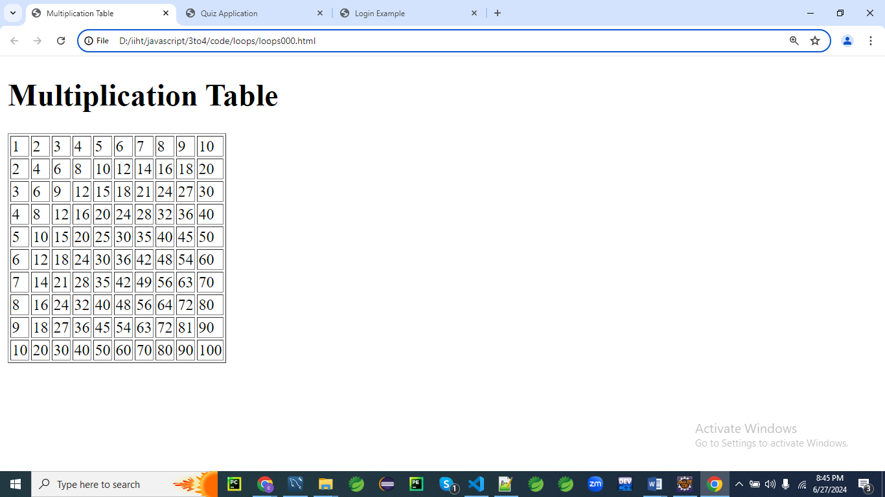

<!DOCTYPE html>

<html lang="en">

<head>

<meta charset="UTF-8">

<meta name="viewport" content="width=device-width, initial-scale=1.0">

<title>Multiplication Table</title>

</head>

<body>

<h1>Multiplication Table</h1>

<table border="1" id="multiplicationTable"></table>

<script>

const table = document.getElementById('multiplicationTable');

for (let i = 1; i <= 10; i++) {

const row = table.insertRow();

for (let j = 1; j <= 10; j++) {

const cell = row.insertCell();

cell.innerText = i * j;

}

}

</script>

</body>

</html>

**Explanation**

1. **HTML Structure:**
   * The HTML includes a table element where the multiplication table will be generated.
2. **JavaScript Code:**
   * The outer for loop iterates from 1 to 10 to create the rows of the table.
   * The inner for loop also iterates from 1 to 10 to create the cells of each row.
   * Each cell is filled with the product of the current row and column indices (i * j).

This example demonstrates how to use nested loops to create a structured output, such as a multiplication table, dynamically in the HTML document.

**What do you mean DOMContentLoaded?**

The **DOMContentLoaded** event in JavaScript is fired when the **initial** HTML document has been completely loaded and parsed, without waiting for stylesheets, images, and subframes to finish loading.

This means the event is triggered as soon as the HTML has been fully loaded and the DOM (Document Object Model) has been constructed, allowing scripts to safely interact with the DOM.

Here's a more detailed explanation:

1. **Loading Process of a Web Page:**
   * **HTML Parsing:** The browser parses the HTML document and constructs the DOM.
   * **External Resources:** During the parsing of the HTML, if the browser encounters <script>, <link>, <img>, etc., it requests these resources.
   * **DOMContentLoaded Event:** This event fires when the HTML is completely parsed and the DOM is fully constructed, but **before all external resources like images and stylesheets are loaded**.
   * **load Event:** This event fires after the DOMContentLoaded event, once the entire page including **all dependent resources (stylesheets, images) has fully loaded**.
2. **Usage:**
   * The **DOMContentLoaded** event is useful when you want to execute JavaScript code as soon as the DOM is ready for manipulation, without waiting for the entire page to load.
   * It's commonly used to initialize scripts that rely on the DOM elements being present.

Here is a simple example to illustrate its use:

<!DOCTYPE html>

<html lang="en">

<head>

<meta charset="UTF-8">

<title>DOMContentLoaded Example</title>

</head>

<body>

<div id="content">Hello, World!</div>

<script>

document.addEventListener('DOMContentLoaded', function() {

// This code will run when the DOM is fully loaded

const contentDiv = document.getElementById('content');

contentDiv.textContent = 'DOM fully loaded and parsed!';

});

</script>

</body>

</html>

In this example:

* The DOMContentLoaded event listener is set up to run a function once the DOM is fully loaded.
* When the DOM is ready, it changes the text content of the <div id="content"> element.

**Why Use DOMContentLoaded?**

1. **Safe DOM Manipulation:** Ensures that your JavaScript code that manipulates the DOM will only run after the DOM is ready.
2. **Performance:** It allows your script to run sooner than waiting for the load event, which can improve the perceived performance of your web application.
3. **Avoiding Errors:** Prevents errors that occur when trying to access DOM elements that aren't yet available.

**Summary**

The DOMContentLoaded event is essential for writing scripts that interact with the DOM as soon as it's ready, ensuring that the page's structure is fully available for manipulation, without waiting for all the assets like images to load

**Example 01:**

Let's create a comprehensive example that involves forms and loops with enhanced CSS3 styling.

This example will be a dynamic quiz application where users can add questions, take the quiz, and receive feedback based on their answers.

The application will use loops for rendering the questions, handling form submissions, and calculating results, and will also feature a modern, visually appealing design using CSS3.

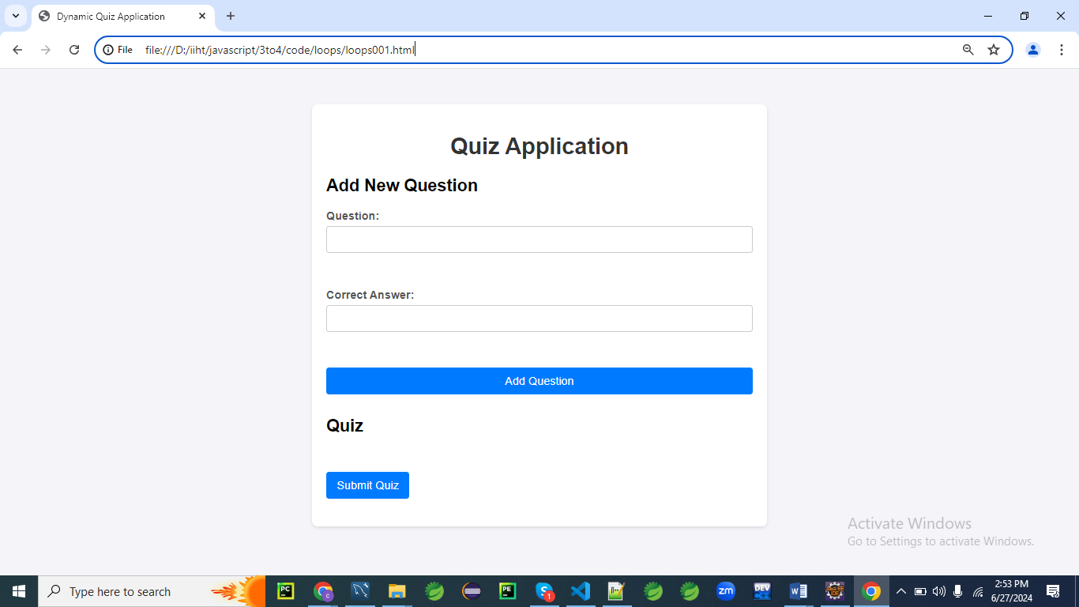

**When you click Add Question button**

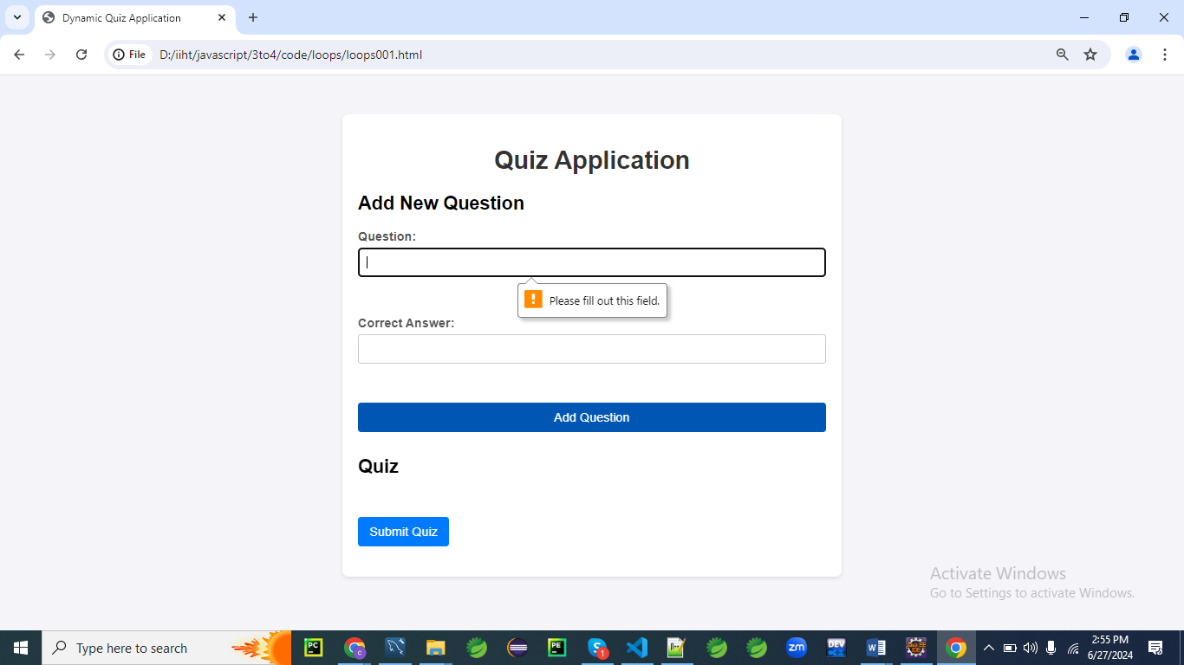

**When you click Submit Quiz button without filling the form**

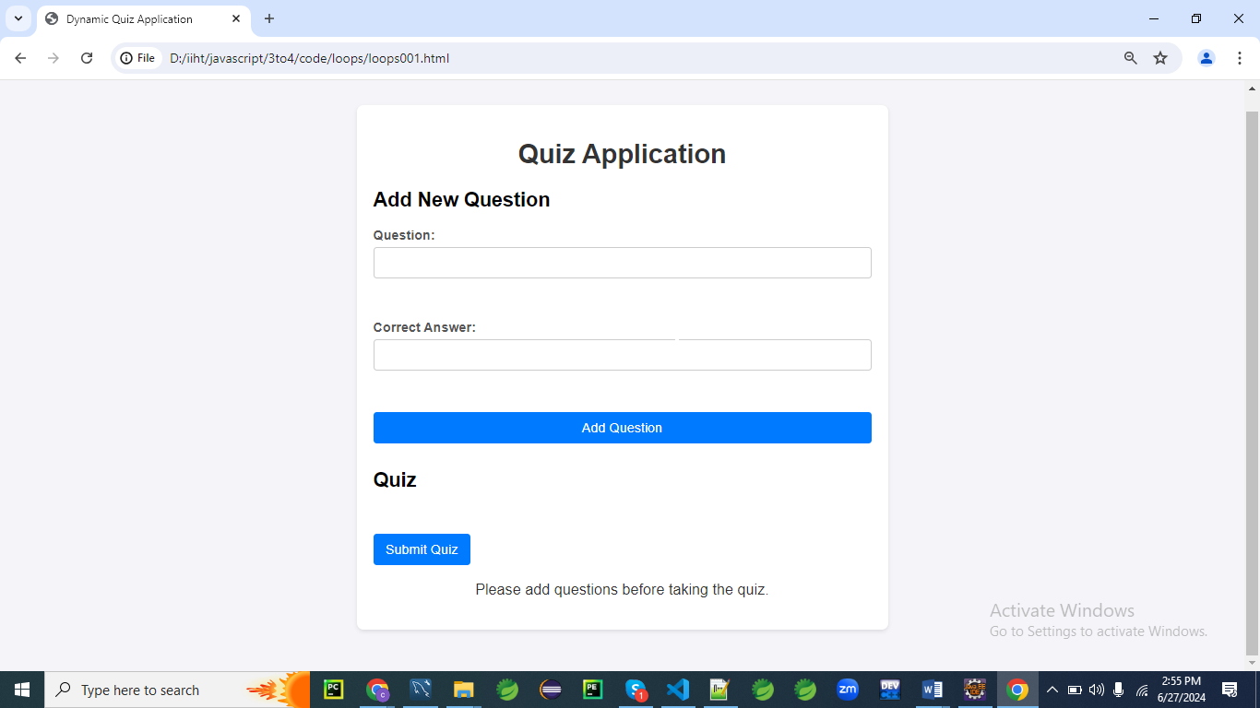

**When you give the data and submit.**

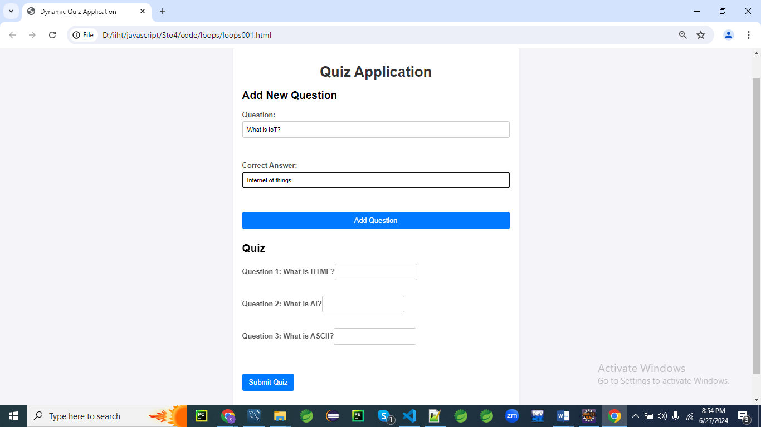

**Final output**

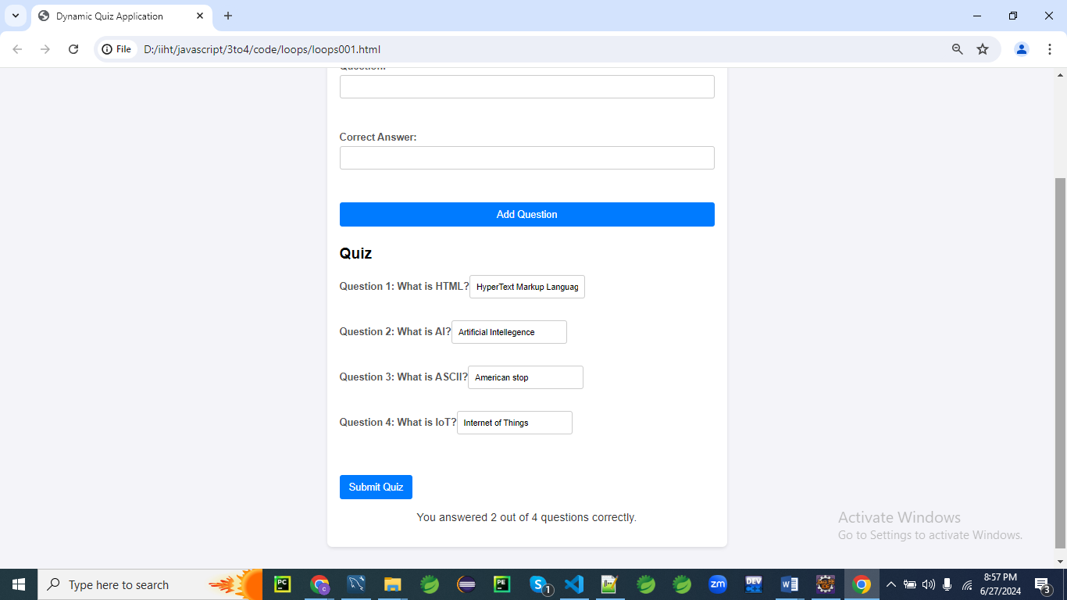

**HTML Form**

First, let's create an HTML structure for the quiz application.

<!DOCTYPE html>

<html lang="en">

<head>

<meta charset="UTF-8">

<meta name="viewport" content="width=device-width, initial-scale=1.0">

<title>Dynamic Quiz Application</title>

<link rel="stylesheet" href="styles003.css">

</head>

<body>

<div class="container">

<h1>Quiz Application</h1>

<!-- Form to add new questions -->

<div class="form-section">

<h2>Add New Question</h2>

<form id="addQuestionForm">

<label for="questionText">Question:</label>

<input type="text" id="questionText" required><br><br>

<label for="correctAnswer">Correct Answer:</label>

<input type="text" id="correctAnswer" required><br><br>

<button type="submit">Add Question</button>

</form>

</div>

<div class="form-section">

<h2>Quiz</h2>

<form id="quizForm"></form>

</div>

<button id="submitQuiz">Submit Quiz</button>

<p id="message"></p>

</div>

<script src="script003.js"></script>

</body>

</html>

**CSS Styles**

Next, let's add the CSS styles for a modern, visually appealing design.

/* styles003.css */

body {

font-family: 'Arial', sans-serif;

background: #f4f4f9;

margin: 0;

padding: 0;

}

.container {

max-width: 600px;

margin: 50px auto;

padding: 20px;

background: #fff;

box-shadow: 0 2px 5px rgba(0, 0, 0, 0.1);

border-radius: 8px;

}

h1 {

text-align: center;

color: #333;

}

.form-section {

margin-bottom: 30px;

}

form {

display: flex;

flex-direction: column;

}

label {

margin-bottom: 5px;

font-weight: bold;

color: #555;

}

input[type="text"] {

padding: 10px;

margin-bottom: 15px;

border: 1px solid #ccc;

border-radius: 4px;

}

button {

padding: 10px 15px;

border: none;

border-radius: 4px;

background: #007bff;

color: #fff;

cursor: pointer;

font-size: 16px;

}

button:hover {

background: #0056b3;

}

#message {

text-align: center;

font-size: 18px;

color: #333;

}

.question {

margin-bottom: 20px;

}

**Explanation**

Let's go through each CSS rule line by line to explain its purpose and function.

/* styles.css */

**body {**

**font-family: 'Arial', sans-serif;**

**background: #f4f4f9;**

**margin: 0;**

**padding: 0;**

**}**

* body { ... }: Targets the <body> element of the HTML document.
* font-family: 'Arial', sans-serif;: Sets the font for the body text to Arial, with a fallback to sans-serif if Arial is not available.
* background: #f4f4f9;: Sets the background color of the body to a light gray color (#f4f4f9).
* margin: 0;: Removes the default margin from the body element.
* padding: 0;: Removes the default padding from the body element.

**.container {**

**max-width: 600px;**

**margin: 50px auto;**

**padding: 20px;**

**background: #fff;**

**box-shadow: 0 2px 5px rgba(0, 0, 0, 0.1);**

**border-radius: 8px;**

**}**

* .container { ... }: Targets elements with the class container.
* max-width: 600px;: Limits the maximum width of the container to 600 pixels.
* margin: 50px auto;: Centers the container horizontally and adds a 50-pixel margin at the top and bottom.
* padding: 20px;: Adds a 20-pixel padding inside the container.
* background: #fff;: Sets the background color of the container to white.
* box-shadow: 0 2px 5px rgba(0, 0, 0, 0.1);: Adds a subtle shadow around the container to give it a slight 3D effect.
* border-radius: 8px;: Rounds the corners of the container with an 8-pixel radius.

**h1 {**

**text-align: center;**

**color: #333;**

**}**

* h1 { ... }: Targets <h1> elements.
* text-align: center;: Centers the text horizontally within the <h1> element.
* color: #333;: Sets the text color to a dark gray (#333).

**.form-section {**

**margin-bottom: 30px;**

**}**

* .form-section { ... }: Targets elements with the class form-section.
* margin-bottom: 30px;: Adds a 30-pixel margin below the element.

**form {**

**display: flex;**

**flex-direction: column;**

**}**

* form { ... }: Targets <form> elements.
* display: flex;: Uses Flexbox for layout within the form.
* flex-direction: column;: Arranges the form's child elements in a vertical column.

**label {**

**margin-bottom: 5px;**

**font-weight: bold;**

**color: #555;**

**}**

* label { ... }: Targets <label> elements.
* margin-bottom: 5px;: Adds a 5-pixel margin below each label.
* font-weight: bold;: Makes the label text bold.
* color: #555;: Sets the text color to a medium gray (#555).

**input[type="text"] {**

**padding: 10px;**

**margin-bottom: 15px;**

**border: 1px solid #ccc;**

**border-radius: 4px;**

**}**

* input[type="text"] { ... }: Targets text input fields (<input type="text">).
* padding: 10px;: Adds 10 pixels of padding inside the input field.
* margin-bottom: 15px;: Adds a 15-pixel margin below the input field.
* border: 1px solid #ccc;: Adds a 1-pixel solid border with a light gray color (#ccc).
* border-radius: 4px;: Rounds the corners of the input field with a 4-pixel radius.

**button {**

**padding: 10px 15px;**

**border: none;**

**border-radius: 4px;**

**background: #007bff;**

**color: #fff;**

**cursor: pointer;**

**font-size: 16px;**

**}**

* button { ... }: Targets <button> elements.
* padding: 10px 15px;: Adds 10 pixels of padding at the top and bottom, and 15 pixels at the sides.
* border: none;: Removes any default border.
* border-radius: 4px;: Rounds the corners of the button with a 4-pixel radius.
* background: #007bff;: Sets the background color of the button to a blue color (#007bff).
* color: #fff;: Sets the text color of the button to white.
* cursor: pointer;: Changes the cursor to a pointer when hovering over the button.
* font-size: 16px;: Sets the font size of the button text to 16 pixels.

**button:hover {**

**background: #0056b3;**

**}**

* button:hover { ... }: Targets <button> elements when they are hovered over.
* background: #0056b3;: Changes the background color of the button to a darker blue (#0056b3) when hovered over.

**#message {**

**text-align: center;**

**font-size: 18px;**

**color: #333;**

**}**

* #message { ... }: Targets the element with the id message.
* text-align: center;: Centers the text horizontally within the element.
* font-size: 18px;: Sets the font size of the text to 18 pixels.
* color: #333;: Sets the text color to a dark gray (#333).

**.question {**

**margin-bottom: 20px;**

**}**

* .question { ... }: Targets elements with the class question.
* margin-bottom: 20px;: Adds a 20-pixel margin below the element.

**JavaScript Code**

Finally, let's write the JavaScript code that handles adding questions, taking the quiz, and providing feedback.

document.addEventListener('DOMContentLoaded', function() {

const addQuestionForm = document.getElementById('addQuestionForm');

const quizForm = document.getElementById('quizForm');

const submitQuizButton = document.getElementById('submitQuiz');

const message = document.getElementById('message');

let questions = [];

addQuestionForm.addEventListener('submit', function(event) {

event.preventDefault(); // Prevent the form from submitting the traditional way

const questionText = document.getElementById('questionText').value;

const correctAnswer = document.getElementById('correctAnswer').value;

// Add new question to the questions array

questions.push({ questionText, correctAnswer });

// Clear the form fields

addQuestionForm.reset();

// Render the questions

renderQuestions();

});

function renderQuestions() {

quizForm.innerHTML = ''; // Clear existing questions

// Loop through questions array and create form elements

questions.forEach((question, index) => {

const div = document.createElement('div');

div.className = 'question';

const label = document.createElement('label');

label.textContent = `Question ${index + 1}: ${question.questionText}`;

div.appendChild(label);

const input = document.createElement('input');

input.type = 'text';

input.name = `q${index}`;

input.required = true;

div.appendChild(input);

quizForm.appendChild(div);

});

}

submitQuizButton.addEventListener('click', function(event) {

event.preventDefault(); // Prevent the button from submitting the traditional way

// Check if there are questions to answer

if (questions.length === 0) {

message.textContent = 'Please add questions before taking the quiz.';

return;

}

// Get user's answers

const formData = new FormData(quizForm);

let score = 0;

// Loop through questions and compare answers

questions.forEach((question, index) => {

const userAnswer = formData.get(`q${index}`);

if (userAnswer && userAnswer.toLowerCase() === question.correctAnswer.toLowerCase()) {

score++;

}

});

// Display feedback

const feedback = `You answered ${score} out of ${questions.length} questions correctly.`;

message.textContent = feedback;

});

});

**Explanation:**

Let's go through this JavaScript code line by line.

**document.addEventListener('DOMContentLoaded', function() {**

* Adds an event listener to the document that fires when the DOM content is fully loaded and parsed, ensuring the script runs only after the document is ready.

**const addQuestionForm = document.getElementById('addQuestionForm');**

**const quizForm = document.getElementById('quizForm');**

**const submitQuizButton = document.getElementById('submitQuiz');**

**const message = document.getElementById('message');**

* Retrieves elements by their IDs and assigns them to constants for easy reference:
  + addQuestionForm: The form for adding new questions.
  + quizForm: The form where the quiz questions will be displayed.
  + submitQuizButton: The button to submit the quiz.
  + message: An element to display messages or feedback to the user.

**let questions = [];**

Initializes an empty array to store the questions.

**addQuestionForm.addEventListener('submit', function(event) {**

**event.preventDefault(); // Prevent the form from submitting the traditional way**

**const questionText = document.getElementById('questionText').value;**

**const correctAnswer = document.getElementById('correctAnswer').value;**

**// Add new question to the questions array**

**questions.push({ questionText, correctAnswer });**

**// Clear the form fields**

**addQuestionForm.reset();**

**// Render the questions**

**renderQuestions();**

**});**

* Adds a 'submit' event listener to addQuestionForm that:
  + Prevents the form's default submit action.
  + Retrieves the values of questionText and correctAnswer input fields.
  + Adds the new question (as an object) to the questions array.
  + Resets the form fields to empty.
  + Calls renderQuestions to update the quiz form with the new questions.

**function renderQuestions() {**

**quizForm.innerHTML = ''; // Clear existing questions**

**// Loop through questions array and create form elements**

**questions.forEach((question, index) => {**

**const div = document.createElement('div');**

**div.className = 'question';**

**const label = document.createElement('label');**

**label.textContent = `Question ${index + 1}: ${question.questionText}`;**

**div.appendChild(label);**

**const input = document.createElement('input');**

**input.type = 'text';**

**input.name = `q${index}`;**

**input.required = true;**

**div.appendChild(input);**

**quizForm.appendChild(div);**

**});**

**}**

* Defines the renderQuestions function that:
  + Clears the existing content of quizForm.
  + Iterates over the questions array.
  + For each question:
    - Creates a div element with the class question.
    - Creates a label element with the question text and appends it to the div.
    - Creates an input element for the answer, names it based on its index, sets it as required, and appends it to the div.
    - Appends the div to the quizForm.

**submitQuizButton.addEventListener('click', function(event) {**

**event.preventDefault(); // Prevent the button from submitting the traditional way**

**// Check if there are questions to answer**

**if (questions.length === 0) {**

**message.textContent = 'Please add questions before taking the quiz.';**

**return;**

**}**

**// Get user's answers**

**const formData = new FormData(quizForm);**

**let score = 0;**

**// Loop through questions and compare answers**

**questions.forEach((question, index) => {**

**const userAnswer = formData.get(`q${index}`);**

**if (userAnswer && userAnswer.toLowerCase() === question.correctAnswer.toLowerCase()) {**

**score++;**

**}**

**});**

**// Display feedback**

**const feedback = `You answered ${score} out of ${questions.length} questions correctly.`;**

**message.textContent = feedback;**

**});**

**});**

* Adds a 'click' event listener to submitQuizButton that:
  + Prevents the default button action.
  + Checks if there are any questions; if not, displays a message and exits.
  + Collects the form data using FormData.
  + Initializes a score counter.
  + Iterates over the questions array:
    - Retrieves the user's answer for each question from the form data.
    - Compares it (case-insensitively) to the correct answer.
    - Increments the score if the answers match.
  + Displays feedback with the user's score in the message element.

**Explanation**

1. **HTML Structure:**
   * The HTML includes a form to add new questions and a separate form to take the quiz.
   * A button is provided to submit the quiz and display the results.
2. **CSS Styles:**
   * The CSS styles create a modern and clean design for the quiz application.
   * It includes styles for the body, container, headings, forms, labels, input fields, buttons, and messages.
   * Hover effects and rounded corners enhance the visual appeal.
3. **JavaScript Code:**
   * **Event Listener for Adding Questions:**
     + An event listener on the addQuestionForm handles form submission, preventing the default form submission behavior.
     + The question and correct answer are retrieved from the form fields and added to the questions array.
     + The form fields are cleared, and the renderQuestions function is called to update the quiz form.
   * **Render Questions Function:**
     + This function loops through the questions array and creates form elements for each question.
     + It dynamically creates div elements with labels and input fields for each question and appends them to the quizForm.
   * **Event Listener for Submitting Quiz:**
     + An event listener on the submitQuizButton handles the quiz submission, preventing the default behavior.
     + It checks if there are any questions to answer and displays a message if there are none.
     + It retrieves the user's answers using the FormData object and loops through the questions array to compare the answers.
     + The user's score is calculated, and feedback is displayed based on the number of correct answers.

This example demonstrates how to use loops to dynamically create form elements, handle form submissions, and process user input in a more complex scenario involving a dynamically generated quiz application.

The use of CSS3 styling enhances the visual appeal and user experience.

**Example 02**

Let's create a comprehensive example of a survey form where users can add questions dynamically, provide multiple choice answers, and submit their responses.

This example will include loops for rendering questions and answers, handling form submissions, and calculating the results.

We'll also enhance the form with modern CSS3 styling.

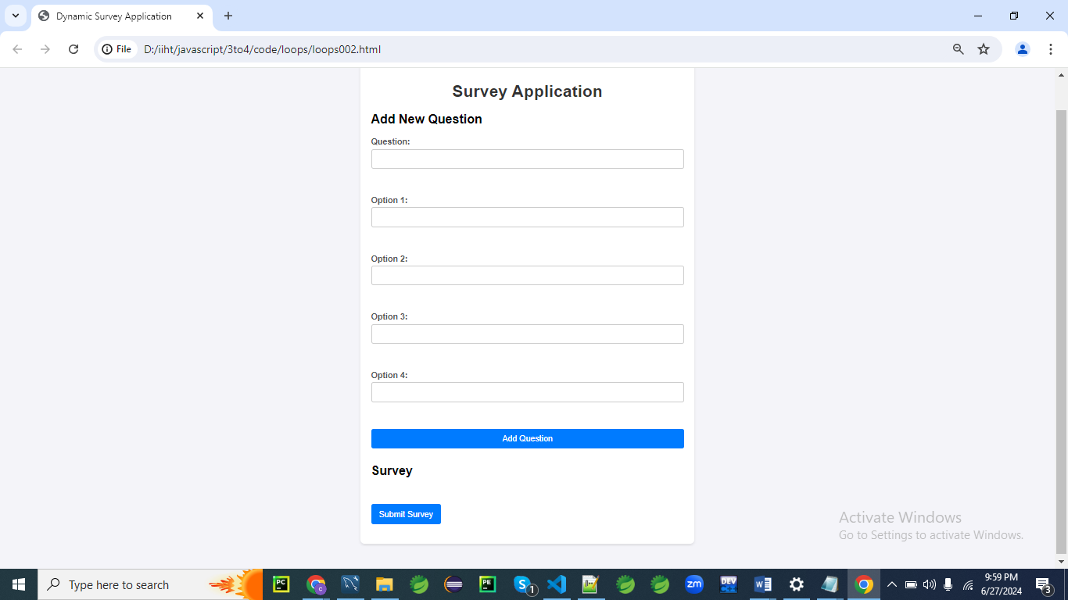

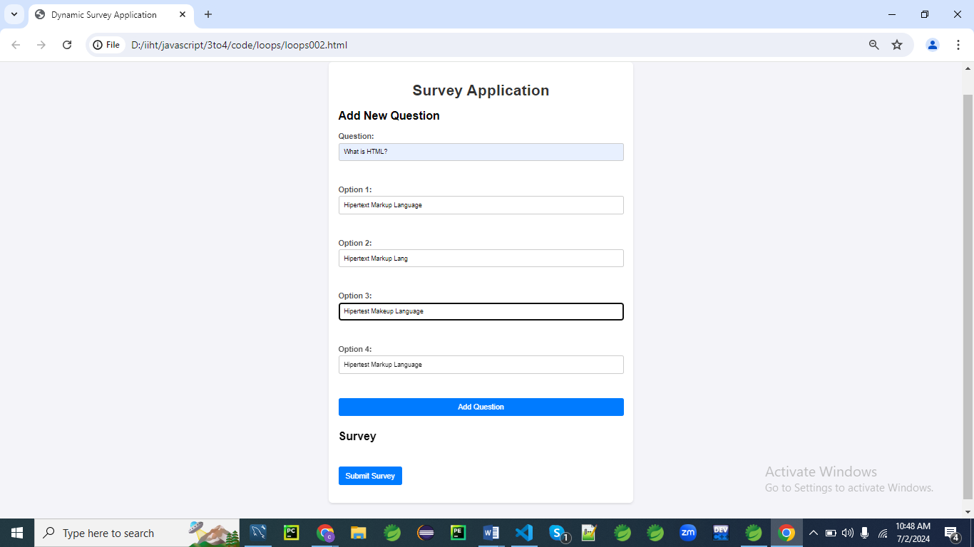

**Add data and click on Add Question**

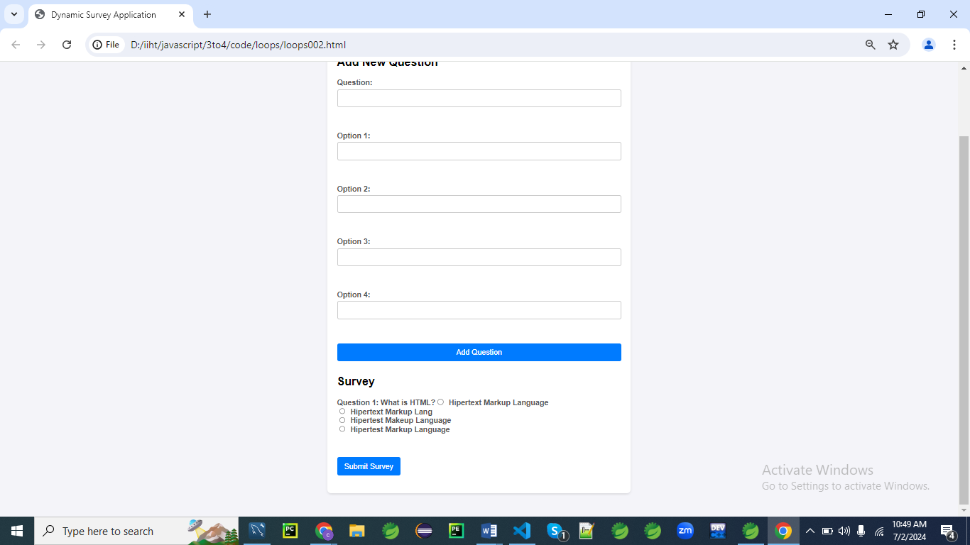

**Final Output:**

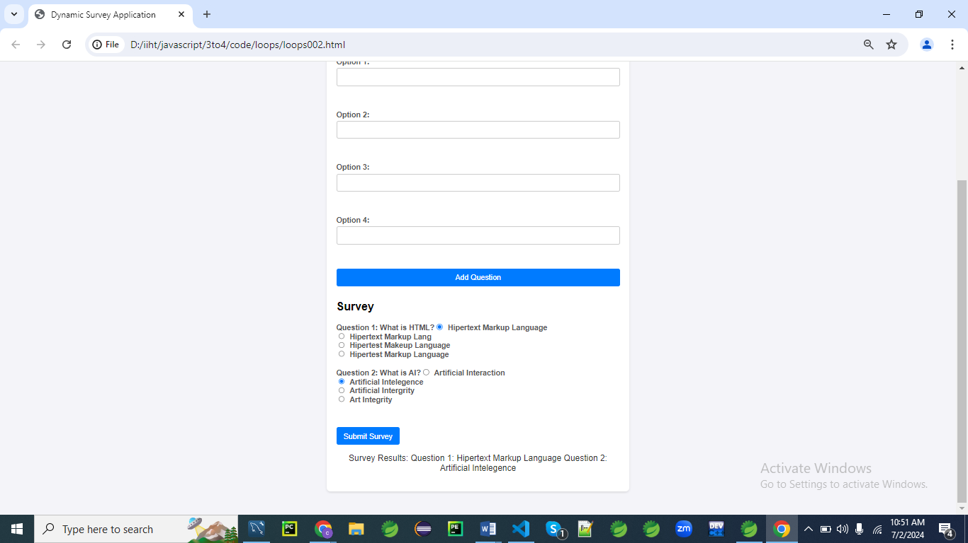

**HTML Form**

First, let's create an HTML structure for the survey application.

<!DOCTYPE html>

<html lang="en">

<head>

<meta charset="UTF-8">

<meta name="viewport" content="width=device-width, initial-scale=1.0">

<title>Dynamic Survey Application</title>

<link rel="stylesheet" href="styles.css">

</head>

<body>

<div class="container">

<h1>Survey Application</h1>

<!-- Form to add new questions -->

<div class="form-section">

<h2>Add New Question</h2>

<form id="addQuestionForm">

<label for="questionText">Question:</label>

<input type="text" id="questionText" required><br><br>

<label for="option1">Option 1:</label>

<input type="text" id="option1" required><br><br>

<label for="option2">Option 2:</label>

<input type="text" id="option2" required><br><br>

<label for="option3">Option 3:</label>

<input type="text" id="option3" required><br><br>

<label for="option4">Option 4:</label>

<input type="text" id="option4" required><br><br>

<button type="submit">Add Question</button>

</form>

</div>

<div class="form-section">

<h2>Survey</h2>

<form id="surveyForm"></form>

</div>

<button id="submitSurvey">Submit Survey</button>

<p id="message"></p>

</div>

<script src="script.js"></script>

</body>

</html>

**CSS Styles**

Next, let's add the CSS styles for a modern, visually appealing design.

/* styles.css */

body {

font-family: 'Arial', sans-serif;

background: #f4f4f9;

margin: 0;

padding: 0;

}

.container {

max-width: 600px;

margin: 50px auto;

padding: 20px;

background: #fff;

box-shadow: 0 2px 5px rgba(0, 0, 0, 0.1);

border-radius: 8px;

}

h1 {

text-align: center;

color: #333;

}

.form-section {

margin-bottom: 30px;

}

form {

display: flex;

flex-direction: column;

}

label {

margin-bottom: 5px;

font-weight: bold;

color: #555;

}

input[type="text"] {

padding: 10px;

margin-bottom: 15px;

border: 1px solid #ccc;

border-radius: 4px;

}

input[type="radio"] {

margin-right: 10px;

}

button {

padding: 10px 15px;

border: none;

border-radius: 4px;

background: #007bff;

color: #fff;

cursor: pointer;

font-size: 16px;

}

button:hover {

background: #0056b3;

}

#message {

text-align: center;

font-size: 18px;

color: #333;

}

.question {

margin-bottom: 20px;

}

**Explanation**

Let's go through the CSS code line by line to understand its purpose and effect.

**body {**

**font-family: 'Arial', sans-serif;**

**background: #f4f4f9;**

**margin: 0;**

**padding: 0;**

**}**

* font-family: 'Arial', sans-serif; sets the font of the body to Arial or, if Arial is not available, to a generic sans-serif font.
* background: #f4f4f9; sets the background color of the body to a light gray.
* margin: 0; removes the default margin from the body.
* padding: 0; removes the default padding from the body.

**.container {**

**max-width: 600px;**

**margin: 50px auto;**

**padding: 20px;**

**background: #fff;**

**box-shadow: 0 2px 5px rgba(0, 0, 0, 0.1);**

**border-radius: 8px;**

**}**

* max-width: 600px; restricts the maximum width of the container to 600 pixels.
* margin: 50px auto; centers the container horizontally and adds a 50-pixel margin at the top and bottom.
* padding: 20px; adds 20 pixels of padding inside the container.
* background: #fff; sets the background color of the container to white.
* box-shadow: 0 2px 5px rgba(0, 0, 0, 0.1); adds a subtle shadow around the container to give it a slight 3D effect.
* border-radius: 8px; rounds the corners of the container with an 8-pixel radius.

**h1 {**

**text-align: center;**

**color: #333;**

**}**

* text-align: center; centers the text of all h1 elements.
* color: #333; sets the text color of h1 elements to a dark gray.

**.form-section {**

**margin-bottom: 30px;**

**}**

* margin-bottom: 30px; adds a 30-pixel margin below elements with the form-section class.

**form {**

**display: flex;**

**flex-direction: column;**

**}**

* display: flex; makes all form elements use flexbox layout.
* flex-direction: column; arranges the children of form elements in a column (one below the other).

**label {**

**margin-bottom: 5px;**

**font-weight: bold;**

**color: #555;**

**}**

* margin-bottom: 5px; adds a 5-pixel margin below all label elements.
* font-weight: bold; makes the text of all label elements bold.
* color: #555; sets the text color of all label elements to a medium gray.

**input[type="text"] {**

**padding: 10px;**

**margin-bottom: 15px;**

**border: 1px solid #ccc;**

**border-radius: 4px;**

**}**

* padding: 10px; adds 10 pixels of padding inside all text input elements.
* margin-bottom: 15px; adds a 15-pixel margin below all text input elements.
* border: 1px solid #ccc; sets a 1-pixel solid border with a light gray color around all text input elements.
* border-radius: 4px; rounds the corners of all text input elements with a 4-pixel radius.

**input[type="radio"] {**

**margin-right: 10px;**

**}**

* margin-right: 10px; adds a 10-pixel margin to the right of all radio input elements.

**button {**

**padding: 10px 15px;**

**border: none;**

**border-radius: 4px;**

**background: #007bff;**

**color: #fff;**

**cursor: pointer;**

**font-size: 16px;**

**}**

* padding: 10px 15px; adds 10 pixels of padding vertically and 15 pixels of padding horizontally inside all button elements.
* border: none; removes the default border from all button elements.
* border-radius: 4px; rounds the corners of all button elements with a 4-pixel radius.
* background: #007bff; sets the background color of all button elements to a blue color.
* color: #fff; sets the text color of all button elements to white.
* cursor: pointer; changes the cursor to a pointer when hovering over all button elements.
* font-size: 16px; sets the font size of all button elements to 16 pixels.

**button:hover {**

**background: #0056b3;**

**}**

* background: #0056b3; changes the background color of all button elements to a darker blue when they are hovered over.

**#message {**

**text-align: center;**

**font-size: 18px;**

**color: #333;**

**}**

* text-align: center; centers the text of the element with the ID message.
* font-size: 18px; sets the font size of the message element to 18 pixels.
* color: #333; sets the text color of the message element to dark gray.

**.question {**

**margin-bottom: 20px;**

**}**

* margin-bottom: 20px; adds a 20-pixel margin below elements with the question class.

**JavaScript Code**

Finally, let's write the JavaScript code that handles adding questions, taking the survey, and providing feedback.

document.addEventListener('DOMContentLoaded', function() {

const addQuestionForm = document.getElementById('addQuestionForm');

const surveyForm = document.getElementById('surveyForm');

const submitSurveyButton = document.getElementById('submitSurvey');

const message = document.getElementById('message');

let questions = [];

addQuestionForm.addEventListener('submit', function(event) {

event.preventDefault(); // Prevent the form from submitting the traditional way

const questionText = document.getElementById('questionText').value;

const option1 = document.getElementById('option1').value;

const option2 = document.getElementById('option2').value;

const option3 = document.getElementById('option3').value;

const option4 = document.getElementById('option4').value;

// Add new question to the questions array

questions.push({

questionText,

options: [option1, option2, option3, option4]

});

// Clear the form fields

addQuestionForm.reset();

// Render the questions

renderQuestions();

});

function renderQuestions() {

surveyForm.innerHTML = ''; // Clear existing questions

// Loop through questions array and create form elements

questions.forEach((question, index) => {

const div = document.createElement('div');

div.className = 'question';

const label = document.createElement('label');

label.textContent = `Question ${index + 1}: ${question.questionText}`;

div.appendChild(label);

question.options.forEach((option, optIndex) => {

const optionLabel = document.createElement('label');

const input = document.createElement('input');

input.type = 'radio';

input.name = `q${index}`;

input.value = option;

input.required = true;

optionLabel.appendChild(input);

optionLabel.appendChild(document.createTextNode(option));

div.appendChild(optionLabel);

div.appendChild(document.createElement('br'));

});

surveyForm.appendChild(div);

});

}

submitSurveyButton.addEventListener('click', function(event) {

event.preventDefault(); // Prevent the button from submitting the traditional way

// Check if there are questions to answer

if (questions.length === 0) {

message.textContent = 'Please add questions before taking the survey.';

return;

}

// Get user's answers

const formData = new FormData(surveyForm);

let results = {};

// Loop through questions and record answers

questions.forEach((question, index) => {

const userAnswer = formData.get(`q${index}`);

results[`Question ${index + 1}`] = userAnswer;

});

// Display results

let feedback = 'Survey Results:\n';

for (const [question, answer] of Object.entries(results)) {

feedback += `${question}: ${answer}\n`;

}

message.textContent = feedback;

});

});

**Explanation**

Let's go through the JavaScript code line by line to understand its purpose and functionality.

**document.addEventListener('DOMContentLoaded', function() {**

* This line adds an event listener to the document that waits for the DOM content to be fully loaded before running the enclosed function. This ensures that the JavaScript code runs after the HTML has been completely loaded.

**const addQuestionForm = document.getElementById('addQuestionForm');**

**const surveyForm = document.getElementById('surveyForm');**

**const submitSurveyButton = document.getElementById('submitSurvey');**

**const message = document.getElementById('message');**

* These lines get references to the HTML elements with the IDs addQuestionForm, surveyForm, submitSurvey, and message, and store them in variables for later use.

**let questions = [];**

* This line initializes an empty array questions to store the survey questions and their options.

**addQuestionForm.addEventListener('submit', function(event) {**

* This line adds a submit event listener to the addQuestionForm element. When the form is submitted, the enclosed function will run.

**event.preventDefault(); // Prevent the form from submitting the traditional way**

* This line prevents the default form submission behavior, which would cause the page to reload.

**const questionText = document.getElementById('questionText').value;**

**const option1 = document.getElementById('option1').value;**

**const option2 = document.getElementById('option2').value;**

**const option3 = document.getElementById('option3').value;**

**const option4 = document.getElementById('option4').value;**

* These lines get the values from the input fields with IDs questionText, option1, option2, option3, and option4, and store them in variables.

**// Add new question to the questions array**

**questions.push({**

**questionText,**

**options: [option1, option2, option3, option4]**

**});**

* This line creates a new question object with the text and options, and adds it to the questions array.

**// Clear the form fields**

**addQuestionForm.reset();**

* This line resets the addQuestionForm, clearing all input fields.

**// Render the questions**

**renderQuestions();**

**});**

* This line calls the renderQuestions function to update the survey form with the newly added question.

**function renderQuestions() {**

**surveyForm.innerHTML = ''; // Clear existing questions**

* This line clears any existing questions in the surveyForm.

**// Loop through questions array and create form elements**

**questions.forEach((question, index) => {**

**const div = document.createElement('div');**

**div.className = 'question';**

* This loop iterates over the questions array, creating a new div element for each question and assigning it the class question.

**const label = document.createElement('label');**

**label.textContent = `Question ${index + 1}: ${question.questionText}`;**

**div.appendChild(label);**

* This creates a label element for the question text and appends it to the div.

**question.options.forEach((option, optIndex) => {**

**const optionLabel = document.createElement('label');**

**const input = document.createElement('input');**

**input.type = 'radio';**

**input.name = `q${index}`;**

**input.value = option;**

**input.required = true;**

* This inner loop iterates over the options for each question, creating a label and input element for each option.
* The input elements are of type radio, grouped by name (q${index}) to ensure that only one option can be selected per question.
* The required attribute makes answering each question mandatory.

**optionLabel.appendChild(input);**

**optionLabel.appendChild(document.createTextNode(option));**

**div.appendChild(optionLabel);**

**div.appendChild(document.createElement('br'));**

**});**

* These lines append the input and option text to the optionLabel, then append the optionLabel to the div, and add a line break for layout purposes.

**surveyForm.appendChild(div);**

**});**

**}**

* This line appends the div containing the question and options to the surveyForm.

**submitSurveyButton.addEventListener('click', function(event) {**

**event.preventDefault(); // Prevent the button from submitting the traditional way**

* This line adds a click event listener to the submitSurveyButton. When the button is clicked, the enclosed function will run, and the default form submission behavior will be prevented.

**// Check if there are questions to answer**

**if (questions.length === 0) {**

**message.textContent = 'Please add questions before taking the survey.';**

**return;**

**}**

* This block checks if there are any questions in the questions array. If there are none, it updates the message element with a prompt to add questions and exits the function.

**// Get user's answers**

**const formData = new FormData(surveyForm);**

**let results = {};**

* This line creates a FormData object from the surveyForm to easily access the user's answers. It also initializes an empty object results to store the answers.

**// Loop through questions and record answers**

**questions.forEach((question, index) => {**

**const userAnswer = formData.get(`q${index}`);**

**results[`Question ${index + 1}`] = userAnswer;**

**});**

* This loop iterates over the questions array, retrieves the user's answer for each question from the FormData object, and stores it in the results object.

**// Display results**

**let feedback = 'Survey Results:\n';**

**for (const [question, answer] of Object.entries(results)) {**

**feedback += `${question}: ${answer}\n`;**

**}**

**message.textContent = feedback;**

**});**

**});**

* This block constructs a feedback string from the results object and updates the message element with the survey results.

**Explanation**

1. **HTML Structure:**
   * The HTML includes a form to add new questions and a separate form to take the survey.
   * A button is provided to submit the survey and display the results.
2. **CSS Styles:**
   * The CSS styles create a modern and clean design for the survey application.
   * It includes styles for the body, container, headings, forms, labels, input fields, radio buttons, buttons, and messages.
   * Hover effects and rounded corners enhance the visual appeal.
3. **JavaScript Code:**
   * **Event Listener for Adding Questions:**
     + An event listener on the addQuestionForm handles form submission, preventing the default form submission behavior.
     + The question and options are retrieved from the form fields and added to the questions array.
     + The form fields are cleared, and the renderQuestions function is called to update the survey form.
   * **Render Questions Function:**
     + This function loops through the questions array and creates form elements for each question.
     + It dynamically creates div elements with labels, radio buttons, and options for each question and appends them to the surveyForm.
   * **Event Listener for Submitting Survey:**
     + An event listener on the submitSurveyButton handles the survey submission, preventing the default behavior.
     + It checks if there are any questions to answer and displays a message if there are none.
     + It retrieves the user's answers using the FormData object and loops through the questions array to record the answers.
     + The user's responses are displayed as feedback.

This example demonstrates how to use loops to dynamically create form elements, handle form submissions, and process user input in a more complex scenario involving a dynamically generated survey application. The use of CSS3 styling enhances the visual appeal and user experience.

**Example 03**

Let's create an example that involves a dynamic to-do list application.

This application will allow users to add tasks, mark them as complete or incomplete, and delete tasks.

The application will use loops to render tasks and handle user interactions.

Additionally, we'll enhance the form with modern CSS3 styling.

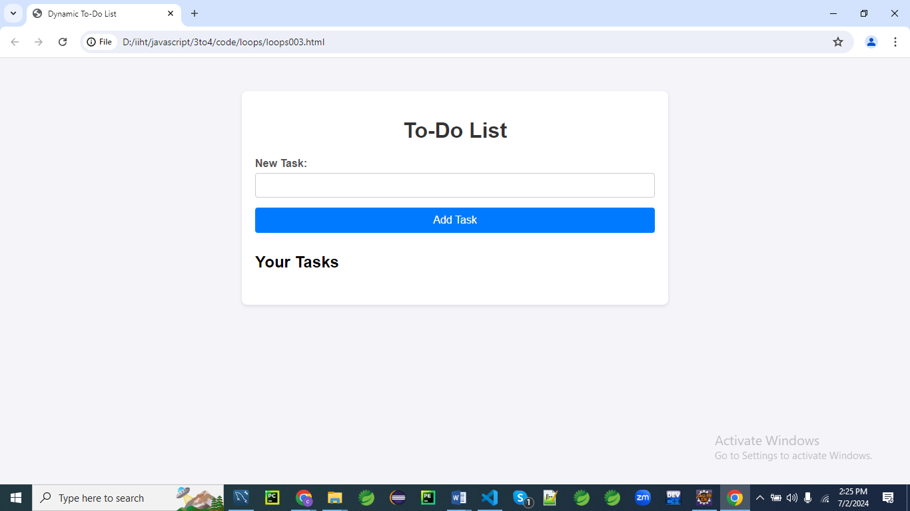

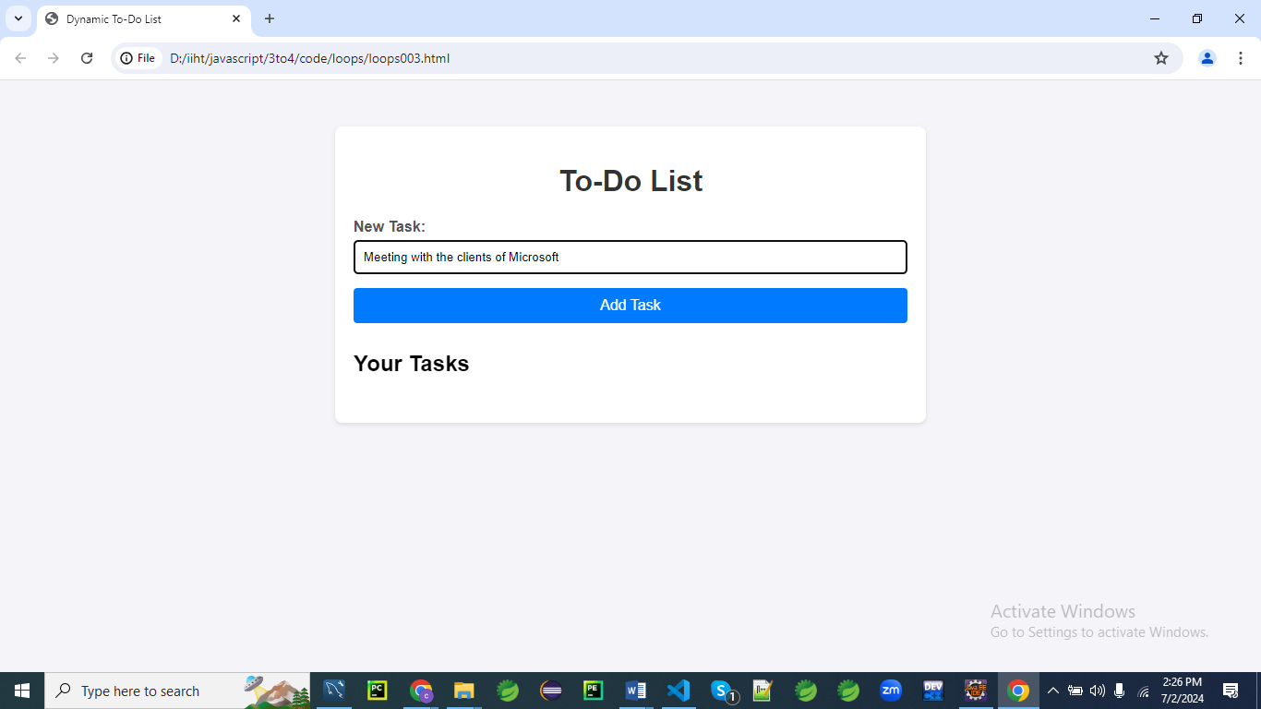

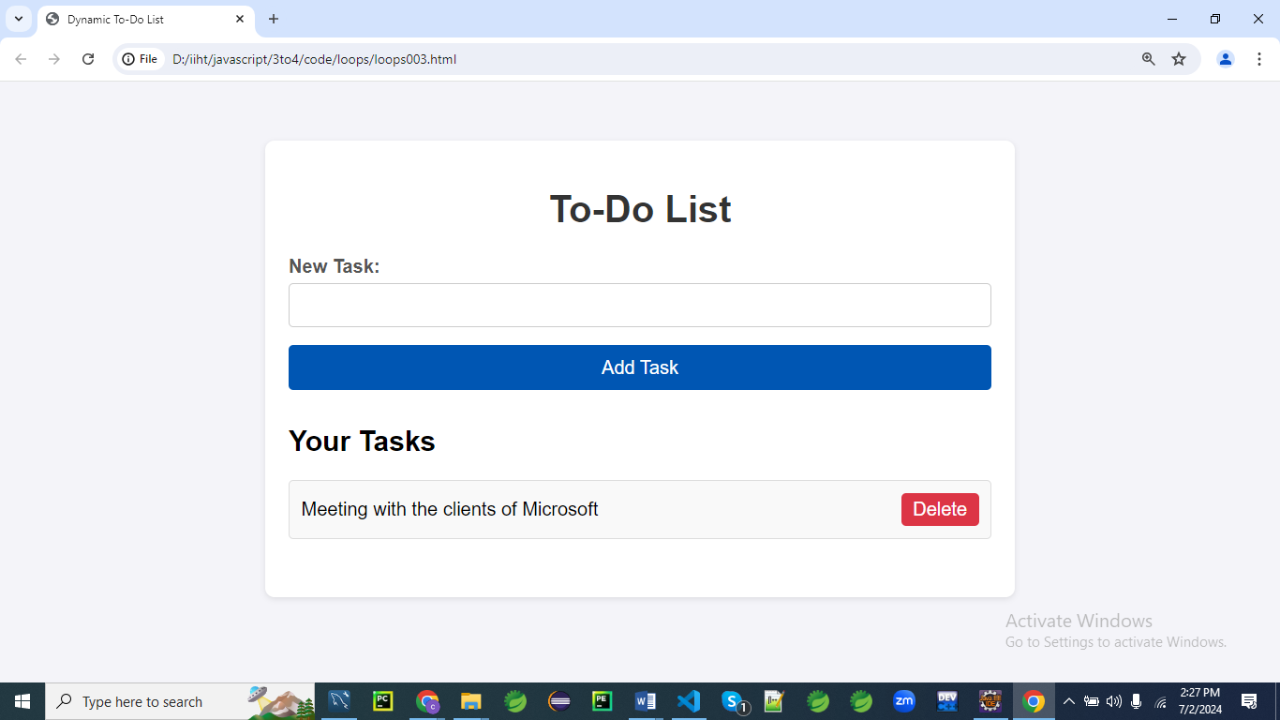

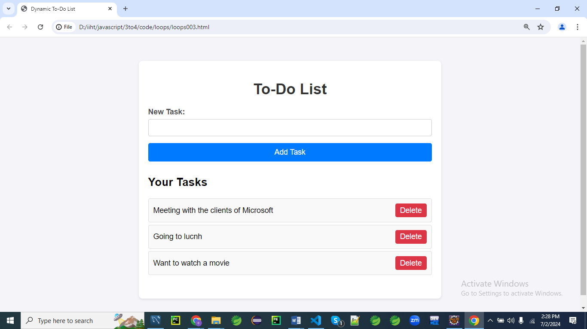

After deleting the option Going to Lunch

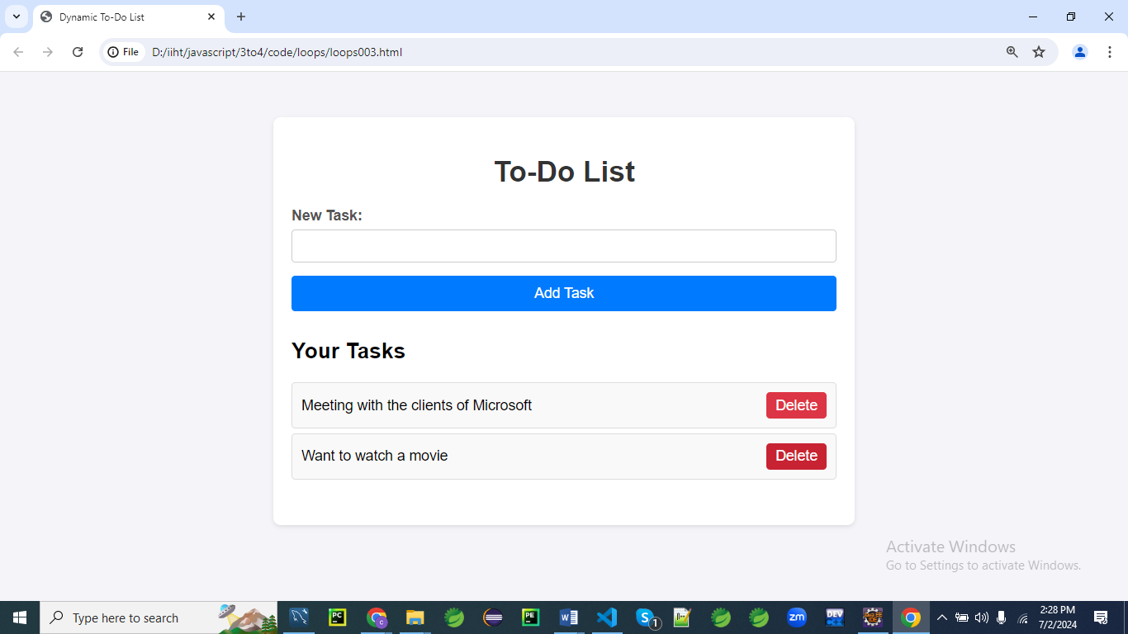

**HTML Structure**

First, let's create an HTML structure for the to-do list application.

<!DOCTYPE html>

<html lang="en">

<head>

<meta charset="UTF-8">

<meta name="viewport" content="width=device-width, initial-scale=1.0">

<title>Dynamic To-Do List</title>

<link rel="stylesheet" href="styles.css">

</head>

<body>

<div class="container">

<h1>To-Do List</h1>

<!-- Form to add new tasks -->

<div class="form-section">

<form id="addTaskForm">

<label for="taskText">New Task:</label>

<input type="text" id="taskText" required>

<button type="submit">Add Task</button>

</form>

</div>

<div class="form-section">

<h2>Your Tasks</h2>

<ul id="taskList"></ul>

</div>

</div>

<script src="script.js"></script>

</body>

</html>

**CSS Styles**

Next, let's add the CSS styles for a modern, visually appealing design.

/* styles.css */

body {

font-family: 'Arial', sans-serif;

background: #f4f4f9;

margin: 0;

padding: 0;

}

.container {

max-width: 600px;

margin: 50px auto;

padding: 20px;

background: #fff;

box-shadow: 0 2px 5px rgba(0, 0, 0, 0.1);

border-radius: 8px;

}

h1 {

text-align: center;

color: #333;

}

.form-section {

margin-bottom: 30px;

}

form {

display: flex;

flex-direction: column;

}

label {

margin-bottom: 5px;

font-weight: bold;

color: #555;

}

input[type="text"] {

padding: 10px;

margin-bottom: 15px;

border: 1px solid #ccc;

border-radius: 4px;

}

button {

padding: 10px 15px;

border: none;

border-radius: 4px;

background: #007bff;

color: #fff;

cursor: pointer;

font-size: 16px;

}

button:hover {

background: #0056b3;

}

ul {

list-style-type: none;

padding: 0;

}

li {

padding: 10px;

margin: 5px 0;

background: #f9f9f9;

border: 1px solid #ddd;

border-radius: 4px;

display: flex;

justify-content: space-between;

align-items: center;

}

li.completed {

text-decoration: line-through;

color: #888;

}

li button {

background: #dc3545;

border: none;

color: white;

cursor: pointer;

padding: 5px 10px;

border-radius: 4px;

}

li button:hover {

background: #c82333;

}

**Explanation**

Let's go through the CSS code line by line to understand its purpose and functionality.

**body {**

**font-family: 'Arial', sans-serif;**

**background: #f4f4f9;**

**margin: 0;**

**padding: 0;**

**}**

* font-family: 'Arial', sans-serif; sets the font family to Arial, with sans-serif as a fallback.
* background: #f4f4f9; sets the background color of the body to a light grey (#f4f4f9).
* margin: 0; removes any default margin around the body.
* padding: 0; removes any default padding within the body.

**.container {**

**max-width: 600px;**

**margin: 50px auto;**

**padding: 20px;**

**background: #fff;**

**box-shadow: 0 2px 5px rgba(0, 0, 0, 0.1);**

**border-radius: 8px;**

**}**

* max-width: 600px; sets the maximum width of the container to 600 pixels.
* margin: 50px auto; centers the container horizontally and adds 50 pixels of margin above and below it.
* padding: 20px; adds 20 pixels of padding inside the container.
* background: #fff; sets the background color of the container to white.
* box-shadow: 0 2px 5px rgba(0, 0, 0, 0.1); adds a subtle shadow to the container for depth.
* border-radius: 8px; rounds the corners of the container with an 8-pixel radius.

**h1 {**

**text-align: center;**

**color: #333;**

**}**

* text-align: center; centers the text within the <h1> element.
* color: #333; sets the text color to a dark grey (#333).

**.form-section {**

**margin-bottom: 30px;**

**}**

* margin-bottom: 30px; adds 30 pixels of margin below each .form-section element.

**form {**

**display: flex;**

**flex-direction: column;**

**}**

* display: flex; makes the form a flex container.
* flex-direction: column; stacks the form's children vertically.

**label {**

**margin-bottom: 5px;**

**font-weight: bold;**

**color: #555;**

**}**

* margin-bottom: 5px; adds 5 pixels of margin below each label.
* font-weight: bold; makes the label text bold.
* color: #555; sets the label text color to a medium grey (#555).

**input[type="text"] {**

**padding: 10px;**

**margin-bottom: 15px;**

**border: 1px solid #ccc;**

**border-radius: 4px;**

**}**

* padding: 10px; adds 10 pixels of padding inside the text input.
* margin-bottom: 15px; adds 15 pixels of margin below the text input.
* border: 1px solid #ccc; gives the text input a 1-pixel border with a light grey color (#ccc).
* border-radius: 4px; rounds the corners of the text input with a 4-pixel radius.

**button {**

**padding: 10px 15px;**

**border: none;**

**border-radius: 4px;**

**background: #007bff;**

**color: #fff;**

**cursor: pointer;**

**font-size: 16px;**

**}**

* padding: 10px 15px; adds 10 pixels of vertical and 15 pixels of horizontal padding inside the button.
* border: none; removes the default border from the button.
* border-radius: 4px; rounds the corners of the button with a 4-pixel radius.
* background: #007bff; sets the button's background color to a blue shade (#007bff).
* color: #fff; sets the button's text color to white.
* cursor: pointer; changes the cursor to a pointer when hovering over the button.
* font-size: 16px; sets the font size of the button's text to 16 pixels.

**button:hover {**

**background: #0056b3;**

**}**

* background: #0056b3; changes the button's background color to a darker blue (#0056b3) when hovered over.

**ul {**

**list-style-type: none;**

**padding: 0;**

**}**

* list-style-type: none; removes the default list bullets.
* padding: 0; removes the default padding from the unordered list.

**li {**

**padding: 10px;**

**margin: 5px 0;**

**background: #f9f9f9;**

**border: 1px solid #ddd;**

**border-radius: 4px;**

**display: flex;**

**justify-content: space-between;**

**align-items: center;**

**}**

* padding: 10px; adds 10 pixels of padding inside each list item.
* margin: 5px 0; adds 5 pixels of margin above and below each list item.
* background: #f9f9f9; sets the list item's background color to a very light grey (#f9f9f9).
* border: 1px solid #ddd; gives the list item a 1-pixel border with a light grey color (#ddd).
* border-radius: 4px; rounds the corners of the list item with a 4-pixel radius.
* display: flex; makes each list item a flex container.
* justify-content: space-between; spaces the child elements of the list item evenly with space between them.
* align-items: center; vertically centers the child elements of the list item.

**li.completed {**

**text-decoration: line-through;**

**color: #888;**

**}**

* text-decoration: line-through; adds a line through the text of completed list items.
* color: #888; sets the text color of completed list items to a light grey (#888).

**li button {**

**background: #dc3545;**

**border: none;**

**color: white;**

**cursor: pointer;**

**padding: 5px 10px;**

**border-radius: 4px;**

**}**

* background: #dc3545; sets the button's background color to a red shade (#dc3545).
* border: none; removes the default border from the button.
* color: white; sets the button's text color to white.
* cursor: pointer; changes the cursor to a pointer when hovering over the button.
* padding: 5px 10px; adds 5 pixels of vertical and 10 pixels of horizontal padding inside the button.
* border-radius: 4px; rounds the corners of the button with a 4-pixel radius.

**li button:hover {**

**background: #c82333;**

**}**

* background: #c82333; changes the button's background color to a darker red (#c82333) when hovered over.

**JavaScript Code**

Finally, let's write the JavaScript code that handles adding tasks, marking tasks as complete or incomplete, and deleting tasks.

document.addEventListener('DOMContentLoaded', function() {

const addTaskForm = document.getElementById('addTaskForm');

const taskList = document.getElementById('taskList');

let tasks = [];

addTaskForm.addEventListener('submit', function(event) {

event.preventDefault(); // Prevent the form from submitting the traditional way

const taskText = document.getElementById('taskText').value;

// Add new task to the tasks array

tasks.push({ text: taskText, completed: false });

// Clear the form field

addTaskForm.reset();

// Render the tasks

renderTasks();

});

function renderTasks() {

taskList.innerHTML = ''; // Clear existing tasks

// Loop through tasks array and create list elements

**tasks.forEach**((task, index) => {

const li = document.createElement('li');

li.className = task.completed ? 'completed' : '';

const span = document.createElement('span');

span.textContent = task.text;

span.addEventListener('click', () => toggleTask(index));

li.appendChild(span);

const deleteButton = document.createElement('button');

deleteButton.textContent = 'Delete';

deleteButton.addEventListener('click', () => deleteTask(index));

li.appendChild(deleteButton);

taskList.appendChild(li);

});

}

function toggleTask(index) {

tasks[index].completed = !tasks[index].completed;

renderTasks();

}

function deleteTask(index) {

tasks.splice(index, 1);

renderTasks();

}

});

**Explanation**

Let's break down the JavaScript code line by line with detailed explanations.

**document.addEventListener('DOMContentLoaded', function() {**

1. This line adds an event listener to the document that listens for the DOMContentLoaded event.
2. The DOMContentLoaded event is fired when the initial HTML document has been completely loaded and parsed, without waiting for stylesheets, images, and subframes to finish loading.
3. The function passed as a callback will be executed once the DOM is fully loaded, ensuring that all DOM elements are available for manipulation.

**const addTaskForm = document.getElementById('addTaskForm');**

**const taskList = document.getElementById('taskList');**

1. These lines select the form element with the ID addTaskForm and assign it to the constant addTaskForm.
2. Similarly, the unordered list element with the ID taskList is selected and assigned to the constant taskList.
3. These constants will be used to interact with the form and list elements in the DOM.

**let tasks = [];**

1. This line initializes an empty array named tasks.
2. The tasks array will be used to store the list of task objects.
3. Each task object will contain information about the task text and its completion status.

**addTaskForm.addEventListener('submit', function(event) {**

1. This line adds an event listener to the addTaskForm that listens for the submit event.
2. When the form is submitted, the provided callback function will be executed.
3. The submit event occurs when the form is submitted, either by clicking the submit button or pressing Enter.

**event.preventDefault(); // Prevent the form from submitting the traditional way**

1. The preventDefault method is called on the event object to prevent the default form submission behavior.
2. Preventing the default behavior allows us to handle the form submission using JavaScript instead of refreshing the page.
3. This is crucial for adding tasks dynamically without reloading the page.

const taskText = document.getElementById('taskText').value;

1. This line selects the input element with the ID taskText and retrieves its value.
2. The value of the input field (i.e., the task text entered by the user) is stored in the taskText variable.
3. This value will be used to create a new task object in the next step.

**// Add new task to the tasks array**

**tasks.push({ text: taskText, completed: false });**

1. A new task object is created with the text property set to the value of taskText and the completed property set to false.
2. The new task object is then added to the tasks array using the push method.
3. This effectively adds a new task to the list of tasks.

**// Clear the form field**

**addTaskForm.reset();**

1. The reset method is called on the addTaskForm to clear all its input fields.
2. This ensures that the input field is empty and ready for a new task to be entered.
3. This step improves the user experience by resetting the form after a task is added.

**// Render the tasks**

**renderTasks();**

1. The renderTasks function is called to update the task list displayed on the page.
2. This function will dynamically create and display the list items for each task in the tasks array.
3. By calling renderTasks, the new task is immediately visible to the user.

**function renderTasks() {**

**taskList.innerHTML = ''; // Clear existing tasks**

1. The renderTasks function starts by clearing the existing content of the taskList element.
2. Setting taskList.innerHTML to an empty string removes all current child elements (i.e., list items) from the task list.
3. This ensures that the task list is refreshed and avoids duplicating tasks when the list is re-rendered.

**// Loop through tasks array and create list elements**

**tasks.forEach((task, index) => {**

**const li = document.createElement('li');**

**li.className = task.completed ? 'completed' : '';**

1. The forEach method is used to iterate over each task in the tasks array.
2. For each task, a new <li> element is created using document.createElement('li').
3. The className of the <li> element is set to 'completed' if the task is completed, or an empty string otherwise.

**const span = document.createElement('span');**

**span.textContent = task.text;**

**span.addEventListener('click', () => toggleTask(index));**

**li.appendChild(span);**

1. A new <span> element is created to hold the task text.
2. The textContent property of the <span> element is set to the task's text.
3. An event listener is added to the <span> element that calls the toggleTask function when the <span> is clicked. This will toggle the task's completion status.

**const deleteButton = document.createElement('button');**

**deleteButton.textContent = 'Delete';**

**deleteButton.addEventListener('click', () => deleteTask(index));**

**li.appendChild(deleteButton);**

1. A new <button> element is created with the text content 'Delete'.
2. An event listener is added to the deleteButton that calls the deleteTask function when the button is clicked. This will delete the task.
3. The deleteButton is appended to the <li> element.

**taskList.appendChild(li);**

**});**

**}**

1. The <li> element, which now contains the task text and delete button, is appended to the taskList element.
2. This process is repeated for each task in the tasks array, resulting in a complete list of tasks displayed in the DOM.
3. The renderTasks function ends after all tasks have been added to the taskList.

**function toggleTask(index) {**

**tasks[index].completed = !tasks[index].completed;**

**renderTasks();**

**}**

1. The toggleTask function takes the index of a task as an argument.
2. It toggles the completed property of the specified task by setting it to the opposite of its current value.
3. The renderTasks function is called to update the task list display.

**function deleteTask(index) {**

**tasks.splice(index, 1);**

**renderTasks();**

**}**

1. The deleteTask function takes the index of a task as an argument.
2. It removes the specified task from the tasks array using the splice method.
3. The renderTasks function is called to update the task list display.

**});**

1. This line closes the callback function passed to the DOMContentLoaded event listener.
2. It ensures all the defined functions and event listeners are executed only after the DOM is fully loaded.
3. The script ends, encapsulating all the functionality within the DOMContentLoaded event listener.

**Explanation**

1. **HTML Structure:**
   * The HTML includes a form to add new tasks and an unordered list to display the tasks.
   * A button is provided to submit the new task.
2. **CSS Styles:**
   * The CSS styles create a modern and clean design for the to-do list application.
   * It includes styles for the body, container, headings, forms, labels, input fields, buttons, list items, and task completion states.
   * Hover effects and rounded corners enhance the visual appeal.
3. **JavaScript Code:**
   * **Event Listener for Adding Tasks:**
     + An event listener on the addTaskForm handles form submission, preventing the default form submission behavior.
     + The task text is retrieved from the form field and added to the tasks array.
     + The form field is cleared, and the renderTasks function is called to update the task list.
   * **Render Tasks Function:**
     + This function loops through the tasks array and creates list elements for each task.
     + It dynamically creates li elements with spans and buttons for each task and appends them to the taskList.
   * **Toggle Task Function:**
     + This function toggles the completion state of a task when its span is clicked.
     + It updates the completed property of the task and re-renders the task list.
   * **Delete Task Function:**
     + This function deletes a task when its delete button is clicked.
     + It removes the task from the tasks array and re-renders the task list.

This example demonstrates how to use loops to dynamically create list elements, handle form submissions, and process user input in a more complex scenario involving a dynamically generated to-do list application. The use of CSS3 styling enhances the visual appeal and user experience.

**Arrays**

In JavaScript, an array is a data structure that can hold multiple values at once.

Arrays are used to store a collection of data in a single variable.

Each value in an array is called an element, and each element has a **numeric index starting from 0.**

**Creating Arrays**

You can create arrays in JavaScript using different methods:

1. **Using square brackets:**

let fruits = ["Apple", "Banana", "Cherry"];

1. **Using the Array constructor:**

let fruits = new Array("Apple", "Banana", "Cherry");

**Accessing Elements**

You can access elements in an array using their index:

let fruits = ["Apple", "Banana", "Cherry"];

console.log(fruits[0]); // Output: Apple

console.log(fruits[1]); // Output: Banana

console.log(fruits[2]); // Output: Cherry

**Modifying Elements**

You can modify elements in an array by assigning **new values** to **specific indices**:

let fruits = ["Apple", "Banana", "Cherry"];

fruits[1] = "Blueberry";

console.log(fruits); // Output: ["Apple", "Blueberry", "Cherry"]

**Adding and Removing Elements**

JavaScript arrays come with many built-in methods for adding and removing elements.

**Adding elements:**

1. **Using push:** Adds one or more elements to the **end of** an array.

let fruits = ["Apple", "Banana"];

fruits.push("Cherry");

console.log(fruits); // Output: ["Apple", "Banana", "Cherry"]

1. **Using unshift:** Adds one or more elements to the **beginning of** an array.

let fruits = ["Apple", "Banana"];

fruits.unshift("Cherry");

console.log(fruits); // Output: ["Cherry", "Apple", "Banana"]

**Removing elements:**

1. **Using pop:** Removes the **last element** from an array.

let fruits = ["Apple", "Banana", "Cherry"];

fruits.pop();

console.log(fruits); // Output: ["Apple", "Banana"]

1. **Using shift:** Removes the **first element** from an array.

let fruits = ["Apple", "Banana", "Cherry"];

fruits.shift();

console.log(fruits); // Output: ["Banana", "Cherry"]

**Array Properties and Methods**

* **length:** Returns the number of elements in an array.

let fruits = ["Apple", "Banana", "Cherry"];

console.log(fruits.length); // Output: 3

* **concat:** Merges two or more arrays.

let fruits = ["Apple", "Banana"];

let moreFruits = ["Cherry", "Date"];

let allFruits = fruits.concat(moreFruits);

console.log(allFruits); // Output: ["Apple", "Banana", "Cherry", "Date"]

* **slice:** Returns a shallow copy of a portion of an array into a new array.

let fruits = ["Apple", "Banana", "Cherry", "Date"];

let someFruits = fruits.slice(1, 3);

console.log(someFruits); // Output: ["Banana", "Cherry"]

* **splice:** Adds/removes items to/from an array.
* array.splice(start, **deleteCount**, item1, item2, ...);

**Parameters:**

* **start**: The index at which to start changing the array.
* **deleteCount**: The number of elements to remove.
* **item1, item2, ...**: The elements to add to the array.

let fruits = ["Apple", "Banana", "Cherry"];

fruits.splice(1, 1, "Blueberry", "Cantaloupe");

console.log(fruits); // Output: ["Apple", "Blueberry", "Cantaloupe", "Cherry"]

* **forEach:** Executes a provided function once for each array element.

let fruits = ["Apple", "Banana", "Cherry"];

fruits.forEach(function(fruit) {

console.log(fruit);

});

// Output:

// Apple

// Banana

// Cherry

**Multidimensional Arrays**

You can create arrays of arrays, which are known as multidimensional arrays:

let matrix = [

[1, 2, 3],

[4, 5, 6],

[7, 8, 9]

];

console.log(matrix[1][2]); // Output: 6

**Summary**

Arrays in JavaScript are versatile and powerful data structures used to store multiple values in a single variable.

They provide various methods and properties to manipulate and traverse the data efficiently.

**Example 001**

Let's create a simple application where users can input numbers into an array, and the program will display various operations performed on the array, such as calculating the sum, average, maximum, and minimum values.

This example will include HTML, CSS, and JavaScript.

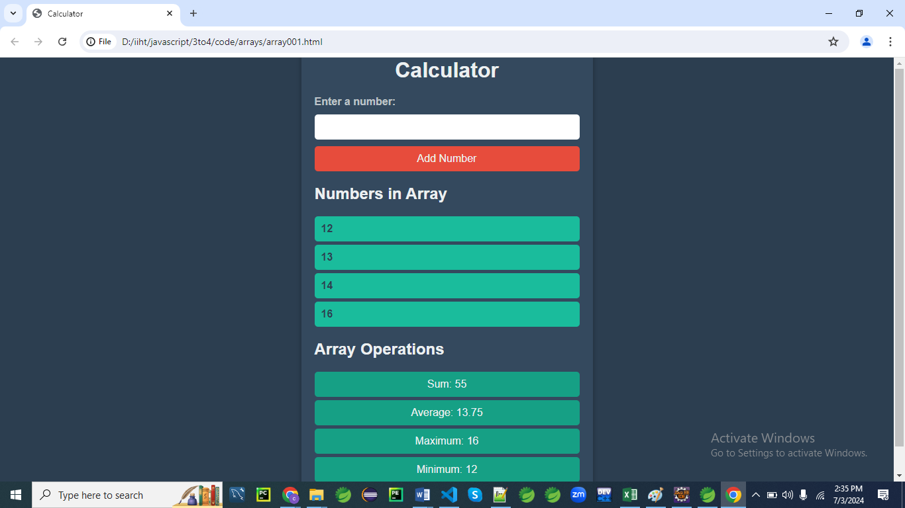

**HTML Structure**

<!DOCTYPE html>

<html lang="en">

<head>

<meta charset="UTF-8">

<meta name="viewport" content="width=device-width, initial-scale=1.0">

<title>Calculator</title>

<link rel="stylesheet" href="styles001.css">

</head>

<body>

<div class="container">

<h1>Mathematic Operations</h1>

<!-- Form to add numbers to the array -->

<div class="form-section">

<form id="addNumberForm">

<label for="numberInput">Enter a number:</label>

<input type="number" id="numberInput" required>

<button type="submit">Add Number</button>

</form>

</div>

<div class="form-section">

<h2>Numbers</h2>

<ul id="numberList"></ul>

</div>

<div class="form-section">

<h2>Array Operations</h2>

<p id="sum">Sum: 0</p>

<p id="average">Average: 0</p>

<p id="maximum">Maximum: 0</p>

<p id="minimum">Minimum: 0</p>

</div>

</div>

<script src="script001.js"></script>

</body>

</html>

**Explanation:**

* **DOCTYPE and <html> Tag:** The document type declaration (<!DOCTYPE html>) tells the browser that this is an HTML5 document. The <html> tag encloses the entire HTML document and specifies the language as English (lang="en").
* **Head Section (<head>):**
  + <meta charset="UTF-8"> specifies the character encoding for the document.
  + <meta name="viewport" content="width=device-width, initial-scale=1.0"> ensures the page is responsive and adjusts correctly on different devices.
  + <title>Calculator</title> sets the title of the web page that appears in the browser tab.
  + <link rel="stylesheet" href="styles001.css"> links the external CSS file for styling.
* **Body Section (<body>):**
  + <div class="container"> serves as the main wrapper for the content.
  + <h1>Calculator</h1> is a heading for the page.
  + **Form Section (<div class="form-section">):** Contains a form with an ID of addNumberForm for adding numbers to the array.
    - <label for="numberInput">Enter a number:</label> provides a label for the input field.
    - <input type="number" id="numberInput" required> is a numeric input field with an ID of numberInput that is required.
    - <button type="submit">Add Number</button> is a button to submit the form.
  + **Numbers Section (<div class="form-section">):** Displays the list of numbers in an unordered list with an ID of numberList.
  + **Operations Section (<div class="form-section">):** Displays the results of mathematical operations:
    - <p id="sum">Sum: 0</p> shows the sum of the numbers.
    - <p id="average">Average: 0</p> shows the average of the numbers.
    - <p id="maximum">Maximum: 0</p> shows the maximum number.
    - <p id="minimum">Minimum: 0</p> shows the minimum number.
* **JavaScript File (<script src="script001.js"></script>):** Links the external JavaScript file that contains the logic for handling the form submission and performing the calculations.

**CSS Styles**

/* styles001.css */

body {

    font-family: 'Arial', sans-serif;

    background: #2c3e50;

    color: #ecf0f1;

    margin: 0;

    padding: 0;

    display: flex;

    justify-content: center;

    align-items: center;

    height: 100vh;

}

.container {

    background: #34495e;

    padding: 20px;

    border-radius: 10px;

    box-shadow: 0 4px 8px rgba(0, 0, 0, 0.3);

    max-width: 400px;

    width: 100%;

}

h1 {

    text-align: center;

    color: #ecf0f1;

    margin-bottom: 20px;

}

.form-section {

    margin-bottom: 20px;

}

form {

    display: flex;

    flex-direction: column;

    gap: 10px;

}

label {

    font-weight: bold;

    color: #bdc3c7;

}

input[type="number"] {

    padding: 10px;

    border: none;

    border-radius: 5px;

    outline: none;

    font-size: 16px;

}

button {

    padding: 10px;

    border: none;

    border-radius: 5px;

    background: #e74c3c;

    color: #ecf0f1;

    cursor: pointer;

    font-size: 16px;

    transition: background 0.3s;

}

button:hover {

    background: #c0392b;

}

ul {

    list-style-type: none;

    padding: 0;

}

li {

    padding: 10px;

    margin: 5px 0;

    background: #1abc9c;

    border-radius: 5px;

    color: #2c3e50;

    font-weight: bold;

    display: flex;

    justify-content: space-between;

}

.form-section p {

    margin: 5px 0;

    padding: 10px;

    background: #16a085;

    border-radius: 5px;

    text-align: center;

}

**Explanation:**

**Body Element Styles**

**body {**

**font-family: 'Arial', sans-serif;**

**background: #2c3e50;**

**color: #ecf0f1;**

**margin: 0;**

**padding: 0;**

**display: flex;**

**justify-content: center;**

**align-items: center;**

**height: 100vh;**

**}**

**Explanation:**

* font-family: 'Arial', sans-serif;: Sets the font family of the text to Arial, with a fallback to sans-serif.
* background: #2c3e50;: Sets the background color of the body to a dark blue-gray color.
* color: #ecf0f1;: Sets the text color to a light gray.
* margin: 0;: Removes the default margin around the body.
* padding: 0;: Removes the default padding inside the body.
* display: flex;: Uses flexbox layout for the body, making it a flex container.
* justify-content: center;: Horizontally centers the flex items (in this case, the container).
* align-items: center;: Vertically centers the flex items.
* height: 100vh;: Sets the height of the body to 100% of the viewport height, making it full-screen height.

**Container Element Styles**

**.container {**

**background: #34495e;**

**padding: 20px;**

**border-radius: 10px;**

**box-shadow: 0 4px 8px rgba(0, 0, 0, 0.3);**

**max-width: 400px;**

**width: 100%;**

**}**

**Explanation:**

* background: #34495e;: Sets the background color of the container to a slightly darker shade.
* padding: 20px;: Adds 20 pixels of padding inside the container.
* border-radius: 10px;: Rounds the corners of the container with a 10-pixel radius.
* box-shadow: 0 4px 8px rgba(0, 0, 0, 0.3);: Adds a shadow below the container to give a 3D effect.
* max-width: 400px;: Sets the maximum width of the container to 400 pixels.
* width: 100%;: Ensures the container takes up 100% of the width of its parent (in this case, the body).

**Heading Styles**

**h1 {**

**text-align: center;**

**color: #ecf0f1;**

**margin-bottom: 20px;**

**}**

**Explanation:**

* text-align: center;: Centers the text horizontally.
* color: #ecf0f1;: Sets the color of the heading text to a light gray.
* margin-bottom: 20px;: Adds 20 pixels of margin below the heading to create space between it and the next element.

**Form Section Styles**

**.form-section {**

**margin-bottom: 20px;**

**}**

**Explanation:**

* margin-bottom: 20px;: Adds 20 pixels of margin below each form section to create space between sections.

**Form Styles**

**form {**

**display: flex;**

**flex-direction: column;**

**gap: 10px;**

**}**

**Explanation:**

* display: flex;: Uses flexbox layout for the form, making it a flex container.
* flex-direction: column;: Stacks the flex items (form elements) vertically.
* gap: 10px;: Adds 10 pixels of space between the flex items.

**Label Styles**

**label {**

**font-weight: bold;**

**color: #bdc3c7;**

**}**

**Explanation:**

* font-weight: bold;: Makes the text bold.
* color: #bdc3c7;: Sets the color of the label text to a light gray.

**Input Field Styles**

**input[type="number"] {**

**padding: 10px;**

**border: none;**

**border-radius: 5px;**

**outline: none;**

**font-size: 16px;**

**}**

**Explanation:**

* padding: 10px;: Adds 10 pixels of padding inside the input field.
* border: none;: Removes the default border of the input field.
* border-radius: 5px;: Rounds the corners of the input field with a 5-pixel radius.
* outline: none;: Removes the outline that typically appears when the input field is focused.
* font-size: 16px;: Sets the font size of the text inside the input field to 16 pixels.

**Button Styles**

**button {**

**padding: 10px;**

**border: none;**

**border-radius: 5px;**

**background: #e74c3c;**

**color: #ecf0f1;**

**cursor: pointer;**

**font-size: 16px;**

**transition: background 0.3s;**

**}**

**Explanation:**

* padding: 10px;: Adds 10 pixels of padding inside the button.
* border: none;: Removes the default border of the button.
* border-radius: 5px;: Rounds the corners of the button with a 5-pixel radius.
* background: #e74c3c;: Sets the background color of the button to a red shade.
* color: #ecf0f1;: Sets the text color of the button to a light gray.
* cursor: pointer;: Changes the cursor to a pointer when hovering over the button.
* font-size: 16px;: Sets the font size of the button text to 16 pixels.
* transition: background 0.3s;: Adds a transition effect to the background color change.

**Button Hover Styles**

**button:hover {**

**background: #c0392b;**

**}**

**Explanation:**

* background: #c0392b;: Changes the background color of the button to a darker red shade when hovered over.

**List Styles**

**ul {**

**list-style-type: none;**

**padding: 0;**

**}**

**Explanation:**

* list-style-type: none;: Removes the default bullet points from the list items.
* padding: 0;: Removes the default padding of the unordered list.

**List Item Styles**

**li {**

**padding: 10px;**

**margin: 5px 0;**

**background: #1abc9c;**

**border-radius: 5px;**

**color: #2c3e50;**

**font-weight: bold;**

**display: flex;**

**justify-content: space-between;**

**}**

**Explanation:**

* padding: 10px;: Adds 10 pixels of padding inside each list item.
* margin: 5px 0;: Adds 5 pixels of margin above and below each list item.
* background: #1abc9c;: Sets the background color of each list item to a teal shade.
* border-radius: 5px;: Rounds the corners of each list item with a 5-pixel radius.
* color: #2c3e50;: Sets the text color of each list item to a dark blue-gray.
* font-weight: bold;: Makes the text bold.
* display: flex;: Uses flexbox layout for the list items.
* justify-content: space-between;: Distributes space between the child elements of each list item, pushing them to opposite ends.

**Form Section Paragraph Styles**

**.form-section p {**

**margin: 5px 0;**

**padding: 10px;**

**background: #16a085;**

**border-radius: 5px;**

**text-align: center;**

**}**

**Explanation:**

* margin: 5px 0;: Adds 5 pixels of margin above and below each paragraph.
* padding: 10px;: Adds 10 pixels of padding inside each paragraph.
* background: #16a085;: Sets the background color of each paragraph to a greenish shade.
* border-radius: 5px;: Rounds the corners of each paragraph with a 5-pixel radius.
* text-align: center;: Centers the text inside each paragraph.

These styles combine to create a visually appealing and modern-looking calculator application, with clearly defined sections, interactive form elements, and responsive design principles.

**JavaScript Code**

//script001.js

document.addEventListener('DOMContentLoaded', function() {

const addNumberForm = document.getElementById('addNumberForm');

const numberList = document.getElementById('numberList');

const sumElement = document.getElementById('sum');

const averageElement = document.getElementById('average');

const maximumElement = document.getElementById('maximum');

const minimumElement = document.getElementById('minimum');

let numbers = [];

addNumberForm.addEventListener('submit', function(event) {

event.preventDefault(); // Prevent the form from submitting the traditional way

const numberInput = document.getElementById('numberInput').value;

const number = parseFloat(numberInput);

if (!isNaN(number)) {

// Add new number to the numbers array

numbers.push(number);

// Clear the form field

addNumberForm.reset();

// Render the numbers and perform operations

renderNumbers();

performOperations();

}

});

function renderNumbers() {

numberList.innerHTML = ''; // Clear existing numbers

// Loop through numbers array and create list elements

numbers.forEach((number) => {

const li = document.createElement('li');

li.textContent = number;

numberList.appendChild(li);

});

}

function performOperations() {

if (numbers.length > 0) {

const sum = numbers.reduce((acc, curr) => acc + curr, 0);

const average = sum / numbers.length;

const maximum = Math.max(...numbers);

const minimum = Math.min(...numbers);

sumElement.textContent = `Sum: ${sum}`;

averageElement.textContent = `Average: ${average}`;

maximumElement.textContent = `Maximum: ${maximum}`;

minimumElement.textContent = `Minimum: ${minimum}`;

}

else {

sumElement.textContent = 'Sum: 0';

averageElement.textContent = 'Average: 0';

maximumElement.textContent = 'Maximum: 0';

minimumElement.textContent = 'Minimum: 0';

}

}

});

**Explanation:**

Let's break down the JavaScript code step by step to understand how it works.

**DOMContentLoaded Event Listener**

**document.addEventListener('DOMContentLoaded', function() {**

**// All code inside this function will run once the DOM is fully loaded**

**});**

**Explanation:**

* This line ensures that the JavaScript code runs only after the entire HTML document has been completely loaded and parsed. This prevents issues with accessing DOM elements before they are available.

**Variable Declarations**

**const addNumberForm = document.getElementById('addNumberForm');**

**const numberList = document.getElementById('numberList');**

**const sumElement = document.getElementById('sum');**

**const averageElement = document.getElementById('average');**

**const maximumElement = document.getElementById('maximum');**

**const minimumElement = document.getElementById('minimum');**

**let numbers = [];**

**Explanation:**

* The addNumberForm variable stores the form element used to add numbers to the array.
* The numberList variable stores the <ul> element where the numbers will be displayed.
* The sumElement, averageElement, maximumElement, and minimumElement variables store the <p> elements where the results of the array operations (sum, average, maximum, and minimum) will be displayed.
* The numbers array is initialized as an empty array and will store the numbers added by the user.

**Form Submission Event Listener**

**addNumberForm.addEventListener('submit', function(event) {**

**event.preventDefault(); // Prevent the form from submitting the traditional way**

**const numberInput = document.getElementById('numberInput').value;**

**const number = parseFloat(numberInput);**

**if (!isNaN(number)) {**

**// Add new number to the numbers array**

**numbers.push(number);**

**// Clear the form field**

**addNumberForm.reset();**

**// Render the numbers and perform operations**

**renderNumbers();**

**performOperations();**

**}**

**});**

**Explanation:**

* Adds an event listener for the form's submit event.
* event.preventDefault(); prevents the form from submitting in the traditional way, which would reload the page.
* Retrieves the value from the number input field, converts it to a floating-point number using parseFloat.
* If the input is a valid number (!isNaN(number)), it is added to the numbers array.
* The form is reset to clear the input field.
* Calls renderNumbers() to update the displayed list of numbers.
* Calls performOperations() to update the displayed results (sum, average, maximum, minimum).

**Render Numbers Function**

**function renderNumbers() {**

**numberList.innerHTML = ''; // Clear existing numbers**

**// Loop through numbers array and create list elements**

**numbers.forEach((number) => {**

**const li = document.createElement('li');**

**li.textContent = number;**

**numberList.appendChild(li);**

**});**

**}**

**Explanation:**

* Clears the current contents of the number list (numberList.innerHTML = '';).
* Loops through each number in the numbers array.
* For each number, creates a new <li> element, sets its text content to the number, and appends it to the numberList <ul> element.

**Perform Operations Function**

**function performOperations() {**

**if (numbers.length > 0) {**

**const sum = numbers.reduce((acc, curr) => acc + curr, 0);**

**const average = sum / numbers.length;**

**const maximum = Math.max(...numbers);**

**const minimum = Math.min(...numbers);**

**sumElement.textContent = `Sum: ${sum}`;**

**averageElement.textContent = `Average: ${average}`;**

**maximumElement.textContent = `Maximum: ${maximum}`;**

**minimumElement.textContent = `Minimum: ${minimum}`;**

**}**

**else {**

**sumElement.textContent = 'Sum: 0';**

**averageElement.textContent = 'Average: 0';**

**maximumElement.textContent = 'Maximum: 0';**

**minimumElement.textContent = 'Minimum: 0';**

**}**

**}**

**Explanation:**

* Checks if the numbers array has any elements (numbers.length > 0).
* If the array has elements:
  + Calculates the sum of the numbers using reduce method.
  + Calculates the average by dividing the sum by the number of elements in the array.
  + Finds the maximum number using Math.max with the **spread operator (...).**
  + Finds the minimum number using Math.min with the spread operator.
  + Updates the text content of the respective elements (sumElement, averageElement, maximumElement, minimumElement) to display the calculated values.
* If the array is empty, sets the text content of the respective elements to 0.

**Summary**

The program creates a simple calculator that allows users to add numbers to an array through a form, displays the numbers, and performs basic arithmetic operations (sum, average, maximum, minimum) on the array.

The results are updated dynamically whenever a new number is added.

The DOMContentLoaded event ensures the script runs only after the HTML is fully loaded, preventing errors due to accessing DOM elements too early.

The CSS file styles the elements to create a visually appealing layout.

**Explanation**

1. **HTML Structure:**
   * The HTML includes a form to add numbers and a section to display the list of numbers.
   * Another section displays the results of various operations performed on the array, such as sum, average, maximum, and minimum.
2. **CSS Styles:**
   * The CSS styles create a clean and modern design for the array operations application.
   * It includes styles for the body, container, headings, forms, labels, input fields, buttons, and list items.
3. **JavaScript Code:**
   * **Event Listener for Adding Numbers:**
     + An event listener on the addNumberForm handles form submission, preventing the default form submission behavior.
     + The number is retrieved from the form field and added to the numbers array.
     + The form field is cleared, and the renderNumbers and performOperations functions are called to update the list of numbers and perform the array operations.
   * **Render Numbers Function:**
     + This function loops through the numbers array and creates list elements for each number.
     + It dynamically creates li elements with the number and appends them to the numberList.
   * **Perform Operations Function:**
     + This function calculates the sum, average, maximum, and minimum of the numbers in the array.
     + It updates the corresponding elements with the results of these operations.

This example demonstrates how to use arrays in JavaScript to store and manipulate data, perform various operations on the data, and dynamically update the DOM to display the results.

The use of CSS3 styling enhances the visual appeal and user experience.

**Example 02**

Let's create a more complex program that deals with an array of products.

This program will allow users to add products, remove products, sort the array by different criteria (e.g., name, price), filter products based on certain conditions, and calculate statistics like total price and average price.

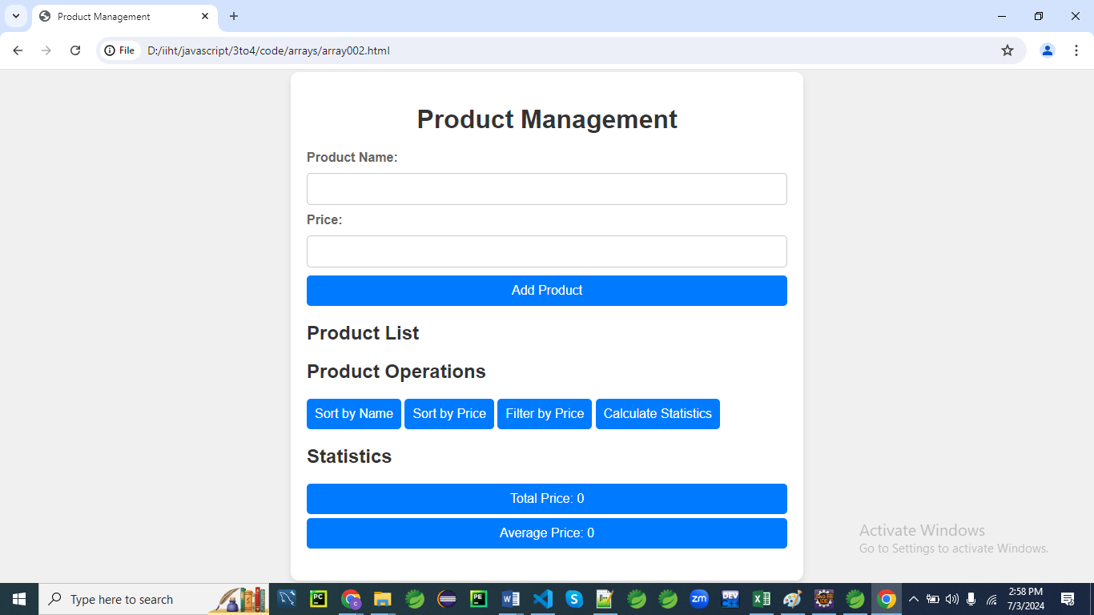

**HTML**

<!DOCTYPE html>

<html lang="en">

<head>

<meta charset="UTF-8">

<meta name="viewport" content="width=device-width, initial-scale=1.0">

<title>Product Management</title>

<link rel="stylesheet" href="styles002.css">

</head>

<body>

<div class="container">

<h1>Product Management</h1>

<!-- Form to add products to the array -->

<div class="form-section">

<form id="addProductForm">

<label for="productName">Product Name:</label>

<input type="text" id="productName" required>

<label for="productPrice">Price:</label>

<input type="number" id="productPrice" min="0" step="0.01" required>

<button type="submit">Add Product</button>

</form>

</div>

<!-- Display the list of products -->

<div class="form-section">

<h2>Product List</h2>

<ul id="productList"></ul>

</div>

<!-- Product Operations -->

<div class="form-section">

<h2>Product Operations</h2>

<button id="sortByName">Sort by Name</button>

<button id="sortByPrice">Sort by Price</button>

<button id="filterByPrice">Filter by Price</button>

<button id="calculateStatistics">Calculate Statistics</button>

</div>

<!-- Statistics -->

<div class="form-section">

<h2>Statistics</h2>

<p id="totalPrice">Total Price: 0</p>

<p id="averagePrice">Average Price: 0</p>

</div>

</div>

<script src="script002.js"></script>

</body>

</html>

**CSS (styles002.css)**

/* styles002.css */

body {

font-family: 'Arial', sans-serif;

background: #f0f0f0;

color: #333;

margin: 0;

padding: 0;

display: flex;

justify-content: center;

align-items: center;

height: 100vh;

}

.container {

background: #fff;

padding: 20px;

border-radius: 10px;

box-shadow: 0 4px 8px rgba(0, 0, 0, 0.1);

max-width: 600px;

width: 100%;

}

h1 {

text-align: center;

color: #333;

margin-bottom: 20px;

}

.form-section {

margin-bottom: 20px;

}

form {

display: flex;

flex-direction: column;

gap: 10px;

}

label {

font-weight: bold;

color: #666;

}

input[type="text"],

input[type="number"] {

padding: 10px;

border: 1px solid #ccc;

border-radius: 5px;

outline: none;

font-size: 16px;

}

button {

padding: 10px;

border: none;

border-radius: 5px;

background: #007bff;

color: #fff;

cursor: pointer;

font-size: 16px;

transition: background 0.3s;

}

button:hover {

background: #0056b3;

}

ul {

list-style-type: none;

padding: 0;

}

li {

padding: 10px;

margin: 5px 0;

background: #f0f0f0;

border-radius: 5px;

color: #333;

font-weight: bold;

display: flex;

justify-content: space-between;

}

.form-section p {

margin: 5px 0;

padding: 10px;

background: #007bff;

border-radius: 5px;

text-align: center;

color: #fff;

}

**Explanation:**

Let's break down the CSS file (styles002.css) provided, line by line:

**1. body styles**

**body {**

**font-family: 'Arial', sans-serif;**

**background: #f0f0f0;**

**color: #333;**

**margin: 0;**

**padding: 0;**

**display: flex;**

**justify-content: center;**

**align-items: center;**

**height: 100vh;**

**}**

* font-family: 'Arial', sans-serif;: Sets the font family for all text within the body to Arial. If Arial is not available, it will use the browser's default sans-serif font.
* background: #f0f0f0;: Sets the background color of the body to a light gray (#f0f0f0).
* color: #333;: Sets the text color inside the body to a dark gray (#333).
* margin: 0; and padding: 0;: Removes default margin and padding from the body, ensuring elements start flush against the edges.
* display: flex;: Uses Flexbox for layout within the body.
* justify-content: center;: Centers content horizontally within the body.
* align-items: center;: Centers content vertically within the body.
* height: 100vh;: Sets the height of the body to 100% of the viewport height, ensuring the content is always centered and fills the screen.

**2. .container styles**

**.container {**

**background: #fff;**

**padding: 20px;**

**border-radius: 10px;**

**box-shadow: 0 4px 8px rgba(0, 0, 0, 0.1);**

**max-width: 600px;**

**width: 100%;**

**}**

* background: #fff;: Sets the background color of elements with class .container to white (#fff).
* padding: 20px;: Adds 20 pixels of padding inside elements with class .container.
* border-radius: 10px;: Rounds the corners of elements with class .container with a radius of 10 pixels.
* box-shadow: 0 4px 8px rgba(0, 0, 0, 0.1);: Adds a subtle box shadow to elements with class .container. The shadow is positioned at (0px, 4px) with a blur radius of 8 pixels and a color that is 10% opaque black (rgba(0, 0, 0, 0.1)).
* max-width: 600px;: Sets the maximum width of elements with class .container to 600 pixels.
* width: 100%;: Makes elements with class .container fill the entire available width.

**3. h1 styles**

**h1 {**

**text-align: center;**

**color: #333;**

**margin-bottom: 20px;**

**}**

* text-align: center;: Centers the text horizontally within h1 elements.
* color: #333;: Sets the text color of h1 elements to dark gray (#333).
* margin-bottom: 20px;: Adds a bottom margin of 20 pixels below h1 elements, creating space between h1 and subsequent elements.

**4. .form-section styles**

**.form-section {**

**margin-bottom: 20px;**

**}**

* margin-bottom: 20px;: Adds a bottom margin of 20 pixels to elements with class .form-section, creating space between sections.

**5. form styles**

**form {**

**display: flex;**

**flex-direction: column;**

**gap: 10px;**

**}**

* display: flex;: Uses Flexbox for layout within form elements.
* flex-direction: column;: Stacks child elements vertically within form elements.
* gap: 10px;: Adds a gap of 10 pixels between child elements of form.

**6. label styles**

**label {**

**font-weight: bold;**

**color: #666;**

**}**

* font-weight: bold;: Sets the font weight of label elements to bold.
* color: #666;: Sets the text color of label elements to a medium gray (#666).

**7. input[type="text"], input[type="number"] styles**

**input[type="text"],**

**input[type="number"] {**

**padding: 10px;**

**border: 1px solid #ccc;**

**border-radius: 5px;**

**outline: none;**

**font-size: 16px;**

**}**

* Applies these styles to input elements with type="text" and type="number".
* padding: 10px;: Adds 10 pixels of padding inside input elements.
* border: 1px solid #ccc;: Sets a 1-pixel solid border with light gray color (#ccc) around input elements.
* border-radius: 5px;: Rounds the corners of input elements with a radius of 5 pixels.
* outline: none;: Removes the default focus outline from input elements.
* font-size: 16px;: Sets the font size of text in input elements to 16 pixels.

**8. button styles**

**button {**

**padding: 10px;**

**border: none;**

**border-radius: 5px;**

**background: #007bff;**

**color: #fff;**

**cursor: pointer;**

**font-size: 16px;**

**transition: background 0.3s;**

**}**

**button:hover {**

**background: #0056b3;**

**}**

* padding: 10px;: Adds 10 pixels of padding inside button elements.
* border: none;: Removes the border from button elements.
* border-radius: 5px;: Rounds the corners of button elements with a radius of 5 pixels.
* background: #007bff;: Sets the background color of button elements to a blue shade (#007bff).
* color: #fff;: Sets the text color of button elements to white.
* cursor: pointer;: Changes the cursor to a pointer when hovering over button elements.
* font-size: 16px;: Sets the font size of text in button elements to 16 pixels.
* transition: background 0.3s;: Smoothens the background color change over 0.3 seconds when hovering.
* button:hover: Overrides the background color to a darker blue shade (#0056b3) when hovering over button elements.

**9. ul and li styles**

**ul {**

**list-style-type: none;**

**padding: 0;**

**}**

**li {**

**padding: 10px;**

**margin: 5px 0;**

**background: #f0f0f0;**

**border-radius: 5px;**

**color: #333;**

**font-weight: bold;**

**display: flex;**

**justify-content: space-between;**

**}**

* list-style-type: none;: Removes default list styling from ul elements.
* padding: 0;: Removes default padding from ul elements.
* padding: 10px;: Adds 10 pixels of padding inside li elements.
* margin: 5px 0;: Adds 5 pixels of margin above and below li elements.
* background: #f0f0f0;: Sets the background color of li elements to a very light gray (#f0f0f0).
* border-radius: 5px;: Rounds the corners of li elements with a radius of 5 pixels.
* color: #333;: Sets the text color of li elements to dark gray (#333).
* font-weight: bold;: Sets the font weight of li elements to bold.
* display: flex;: Uses Flexbox for layout within li elements.
* justify-content: space-between;: Distributes content evenly between items inside li elements.

**10. .form-section p styles**

**.form-section p {**

**margin: 5px 0;**

**padding: 10px;**

**background: #007bff;**

**border-radius: 5px;**

**text-align: center;**

**color: #fff;**

**}**

* Applies these styles to p elements within elements with class .form-section.
* margin: 5px 0;: Adds 5 pixels of margin above and below p elements within .form-section.
* padding: 10px;: Adds 10 pixels of padding inside p elements within .form-section.
* background: #007bff;: Sets the background color of p elements within .form-section to a blue shade (#007bff).
* border-radius: 5px;: Rounds the corners of p elements within .form-section with a radius of 5 pixels.
* text-align: center;: Centers the text horizontally within p elements within .form-section.
* color: #fff;: Sets the text color of p elements within .form-section to white.

This CSS file defines styles for various HTML elements, focusing on layout, typography, colors, and interactivity to create a cohesive and visually appealing web page layout.

**JavaScript (script002.js)**

// script002.js

document.addEventListener('DOMContentLoaded', function() {

const addProductForm = document.getElementById('addProductForm');

const productList = document.getElementById('productList');

const totalPriceElement = document.getElementById('totalPrice');

const averagePriceElement = document.getElementById('averagePrice');

const sortByNameButton = document.getElementById('sortByName');

const sortByPriceButton = document.getElementById('sortByPrice');

const filterByPriceButton = document.getElementById('filterByPrice');

const calculateStatisticsButton = document.getElementById('calculateStatistics');

let products = [];

addProductForm.addEventListener('submit', function(event) {

event.preventDefault(); // Prevent the form from submitting the traditional way

const productNameInput = document.getElementById('productName').value;

const productPriceInput = parseFloat(document.getElementById('productPrice').value);

if (productNameInput && !isNaN(productPriceInput) && productPriceInput >= 0) {

// Add new product to the products array

const newProduct = {

name: productNameInput,

price: productPriceInput

};

products.push(newProduct);

// Clear the form fields

addProductForm.reset();

// Render the updated product list

renderProducts();

}

});

function renderProducts() {

productList.innerHTML = ''; // Clear existing list

products.forEach((product, index) => {

const li = document.createElement('li');

li.textContent = `${product.name}: $${product.price.toFixed(2)}`;

productList.appendChild(li);

});

}

sortByNameButton.addEventListener('click', function() {

products.sort((a, b) => a.name.localeCompare(b.name));

renderProducts();

});

sortByPriceButton.addEventListener('click', function() {

products.sort((a, b) => a.price - b.price);

renderProducts();

});

filterByPriceButton.addEventListener('click', function() {

const filteredProducts = products.filter(product => product.price <= 50);

products = filteredProducts;

renderProducts();

});

calculateStatisticsButton.addEventListener('click', function() {

const totalPrice = products.reduce((acc, product) => acc + product.price, 0);

const averagePrice = totalPrice / products.length || 0; // Avoid division by zero

totalPriceElement.textContent = `Total Price: $${totalPrice.toFixed(2)}`;

averagePriceElement.textContent = `Average Price: $${averagePrice.toFixed(2)}`;

});

});

**Explanation:**

Let's go through the JavaScript code (script002.js) provided, line by line:

**1. Event Listener for DOMContentLoaded**

**document.addEventListener('DOMContentLoaded', function() {**

**// Code inside here executes when the DOM is fully loaded and parsed**

**});**

* This event listener waits for the DOM (Document Object Model) to be fully loaded before executing the contained function. This ensures that the JavaScript code manipulates elements that have already been rendered.

**2. Variable Declarations**

**const addProductForm = document.getElementById('addProductForm');**

**const productList = document.getElementById('productList');**

**const totalPriceElement = document.getElementById('totalPrice');**

**const averagePriceElement = document.getElementById('averagePrice');**

**const sortByNameButton = document.getElementById('sortByName');**

**const sortByPriceButton = document.getElementById('sortByPrice');**

**const filterByPriceButton = document.getElementById('filterByPrice');**

**const calculateStatisticsButton = document.getElementById('calculateStatistics');**

* These lines fetch references to various HTML elements using document.getElementById(). Each element is identified by its unique id attribute. These variables will be used to interact with and manipulate these elements in the subsequent code.

**3. Array Declaration**

**let products = [];**

* products is an empty array that will hold objects representing products. Each product object has name and price properties.

**4. Event Listener for Form Submission**

**addProductForm.addEventListener('submit', function(event) {**

**event.preventDefault(); // Prevent the form from submitting the traditional way**

**const productNameInput = document.getElementById('productName').value;**

**const productPriceInput = parseFloat(document.getElementById('productPrice').value);**

**if (productNameInput && !isNaN(productPriceInput) && productPriceInput >= 0) {**

**// Add new product to the products array**

**const newProduct = {**

**name: productNameInput,**

**price: productPriceInput**

**};**

**products.push(newProduct);**

**// Clear the form fields**

**addProductForm.reset();**

**// Render the updated product list**

**renderProducts();**

**}**

**});**

* This event listener is attached to the form (addProductForm). It listens for the submit event.
* event.preventDefault(); prevents the form from being submitted in the traditional manner, which would cause a page reload.
* It retrieves the values of the product name and price from input fields.
* If the input values are valid (name is not empty, price is a valid number, and price is non-negative), a new product object is created and pushed into the products array.
* addProductForm.reset(); clears the form fields after adding the product.
* renderProducts(); updates the displayed product list on the webpage.

**5. renderProducts Function**

**function renderProducts() {**

**productList.innerHTML = ''; // Clear existing list**

**products.forEach((product, index) => {**

**const li = document.createElement('li');**

**li.textContent = `${product.name}: $${product.price.toFixed(2)}`;**

**productList.appendChild(li);**

**});**

**}**

* renderProducts updates the UI to display the list of products.
* productList.innerHTML = ''; clears the existing list to prevent duplication.
* It iterates over the products array using forEach, creating a new <li> element for each product. Each <li> displays the product name and price formatted to two decimal places.
* The newly created <li> elements are appended to the productList (<ul> element).

**6. Event Listeners for Sorting and Filtering**

* **Sorting by Name (sortByNameButton)**: Sorts products alphabetically by name.
* **Sorting by Price (sortByPriceButton)**: Sorts products numerically by price.
* **Filtering by Price (filterByPriceButton)**: Filters products to display only those with a price less than or equal to 50.
* Each button (sortByNameButton, sortByPriceButton, filterByPriceButton) has an event listener that modifies the products array and then calls renderProducts() to update the UI accordingly.

**7. Event Listener for Calculating Statistics**

**calculateStatisticsButton.addEventListener('click', function() {**

**const totalPrice = products.reduce((acc, product) => acc + product.price, 0);**

**const averagePrice = totalPrice / products.length || 0; // Avoid division by zero**

**totalPriceElement.textContent = `Total Price: $${totalPrice.toFixed(2)}`;**

**averagePriceElement.textContent = `Average Price: $${averagePrice.toFixed(2)}`;**

**});**

* This event listener calculates and displays statistics (total price and average price) when calculateStatisticsButton is clicked.
* reduce() method is used to sum up all product prices in the products array (totalPrice).
* averagePrice is calculated as the total price divided by the number of products in products, ensuring to avoid division by zero.
* Results are displayed in totalPriceElement and averagePriceElement on the webpage, formatted to two decimal places using toFixed(2).

**Summary**

This JavaScript code manages a product list application. It allows users to add products with names and prices, dynamically updates the UI to display products, provides sorting and filtering functionalities, and calculates basic statistics based on the product prices. The DOM manipulation and event handling ensure a responsive and interactive user experience.

**Explanation**

**HTML Structure**

* **Product Form Section**: Allows users to input product names and prices to add to the array.
* **Product List**: Displays the list of products with their names and prices.
* **Product Operations**: Includes buttons for sorting products by name or price, filtering products by price, and calculating statistics.
* **Statistics**: Shows the total price and average price of all products.

**CSS (styles002.css)**

* **General Styling**: Sets up basic styles for the body, container, headings, forms, buttons, lists, and paragraphs.
* **Form and Input Styling**: Defines styles for forms, labels, inputs, and buttons to ensure they are visually appealing and responsive.
* **List Item Styling**: Styles each product list item (<li>) with padding, margins, background color, border radius, font color, and bold text for clarity and readability.
* **Paragraph Styling**: Styles paragraphs (<p>) in the statistics section with specific background color, border radius, text color, and text alignment.

**JavaScript (script002.js)**

* **DOMContentLoaded Event**: Ensures all JavaScript code runs after the HTML is fully loaded.
* **Event Listeners**: Handles form submissions (submit event) for adding products, button clicks for sorting (sortByNameButton, sortByPriceButton), filtering (filterByPriceButton), and calculating statistics (calculateStatisticsButton).
* **Functions**:
  + renderProducts(): Clears and updates the product list (productList) based on the current state of the products array.
  + Sorting functions (sortByNameButton, sortByPriceButton): Use JavaScript's sort() method with custom comparison functions to sort products alphabetically by name or numerically by price.
  + Filtering function (filterByPriceButton): Uses JavaScript's filter() method to create a new array with products that meet a specified condition (price <= 50).
  + calculateStatisticsButton: Uses JavaScript's reduce() method to calculate the total price of all products and then computes the average price.

**Summary**

This program provides a comprehensive example of managing an array of products dynamically through user input and various operations.

Users can add new products, sort them alphabetically or by price, filter products based on price, and calculate statistics such as total price and average price.

The CSS ensures a clean and modern user interface, while the JavaScript handles data manipulation and updates to reflect user actions.

**Regular Expressions in javascript**

**Regular expressions (regex)** in JavaScript are a powerful tool for pattern matching and text manipulation.

They allow you to search for, match, and replace text based on specific patterns.

Here’s a brief overview:

**Basics**

1. **Syntax**: Regular expressions are defined between two slashes (**/pattern/**), or with the RegExp constructor (**new RegExp('pattern')**).
2. **Patterns**: Patterns consist of ordinary characters (like a, b, 1, etc.) and special characters (metacharacters) that define how the matching should be done.

**Common Metacharacters**

* .: Matches any single character except newline.
* ^: Matches the beginning of a string.
* $: Matches the end of a string.
* *: Matches 0 or more occurrences of the preceding character.
* +: Matches 1 or more occurrences of the preceding character.
* ?: Matches 0 or 1 occurrence of the preceding character.
* [...]: Matches any one of the characters inside the brackets.
* [^...]: Matches any one character not inside the brackets.
* (x|y): Matches either x or y.

**Example**

Here’s a simple example that uses a regular expression to validate an email address:

function isValidEmail(email) {

**const emailPattern = /^[^\s@]+@[^\s@]+\.[^\s@]+$/;**

return emailPattern.test(email);

}

console.log(isValidEmail('test@example.com')); // true

console.log(isValidEmail('invalid-email')); // false

In this example:

* **^[^\s@]+:** Matches the beginning of the string and ensures it has characters other than whitespace and @.
* **@[^\s@]+:** Matches the @ symbol followed by characters other than whitespace and @.
* **\.[^\s@]+$:** Matches a period (.) followed by characters other than whitespace and @ until the end of the string.

**List of escape characters in regular expression**

In regular expressions, escape characters are used to give special meanings to characters that otherwise have a specific function. Here’s a list of common escape characters and sequences:

**Common Escape Characters**

1. **Backslash (\)**
   * **Description**: Escapes a special character or denotes a special sequence.
2. **Special Characters and Sequences**
   * **\d**: Matches any digit, equivalent to [0-9].
   * **\D**: Matches any non-digit character, equivalent to [^0-9].
   * **\w**: Matches any word character (alphanumeric and underscore), equivalent to [a-zA-Z0-9_].
   * **\W**: Matches any non-word character, equivalent to [^a-zA-Z0-9_].
   * **\s**: Matches any whitespace character (spaces, tabs, line breaks), equivalent to [ \t\n\r\f\v].
   * **\S**: Matches any non-whitespace character, equivalent to [^ \t\n\r\f\v].
   * **\b**: Matches a word boundary (the position between a word and a non-word character).
   * **\B**: Matches a non-word boundary (the position between two word characters or two non-word characters).
   * **\**: Escapes the next character if it has a special meaning, e.g., \. matches a literal period.

**Escaping Special Characters**

In regular expressions, special characters that have specific meanings can be escaped to match them literally:

* **\.**: Matches a literal period .
* **\\***: Matches a literal asterisk *.
* **\+**: Matches a literal plus +.
* **\?**: Matches a literal question mark ?.
* **\^**: Matches a literal caret ^.
* **\$**: Matches a literal dollar sign $.
* **\(**: Matches a literal opening parenthesis (.
* **\)**: Matches a literal closing parenthesis ).
* **\[**: Matches a literal opening square bracket [.
* **\]**: Matches a literal closing square bracket ].
* **\{**: Matches a literal opening curly brace {.
* **\}**: Matches a literal closing curly brace }.
* **\|**: Matches a literal vertical bar |.
* **\-**: Matches a literal hyphen - (inside square brackets, it can denote a range if not escaped).

**Using Escape Characters**

Here’s an example of how to use escape characters to match special characters:

const regex = /a\*b/;

console.log(regex.test('a*b')); // true

console.log(regex.test('a-b')); // false

const regex2 = /\d\.\d/;

console.log(regex2.test('3.14')); // true

console.log(regex2.test('314')); // false

In the above examples:

* /a\*b/ matches the string a*b, where \* escapes the asterisk to match it literally.
* /\d\.\d/ matches a digit, a literal period, and another digit, e.g., 3.14.

Understanding how to use and escape these characters helps in building more precise and effective regular expressions. Let me know if you need more details or examples!

**Using RegExp Methods**

JavaScript provides several methods to work with regular expressions:

* test(): Tests if a pattern matches a string.
* exec(): Executes a search for a match and returns an array with the result.
* match(): Retrieves the matches when matching a string against a regular expression.
* replace(): Replaces matched substrings with a new string.
* split(): Splits a string into an array of substrings based on a regular expression.

**Examples**

**1. Matching a Specific Word**

**Regex**: /hello/

**Description**: Matches the exact word "hello" anywhere in the string.

**Example**:

const regex = /hello/;

console.log(regex.test('hello world')); // true

console.log(regex.test('hi there')); // false

**Try with** /hello/I, /HELLO/i

**2. Matching Digits**

**Regex**: /\d/

**Description**: Matches any single digit (0-9).

**Example**:

const regex = /\d/;

console.log(regex.test('My phone number is 1234')); // true

console.log(regex.test('No numbers here')); // false

**3. Matching Multiple Digits**

**Regex**: /\d+/

**Description**: Matches one or more digits.

**Example**:

const regex = /\d+/;

console.log(regex.test('Your age is 45')); // true

console.log(regex.test('No digits here')); // false

**4. Matching Email Format**

**Regex**: /^[^\s@]+@[^\s@]+\.[^\s@]+$/

**Description**: Matches a basic email format (e.g., user@example.com).

**Example**:

const regex = /^[^\s@]+@[^\s@]+\.[^\s@]+$/;

console.log(regex.test('user@example.com')); // true

console.log(regex.test('user@.com')); // false

**5. Matching a Phone Number (US)**

**Regex**: /^\(\d{3}\) \d{3}-\d{4}$/ 🡺USA

[^\d{10}$] 🡺 India

**Description**: Matches a US phone number format like (123) 456-7890.

**Example**:

const regex = /^\(\d{3}\) \d{3}-\d{4}$/;

console.log(regex.test('(123) 456-7890')); // true

console.log(regex.test('123-456-7890')); // false

**6. Matching a Date Format (YYYY-MM-DD)**

**Regex**: /^\d{4}-\d{2}-\d{2}$/

**Description**: Matches a date in the format YYYY-MM-DD.

**Example**:

const regex = /^\d{4}-\d{2}-\d{2}$/;

console.log(regex.test('2024-08-30')); // true

console.log(regex.test('30-08-2024')); // false

**7. Matching a URL**

**Regex**: /^https?:\/\/[^\s$.?#].[^\s]*$/

**Description**: Matches a basic URL that starts with http:// or https://.

**Example**:

const regex = /^https?:\/\/[^\s$.?#].[^\s]*$/;

console.log(regex.test('https://www.example.com')); // true

console.log(regex.test('www.example.com')); // false

**8. Matching Literal Special Characters**

**Example**: Matching a string containing a literal period, asterisk, and parentheses.

const regex = /price\*\(\d+\)/;

console.log(regex.test('price*(123)')); // true

console.log(regex.test('price*(abc)')); // false

console.log(regex.test('price(123)')); // false

**9. Matching Hexadecimal Color Codes**

**Example**: Matching hexadecimal color codes, with or without the # symbol.

const regex = /^#?([a-fA-F0-9]{6}|[a-fA-F0-9]{3})$/;

console.log(regex.test('#ff5733')); // true

console.log(regex.test('a0c')); // true

console.log(regex.test('1234567')); // false

**10. Matching Credit Card Numbers**

**Example**: Matching credit card numbers with optional spaces or hyphens.

const regex = /^(\d{4}[-\s]?){3}\d{4}$/;

console.log(regex.test('1234 5678 9012 3456')); // true

console.log(regex.test('1234-5678-9012-3456')); // true

console.log(regex.test('1234567890123456')); // true

console.log(regex.test('1234 5678 9012')); // false

**11. Matching IPv4 Addresses**

**Example**: Matching IPv4 addresses.

const regex = /^(25[0-5]|2[0-4][0-9]|[01]?[0-9][0-9]?)\.(25[0-5]|2[0-4][0-9]|[01]?[0-9][0-9]?)\.(25[0-5]|2[0-4][0-9]|[01]?[0-9][0-9]?)\.(25[0-5]|2[0-4][0-9]|[01]?[0-9][0-9]?)$/;

console.log(regex.test('192.168.1.1')); // true

console.log(regex.test('256.256.256.256')); // false

**12. Matching Social Security Numbers (SSNs)**

**Example**: Matching US Social Security Numbers in the format XXX-XX-XXXX.

const regex = /^\d{3}-\d{2}-\d{4}$/;

console.log(regex.test('123-45-6789')); // true

console.log(regex.test('123456789')); // false

console.log(regex.test('12-345-6789')); // false

**13. Matching Time in 24-Hour Format**

**Example**: Matching times in HH:MM format, where hours are from 00 to 23 and minutes are from 00 to 59.

const regex = /^([01]\d|2[0-3]):([0-5]\d)$/;

console.log(regex.test('14:30')); // true

console.log(regex.test('23:59')); // true

console.log(regex.test('24:00')); // false

**14. Matching Roman Numerals**

**Example**: Matching Roman numerals from I to MMMCMXCIX (1 to 3999).

const regex = /^(M{0,3})(CM|CD|D?C{0,3})(XC|XL|L?X{0,3})(IX|IV|V?I{0,3})$/;

console.log(regex.test('MMXXIV')); // true

console.log(regex.test('MMXIV')); // true

console.log(regex.test('MMMM')); // false

**15. Matching Floating Point Numbers**

**Example**: Matching floating point numbers with optional sign and decimal places.

const regex = /^[+-]?(\d*\.\d+|\d+)$/;

console.log(regex.test('3.14')); // true

console.log(regex.test('-0.001')); // true

console.log(regex.test('42')); // true

console.log(regex.test('3.14.15'));// false

**16. Matching Passwords with Specific Requirements**

**Example**: Matching passwords that must be at least 8 characters long, include at least one uppercase letter, one lowercase letter, and one digit.

const regex = /^(?=.*[a-z])(?=.*[A-Z])(?=.*\d)[A-Za-z\d]{8,}$/;

console.log(regex.test('Password1')); // true

console.log(regex.test('password')); // false

console.log(regex.test('PASSWORD123'));// false

**17. Matching HTML Tags**

**Example**: Matching simple HTML tags (not accounting for all HTML intricacies).

const regex = /<\/?[a-zA-Z][a-zA-Z0-9]*>/;

console.log(regex.test('<div>')); // true

console.log(regex.test('</span>')); // true

console.log(regex.test('<tag attribute="value">')); // false

**18. Matching IPv6 Addresses**

**Example**: Matching IPv6 addresses with optional compression and hexadecimal groups.

const regex = /^(?:[0-9a-fA-F]{1,4}:){7}(?:[0-9a-fA-F]{1,4}|:)|(?:[0-9a-fA-F]{1,4}:){1,7}|::(?:[0-9a-fA-F]{1,4}:){0,6}[0-9a-fA-F]{1,4}|(?:[0-9a-fA-F]{1,4}:){0,5}::(?:[0-9a-fA-F]{1,4}:){0,5}[0-9a-fA-F]{1,4}$/;

console.log(regex.test('2001:0db8:85a3:0000:0000:8a2e:0370:7334')); // true

console.log(regex.test('::1')); // true

console.log(regex.test('1200:0000:AB00:1234:0000:2552:7777:1313')); // true

console.log(regex.test('1200:0000:AB00:1234:0000:2552:7777:1313:1234')); // false

**19. Matching Positive Integers**

**Example**: Matching positive integers (no leading zeros unless the number is zero).

const regex = /^(0|[1-9]\d*)$/;

console.log(regex.test('123')); // true

console.log(regex.test('00123')); // false

console.log(regex.test('0')); // true

**20. Matching XML Tags**

**Example**: Matching simple XML tags (not accounting for all XML complexities).

const regex = /<\/?[a-zA-Z_][a-zA-Z0-9_-]*>/;

console.log(regex.test('<book>')); // true

console.log(regex.test('</author>')); // true

console.log(regex.test('<book title="example">')); // false

**21. Matching US ZIP Codes**

**Example**: Matching 5-digit ZIP codes and ZIP+4 codes.

const regex = /^\d{5}(-\d{4})?$/;

console.log(regex.test('12345')); // true

console.log(regex.test('12345-6789')); // true

console.log(regex.test('1234')); // false

console.log(regex.test('12345-678')); // false

**22. Matching HTML Comment Tags**

**Example**: Matching HTML comments.

const regex = /<!--[\s\S]*?-->/;

console.log(regex.test('<!-- This is a comment -->')); // true

console.log(regex.test('This is not a comment')); // false

**23. Matching IPv4 Address Ranges**

**Example**: Matching IPv4 addresses within a specific range, e.g., 192.168.x.x.

const regex = /^192\.168\.\d{1,3}\.\d{1,3}$/;

console.log(regex.test('192.168.1.1')); // true

console.log(regex.test('192.168.255.255')); // true

console.log(regex.test('192.169.1.1')); // false

**24. Matching HTML Attribute Values**

**Example**: Matching attribute values enclosed in double quotes.

const regex = /\b\w+="[^"]*"/;

console.log(regex.test('class="myClass"')); // true

console.log(regex.test('id="123"')); // true

console.log(regex.test('name=value')); // false

**25. Matching MAC Addresses**

**Example**: Matching MAC addresses in the format XX:XX:XX:XX:XX:XX.

const regex = /^([0-9A-Fa-f]{2}:){5}[0-9A-Fa-f]{2}$/;

console.log(regex.test('00:1A:2B:3C:4D:5E')); // true

console.log(regex.test('00:1A:2B:3C:4D:5')); // false

console.log(regex.test('001A2B3C4D5E')); // false

**26. Matching Base64 Strings**

**Example**: Matching Base64 encoded strings (with padding or without).

const regex = /^([A-Za-z0-9+\/=]+)$/;

console.log(regex.test('U29tZSBzdHJpbmc=')); // true

console.log(regex.test('Some_string')); // false

**27. Matching MAC Addresses (Alternative Format)**

**Example**: Matching MAC addresses with dashes as separators.

const regex = /^([0-9A-Fa-f]{2}-){5}[0-9A-Fa-f]{2}$/;

console.log(regex.test('00-1A-2B-3C-4D-5E')); // true

console.log(regex.test('00-1A-2B-3C-4D-5')); // false

**28. Matching URL Parameters**

**Example**: Matching URL parameters in the format key=value.

const regex = /[?&](\w+)=([^&]*)/;

console.log(regex.test('?key=value')); // true

console.log(regex.test('&name=John')); // true

console.log(regex.test('key=value')); // false

**29. Matching Non-Whitespace Characters**

**Example**: Matching strings that contain non-whitespace characters only.

const regex = /^\S+$/;

console.log(regex.test('HelloWorld')); // true

console.log(regex.test('Hello World')); // false

console.log(regex.test(' ')); // false

**30. Matching Alphanumeric Strings**

**Example**: Matching strings with only alphanumeric characters and underscores.

const regex = /^\w+$/;

console.log(regex.test('username123')); // true

console.log(regex.test('user_name')); // true

console.log(regex.test('user name')); // false

**31. Matching Dates in YYYY/MM/DD Format**

**Example**: Matching dates formatted as YYYY/MM/DD, with years from 1000 to 2999.

const regex = /^\d{4}\/(0[1-9]|1[0-2])\/(0[1-9]|[12][0-9]|3[01])$/;

console.log(regex.test('2024/08/30')); // true

console.log(regex.test('1999/12/31')); // true

console.log(regex.test('3000/01/01')); // false

**32. Matching Non-Capturing Groups**

**Example**: Using non-capturing groups to group patterns without capturing.

const regex = /(?:\d{3}-\d{2}-\d{4})/;

console.log(regex.test('123-45-6789')); // true

console.log(regex.test('123-456-789')); // false

**33. Matching HTML Self-Closing Tags**

**Example**: Matching self-closing HTML tags, like <br />.

const regex = /<\w+(\s+\w+="[^"]*")*\s*\/>/;

console.log(regex.test('<br />')); // true

console.log(regex.test('<img src="image.jpg" />')); // true

console.log(regex.test('<input>')); // false

**34. Matching US Phone Numbers with Extensions**

**Example**: Matching US phone numbers with optional extensions.

const regex = /^\d{3}-\d{3}-\d{4}(?: x\d{1,5})?$/;

console.log(regex.test('123-456-7890')); // true

console.log(regex.test('123-456-7890 x123')); // true

console.log(regex.test('123-4567-890')); // false

**35. Matching Multiple Email Addresses**

**Example**: Matching a string that contains multiple email addresses separated by commas.

const regex = /(?:[^\s@]+@[^\s@]+\.[^\s@]+\s*,\s*)+[^\s@]+@[^\s@]+\.[^\s@]+/;

console.log(regex.test('email1@example.com, email2@example.com')); // true

console.log(regex.test('email1@example.com, email2@example.com,')); // false

**36. Matching Simple CSV Fields**

**Example**: Matching fields in a simple CSV format where fields are not quoted.

const regex = /^([^,]+,)*[^,]+$/;

console.log(regex.test('field1,field2,field3')); // true

console.log(regex.test('field1,,field3')); // true

console.log(regex.test('field1,"field2",field3')); // false

**37. Matching Positive and Negative Integers**

**Example**: Matching both positive and negative integers.

const regex = /^[+-]?\d+$/;

console.log(regex.test('123')); // true

console.log(regex.test('-456')); // true

console.log(regex.test('78.9')); // false

**38. Matching Hexadecimal Numbers**

**Example**: Matching hexadecimal numbers with or without the 0x prefix.

const regex = /^0x[0-9A-Fa-f]+|^[0-9A-Fa-f]+$/;

console.log(regex.test('0x1F')); // true

console.log(regex.test('1F')); // true

console.log(regex.test('1G')); // false

**39. Matching Words with Hyphens**

**Example**: Matching words that can contain hyphens.

const regex = /^[a-zA-Z]+(-[a-zA-Z]+)*$/;

console.log(regex.test('word')); // true

console.log(regex.test('word-word')); // true

console.log(regex.test('word--word')); // false

**40. Matching Optional Groups**

**Example**: Matching strings where some groups are optional, like an optional middle name in a full name.

const regex = /^[A-Za-z]+( [A-Za-z]+)? [A-Za-z]+$/;

console.log(regex.test('John Doe')); // true

console.log(regex.test('John Michael Doe')); // true

console.log(regex.test('John')); // false

**41. Matching Social Security Numbers with Optional Dashes**

**Example**: Matching SSNs with or without dashes.

const regex = /^\d{3}-?\d{2}-?\d{4}$/;

console.log(regex.test('123-45-6789')); // true

console.log(regex.test('123456789')); // true

console.log(regex.test('123-45-678')); // false

**42. Matching Date Formats with Different Separators**

**Example**: Matching dates with slashes, dashes, or dots.

const regex = /^\d{4}[/-]\d{2}[/-]\d{2}$/;

console.log(regex.test('2024/08/30')); // true

console.log(regex.test('2024-08-30')); // true

console.log(regex.test('2024.08.30')); // true

**43. Matching URLs with Query Parameters**

**Example**: Matching URLs with query parameters.

const regex = /^https?:\/\/[^\s\/]+(?:\/[^\s]*)?\?(?:[^\s=&]+=[^\s=&]*&?)*$/;

console.log(regex.test('http://example.com?page=1&sort=asc')); // true

console.log(regex.test('https://example.com')); // false

**44. Matching Credit Card Numbers with Spaces**

**Example**: Matching credit card numbers with optional spaces.

const regex = /^(\d{4}\s?){3}\d{4}$/;

console.log(regex.test('1234 5678 9012 3456')); // true

console.log(regex.test('1234567890123456')); // true

console.log(regex.test('1234-5678-9012-3456')); // false

**45. Matching Multiple Words Separated by Spaces**

**Example**: Matching strings with multiple words separated by spaces.

const regex = /^(\w+\s*)+$/;

console.log(regex.test('Hello World')); // true

console.log(regex.test('HelloWorld')); // false

**46. Matching Time in 12-Hour Format**

**Example**: Matching times in hh:mm AM/PM format.

const regex = /^(0?[1-9]|1[0-2]):[0-5]\d\s[APM]{2}$/;

console.log(regex.test('08:30 AM')); // true

console.log(regex.test('12:45 PM')); // true

console.log(regex.test('13:00 AM')); // false

**47. Matching Non-Numeric Characters**

**Example**: Matching strings that contain no numeric characters.

const regex = /^[^\d]+$/;

console.log(regex.test('abc')); // true

console.log(regex.test('abc123')); // false

**48. Matching Strings with Special Characters**

**Example**: Matching strings containing special characters.javascript

Copy code

const regex = /^[!@#$%^&*()_+={}\[\]:;"'<>,.?/\\|`~\d\w\s]+$/;

console.log(regex.test('Hello!@#')); // true

console.log(regex.test('Hello123')); // true

console.log(regex.test('Hello!@#123')); // true

**49. Matching Floating Point Numbers with Optional Sign**

**Example**: Matching floating-point numbers with an optional sign.

const regex = /^[+-]?\d*\.\d+$/;

console.log(regex.test('-123.45')); // true

console.log(regex.test('0.123')); // true

console.log(regex.test('123.')); // false

**50. Matching Alphanumeric Strings with Limited Length**

**Example**: Matching alphanumeric strings of exactly 6 characters.

const regex = /^[a-zA-Z0-9]{6}$/;

console.log(regex.test('abc123')); // true

console.log(regex.test('abcdef')); // true

console.log(regex.test('abcd')); // false

**User Defined Functions**

In JavaScript, user-defined functions are functions that you create to perform specific tasks.

These functions allow you to encapsulate code for reuse and better organization.

**Creating a User-Defined Function**

A user-defined function is declared using the **function** keyword, followed by a **name**, **parentheses** (), and a **block of code** {}:

function greet(name) {

console.log("Hello, " + name + "!");

}

In this example, **greet** is a user-defined function that takes one parameter, **name**, and logs a greeting message to the console.

**Calling a Function**

To use the function, you call it by its name and pass the required arguments:

**greet("Alice");** // Output: Hello, Alice!

**Example: Function to Calculate the Sum of Two Numbers**

function sum(a, b) {

return a + b;

}

let result = sum(3, 5);

console.log(result); // Output: 8

**Example: Function with No Parameters**

function sayHello() {

console.log("Hello, world!");

}

sayHello(); // Output: Hello, world!

**Example: Function Expression**

Functions can also be defined as expressions and assigned to variables:

const multiply = function(x, y) {

return x * y;

};

console.log(multiply(4, 5)); // Output: 20

**Example: Arrow Functions**

ES6 introduced arrow functions, a more concise syntax for function expressions:

const subtract = (a, b) => a - b;

console.log(subtract(10, 4)); // Output: 6

**Conclusion**

User-defined functions are fundamental in JavaScript, allowing for modular, reusable, and organized code. They can take parameters, return values, and be defined in multiple ways to suit different needs.

**Example 01**

Let's create an example of a form with various user-defined functions to handle form input and interactions using HTML, CSS, and JavaScript.

This example will include a form for product management, allowing users to add, remove, and list products with some styling.

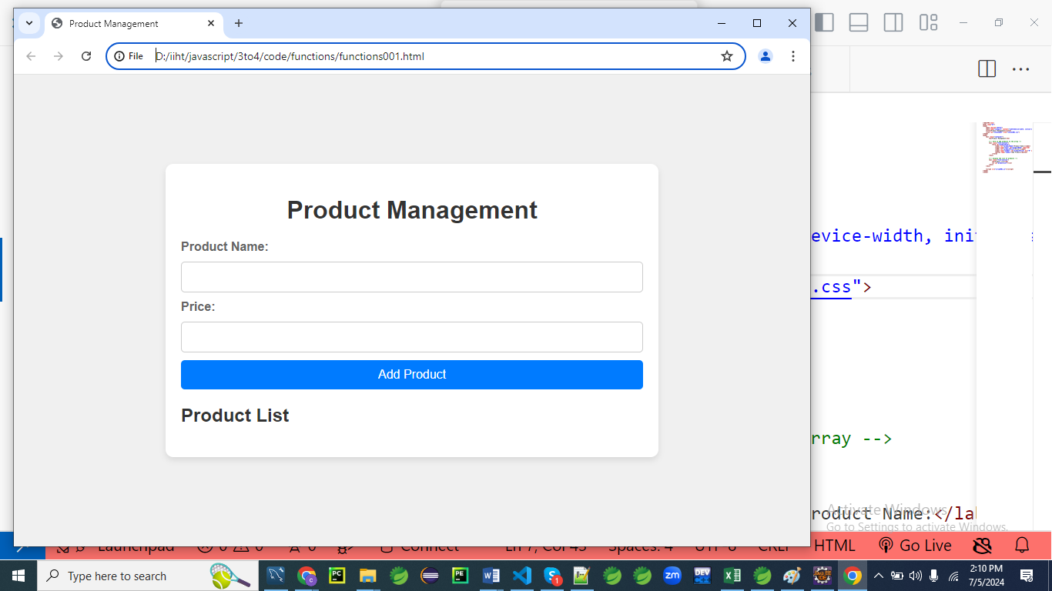

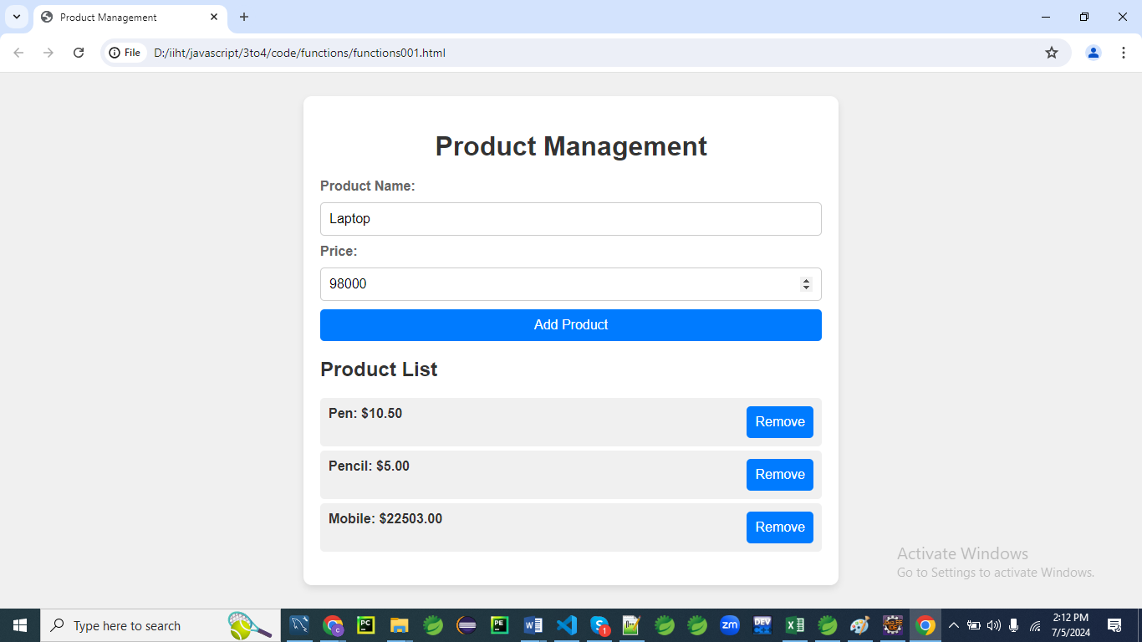

**HTML**

<!DOCTYPE html>

<html lang="en">

<head>

<meta charset="UTF-8">

<meta name="viewport" content="width=device-width, initial-scale=1.0">

<title>Product Management</title>

<link rel="stylesheet" href="styles001.css">

</head>

<body>

<div class="container">

<h1>Product Management</h1>

<!-- Form to add products to the array -->

<div class="form-section">

<form id="productForm">

<label for="productName">Product Name:</label>

<input type="text" id="productName" required>

<label for="productPrice">Price:</label>

<input type="number" id="productPrice" min="0" step="0.01" required>

<button type="submit">Add Product</button>

</form>

</div>

<!-- Display the list of products -->

<div class="form-section">

<h2>Product List</h2>

<ul id="productList"></ul>

</div>

</div>

<script src="script001.js"></script>

</body>

</html>

**CSS (styles001.css)**

body {

font-family: 'Arial', sans-serif;

background: #f0f0f0;

color: #333;

margin: 0;

padding: 0;

display: flex;

justify-content: center;

align-items: center;

height: 100vh;

}

.container {

background: #fff;

padding: 20px;

border-radius: 10px;

box-shadow: 0 4px 8px rgba(0, 0, 0, 0.1);

max-width: 600px;

width: 100%;

}

h1 {

text-align: center;

color: #333;

margin-bottom: 20px;

}

.form-section {

margin-bottom: 20px;

}

form {

display: flex;

flex-direction: column;

gap: 10px;

}

label {

font-weight: bold;

color: #666;

}

input[type="text"],

input[type="number"] {

padding: 10px;

border: 1px solid #ccc;

border-radius: 5px;

outline: none;

font-size: 16px;

}

button {

padding: 10px;

border: none;

border-radius: 5px;

background: #007bff;

color: #fff;

cursor: pointer;

font-size: 16px;

transition: background 0.3s;

}

button:hover {

background: #0056b3;

}

ul {

list-style-type: none;

padding: 0;

}

li {

padding: 10px;

margin: 5px 0;

background: #f0f0f0;

border-radius: 5px;

color: #333;

font-weight: bold;

display: flex;

justify-content: space-between;

}

**Explanation:**

The provided CSS stylesheet (styles001.css) is designed to style a web page with a form and a list of items.

Here’s a breakdown of each section and what it does:

**General Styles**

**body {**

**font-family: 'Arial', sans-serif;**

**background: #f0f0f0;**

**color: #333;**

**margin: 0;**

**padding: 0;**

**display: flex;**

**justify-content: center;**

**align-items: center;**

**height: 100vh;**

**}**

* **font-family**: Uses 'Arial' or a sans-serif font.
* **background**: Sets the background color to light grey (#f0f0f0).
* **color**: Sets the text color to dark grey (#333).
* **margin** and **padding**: Both set to 0 to remove default spacing.
* **display**: Uses Flexbox to center content.
* **justify-content** and **align-items**: Center content horizontally and vertically.
* **height**: Sets the height to 100% of the viewport height.

**Container Styling**

**.container {**

**background: #fff;**

**padding: 20px;**

**border-radius: 10px;**

**box-shadow: 0 4px 8px rgba(0, 0, 0, 0.1);**

**max-width: 600px;**

**width: 100%;**

**}**

* **background**: White background (#fff).
* **padding**: Adds 20px of padding inside the container.
* **border-radius**: Rounds the corners with a 10px radius.
* **box-shadow**: Adds a shadow effect to the container.
* **max-width**: Sets a maximum width of 600px.
* **width**: Ensures the container takes 100% of the available width up to the maximum width.

**Heading Styles**

**h1 {**

**text-align: center;**

**color: #333;**

**margin-bottom: 20px;**

**}**

* **text-align**: Centers the heading text.
* **color**: Sets the text color to dark grey (#333).
* **margin-bottom**: Adds 20px of space below the heading.

**Form Section**

**.form-section {**

**margin-bottom: 20px;**

**}**

* **margin-bottom**: Adds 20px of space below each form section.

**Form Styles**

**form {**

**display: flex;**

**flex-direction: column;**

**gap: 10px;**

**}**

* **display**: Uses Flexbox for the form layout.
* **flex-direction**: Stacks form elements vertically.
* **gap**: Adds 10px of space between form elements.

**Label Styles**

**label {**

**font-weight: bold;**

**color: #666;**

**}**

* **font-weight**: Makes the text bold.
* **color**: Sets the text color to medium grey (#666).

**Input Styles**

**input[type="text"],**

**input[type="number"] {**

**padding: 10px;**

**border: 1px solid #ccc;**

**border-radius: 5px;**

**outline: none;**

**font-size: 16px;**

**}**

* **padding**: Adds 10px of padding inside the input fields.
* **border**: Sets a 1px solid border with a light grey color (#ccc).
* **border-radius**: Rounds the corners with a 5px radius.
* **outline**: Removes the default outline on focus.
* **font-size**: Sets the font size to 16px.

**Button Styles**

**button {**

**padding: 10px;**

**border: none;**

**border-radius: 5px;**

**background: #007bff;**

**color: #fff;**

**cursor: pointer;**

**font-size: 16px;**

**transition: background 0.3s;**

**}**

**button:hover {**

**background: #0056b3;**

**}**

* **padding**: Adds 10px of padding inside the button.
* **border**: Removes the default border.
* **border-radius**: Rounds the corners with a 5px radius.
* **background**: Sets the background color to blue (#007bff).
* **color**: Sets the text color to white (#fff).
* **cursor**: Changes the cursor to a pointer on hover.
* **font-size**: Sets the font size to 16px.
* **transition**: Adds a transition effect for the background color.
* **button**: Changes the background color to a darker blue (#0056b3) on hover.

**List Styles**

**ul {**

**list-style-type: none;**

**padding: 0;**

**}**

* **list-style-type**: Removes the default bullet points.
* **padding**: Removes default padding.

**List Item Styles**

**li {**

**padding: 10px;**

**margin: 5px 0;**

**background: #f0f0f0;**

**border-radius: 5px;**

**color: #333;**

**font-weight: bold;**

**display: flex;**

**justify-content: space-between;**

**}**

* **padding**: Adds 10px of padding inside each list item.
* **margin**: Adds 5px of space above and below each list item.
* **background**: Sets the background color to light grey (#f0f0f0).
* **border-radius**: Rounds the corners with a 5px radius.
* **color**: Sets the text color to dark grey (#333).
* **font-weight**: Makes the text bold.
* **display**: Uses Flexbox for the list item layout.
* **justify-content**: Distributes space between the child elements, placing them at opposite ends of the container.

Overall, the stylesheet ensures a clean, modern, and responsive design for a centered form within a container, with clear and accessible form elements and buttons, as well as styled list items

**JavaScript (script001.js)**

document.addEventListener('DOMContentLoaded', function() {

const productForm = document.getElementById('productForm');

const productList = document.getElementById('productList');

let products = [];

productForm.addEventListener('submit', function(event) {

event.preventDefault(); // Prevent the form from submitting the traditional way

const productName = document.getElementById('productName').value;

const productPrice = parseFloat(document.getElementById('productPrice').value);

if (productName && !isNaN(productPrice) && productPrice >= 0) {

// Add new product to the products array

addProduct(productName, productPrice);

// Clear the form fields

productForm.reset();

// Render the updated product list

renderProducts();

}

});

function addProduct(name, price) {

const newProduct = { name, price };

products.push(newProduct);

}

function renderProducts() {

productList.innerHTML = ''; // Clear existing list

products.forEach((product, index) => {

const li = document.createElement('li');

li.textContent = `${product.name}: $${product.price.toFixed(2)}`;

const removeButton = document.createElement('button');

removeButton.textContent = 'Remove';

removeButton.onclick = () => {

removeProduct(index);

};

li.appendChild(removeButton);

productList.appendChild(li);

});

}

function removeProduct(index) {

products.splice(index, 1);

renderProducts();

}

});

**Explanation:**

The provided JavaScript code (script001.js) is designed to manage a simple product list. It handles form submission to add new products and allows for the removal of products from the list.

Here's an explanation of each part of the code:

**Initial Setup**

**document.addEventListener('DOMContentLoaded', function() {**

**const productForm = document.getElementById('productForm');**

**const productList = document.getElementById('productList');**

**let products = [];**

* **document.addEventListener('DOMContentLoaded', function() {...})**: Ensures the script runs only after the DOM has fully loaded.
* **const productForm = document.getElementById('productForm');**: Selects the form element with the ID productForm.
* **const productList = document.getElementById('productList');**: Selects the unordered list element with the ID productList.
* **let products = [];**: Initializes an empty array to store products.

**Form Submission Event Listener**

**productForm.addEventListener('submit', function(event) {**

**event.preventDefault(); // Prevent the form from submitting the traditional way**

**const productName = document.getElementById('productName').value;**

**const productPrice = parseFloat(document.getElementById('productPrice').value);**

**if (productName && !isNaN(productPrice) && productPrice >= 0) {**

**// Add new product to the products array**

**addProduct(productName, productPrice);**

**// Clear the form fields**

**productForm.reset();**

**// Render the updated product list**

**renderProducts();**

**}**

**});**

* **productForm.addEventListener('submit', function(event) {...})**: Adds an event listener to the form for the submit event.
* **event.preventDefault();**: Prevents the default form submission behavior, which would reload the page.
* **const productName = document.getElementById('productName').value;**: Gets the value of the input field with the ID productName.
* **const productPrice = parseFloat(document.getElementById('productPrice').value);**: Gets the value of the input field with the ID productPrice and converts it to a floating-point number.
* **if (productName && !isNaN(productPrice) && productPrice >= 0) {...}**: Checks if the product name is not empty and the product price is a valid non-negative number.
  + **addProduct(productName, productPrice);**: Calls the addProduct function to add the new product to the products array.
  + **productForm.reset();**: Resets the form fields to their default values.
  + **renderProducts();**: Calls the renderProducts function to update the product list display.

**Adding a Product**

**function addProduct(name, price) {**

**const newProduct = { name, price };**

**products.push(newProduct);**

**}**

* **function addProduct(name, price) {...}**: Defines a function to add a new product.
* **const newProduct = { name, price };**: Creates a new product object with the given name and price.
* **products.push(newProduct);**: Adds the new product to the products array.

**Rendering the Product List**

**function renderProducts() {**

**productList.innerHTML = ''; // Clear existing list**

**products.forEach((product, index) => {**

**const li = document.createElement('li');**

**li.textContent = `${product.name}: $${product.price.toFixed(2)}`;**

**const removeButton = document.createElement('button');**

**removeButton.textContent = 'Remove';**

**removeButton.onclick = () => {**

**removeProduct(index);**

**};**

**li.appendChild(removeButton);**

**productList.appendChild(li);**

**});**

**}**

* **function renderProducts() {...}**: Defines a function to render the product list.
* **productList.innerHTML = '';**: Clears the existing product list.
* **products.forEach((product, index) => {...})**: Iterates over the products array.
  + **const li = document.createElement('li');**: Creates a new list item element.
  + **li.textContent = ${product.name}: $${product.price.toFixed(2)};**: Sets the text content of the list item to show the product name and price.
  + **const removeButton = document.createElement('button');**: Creates a new button element.
  + **removeButton.textContent = 'Remove';**: Sets the button text to "Remove".
  + **removeButton.onclick = () => { removeProduct(index); };**: Adds an event listener to the button to call the removeProduct function with the product index when clicked.
  + **li.appendChild(removeButton);**: Appends the remove button to the list item.
  + **productList.appendChild(li);**: Appends the list item to the product list.

**Removing a Product**

**function removeProduct(index) {**

**products.splice(index, 1);**

**renderProducts();**

**}**

**});**

* **function removeProduct(index) {...}**: Defines a function to remove a product by its index.
* **products.splice(index, 1);**: Removes one element from the products array at the specified index.
* **renderProducts();**: Calls the renderProducts function to update the product list display.

**Summary**

This script:

1. Initializes an empty product list.
2. Listens for form submissions, prevents default behavior, validates input, and adds new products to the list.
3. Updates the displayed product list whenever a new product is added or an existing product is removed.
4. Provides a button to remove individual products from the list.

**Explanation**

**HTML Structure**

* **Product Form Section**: Contains input fields for product name and price, and a submit button to add the product.
* **Product List Section**: Displays the list of products with their names and prices, and a button to remove each product.

**CSS (styles001.css)**

* **General Styling**: Sets up basic styles for the body, container, headings, forms, buttons, lists, and paragraphs.
* **Form and Input Styling**: Defines styles for forms, labels, inputs, and buttons to ensure they are visually appealing and responsive.
* **List Item Styling**: Styles each product list item (<li>) with padding, margins, background color, border radius, font color, and bold text for clarity and readability.
* **Button Styling**: Adds styles for buttons to make them visually appealing, including hover effects.

**JavaScript (script001.js)**

* **DOMContentLoaded Event**: Ensures all JavaScript code runs after the HTML is fully loaded.
* **Event Listeners**: Handles form submission (submit event) for adding products and button clicks for removing products.
* **Functions**:
  + addProduct(name, price): Adds a new product to the products array.
  + renderProducts(): Clears and updates the product list (productList) based on the current state of the products array.
  + removeProduct(index): Removes a product from the products array based on the given index and re-renders the product list.

This program provides a comprehensive example of managing an array of products dynamically through user input and various operations. The CSS ensures a clean and modern user interface, while the JavaScript handles data manipulation and updates to reflect user actions.

**Example 02**

Let's create a more complex example of a form application that manages a list of products. This example will include features such as adding, removing, updating, and filtering products, along with enhanced styling using CSS3.

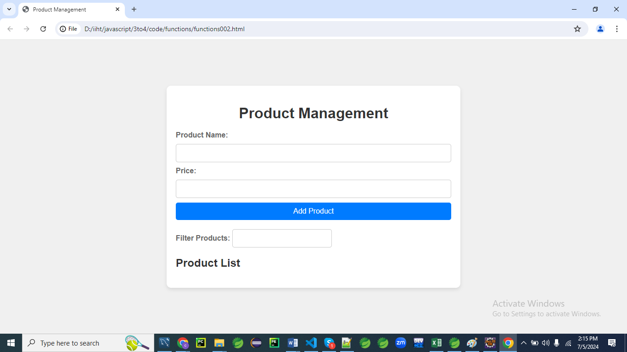

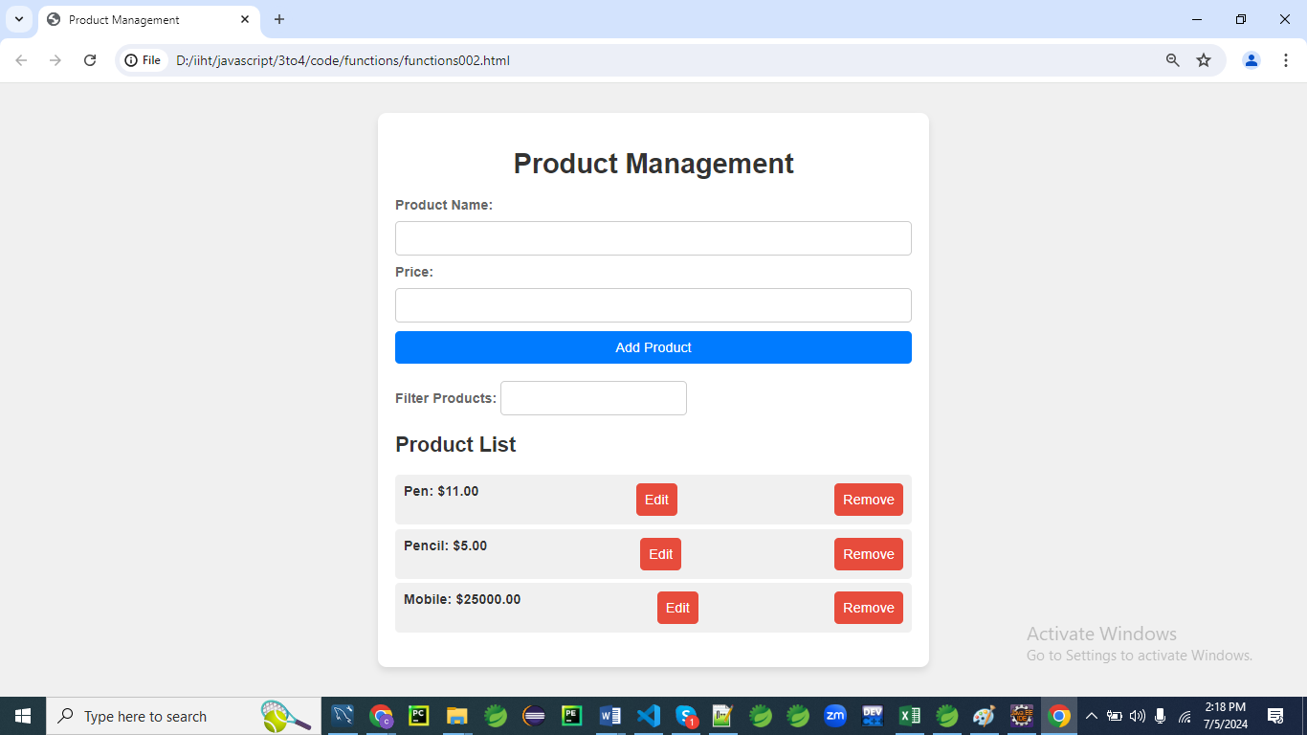

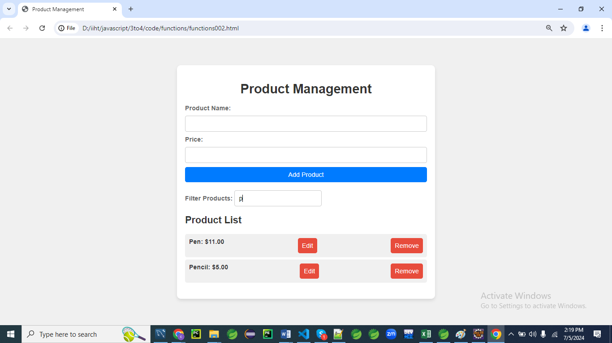

**HTML**

<!DOCTYPE html>

<html lang="en">

<head>

<meta charset="UTF-8">

<meta name="viewport" content="width=device-width, initial-scale=1.0">

<title>Product Management</title>

<link rel="stylesheet" href="styles002.css">

</head>

<body>

<div class="container">

<h1>Product Management</h1>

<!-- Form to add or update products -->

<div class="form-section">

<form id="productForm">

<label for="productName">Product Name:</label>

<input type="text" id="productName" required>

<label for="productPrice">Price:</label>

<input type="number" id="productPrice" min="0" step="0.01" required>

<button type="submit">Add Product</button>

<button type="button" id="updateButton" style="display: none;">Update Product</button>

</form>

</div>

<!-- Form to filter products -->

<div class="form-section">

<label for="filterInput">Filter Products:</label>

<input type="text" id="filterInput">

</div>

<!-- Display the list of products -->

<div class="form-section">

<h2>Product List</h2>

<ul id="productList"></ul>

</div>

</div>

<script src="script002.js"></script>

</body>

</html>

**CSS (styles002.css)**

body {

font-family: 'Arial', sans-serif;

background: #f0f0f0;

color: #333;

margin: 0;

padding: 0;

display: flex;

justify-content: center;

align-items: center;

height: 100vh;

}

.container {

background: #fff;

padding: 20px;

border-radius: 10px;

box-shadow: 0 4px 8px rgba(0, 0, 0, 0.1);

max-width: 600px;

width: 100%;

}

h1 {

text-align: center;

color: #333;

margin-bottom: 20px;

}

.form-section {

margin-bottom: 20px;

}

form {

display: flex;

flex-direction: column;

gap: 10px;

}

label {

font-weight: bold;

color: #666;

}

input[type="text"],

input[type="number"] {

padding: 10px;

border: 1px solid #ccc;

border-radius: 5px;

outline: none;

font-size: 16px;

}

button {

padding: 10px;

border: none;

border-radius: 5px;

background: #007bff;

color: #fff;

cursor: pointer;

font-size: 16px;

transition: background 0.3s;

}

button:hover {

background: #0056b3;

}

ul {

list-style-type: none;

padding: 0;

}

li {

padding: 10px;

margin: 5px 0;

background: #f0f0f0;

border-radius: 5px;

color: #333;

font-weight: bold;

display: flex;

justify-content: space-between;

}

button.edit,

button.remove {

background: #e74c3c;

color: #fff;

margin-left: 10px;

}

button.edit:hover,

button.remove:hover {

background: #c0392b;

}

.hidden {

display: none;

}

**Explanation:**

**body {**

**font-family: 'Arial', sans-serif;**

font-family: Sets the font of the entire webpage to Arial. If Arial isn’t available, it falls back to a generic sans-serif font.

This ensures consistent, clean, readable text.

**background: #f0f0f0;**

Sets a light gray background color for the page.

This creates a soft contrast with the white container.

**color: #333;**

Sets a dark gray font color for all text inside <body>.

Dark gray (#333) is easier on the eyes than pure black.

**margin: 0;**

**padding: 0;**

Removes the default margin and padding from the browser.

Helps in creating a layout from scratch without browser interference.

**display: flex;**

**justify-content: center;**

**align-items: center;**

**height: 100vh;**

**}**

display: flex: Enables Flexbox layout on the body.

justify-content: center: Horizontally centers the child element (the container).

align-items: center: Vertically centers the container.

height: 100vh: Sets the body height to 100% of the viewport height.

The goal here is to perfectly center the container on the screen.

**.container {**

**background: #fff;**

Sets the container background to white, making it stand out from the gray background.

**padding: 20px;**

Adds spacing inside the container to give elements room to breathe.

**border-radius: 10px;**

Rounds the corners of the container for a softer look.

**box-shadow: 0 4px 8px rgba(0, 0, 0, 0.1);**

Adds a subtle drop shadow, giving a floating card-like appearance.

**max-width: 600px;**

**width: 100%;**

**}**

max-width: 600px: Ensures the container doesn’t grow wider than 600px.

width: 100%: Allows the container to shrink on smaller screens (responsive design).

**h1 {**

**text-align: center;**

**color: #333;**

**margin-bottom: 20px;**

**}**

text-align: center: Centers the heading.

color: #333: Reuses dark gray text color.

margin-bottom: 20px: Adds space below the heading to separate it from the form.

**.form-section {**

**margin-bottom: 20px;**

**}**

Adds spacing between different sections of the page (form, filter, and product list).

**form {**

**display: flex;**

**flex-direction: column;**

**gap: 10px;**

**}**

display: flex: Turns the form into a flex container.

flex-direction: column: Stacks inputs vertically.

gap: 10px: Adds space between each input and button.

**label {**

**font-weight: bold;**

**color: #666;**

**}**

font-weight: bold: Makes labels stand out from the input fields.

color: #666: Slightly lighter gray for less visual weight than the main text.

**input[type="text"],**

**input[type="number"] {**

**padding: 10px;**

**border: 1px solid #ccc;**

**border-radius: 5px;**

**outline: none;**

**font-size: 16px;**

**}**

Applies to both text and number inputs.

padding: 10px: Adds inner space for better readability.

border: 1px solid #ccc: Light gray border for subtle separation.

border-radius: 5px: Rounds corners for consistency.

outline: none: Removes the default blue highlight when focused.

font-size: 16px: Ensures consistent and readable text input size.

**button {**

**padding: 10px;**

**border: none;**

**border-radius: 5px;**

**background: #007bff;**

**color: #fff;**

**cursor: pointer;**

**font-size: 16px;**

**transition: background 0.3s;**

**}**

Applies to all buttons.

background: #007bff: Bright blue (Bootstrap-style) background.

color: #fff: White text on the blue background.

cursor: pointer: Changes the mouse pointer to indicate clickability.

transition: background 0.3s: Smooth transition when hovered.

**button:hover {**

**background: #0056b3;**

**}**

On hover, the button becomes a darker blue.

Gives visual feedback to the user.

**ul {**

**list-style-type: none;**

**padding: 0;**

**}**

Removes bullets from the list and removes the default left padding.

Helps in fully customizing the list appearance.

**li {**

**padding: 10px;**

**margin: 5px 0;**

**background: #f0f0f0;**

**border-radius: 5px;**

**color: #333;**

**font-weight: bold;**

**display: flex;**

**justify-content: space-between;**

**}**

Styles each product entry:

Light gray background.

Padding and margin for spacing.

Rounded corners.

Bold text for product names and prices.

display: flex and justify-content: space-between to separate text from buttons on opposite ends.

**button.edit,**

**button.remove {**

**background: #e74c3c;**

**color: #fff;**

**margin-left: 10px;**

**}**

Special styles for Edit and Remove buttons.

Red background to indicate warning or action.

White text and spacing from the previous button.

**button.edit:hover,**

**button.remove:hover {**

**background: #c0392b;**

**}**

Darker red on hover for visual interaction feedback.

**.hidden {**

**display: none;**

**}**

Utility class to hide elements (like the "Update" button when not editing).

Can be toggled on/off using JavaScript.

Summary:

This CSS is well-organized, modern, and user-friendly.

It:

Centers the UI visually.

Makes the form and product list clean and spaced.

Adds interactive styling (hover effects, shadows).

Ensures responsiveness and clarity.

**JavaScript (script002.js)**

document.addEventListener('DOMContentLoaded', function() {

    const productForm = document.getElementById('productForm');

    const productList = document.getElementById('productList');

    const filterInput = document.getElementById('filterInput');

    const updateButton = document.getElementById('updateButton');

    const submitButton = document.querySelector('button[type="submit"]');

    let products = [];

    let editIndex = null;

    productForm.addEventListener('submit', function(event) {

        event.preventDefault();

        const productName = document.getElementById('productName').value;

        const productPrice = parseFloat(document.getElementById('productPrice').value);

        if (editIndex === null) {

            addProduct(productName, productPrice);

        } else {

            updateProduct(editIndex, productName, productPrice);

        }

        productForm.reset(); // clear the form

        renderProducts();

    });

    updateButton.addEventListener('click', function() {

        const productName = document.getElementById('productName').value;

        const productPrice = parseFloat(document.getElementById('productPrice').value);

        updateProduct(editIndex, productName, productPrice);

        productForm.reset(); // clear the form

        renderProducts();

    });

    filterInput.addEventListener('input', function() {

        renderProducts();

    });

    function addProduct(name, price) {

        const newProduct = { name, price };

        products.push(newProduct);

    }

    function updateProduct(index, name, price) {

        products[index] = { name, price };

        editIndex = null;

        submitButton.style.display = 'block';

        updateButton.style.display = 'none';

    }

    function renderProducts() {

        const filterText = filterInput.value.toLowerCase();

        productList.innerHTML = '';

        products.forEach((product, index) => {

            if (product.name.toLowerCase().includes(filterText)) {

                const li = document.createElement('li');

                li.textContent = `${product.name}: $${product.price.toFixed(2)}`;

                const editButton = document.createElement('button');

                editButton.textContent = 'Edit';

                editButton.className = 'edit';

                editButton.onclick = () => {

                    editIndex = index;

                    document.getElementById('productName').value = product.name;

                    document.getElementById('productPrice').value = product.price;

                    submitButton.style.display = 'none';

                    updateButton.style.display = 'block';

                };

                const removeButton = document.createElement('button');

                removeButton.textContent = 'Remove';

                removeButton.className = 'remove';

                removeButton.onclick = () => {

                    removeProduct(index);

                };

                li.appendChild(editButton);

                li.appendChild(removeButton);

                productList.appendChild(li);

            }

        });

    }

    function removeProduct(index) {

        products.splice(index, 1);

        renderProducts();

    }

});

**Explanation:**

Below is a **line-by-line breakdown and broader explanation** of the JavaScript, which handles a product management form with add, edit, remove, and filter features.

**document.addEventListener('DOMContentLoaded', function() {**

* This ensures that the script runs **only after** the entire HTML page has fully loaded.
* Prevents errors when trying to access DOM elements before they're ready.

**const productForm = document.getElementById('productForm');**

* Grabs the form element (<form id="productForm">) so we can handle its submit event.

**const productList = document.getElementById('productList');**

* Refers to the <ul> where products will be listed.

**const filterInput = document.getElementById('filterInput');**

* Refers to the text box used to **filter products** by name.

**const updateButton = document.getElementById('updateButton');**

* Refers to a special **update button** that appears when editing a product.

**const submitButton = document.querySelector('button[type="submit"]');**

* Refers to the standard **submit button** for adding new products.

**let products = [];**

* A list (array) to **store all added products** as objects (e.g., { name: "Pen", price: 5 }).

**let editIndex = null;**

* Tracks the **index of the product being edited**. If null, no product is being edited.

**Handling Form Submission**

**productForm.addEventListener('submit', function(event) {**

**event.preventDefault();**

* Prevents the form from actually submitting (which would reload the page).
* Allows us to handle the submission using JavaScript.

**const productName = document.getElementById('productName').value;**

**const productPrice = parseFloat(document.getElementById('productPrice').value);**

* Gets the values of the name and price input fields.
* parseFloat() ensures the price is treated as a number (e.g., 5.99, not a string).

**if (editIndex === null) {**

**addProduct(productName, productPrice);**

**} else {**

**updateProduct(editIndex, productName, productPrice);**

**}**

* If not editing (editIndex is null), we **add** a new product.
* Otherwise, we're in **edit mode**, so we update the product at the specified index.

**productForm.reset(); // clear the form**

**renderProducts(); // refresh the product list**

**});**

* Resets the form fields (clears them).
* Renders the updated product list on the screen.

**Handling the Update Button**

**updateButton.addEventListener('click', function() {**

**const productName = document.getElementById('productName').value;**

**const productPrice = parseFloat(document.getElementById('productPrice').value);**

* When "Update" is clicked, fetch the current input values.

**updateProduct(editIndex, productName, productPrice);**

**productForm.reset(); // clear the form**

**renderProducts(); // refresh the list**

**});**

* Calls the update function with the index of the product being edited.
* Resets and re-renders just like on form submit.

**Filter Product List**

**filterInput.addEventListener('input', function() {**

**renderProducts();**

**});**

* Every time the user types in the filter box, the product list updates to match the filter text.

**Add Product Function**

**function addProduct(name, price) {**

**const newProduct = { name, price };**

**products.push(newProduct);**

**}**

* Creates a new product object and **adds it to the array** of products.

**Update Product Function**

**function updateProduct(index, name, price) {**

**products[index] = { name, price }; // update product at index**

**editIndex = null; // exit edit mode**

* Replaces the old product data at index with the updated one.
* Resets editIndex so we know we're not editing anymore.

**submitButton.style.display = 'block';**

**updateButton.style.display = 'none';**

**}**

* Hides the "Update" button and **shows** the "Submit" button again.

**Render Products Function**

**function renderProducts() {**

**const filterText = filterInput.value.toLowerCase();**

**productList.innerHTML = '';**

* Gets the filter input (converted to lowercase for case-insensitive search).
* Clears the current product list to avoid duplicates.

**products.forEach((product, index) => {**

**if (product.name.toLowerCase().includes(filterText)) {**

* Loops over all products and only shows those that **match the filter**.

**const li = document.createElement('li');**

**li.textContent = `${product.name}: $${product.price.toFixed(2)}`;**

* Creates a new list item showing the product’s name and price, formatted to 2 decimal places.

**Edit Button**

**const editButton = document.createElement('button');**

**editButton.textContent = 'Edit';**

**editButton.className = 'edit';**

**editButton.onclick = () => {**

**editIndex = index;**

**document.getElementById('productName').value = product.name;**

**document.getElementById('productPrice').value = product.price;**

**submitButton.style.display = 'none';**

**updateButton.style.display = 'block';**

**};**

* Creates the Edit button.
* On click, loads product data into form for editing.
* Sets editIndex so we know which product is being updated.
* Switches from "Submit" to "Update" mode.

**Remove Button**

**const removeButton = document.createElement('button');**

**removeButton.textContent = 'Remove';**

**removeButton.className = 'remove';**

**removeButton.onclick = () => {**

**removeProduct(index);**

**};**

* Creates a Remove button.
* On click, calls removeProduct() to delete that product.

**li.appendChild(editButton);**

**li.appendChild(removeButton);**

**productList.appendChild(li);**

**}**

**});**

**}**

* Adds both buttons to the <li>, then adds the <li> to the <ul> product list.

**Remove Product Function**

**function removeProduct(index) {**

**products.splice(index, 1);**

**renderProducts();**

**}**

* Removes one item from the products array using splice(index, 1).
* Re-renders the list afterward to reflect the change.

**Summary**

This script provides the full functionality for:

* **Adding** a new product
* **Editing** an existing product
* **Deleting** a product
* **Filtering** products by name
* Dynamically updating the UI using DOM manipulation
* Using editIndex to switch between "add" and "edit" modes

**Explanation**

**HTML Structure**

* **Product Form Section**: Includes input fields for product name and price, and buttons for adding and updating products.
* **Filter Section**: An input field for filtering the products based on the name.
* **Product List Section**: Displays the list of products, each with edit and remove buttons.

**CSS (styles002.css)**

* **General Styling**: Basic styles for the body, container, headings, forms, buttons, lists, and paragraphs.
* **Form and Input Styling**: Ensures that the forms, labels, inputs, and buttons are visually appealing and responsive.
* **List Item Styling**: Styles each product list item (<li>) with padding, margins, background color, border radius, font color, and bold text.
* **Button Styling**: Adds styles for buttons, including hover effects. Edit and remove buttons are styled differently for clarity.

**JavaScript (script002.js)**

* **DOMContentLoaded Event**: Ensures all JavaScript code runs after the HTML is fully loaded.
* **Event Listeners**: Handles form submission (submit event) for adding or updating products and input event for filtering products.
* **Functions**:
  + addProduct(name, price): Adds a new product to the products array.
  + updateProduct(index, name, price): Updates an existing product in the products array.
  + renderProducts(): Clears and updates the product list (productList) based on the current state of the products array and the filter input.
  + removeProduct(index): Removes a product from the products array based on the given index and re-renders the product list.

This complex example includes more advanced features such as updating and filtering products, making it a comprehensive and functional product management system.

The enhanced CSS ensures a clean and modern user interface, while the JavaScript handles dynamic data manipulation and user interactions.

**Example 03**

Let's create a more complex example with a form application that manages a list of tasks for a to-do list.

This example will include features such as adding, removing, updating, and filtering tasks, along with enhanced styling using CSS3.

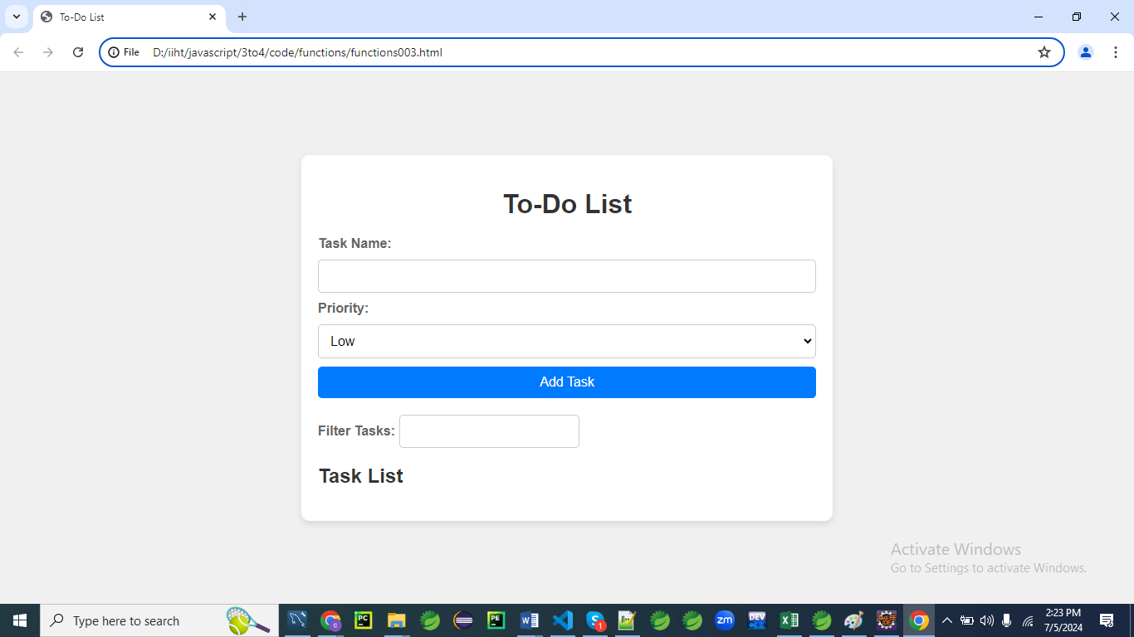

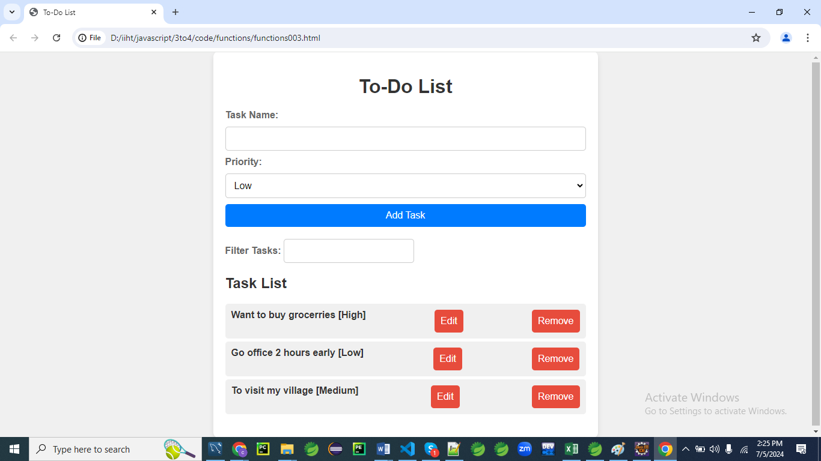

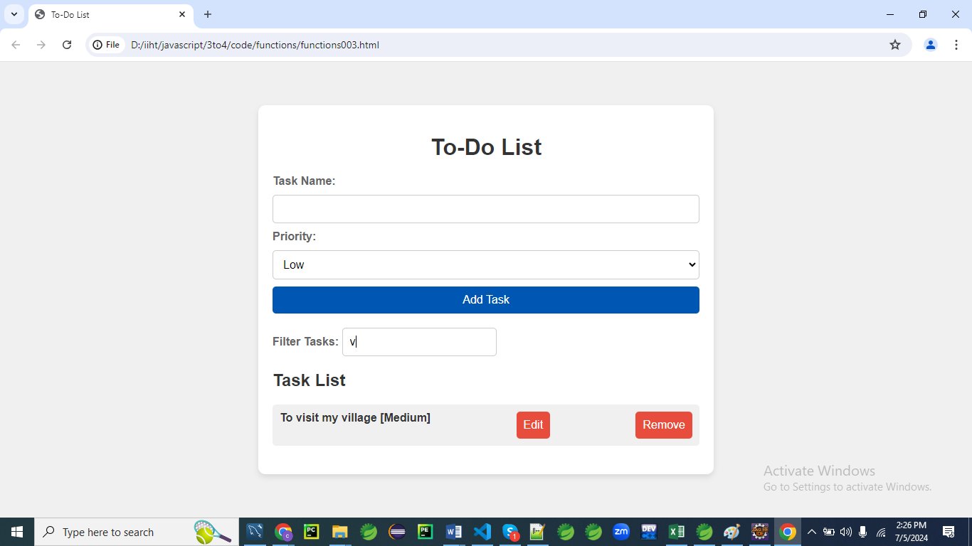

**HTML**

<!DOCTYPE html>

<html lang="en">

<head>

<meta charset="UTF-8">

<meta name="viewport" content="width=device-width, initial-scale=1.0">

<title>To-Do List</title>

<link rel="stylesheet" href="styles003.css">

</head>

<body>

<div class="container">

<h1>To-Do List</h1>

<!-- Form to add or update tasks -->

<div class="form-section">

<form id="taskForm">

<label for="taskName">Task Name:</label>

<input type="text" id="taskName" required>

<label for="taskPriority">Priority:</label>

<select id="taskPriority" required>

<option value="Low">Low</option>

<option value="Medium">Medium</option>

<option value="High">High</option>

</select>

<button type="submit">Add Task</button>

<button type="button" id="updateButton" style="display: none;">Update Task</button>

</form>

</div>

<!-- Form to filter tasks -->

<div class="form-section">

<label for="filterInput">Filter Tasks:</label>

<input type="text" id="filterInput">

</div>

<!-- Display the list of tasks -->

<div class="form-section">

<h2>Task List</h2>

<ul id="taskList"></ul>

</div>

</div>

<script src="script003.js"></script>

</body>

</html>

**CSS (styles003.css)**

body {

font-family: 'Arial', sans-serif;

background: #f0f0f0;

color: #333;

margin: 0;

padding: 0;

display: flex;

justify-content: center;

align-items: center;

height: 100vh;

}

.container {

background: #fff;

padding: 20px;

border-radius: 10px;

box-shadow: 0 4px 8px rgba(0, 0, 0, 0.1);

max-width: 600px;

width: 100%;

}

h1 {

text-align: center;

color: #333;

margin-bottom: 20px;

}

.form-section {

margin-bottom: 20px;

}

form {

display: flex;

flex-direction: column;

gap: 10px;

}

label {

font-weight: bold;

color: #666;

}

input[type="text"],

select {

padding: 10px;

border: 1px solid #ccc;

border-radius: 5px;

outline: none;

font-size: 16px;

}

button {

padding: 10px;

border: none;

border-radius: 5px;

background: #007bff;

color: #fff;

cursor: pointer;

font-size: 16px;

transition: background 0.3s;

}

button:hover {

background: #0056b3;

}

ul {

list-style-type: none;

padding: 0;

}

li {

padding: 10px;

margin: 5px 0;

background: #f0f0f0;

border-radius: 5px;

color: #333;

font-weight: bold;

display: flex;

justify-content: space-between;

}

button.edit,

button.remove {

background: #e74c3c;

color: #fff;

margin-left: 10px;

}

button.edit:hover,

button.remove:hover {

background: #c0392b;

}

.hidden {

display: none;

}

**JavaScript (script003.js)**

document.addEventListener('DOMContentLoaded', function() {

const taskForm = document.getElementById('taskForm');

const taskList = document.getElementById('taskList');

const filterInput = document.getElementById('filterInput');

const updateButton = document.getElementById('updateButton');

let tasks = [];

let editIndex = null;

taskForm.addEventListener('submit', function(event) {

event.preventDefault();

const taskName = document.getElementById('taskName').value;

const taskPriority = document.getElementById('taskPriority').value;

if (editIndex === null) {

addTask(taskName, taskPriority);

} else {

updateTask(editIndex, taskName, taskPriority);

}

taskForm.reset();

renderTasks();

});

filterInput.addEventListener('input', function() {

renderTasks();

});

function addTask(name, priority) {

const newTask = { name, priority };

tasks.push(newTask);

}

function updateTask(index, name, priority) {

tasks[index] = { name, priority };

editIndex = null;

document.querySelector('button[type="submit"]').style.display = 'block';

updateButton.style.display = 'none';

}

function renderTasks() {

const filterText = filterInput.value.toLowerCase();

taskList.innerHTML = '';

tasks.forEach((task, index) => {

if (task.name.toLowerCase().includes(filterText)) {

const li = document.createElement('li');

li.textContent = `${task.name} [${task.priority}]`;

const editButton = document.createElement('button');

editButton.textContent = 'Edit';

editButton.className = 'edit';

editButton.onclick = () => {

editIndex = index;

document.getElementById('taskName').value = task.name;

document.getElementById('taskPriority').value = task.priority;

document.querySelector('button[type="submit"]').style.display = 'none';

updateButton.style.display = 'block';

};

const removeButton = document.createElement('button');

removeButton.textContent = 'Remove';

removeButton.className = 'remove';

removeButton.onclick = () => {

removeTask(index);

};

li.appendChild(editButton);

li.appendChild(removeButton);

taskList.appendChild(li);

}

});

}

function removeTask(index) {

tasks.splice(index, 1);

renderTasks();

}

});

**Explanation**

**HTML Structure**

* **Task Form Section**: Includes input fields for task name and priority, and buttons for adding and updating tasks.
* **Filter Section**: An input field for filtering the tasks based on the name.
* **Task List Section**: Displays the list of tasks, each with edit and remove buttons.

**CSS (styles.css)**

* **General Styling**: Basic styles for the body, container, headings, forms, buttons, lists, and paragraphs.
* **Form and Input Styling**: Ensures that the forms, labels, inputs, and buttons are visually appealing and responsive.
* **List Item Styling**: Styles each task list item (<li>) with padding, margins, background color, border radius, font color, and bold text.
* **Button Styling**: Adds styles for buttons, including hover effects. Edit and remove buttons are styled differently for clarity.

**JavaScript (script.js)**

* **DOMContentLoaded Event**: Ensures all JavaScript code runs after the HTML is fully loaded.
* **Event Listeners**: Handles form submission (submit event) for adding or updating tasks and input event for filtering tasks.
* **Functions**:
  + addTask(name, priority): Adds a new task to the tasks array.
  + updateTask(index, name, priority): Updates an existing task in the tasks array.
  + renderTasks(): Clears and updates the task list (taskList) based on the current state of the tasks array and the filter input.
  + removeTask(index): Removes a task from the tasks array based on the given index and re-renders the task list.

This complex example includes more advanced features such as updating and filtering tasks, making it a comprehensive and functional to-do list application. The enhanced CSS ensures a clean and modern user interface, while the JavaScript handles dynamic data manipulation and user interactions.

**Example 04**

Let's create a large and complex example involving a student management system.

This example will allow you to add, edit, and delete student information, filter students by name, and sort them by different criteria. This example will use HTML, CSS3, and JavaScript.

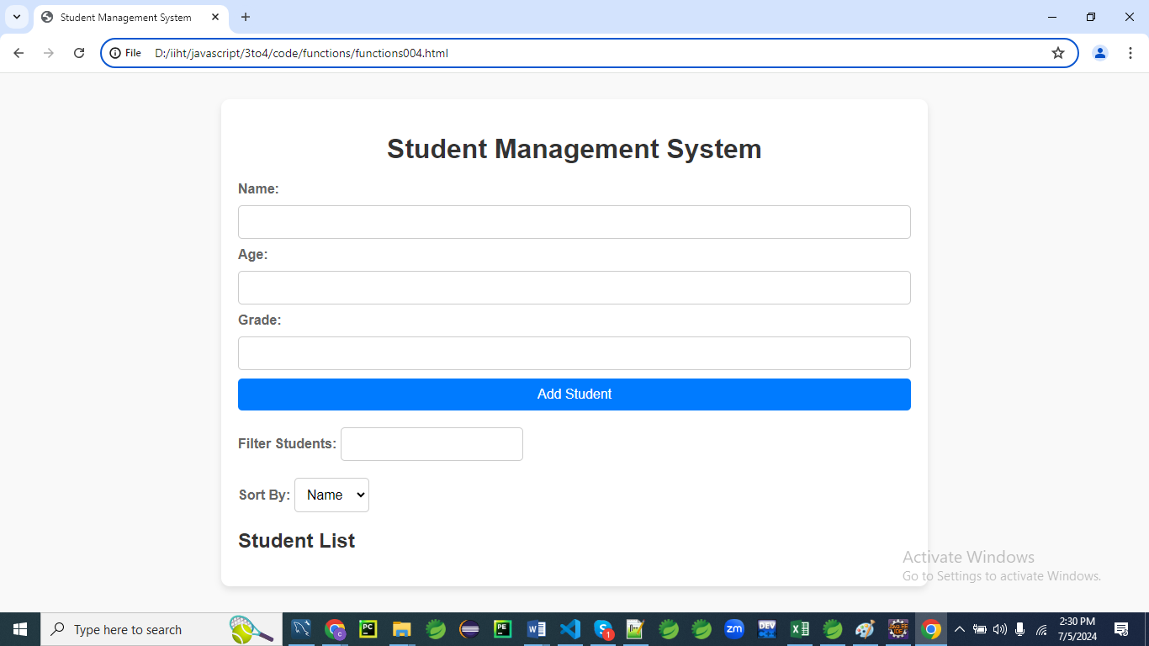

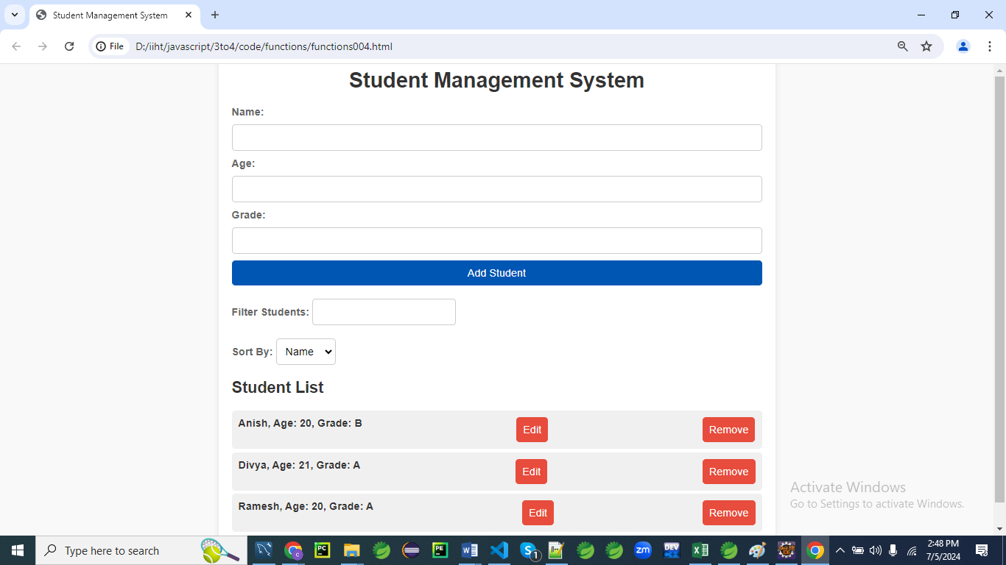

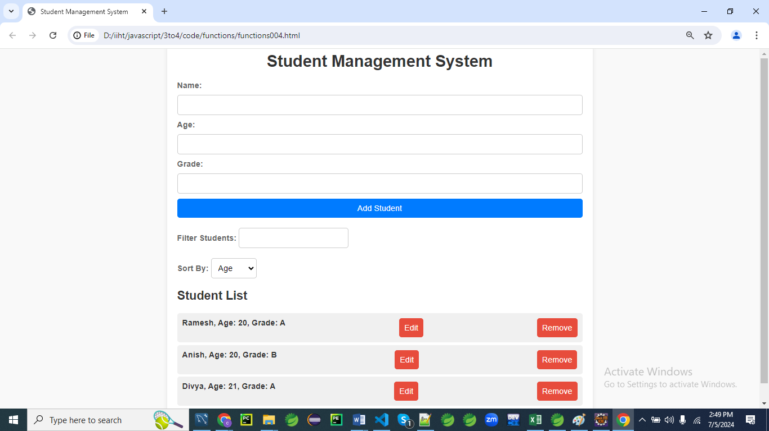

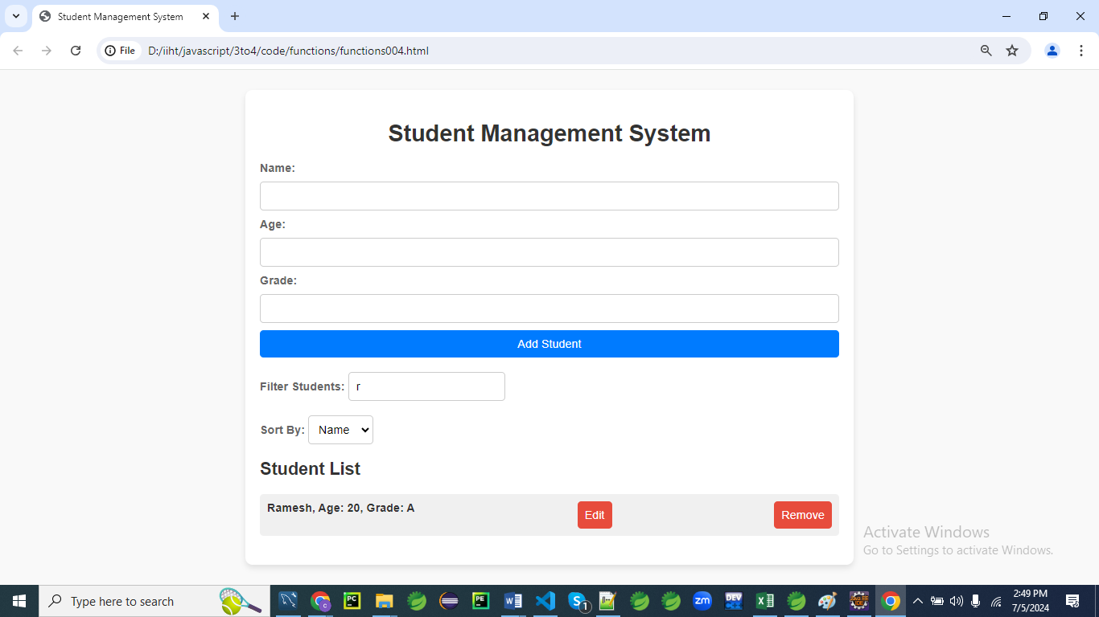

**HTML**

<!DOCTYPE html>

<html lang="en">

<head>

<meta charset="UTF-8">

<meta name="viewport" content="width=device-width, initial-scale=1.0">

<title>Student Management System</title>

<link rel="stylesheet" href="styles004.css">

</head>

<body>

<div class="container">

<h1>Student Management System</h1>

<!-- Form to add or update students -->

<div class="form-section">

<form id="studentForm">

<label for="studentName">Name:</label>

<input type="text" id="studentName" required>

<label for="studentAge">Age:</label>

<input type="number" id="studentAge" required>

<label for="studentGrade">Grade:</label>

<input type="text" id="studentGrade" required>

<button type="submit">Add Student</button>

<button type="button" id="updateButton" style="display: none;">Update Student</button>

</form>

</div>

<!-- Form to filter students -->

<div class="form-section">

<label for="filterInput">Filter Students:</label>

<input type="text" id="filterInput">

</div>

<!-- Sorting options -->

<div class="form-section">

<label for="sortOptions">Sort By:</label>

<select id="sortOptions">

<option value="name">Name</option>

<option value="age">Age</option>

<option value="grade">Grade</option>

</select>

</div>

<!-- Display the list of students -->

<div class="form-section">

<h2>Student List</h2>

<ul id="studentList"></ul>

</div>

</div>

<script src="script004.js"></script>

</body>

</html>

**CSS (styles004.css)**

body {

font-family: 'Arial', sans-serif;

background: #f9f9f9;

color: #333;

margin: 0;

padding: 0;

display: flex;

justify-content: center;

align-items: center;

height: 100vh;

}

.container {

background: #fff;

padding: 20px;

border-radius: 10px;

box-shadow: 0 4px 8px rgba(0, 0, 0, 0.1);

max-width: 800px;

width: 100%;

}

h1 {

text-align: center;

color: #333;

margin-bottom: 20px;

}

.form-section {

margin-bottom: 20px;

}

form {

display: flex;

flex-direction: column;

gap: 10px;

}

label {

font-weight: bold;

color: #666;

}

input[type="text"],

input[type="number"],

select {

padding: 10px;

border: 1px solid #ccc;

border-radius: 5px;

outline: none;

font-size: 16px;

}

button {

padding: 10px;

border: none;

border-radius: 5px;

background: #007bff;

color: #fff;

cursor: pointer;

font-size: 16px;

transition: background 0.3s;

}

button:hover {

background: #0056b3;

}

ul {

list-style-type: none;

padding: 0;

}

li {

padding: 10px;

margin: 5px 0;

background: #f0f0f0;

border-radius: 5px;

color: #333;

font-weight: bold;

display: flex;

justify-content: space-between;

}

button.edit,

button.remove {

background: #e74c3c;

color: #fff;

margin-left: 10px;

}

button.edit:hover,

button.remove:hover {

background: #c0392b;

}

.hidden {

display: none;

}

**JavaScript (script.js)**

document.addEventListener('DOMContentLoaded', function() {

const studentForm = document.getElementById('studentForm');

const studentList = document.getElementById('studentList');

const filterInput = document.getElementById('filterInput');

const sortOptions = document.getElementById('sortOptions');

const updateButton = document.getElementById('updateButton');

let students = [];

let editIndex = null;

studentForm.addEventListener('submit', function(event) {

event.preventDefault();

const studentName = document.getElementById('studentName').value;

const studentAge = document.getElementById('studentAge').value;

const studentGrade = document.getElementById('studentGrade').value;

if (editIndex === null) {

addStudent(studentName, studentAge, studentGrade);

}

else {

updateStudent(editIndex, studentName, studentAge, studentGrade);

}

studentForm.reset();

renderStudents();

});

updateButton.addEventListener('click', function() {

const studentName = document.getElementById('studentName').value;

const studentAge = document.getElementById('studentAge').value;

const studentGrade = document.getElementById('studentGrade').value;

updateStudent(editIndex, studentName, studentAge, studentGrade);

studentForm.reset();

renderStudents();

});

filterInput.addEventListener('input', function() {

renderStudents();

});

sortOptions.addEventListener('change', function() {

renderStudents();

});

function addStudent(name, age, grade) {

const newStudent = { name, age, grade };

students.push(newStudent);

}

function updateStudent(index, name, age, grade) {

students[index] = { name, age, grade };

editIndex = null;

document.querySelector('button[type="submit"]').style.display = 'block';

updateButton.style.display = 'none';

}

function renderStudents() {

const filterText = filterInput.value.toLowerCase();

const sortBy = sortOptions.value;

const sortedStudents = [...students].sort((a, b) => {

if (a[sortBy] < b[sortBy]) return -1;

if (a[sortBy] > b[sortBy]) return 1;

return 0;

});

studentList.innerHTML = '';

sortedStudents.forEach((student, index) => {

if (student.name.toLowerCase().includes(filterText)) {

const li = document.createElement('li');

li.textContent = `${student.name}, Age: ${student.age}, Grade: ${student.grade}`;

const editButton = document.createElement('button');

editButton.textContent = 'Edit';

editButton.className = 'edit';

editButton.onclick = () => {

editIndex = index;

document.getElementById('studentName').value = student.name;

document.getElementById('studentAge').value = student.age;

document.getElementById('studentGrade').value = student.grade;

document.querySelector('button[type="submit"]').style.display = 'none';

updateButton.style.display = 'block';

};

const removeButton = document.createElement('button');

removeButton.textContent = 'Remove';

removeButton.className = 'remove';

removeButton.onclick = () => {

removeStudent(index);

};

li.appendChild(editButton);

li.appendChild(removeButton);

studentList.appendChild(li);

}

});

}

function removeStudent(index) {

students.splice(index, 1);

renderStudents();

}

});

**Explanation for the code**

**const sortedStudents = [...students].sort((a, b) => {**

**if (a[sortBy] < b[sortBy]) return -1;**

**if (a[sortBy] > b[sortBy]) return 1;**

**return 0;**

**});**

**Let's break down this piece of code line by line and explain it in detail:**

**const sortedStudents = [...students].sort((a, b) => {**

This line creates a new constant variable called sortedStudents that holds the result of sorting the students array.

* **[...]** is the spread operator, which creates a shallow copy of the students array. This ensures the original students array is not modified.
* **.sort((a, b) => { ... })** is a method that sorts the copied array. It takes a comparison function as an argument. This function determines the order of the elements in the array.

**if (a[sortBy] < b[sortBy]) return -1;**

Inside the comparison function, this line compares the values of the sortBy property for two elements, a and b.

* **a and b** represent two elements being compared in the array.
* **sortBy** is a variable representing the property by which the array should be sorted (e.g., "name", "age", "grade").
* **If a[sortBy] is less than b[sortBy]**, the function returns -1, which means a should come before b in the sorted array.

**if (a[sortBy] > b[sortBy]) return 1;**

This line continues the comparison:

* **If a[sortBy] is greater than b[sortBy],** the function returns 1, which means a should come after b in the sorted array.

**return 0;**

This line handles the case where a[sortBy] is equal to b[sortBy]:

* If a[sortBy] is equal to b[sortBy], the function returns 0, which means a and b are considered equal in terms of sorting, and their order does not change.

**Summary**

1. **Create a Copy**: const sortedStudents = [...students] creates a shallow copy of the students array.
2. **Sort the Copy**: .sort((a, b) => { ... }) sorts this copied array using a comparison function.
3. **Comparison Function**:
   * if (a[sortBy] < b[sortBy]) return -1; compares two elements and if a[sortBy] is less than b[sortBy], a comes before b.
   * if (a[sortBy] > b[sortBy]) return 1; if a[sortBy] is greater than b[sortBy], a comes after b.
   * return 0; if a[sortBy] is equal to b[sortBy], their order doesn't change.

This entire process results in the students array being sorted based on the specified sortBy property without altering the original array.

**Explanation**

**HTML Structure**

* **Student Form Section**: Input fields for student name, age, and grade, and buttons for adding and updating students.
* **Filter Section**: An input field for filtering the students based on the name.
* **Sorting Options**: A dropdown for sorting students by name, age, or grade.
* **Student List Section**: Displays the list of students, each with edit and remove buttons.

**CSS (styles.css)**

* **General Styling**: Basic styles for the body, container, headings, forms, buttons, lists, and paragraphs.
* **Form and Input Styling**: Ensures that the forms, labels, inputs, and buttons are visually appealing and responsive.
* **List Item Styling**: Styles each student list item (<li>) with padding, margins, background color, border radius, font color, and bold text.
* **Button Styling**: Adds styles for buttons, including hover effects. Edit and remove buttons are styled differently for clarity.

**JavaScript (script.js)**

* **DOMContentLoaded Event**: Ensures all JavaScript code runs after the HTML is fully loaded.
* **Event Listeners**: Handles form submission (submit event) for adding or updating students, input event for filtering students, and change event for sorting students.
* **Functions**:
  + addStudent(name, age, grade): Adds a new student to the students array.
  + updateStudent(index, name, age, grade): Updates an existing student in the students array.
  + renderStudents(): Clears and updates the student list (studentList) based on the current state of the students array, the filter input, and the sorting options.
  + removeStudent(index): Removes a student from the students array based on the given index and re-renders the student list.

**What is DOM in JavaScript?**

The Document Object Model (DOM) in JavaScript is a programming interface for web documents.

It represents the structure of a document as a tree of objects, allowing scripts to update the content, structure, and style of a document while it is being viewed.

The DOM provides a way for JavaScript to access and manipulate the HTML elements of a webpage.

For example, you can use JavaScript to change text, add or remove elements, and respond to user events.

**Key Points:**

* **Tree Structure**: The DOM represents HTML as a tree structure, where each element is a node.
* **Access and Manipulation**: JavaScript can access and manipulate these nodes using various methods and properties.
* **Event Handling**: The DOM allows JavaScript to listen for and handle events like clicks, input changes, and form submissions.

**Example 01:**

Here's a simple example showing how to manipulate the DOM:

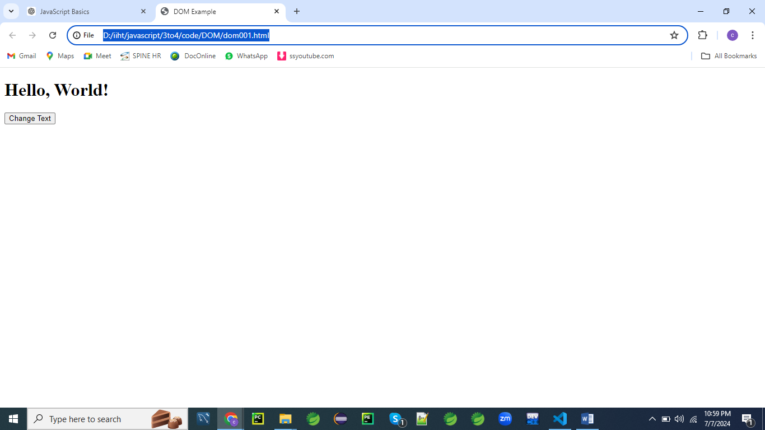

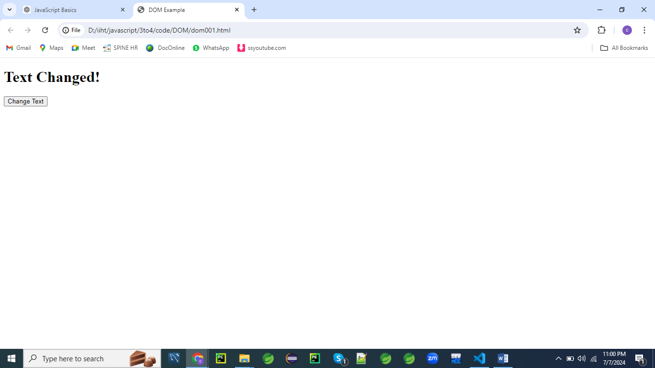

**HTML:**

<!DOCTYPE html>

<html lang="en">

<head>

<meta charset="UTF-8">

<meta name="viewport" content="width=device-width, initial-scale=1.0">

<title>DOM Example</title>

</head>

<body>

<h1 id="title">Hello, World!</h1>

<button id="changeTextButton">Change Text</button>

<script src="script001.js"></script>

</body>

</html>

**JavaScript (script001.js):**

document.addEventListener('DOMContentLoaded', function() {

const button = document.getElementById('changeTextButton');

const title = document.getElementById('title');

button.addEventListener('click', function() {

title.textContent = 'Text Changed!';

});

});

In this example, when the button is clicked, the text of the h1 element is changed to "Text Changed!".

This demonstrates how you can interact with and manipulate the DOM using JavaScript.

**Understanding the DOM in JavaScript**

The Document Object Model (DOM) is an essential concept in web development, providing a structured representation of HTML or XML documents.

Here are more details about the DOM in JavaScript:

**Structure of the DOM**

* **Nodes and Elements**: The DOM treats an HTML or XML document as a tree structure where each node is an object representing a part of the document. Nodes can be elements, text, or attributes.
* **Hierarchy**: The root of the tree is the document object, from which various elements like head, body, and their children branch out.

**Accessing the DOM**

JavaScript can access DOM elements using methods such as:

* **document.getElementById(id):** Selects an element by its unique ID.
* **document.getElementsByClassName(className):** Selects elements by their class name.
* **document.getElementsByTagName(tagName):** Selects elements by their tag name.
* **document.querySelector(selector):** Selects the first element that matches a CSS selector.
* **document.querySelectorAll(selector):** Selects all elements that match a CSS selector.

**Manipulating the DOM**

Once elements are accessed, JavaScript can manipulate them:

* **Content Manipulation**: Changing the text or HTML content using textContent, innerHTML, or innerText.
* **Attribute Manipulation**: Adding, modifying, or removing attributes using setAttribute, getAttribute, or removeAttribute.
* **Style Manipulation**: Modifying the CSS styles of elements using the style property.
* **Element Creation and Removal**: Creating new elements using document.createElement and appending them to the DOM with methods like appendChild or insertBefore. Elements can be removed using removeChild.

**Event Handling**

JavaScript can respond to user interactions through event listeners:

* **Adding Event Listeners**: Using **addEventListener(event, function)**, you can attach a function to run when an event occurs.
* **Common Events**: Events include clicks (click), form submissions (submit), input changes (change), and more.

**Traversal and Navigation**

JavaScript provides properties to traverse the DOM tree:

* **Parent and Children**: parentNode, childNodes, firstChild, lastChild.
* **Siblings**: nextSibling, previousSibling.

Understanding the DOM is crucial for dynamic web development, enabling you to create interactive and responsive web applications.

**Example 02**

Let's create an example that demonstrates the use of the DOM in JavaScript.

This example will involve a to-do list application where users can add tasks, mark them as completed, edit them, and delete them.

The example will include HTML, CSS, and JavaScript.

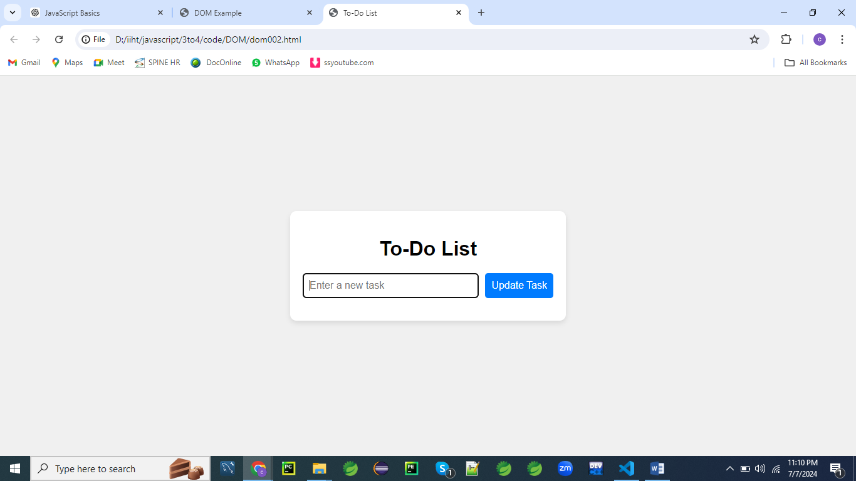

You can give following items as input

Daily Planner

Task Tracker

Goal Getter

Productivity Master

Chore Organizer

Work Scheduler

Errand Runner

Project Planner

Task Manager

Priority Keeper

Study Schedule

Life Organizer

Task Dashboard

Mission Accomplisher

Job Juggler

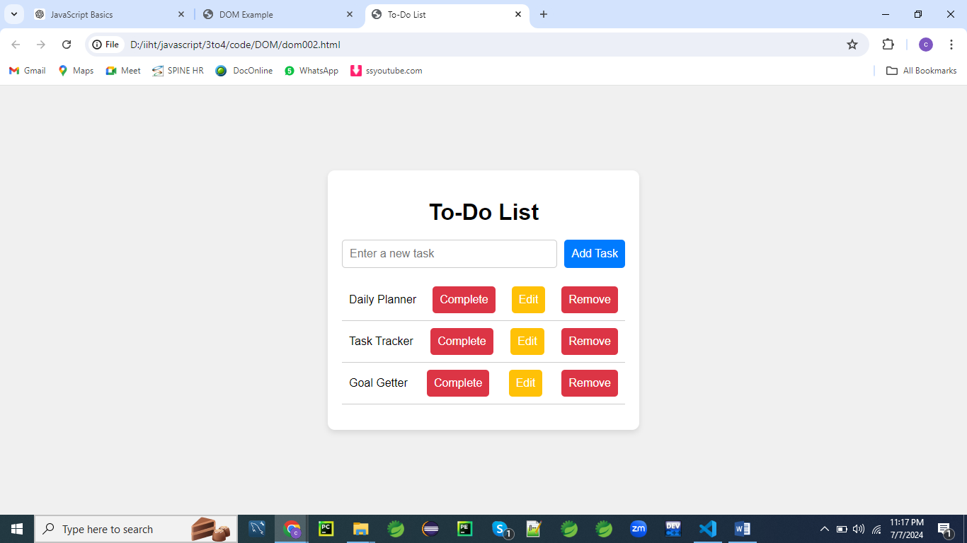

**HTML:**

<!DOCTYPE html>

<html lang="en">

<head>

<meta charset="UTF-8">

<meta name="viewport" content="width=device-width, initial-scale=1.0">

<title>To-Do List</title>

<link rel="stylesheet" href="styles002.css">

</head>

<body>

<div class="container">

<h1>To-Do List</h1>

<form id="taskForm">

<input type="text" id="taskInput" placeholder="Enter a new task" required>

<button type="submit">Add Task</button>

</form>

<ul id="taskList"></ul>

</div>

<script src="script002.js"></script>

</body>

</html>

**CSS (styles002.css):**

body {

font-family: 'Arial', sans-serif;

background: #f0f0f0;

margin: 0;

padding: 0;

display: flex;

justify-content: center;

align-items: center;

height: 100vh;

}

.container {

background: #ffffff;

padding: 20px;

border-radius: 10px;

box-shadow: 0 4px 8px rgba(0, 0, 0, 0.1);

max-width: 400px;

width: 100%;

}

h1 {

text-align: center;

margin-bottom: 20px;

}

form {

display: flex;

justify-content: space-between;

gap: 10px;

}

input[type="text"] {

flex-grow: 1;

padding: 10px;

border: 1px solid #ccc;

border-radius: 5px;

font-size: 16px;

}

button {

padding: 10px;

border: none;

border-radius: 5px;

background: #007BFF;

color: #ffffff;

cursor: pointer;

font-size: 16px;

}

button:hover {

background: #0056b3;

}

ul {

list-style-type: none;

padding: 0;

}

li {

display: flex;

justify-content: space-between;

align-items: center;

padding: 10px;

border-bottom: 1px solid #ccc;

}

li.completed {

text-decoration: line-through;

color: #888;

}

li button {

margin-left: 10px;

background: #dc3545;

}

li button.edit {

background: #ffc107;

}

li button:hover {

opacity: 0.8;

}

**JavaScript (script002.js):**

document.addEventListener('DOMContentLoaded', function() {

const taskForm = document.getElementById('taskForm');

const taskInput = document.getElementById('taskInput');

const taskList = document.getElementById('taskList');

let tasks = [];

let editIndex = null;

taskForm.addEventListener('submit', function(event) {

event.preventDefault();

const taskText = taskInput.value;

if (editIndex === null) {

addTask(taskText);

} else {

updateTask(editIndex, taskText);

}

taskForm.reset();

renderTasks();

});

function addTask(text) {

const newTask = { text, completed: false };

tasks.push(newTask);

}

function updateTask(index, text) {

tasks[index].text = text;

editIndex = null;

document.querySelector('button[type="submit"]').textContent = 'Add Task';

}

function renderTasks() {

taskList.innerHTML = '';

tasks.forEach((task, index) => {

const li = document.createElement('li');

li.textContent = task.text;

if (task.completed) {

li.classList.add('completed');

}

const completeButton = document.createElement('button');

completeButton.textContent = 'Complete';

completeButton.onclick = () => toggleCompleteTask(index);

const editButton = document.createElement('button');

editButton.textContent = 'Edit';

editButton.className = 'edit';

editButton.onclick = () => {

editIndex = index;

taskInput.value = task.text;

document.querySelector('button[type="submit"]').textContent = 'Update Task';

};

const removeButton = document.createElement('button');

removeButton.textContent = 'Remove';

removeButton.onclick = () => {

removeTask(index);

renderTasks();

};

li.appendChild(completeButton);

li.appendChild(editButton);

li.appendChild(removeButton);

taskList.appendChild(li);

});

}

function toggleCompleteTask(index) {

tasks[index].completed = !tasks[index].completed;

renderTasks();

}

function removeTask(index) {

tasks.splice(index, 1);

}

});

**Explanation:**

* **HTML**:
  + The HTML structure consists of a container with a form for adding tasks and an unordered list to display the tasks.
* **CSS**:
  + The CSS styles the page, giving it a centered layout with a card-like container, input field styling, button styling, and list item styling.
  + It also defines styles for completed tasks.
* **JavaScript**:
  + The JavaScript code manages the task list.
  + It sets up event listeners for form submission, task completion, task editing, and task removal.
  + The addTask, updateTask, renderTasks, toggleCompleteTask, and removeTask functions handle the core logic of adding, updating, rendering, completing, and removing tasks.

This example covers a broad range of DOM manipulation techniques and provides a functional to-do list application.

**Example 03**

Let's create an advanced example of a different kind of application that demonstrates the use of the DOM with HTML, CSS, and JavaScript.

This is about a simple library management system.

This will allow you to add, edit, delete, filter, and sort books.

Here are some sample book entries that you can use with the library management system:

Moby Dick, Herman Melville, 11-14-1851, Adventure

Pride and Prejudice, Jane Austen, 01-28-1813, Romance

1984, George Orwell, 06-08-1949, Dystopian Fiction

To Kill a Mockingbird, Harper Lee, 07-11-1960, Fiction

The Great Gatsby, F. Scott Fitzgerald, 04-10-1925, Literary Fiction

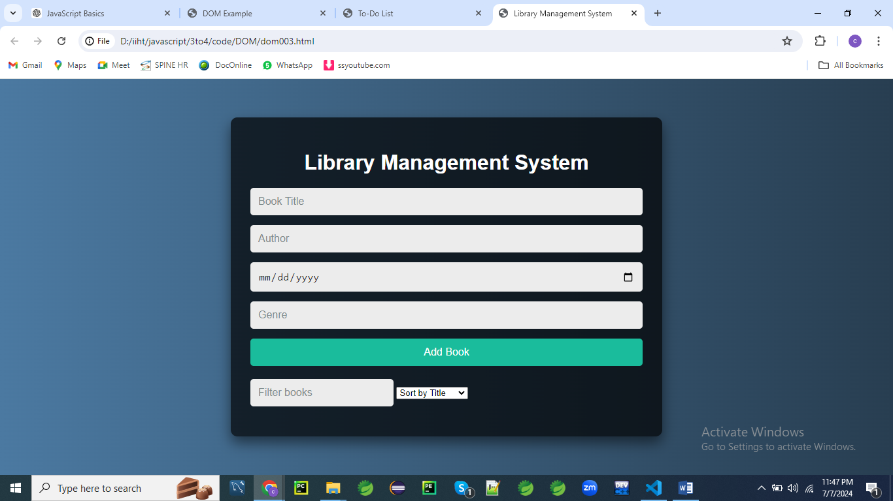

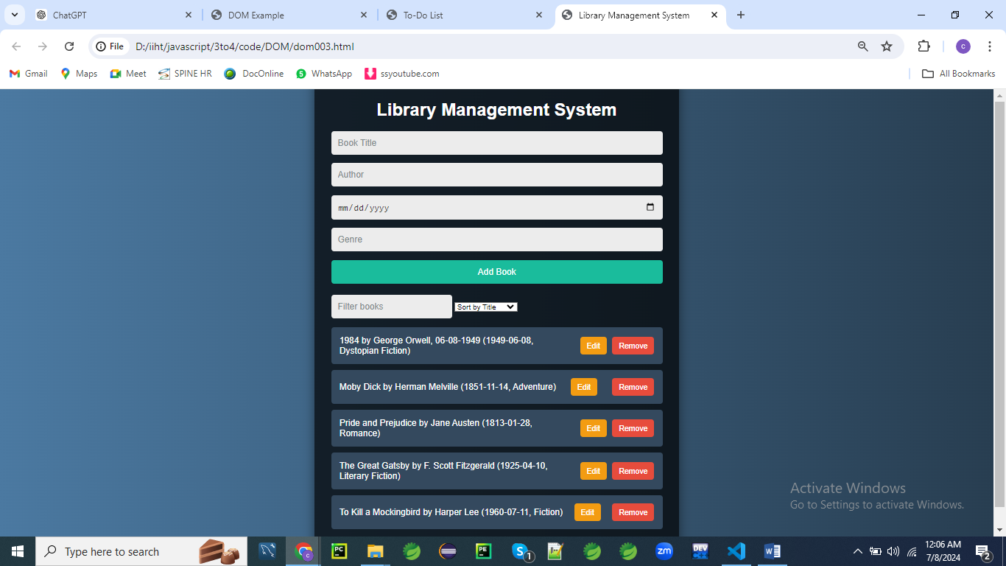

**Filter : To**

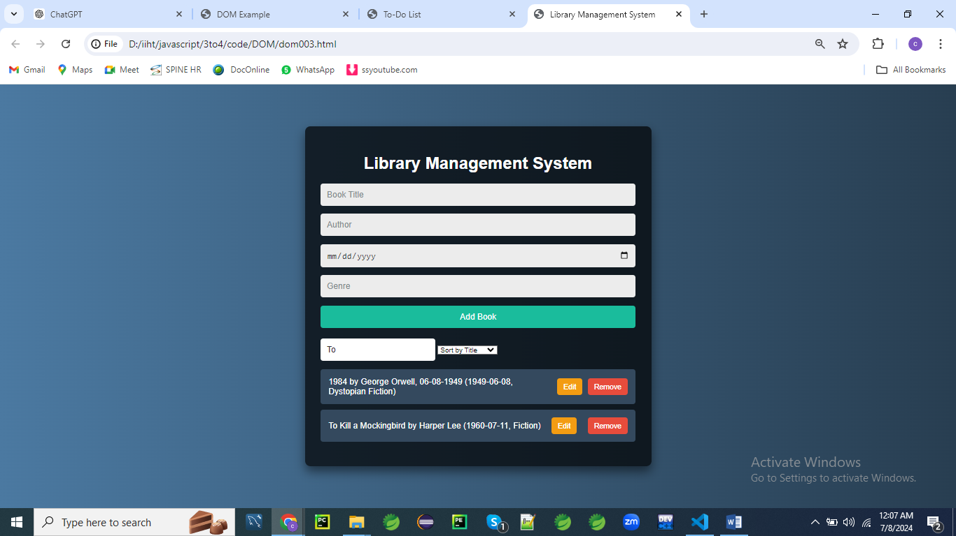

**Sort By Author**

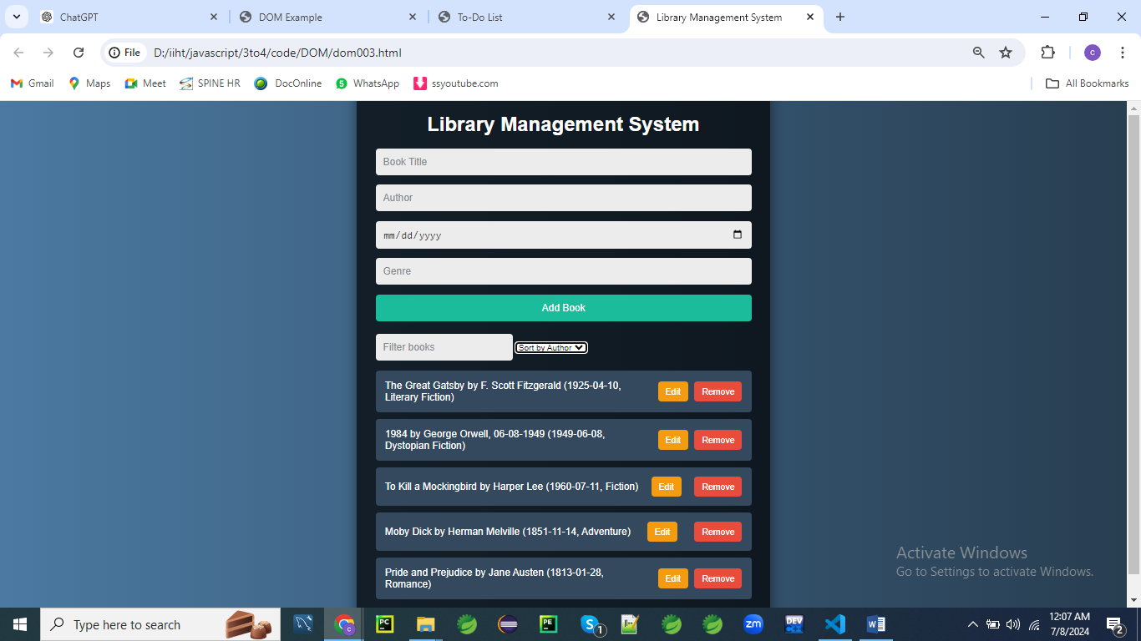

**Sort By Date**

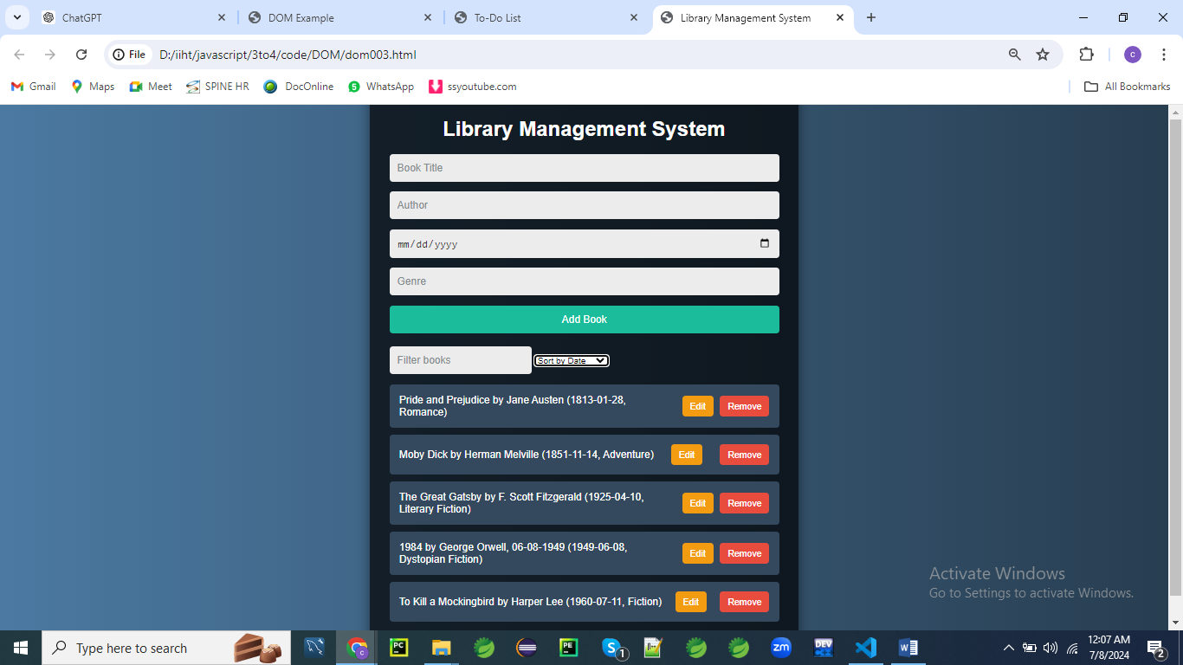

**HTML**

<!DOCTYPE html>

<html lang="en">

<head>

<meta charset="UTF-8">

<meta name="viewport" content="width=device-width, initial-scale=1.0">

<title>Library Management System</title>

<link rel="stylesheet" href="styles003.css">

</head>

<body>

<div class="container">

<h1>Library Management System</h1>

<form id="bookForm">

<input type="text" id="titleInput" placeholder="Book Title" required>

<input type="text" id="authorInput" placeholder="Author" required>

<input type="date" id="dateInput">

<input type="text" id="genreInput" placeholder="Genre">

<button type="submit">Add Book</button>

</form>

<input type="text" id="filterInput" placeholder="Filter books">

<select id="sortOptions">

<option value="title">Sort by Title</option>

<option value="author">Sort by Author</option>

<option value="date">Sort by Date</option>

</select>

<ul id="bookList"></ul>

</div>

<script src="script003.js"></script>

</body>

</html>

**CSS (styles003.css)**

body {

font-family: 'Arial', sans-serif;

background: #f0f0f0;

color: #333;

margin: 0;

padding: 0;

display: flex;

justify-content: center;

align-items: center;

height: 100vh;

}

.container {

background: #fff;

padding: 20px;

border-radius: 10px;

box-shadow: 0 4px 8px rgba(0, 0, 0, 0.1);

max-width: 600px;

width: 100%;

}

h1 {

text-align: center;

color: #333;

margin-bottom: 20px;

}

form {

display: flex;

flex-direction: column;

gap: 10px;

margin-bottom: 20px;

}

input[type="text"], input[type="date"] {

padding: 10px;

border: 1px solid #ddd;

border-radius: 5px;

outline: none;

font-size: 16px;

}

button {

padding: 10px;

border: none;

border-radius: 5px;

background: #007bff;

color: #fff;

cursor: pointer;

font-size: 16px;

}

button:hover {

background: #0056b3;

}

ul {

list-style-type: none;

padding: 0;

}

li {

padding: 10px;

margin: 5px 0;

background: #f8f9fa;

border: 1px solid #ddd;

border-radius: 5px;

display: flex;

justify-content: space-between;

align-items: center;

}

.edit, .remove {

margin-left: 10px;

padding: 5px 10px;

border: none;

border-radius: 5px;

cursor: pointer;

}

.edit {

background: #ffc107;

color: #fff;

}

.remove {

background: #dc3545;

color: #fff;

}

.edit:hover {

background: #e0a800;

}

.remove:hover {

background: #c82333;

}

**JavaScript (script003.js)**

document.addEventListener('DOMContentLoaded', function() {

const bookForm = document.getElementById('bookForm');

const bookList = document.getElementById('bookList');

const filterInput = document.getElementById('filterInput');

const sortOptions = document.getElementById('sortOptions');

let books = [];

let editIndex = null;

bookForm.addEventListener('submit', function(event) {

event.preventDefault();

const title = document.getElementById('titleInput').value;

const author = document.getElementById('authorInput').value;

const date = document.getElementById('dateInput').value;

const genre = document.getElementById('genreInput').value;

if (editIndex === null) {

addBook(title, author, date, genre);

} else {

updateBook(editIndex, title, author, date, genre);

}

bookForm.reset();

renderBooks();

});

filterInput.addEventListener('input', function() {

renderBooks();

});

sortOptions.addEventListener('change', function() {

renderBooks();

});

function addBook(title, author, date, genre) {

const newBook = { title, author, date, genre };

books.push(newBook);

}

function updateBook(index, title, author, date, genre) {

books[index] = { title, author, date, genre };

editIndex = null;

document.querySelector('button[type="submit"]').style.display = 'block';

}

function renderBooks() {

const filterText = filterInput.value.toLowerCase();

const sortBy = sortOptions.value;

const sortedBooks = [...books].sort((a, b) => {

if (a[sortBy] < b[sortBy]) return -1;

if (a[sortBy] > b[sortBy]) return 1;

return 0;

});

bookList.innerHTML = '';

sortedBooks.forEach((book, index) => {

if (book.title.toLowerCase().includes(filterText) || book.author.toLowerCase().includes(filterText) || book.genre.toLowerCase().includes(filterText)) {

const li = document.createElement('li');

li.textContent = `${book.title} by ${book.author} (${book.date}, ${book.genre})`;

const editButton = document.createElement('button');

editButton.textContent = 'Edit';

editButton.className = 'edit';

editButton.onclick = () => {

editIndex = index;

document.getElementById('titleInput').value = book.title;

document.getElementById('authorInput').value = book.author;

document.getElementById('dateInput').value = book.date;

document.getElementById('genreInput').value = book.genre;

document.querySelector('button[type="submit"]').style.display = 'none';

};

const removeButton = document.createElement('button');

removeButton.textContent = 'Remove';

removeButton.className = 'remove';

removeButton.onclick = () => {

removeBook(index);

};

li.appendChild(editButton);

li.appendChild(removeButton);

bookList.appendChild(li);

}

});

}

function removeBook(index) {

books.splice(index, 1);

renderBooks();

}

});

This example demonstrates a fully functional library management system with extensive DOM manipulation, event handling, and form handling in JavaScript.

**Explanation:**

This JavaScript code sets up a simple book management application that allows users to add, edit, remove, filter, and sort books dynamically. Let's break down each part:

**Event Listeners and Initialization**

**document.addEventListener('DOMContentLoaded', function() {**

**const bookForm = document.getElementById('bookForm');**

**const bookList = document.getElementById('bookList');**

**const filterInput = document.getElementById('filterInput');**

**const sortOptions = document.getElementById('sortOptions');**

**let books = [];**

**let editIndex = null;**

* **DOMContentLoaded Event**: This ensures that the JavaScript executes only after the HTML document has been fully loaded.
* **Variables**:
  + bookForm, bookList, filterInput, and sortOptions are references to various HTML elements:
    - bookForm represents the form where users can add or edit books.
    - bookList is the <ul> element where the list of books will be displayed.
    - filterInput is an input field where users can type to filter books by title, author, or genre.
    - sortOptions is a <select> element allowing users to choose how to sort the books (by title, author, date, or genre).
  + books is an array that will store objects representing each book's details (title, author, date, genre).
  + editIndex keeps track of the index of the book being edited, initialized to null indicating no book is currently being edited.

**Form Submission Handling**

**bookForm.addEventListener('submit', function(event) {**

**event.preventDefault();**

**const title = document.getElementById('titleInput').value;**

**const author = document.getElementById('authorInput').value;**

**const date = document.getElementById('dateInput').value;**

**const genre = document.getElementById('genreInput').value;**

**if (editIndex === null) {**

**addBook(title, author, date, genre);**

**} else {**

**updateBook(editIndex, title, author, date, genre);**

**}**

**bookForm.reset();**

**renderBooks();**

**});**

* **Form Submission**: When the bookForm is submitted:
  + event.preventDefault() prevents the default form submission behavior.
  + It retrieves the values entered for title, author, date, and genre.
  + If editIndex is null, it calls addBook() to add a new book to the books array. Otherwise, it calls updateBook() to update the existing book at editIndex.
  + The form is reset (bookForm.reset()) and renderBooks() is called to update the displayed list of books.

**Filtering and Sorting**

**filterInput.addEventListener('input', function() {**

**renderBooks();**

**});**

**sortOptions.addEventListener('change', function() {**

**renderBooks();**

**});**

* **Filtering**: Whenever the filterInput value changes (input event) or the sortOptions selection changes (change event):
  + It triggers renderBooks() to update the displayed list of books based on the current filter text (filterText) and sorting option (sortBy).

**Helper Functions**

**function addBook(title, author, date, genre) {**

**const newBook = { title, author, date, genre };**

**books.push(newBook);**

**}**

**function updateBook(index, title, author, date, genre) {**

**books[index] = { title, author, date, genre };**

**editIndex = null;**

**document.querySelector('button[type="submit"]').style.display = 'block';**

**}**

**function renderBooks() {**

**const filterText = filterInput.value.toLowerCase();**

**const sortBy = sortOptions.value;**

**const sortedBooks = [...books].sort((a, b) => {**

**if (a[sortBy] < b[sortBy]) return -1;**

**if (a[sortBy] > b[sortBy]) return 1;**

**return 0;**

**});**

**bookList.innerHTML = '';**

**sortedBooks.forEach((book, index) => {**

**if (book.title.toLowerCase().includes(filterText) || book.author.toLowerCase().includes(filterText) || book.genre.toLowerCase().includes(filterText)) {**

**const li = document.createElement('li');**

**li.textContent = `${book.title} by ${book.author} (${book.date}, ${book.genre})`;**

**const editButton = document.createElement('button');**

**editButton.textContent = 'Edit';**

**editButton.className = 'edit';**

**editButton.onclick = () => {**

**editIndex = index;**

**document.getElementById('titleInput').value = book.title;**

**document.getElementById('authorInput').value = book.author;**

**document.getElementById('dateInput').value = book.date;**

**document.getElementById('genreInput').value = book.genre;**

**document.querySelector('button[type="submit"]').style.display = 'none';**

**};**

**const removeButton = document.createElement('button');**

**removeButton.textContent = 'Remove';**

**removeButton.className = 'remove';**

**removeButton.onclick = () => {**

**removeBook(index);**

**};**

**li.appendChild(editButton);**

**li.appendChild(removeButton);**

**bookList.appendChild(li);**

**}**

**});**

**}**

**function removeBook(index) {**

**books.splice(index, 1);**

**renderBooks();**

**}**

**});**

* **Helper Functions**:
  + addBook(title, author, date, genre): Creates a new book object and pushes it into the books array.
  + updateBook(index, title, author, date, genre): Updates the book at index in the books array with new values. Resets editIndex to null and displays the submit button (button[type="submit"]).
  + renderBooks(): Updates the bookList based on the current filter and sort options:
    - filterText retrieves the lowercase filter text from filterInput.
    - sortBy retrieves the current sorting option from sortOptions.
    - sortedBooks is a sorted copy of books based on the chosen sorting option.
    - Clears bookList (bookList.innerHTML = '') and iterates over sortedBooks. For each book:
      * Checks if title, author, or genre contains filterText.
      * Creates an <li> element displaying book details, including edit and remove buttons.
      * Edit button (editButton.onclick) sets up the form fields for editing the selected book.
      * Remove button (removeButton.onclick) removes the selected book from books and updates the display.
  + removeBook(index): Removes the book at index from books, then calls renderBooks() to update the displayed list.

**Summary**

This script creates a dynamic book management system where users can add, edit, and remove books. Books are displayed in a list that can be filtered and sorted based on user input. The code leverages event listeners, array manipulation, DOM manipulation, and sorting algorithms to achieve its functionality.

**Example 04:**

Let's create a different example that showcases a more generic use case involving a list of items with checkboxes to mark them as done.

This example will still use HTML, CSS, and JavaScript but will focus on a simple list management system.

Here are some sample items you can use to add to the "List Manager" form:

1. **Grocery Shopping**

Milk

Bread

Eggs

Butter

Cheese

1. **Work Tasks**

Finish report

Send emails

Schedule meeting

Review project plan

Update client on progress

1. **Household Chores**

Vacuum the living room

Wash dishes

Laundry

Clean bathroom

Take out the trash

1. **Personal Goals**

Read a book

Exercise

Meditate

Learn a new skill

Journal

1. **Event Planning**

Create guest list

Send invitations

Plan menu

Arrange decorations

Confirm venue

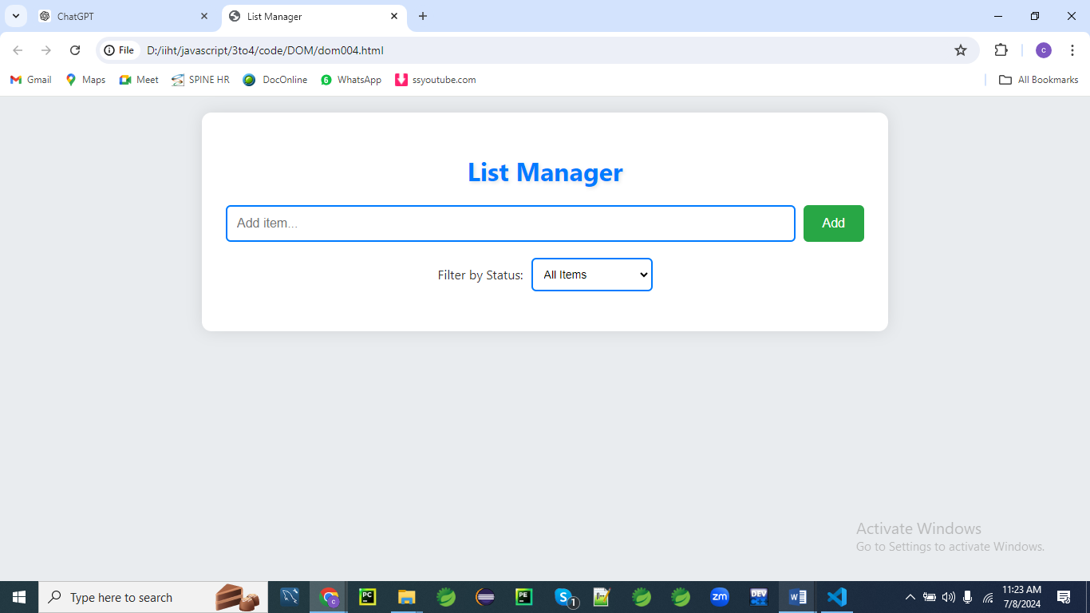

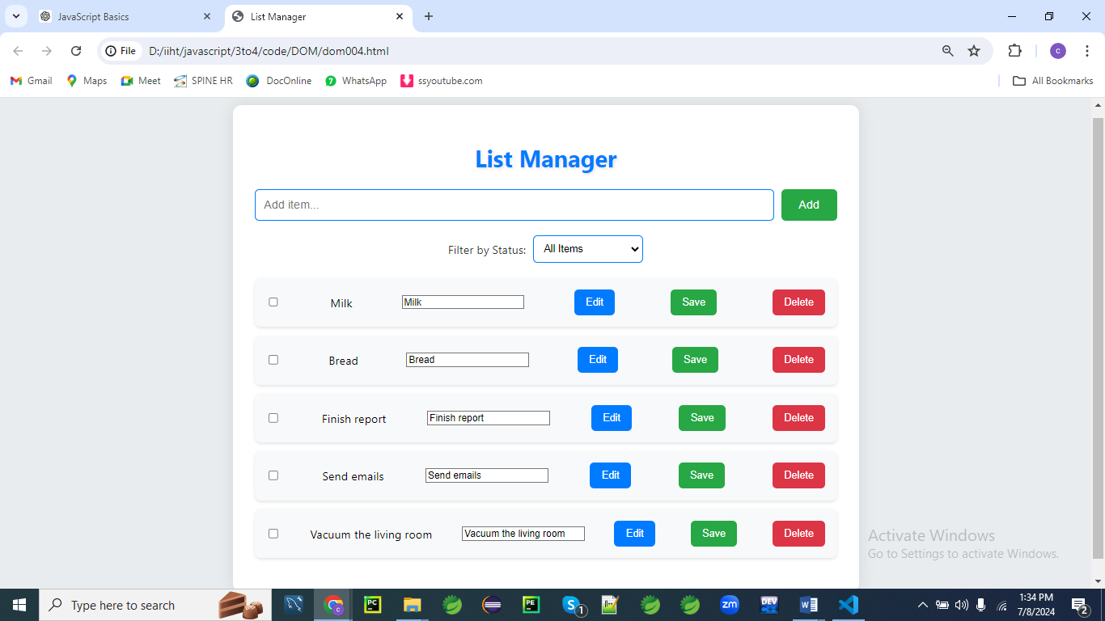

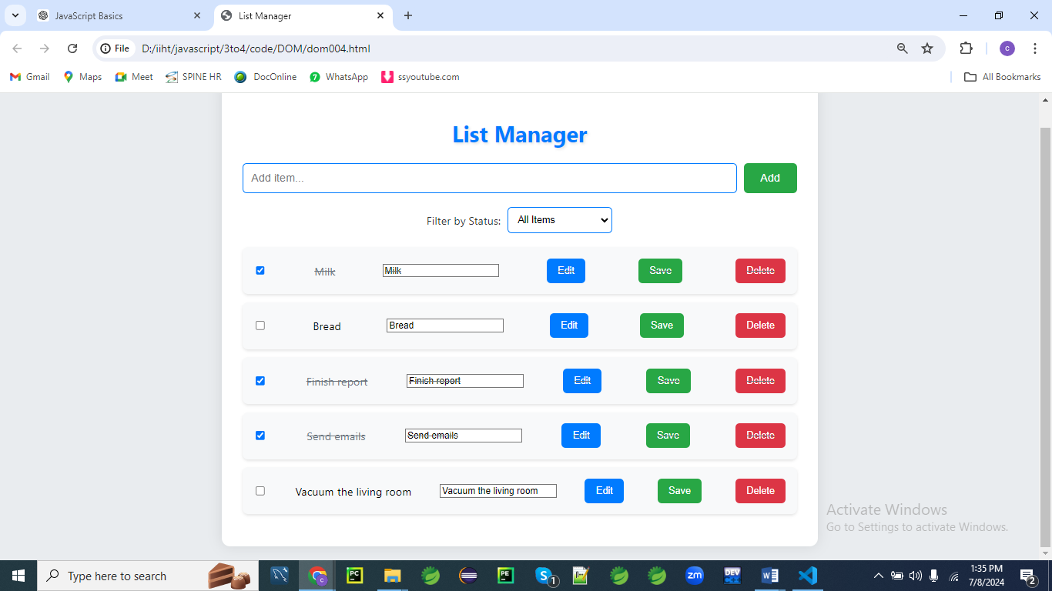

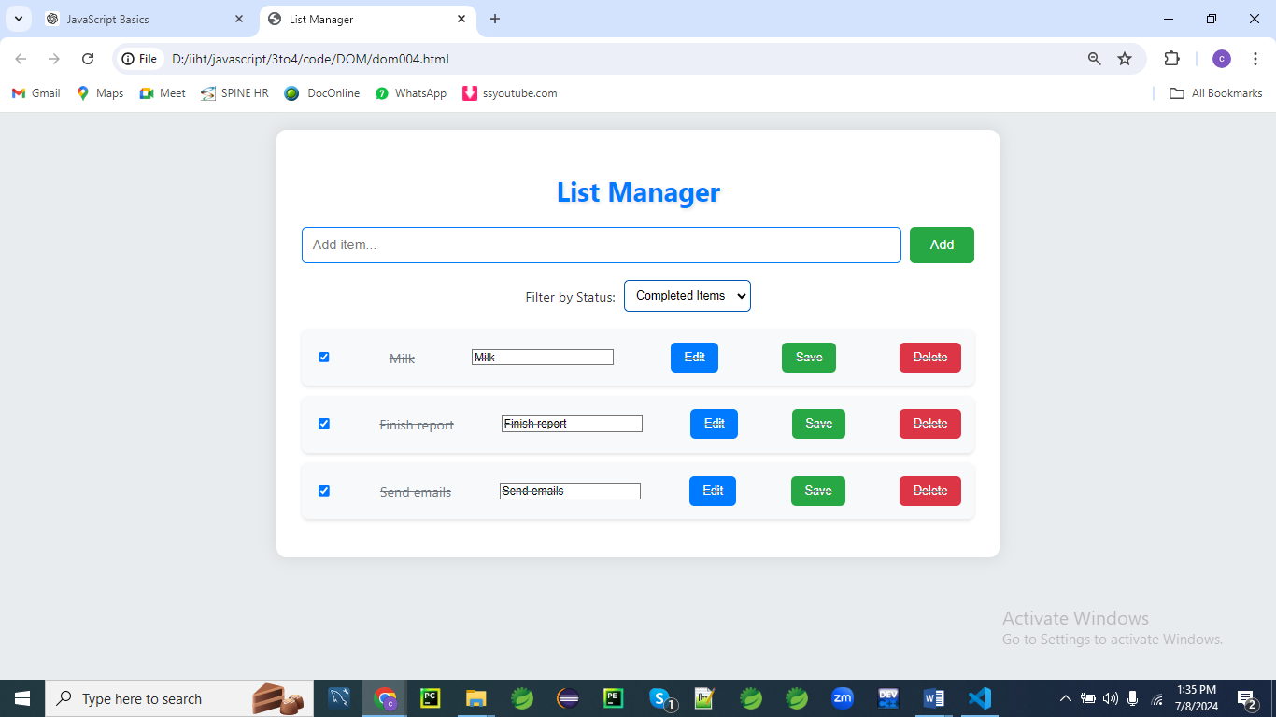

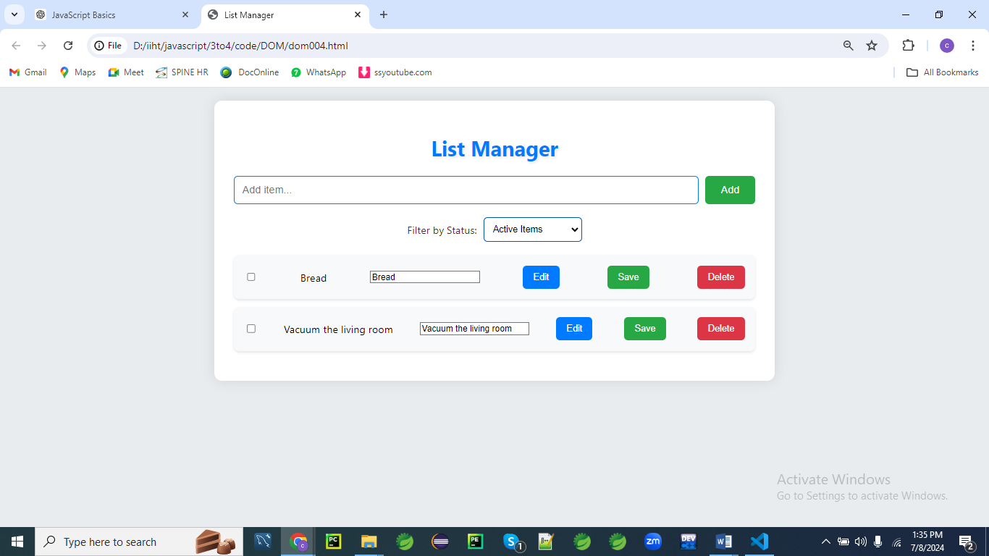

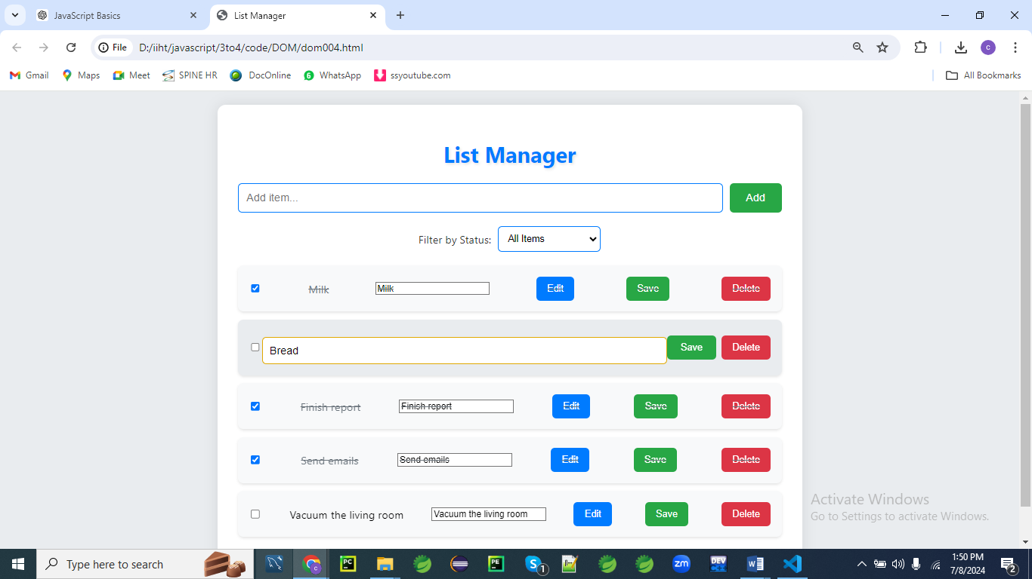

**After deleting last item in the list**

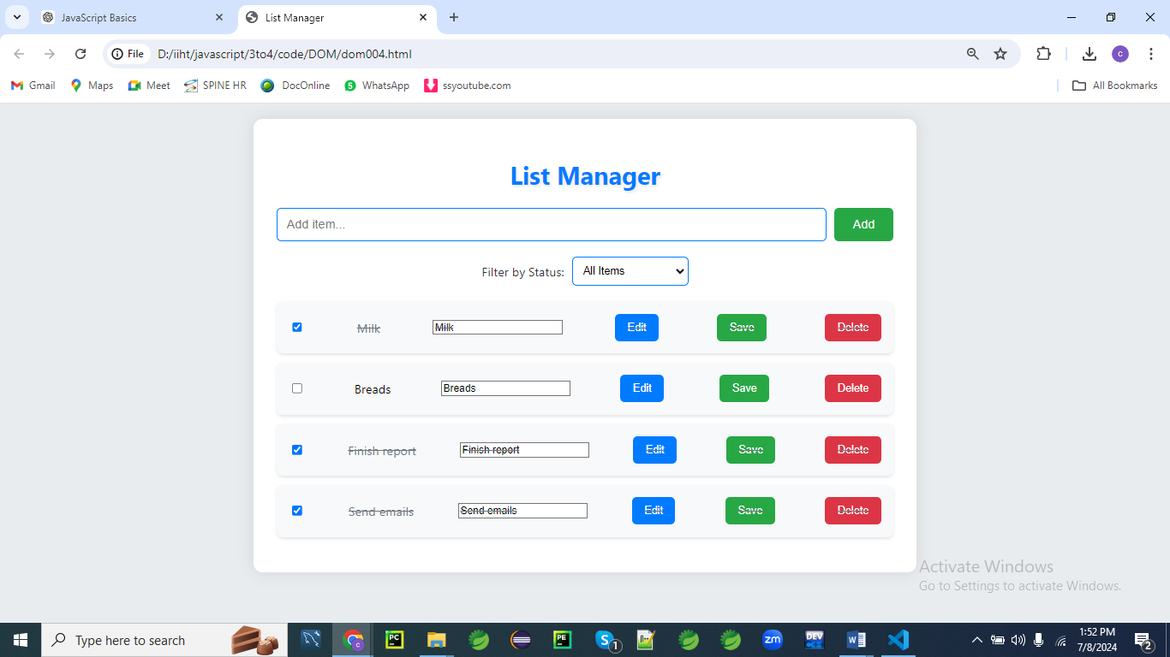

**HTML (index.html)**

<!DOCTYPE html>

<html lang="en">

<head>

<meta charset="UTF-8">

<meta name="viewport" content="width=device-width, initial-scale=1.0">

<title>List Manager</title>

<link rel="stylesheet" href="styles004.css">

</head>

<body>

<div class="container">

<h1>List Manager</h1>

<form id="itemForm" class="item-form">

<input type="text" id="itemInput" placeholder="Add item...">

<button type="submit">Add</button>

</form>

<div class="filters">

<label>Filter by Status:</label>

<select id="filterSelect">

<option value="all">All Items</option>

<option value="active">Active Items</option>

<option value="completed">Completed Items</option>

</select>

</div>

<ul id="itemList" class="item-list">

<!-- Items will be dynamically added here -->

</ul>

</div>

<script src="script004.js"></script>

</body>

</html>

**CSS (styles004.css)**

/* General styling */

body {

font-family: Arial, sans-serif;

background-color: #f0f0f0;

margin: 0;

padding: 0;

}

.container {

max-width: 600px;

margin: 20px auto;

background-color: #fff;

padding: 20px;

border-radius: 8px;

box-shadow: 0 0 10px rgba(0,0,0,0.1);

}

h1 {

text-align: center;

color: #333;

}

/* Form styling */

.item-form {

display: flex;

margin-bottom: 20px;

}

.item-form input[type="text"] {

flex: 1;

padding: 10px;

font-size: 16px;

border: 1px solid #ddd;

border-radius: 4px;

margin-right: 10px;

}

.item-form button[type="submit"] {

padding: 10px 20px;

font-size: 16px;

background-color: #007bff;

color: #fff;

border: none;

border-radius: 4px;

cursor: pointer;

}

/* Filters styling */

.filters {

margin-bottom: 20px;

display: flex;

align-items: center;

}

.filters label {

margin-right: 10px;

}

.filters select {

padding: 8px;

font-size: 14px;

border: 1px solid #ddd;

border-radius: 4px;

}

/* List styling */

.item-list {

list-style-type: none;

padding: 0;

}

.item {

display: flex;

align-items: center;

justify-content: space-between;

padding: 10px;

border-bottom: 1px solid #ddd;

}

.item:last-child {

border-bottom: none;

}

.item.completed {

text-decoration: line-through;

color: #aaa;

}

/* Editing mode styling */

.editing input[type="text"] {

display: block;

}

.editing span {

display: none;

}

.editing button.edit-btn {

display: none;

}

.editing button.save-btn {

display: inline-block;

}

/* Button styling */

.item button {

padding: 8px 12px;

font-size: 14px;

border: none;

border-radius: 4px;

cursor: pointer;

}

.item button.edit-btn {

background-color: #ffc107;

color: #333;

margin-right: 5px;

}

.item button.save-btn {

background-color: #28a745;

color: #fff;

margin-right: 5px;

}

.item button.delete-btn {

background-color: #dc3545;

color: #fff;

}

**General Styling**

**body**

**body {**

**font-family: Arial, sans-serif;**

**background-color: #f0f0f0;**

**margin: 0;**

**padding: 0;**

**}**

1. **font-family: Arial, sans-serif;**
   * **Sets the font for the entire page.** Arial is a sans-serif font, and sans-serif is a fallback if Arial isn't available.
   * **Ensures consistency in text appearance.** Applies a modern and clean typeface across the body.
   * **Improves readability.** Arial is easy to read, which contributes to a user-friendly interface.
   * **Establishes a base font style.** Ensures that text throughout the page has a consistent look.
   * **Affects all text content.** Applies to all elements within the body unless overridden by more specific rules.
2. **background-color: #f0f0f0;**
   * **Sets the background color of the body.** A light gray (#f0f0f0) creates a subtle, neutral background.
   * **Enhances readability.** A light background provides good contrast for text and other elements.
   * **Adds visual softness.** A light gray background reduces strain on the eyes compared to pure white.
   * **Provides a clean look.** A neutral background ensures that other design elements stand out.
   * **Serves as a base for other elements.** Creates a consistent backdrop for the entire page.
3. **margin: 0;**
   * **Removes default margin around the body.** Ensures that the body content extends to the edges of the viewport.
   * **Eliminates unwanted spacing.** Starts with no extra space around the body, providing a clean layout.
   * **Helps in creating a uniform design.** Ensures that no additional margin affects the overall layout.
   * **Allows precise control of spacing.** Prevents default margins from interfering with custom spacing rules.
   * **Creates a predictable layout environment.** Helps in achieving consistent visual results.
4. **padding: 0;**
   * **Removes default padding inside the body.** Ensures content starts at the edge of the body without extra internal space.
   * **Ensures full use of viewport space.** Prevents padding from affecting the layout and spacing of content.
   * **Creates a clean design canvas.** Allows precise control over padding and layout of other elements.
   * **Prevents default padding interference.** Ensures that other padding rules are applied as intended.
   * **Provides a uniform starting point.** Helps in achieving consistent and controlled design.

**Container**

**.container {**

**max-width: 600px;**

**margin: 20px auto;**

**background-color: #fff;**

**padding: 20px;**

**border-radius: 8px;**

**box-shadow: 0 0 10px rgba(0,0,0,0.1);**

**}**

1. **max-width: 600px;**
   * **Sets the maximum width of the container.** Limits the width to 600 pixels to prevent it from becoming too wide on larger screens.
   * **Ensures readability.** Keeps content at a comfortable width for reading.
   * **Provides a responsive layout.** The container will shrink below 600px on smaller screens but won’t exceed this width on larger screens.
   * **Maintains design consistency.** Helps in keeping content areas uniformly sized.
   * **Enhances user experience.** Prevents overly stretched content that can be hard to read.
2. **margin: 20px auto;**
   * **Centers the container horizontally.** The auto value for left and right margins centers the container within its parent element.
   * **Adds vertical spacing.** The 20px margin adds space above and below the container.
   * **Improves visual balance.** Centers the content and provides consistent spacing from surrounding elements.
   * **Creates a visually appealing layout.** Adds margin to separate the container from other elements or the viewport edges.
   * **Provides a clean, centered look.** Enhances the overall layout aesthetics.
3. **background-color: #fff;**
   * **Sets the background color to white.** Provides a clean and bright backdrop for the container.
   * **Enhances readability.** A white background creates a high contrast with text and other content.
   * **Ensures a clean look.** A plain white background helps in maintaining a minimalistic design.
   * **Highlights the container's content.** Distinguishes the container from the rest of the page’s background.
   * **Provides a neutral color.** A white background is versatile and complements various design styles.
4. **padding: 20px;**
   * **Adds 20 pixels of padding inside the container.** Creates space between the container's content and its edges.
   * **Improves readability.** Ensures that content is not cramped against the container’s borders.
   * **Enhances visual appeal.** Adds internal space that makes the content look more organized.
   * **Part of the box model.** Padding affects the total size of the container when combined with margins and borders.
   * **Provides a balanced layout.** Ensures that content has enough breathing room inside the container.
5. **border-radius: 8px;**
   * **Rounds the corners of the container.** Applies an 8-pixel radius to each corner, creating a soft, rounded look.
   * **Enhances visual appeal.** Rounded corners can make the design appear more modern and approachable.
   * **Softens the container’s appearance.** Creates a contrast with sharp-cornered elements.
   * **Part of the box model.** Affects the visual shape of the container, without altering its size.
   * **Improves user experience.** Rounded corners can contribute to a more aesthetically pleasing interface.
6. **box-shadow: 0 0 10px rgba(0,0,0,0.1);**
   * **Adds a subtle shadow around the container.** Creates a shadow with a 10-pixel blur radius and a 10% opacity.
   * **Provides depth and separation.** The shadow makes the container stand out against the background.
   * **Improves visual hierarchy.** Adds a sense of layering to the design.
   * **Enhances overall aesthetics.** The subtle shadow adds a polished look to the container.
   * **Maintains a clean design.** A soft shadow ensures that the effect is not too overpowering.

**Heading**

**h1 {**

**text-align: center;**

**color: #333;**

**}**

1. **text-align: center;**
   * **Centers the heading text horizontally.** Aligns the text to the center of its container.
   * **Creates a balanced look.** Center alignment can be visually appealing and makes headings stand out.
   * **Useful for page titles.** Centers the main heading to draw attention.
   * **Affects all h1 elements.** Ensures uniform alignment for all headings of this level.
   * **Enhances readability.** Centered text can be easier to focus on for important titles.
2. **color: #333;**
   * **Sets the text color to a dark gray.** #333 is a near-black shade that provides high contrast against light backgrounds.
   * **Improves readability.** Dark gray is easier on the eyes than pure black and is good for long reading.
   * **Ensures consistency.** The color applies to all h1 headings, providing a uniform look.
   * **Creates a clear focal point.** Darker text helps headings stand out.
   * **Matches the design theme.** Dark gray is often used for a professional and clean appearance.

**Form Styling**

**.item-form {**

**display: flex;**

**margin-bottom: 20px;**

**}**

1. **display: flex;**
   * **Enables flexbox layout for the form.** Flexbox allows for flexible alignment and distribution of child elements.
   * **Aligns form elements horizontally.** Places input fields and buttons in a row.
   * **Improves layout control.** Flexbox provides more control over the spacing and alignment of elements.
   * **Simplifies responsive design.** Flexbox can easily adapt to different screen sizes.
   * **Ensures a clean and organized appearance.** Flex layout helps in aligning elements consistently.
2. **margin-bottom: 20px;**
   * **Adds space below the form.** Creates a 20-pixel gap between the form and elements below it.
   * **Improves spacing.** Prevents elements from being too close together, enhancing readability and layout.
   * **Maintains visual balance.** Provides consistent spacing throughout the form section.
   * **Enhances overall design.** Adds margin for a clean and separated look.
   * **Contributes to a well-organized layout.** Keeps form elements from overlapping or appearing cluttered.

**.item-form input[type="text"]**

**.item-form input[type="text"] {**

**flex: 1;**

**padding: 10px;**

**font-size: 16px;**

**border: 1px solid #ddd;**

**border-radius: 4px;**

**margin-right: 10px;**

**}**

1. **flex: 1;**
   * **Allows the input field to grow and fill available space.** Makes the input field flexible and responsive.
   * **Distributes space evenly.** Ensures the input field uses available space effectively.
   * **Improves layout consistency.** Allows for a uniform size among input fields.
   * **Facilitates responsive design.** Adjusts size based on container width.
   * **Enhances user experience.** Provides a comfortable amount of space for text input.
2. **padding: 10px;**
   * **Adds internal space within the input field.** Creates 10 pixels of padding inside the field.
   * **Improves readability.** Ensures text doesn’t touch the edges of the input field.
   * **Enhances usability.** Provides a more comfortable area for typing.
   * **Affects input field’s appearance.** Makes the field look more spacious and user-friendly.
   * **Part of the box model.** Padding contributes to the total size of the input field.
3. **font-size: 16px;**
   * **Sets the font size for the input text.** Ensures that text within the input field is 16 pixels high.
   * **Improves readability.** A larger font size is easier to read and interact with.
   * **Ensures consistency.** Applies a uniform text size for all input fields.
   * **Affects overall input appearance.** Provides a comfortable size for user input.
   * **Facilitates user interaction.** Larger text improves usability and reduces strain.
4. **border: 1px solid #ddd;**
   * **Adds a 1-pixel solid border around the input field.** The border color #ddd is a light gray.
   * **Defines the input field's edges.** Provides a subtle outline that differentiates it from other elements.
   * **Enhances visual clarity.** A light gray border is less intrusive but still noticeable.
   * **Improves design aesthetics.** Creates a clean and subtle border effect.
   * **Part of the box model.** The border is included in the total size of the input field.
5. **border-radius: 4px;**
   * **Rounds the corners of the input field.** Applies a 4-pixel radius to each corner.
   * **Enhances the visual appeal.** Rounded corners create a softer look compared to sharp corners.
   * **Contributes to a modern design.** Rounded edges are often used in contemporary user interfaces.
   * **Improves the user experience.** Creates a more approachable and less harsh appearance.
   * **Part of the box model.** Affects the visual shape without changing the input field's size.
6. **margin-right: 10px;**
   * **Adds space to the right of the input field.** Creates a 10-pixel gap between the input field and any element to its right.
   * **Prevents overlapping.** Ensures that elements do not crowd each other.
   * **Improves layout spacing.** Adds visual separation between form elements.
   * **Maintains consistent alignment.** Helps in aligning multiple form elements evenly.
   * **Enhances the overall design.** Provides a clean and organized appearance.

**.item-form button[type="submit"]**

**.item-form button[type="submit"] {**

**padding: 10px 20px;**

**font-size: 16px;**

**background-color: #007bff;**

**color: #fff;**

**border: none;**

**border-radius: 4px;**

**cursor: pointer;**

**}**

1. **padding: 10px 20px;**
   * **Adds padding inside the submit button.** Creates 10 pixels of padding on top and bottom, and 20 pixels on left and right.
   * **Improves button appearance.** Provides ample space for the button text and enhances visual appeal.
   * **Enhances user interaction.** Creates a larger clickable area for better usability.
   * **Contributes to a balanced design.** Ensures that the button looks well-proportioned.
   * **Part of the box model.** Padding affects the total size of the button.
2. **font-size: 16px;**
   * **Sets the font size for button text.** Ensures that text within the button is 16 pixels high.
   * **Improves readability.** Larger text is easier to read and click on.
   * **Ensures consistency.** Applies a uniform text size to the button.
   * **Enhances visual impact.** A clear and legible font size makes the button more noticeable.
   * **Facilitates user interaction.** Makes the button text easier to see and interact with.
3. **background-color: #007bff;**
   * **Sets the background color of the submit button.** #007bff is a bright blue color.
   * **Enhances visibility.** A bright blue color makes the button stand out.
   * **Creates a call-to-action effect.** The color draws attention and encourages interaction.
   * **Maintains a clean look.** The button color contrasts well with the text color.
   * **Contributes to a consistent design.** Blue is often used for action buttons, creating a recognizable pattern.
4. **color: #fff;**
   * **Sets the text color of the button to white.** Provides high contrast with the blue background.
   * **Improves readability.** White text is easy to read against a dark background.
   * **Ensures consistency.** Applies a uniform text color to all buttons with this style.
   * **Enhances design clarity.** White text on a colored background is a common and effective design choice.
   * **Contributes to a clean look.** White text contrasts well with the button's background color.
5. **border: none;**
   * **Removes the default border from the button.** Ensures that the button has a clean, borderless appearance.
   * **Enhances visual design.** A borderless button often looks more modern and sleek.
   * **Provides a consistent look.** Removes any default styling that might interfere with the design.
   * **Prevents unwanted borders.** Ensures that no additional border styles are applied.
   * **Part of a polished design.** Helps achieve a clean and contemporary button appearance.
6. **border-radius: 4px;**
   * **Rounds the corners of the button.** Applies a 4-pixel radius to each corner for a softer look.
   * **Enhances visual appeal.** Rounded corners make the button appear more approachable.
   * **Contributes to modern design.** Rounded edges are a common design choice for interactive elements.
   * **Improves user experience.** Creates a more visually pleasing button.
   * **Part of the button’s box model.** Affects the visual shape without altering the button’s size.
7. **cursor: pointer;**
   * **Changes the cursor to a pointer when hovering over the button.** Indicates that the button is clickable.
   * **Improves user interaction.** Provides a clear visual cue that the button is interactive.
   * **Enhances usability.** Helps users understand that the element can be clicked.
   * **Consistent with common design practices.** A pointer cursor is widely used for buttons and links.
   * **Contributes to a better user experience.** Makes interactive elements more intuitive.

**Filters Styling**

**.filters**

**.filters {**

**margin-bottom: 20px;**

**display: flex;**

**align-items: center;**

**}**

1. **margin-bottom: 20px;**
   * **Adds space below the filters section.** Creates a 20-pixel gap between the filters and elements below.
   * **Improves layout spacing.** Keeps the filters section visually separated from other elements.
   * **Maintains design consistency.** Provides uniform spacing for better visual balance.
   * **Enhances readability.** Prevents the filters section from crowding other content.
   * **Contributes to an organized layout.** Ensures clear separation of different sections.
2. **display: flex;**
   * **Enables flexbox layout for the filters section.** Allows for flexible alignment and distribution of child elements.
   * **Aligns filter elements horizontally.** Places labels and selects in a row.
   * **Improves layout control.** Provides more control over the spacing and alignment of filter elements.
   * **Facilitates responsive design.** Flexbox adapts to different screen sizes.
   * **Creates a clean and organized appearance.** Aligns elements consistently within the filters section.
3. **align-items: center;**
   * **Vertically centers filter elements within the container.** Aligns elements along the center of the cross-axis.
   * **Creates a balanced look.** Ensures that all elements are aligned consistently.
   * **Improves visual appeal.** Maintains even spacing and alignment.
   * **Enhances usability.** Provides a uniform and centered appearance for filter controls.
   * **Supports a clean layout.** Ensures that all elements within the filters section are properly aligned.

**.filters label**

**.filters label {**

**margin-right: 10px;**

**}**

1. **margin-right: 10px;**
   * **Adds space to the right of each label.** Creates a 10-pixel gap between the label and the next element.
   * **Prevents overlapping.** Ensures that labels and other elements do not crowd each other.
   * **Improves readability.** Adds visual separation between labels and associated controls.
   * **Maintains consistent spacing.** Helps in aligning elements evenly within the filters section.
   * **Enhances the overall design.** Provides a clean and organized look.

**.filters select**

**.filters select {**

**padding: 8px;**

**font-size: 14px;**

**border: 1px solid #ddd;**

**border-radius: 4px;**

**}**

1. **padding: 8px;**
   * **Adds internal space inside the select element.** Creates 8 pixels of padding around the text.
   * **Improves readability.** Ensures that text does not touch the edges of the select dropdown.
   * **Enhances usability.** Provides a comfortable area for selecting options.
   * **Affects the appearance.** Makes the select element look more spacious and user-friendly.
   * **Part of the box model.** Padding affects the total size of the select element.
2. **font-size: 14px;**
   * **Sets the font size for text within the select dropdown.** Ensures text is 14 pixels high.
   * **Improves readability.** A consistent font size makes the options easy to read.
   * **Maintains design consistency.** Applies the same text size across all select elements.
   * **Enhances user experience.** Provides a comfortable size for selecting options.
   * **Contributes to a balanced design.** Ensures that text size is visually appealing and readable.
3. **border: 1px solid #ddd;**
   * **Adds a 1-pixel solid border around the select element.** The border color #ddd is a light gray.
   * **Defines the edges of the select dropdown.** Provides a subtle outline that distinguishes it from other elements.
   * **Improves visual clarity.** A light gray border is less intrusive but still noticeable.
   * **Enhances design aesthetics.** Creates a clean and subtle border effect.
   * **Part of the box model.** The border is included in the total size of the select element.
4. **border-radius: 4px;**
   * **Rounds the corners of the select element.** Applies a 4-pixel radius to each corner.
   * **Enhances visual appeal.** Rounded corners provide a softer look compared to sharp edges.
   * **Contributes to modern design.** Rounded edges are commonly used for interactive elements.
   * **Improves the user experience.** Creates a more approachable and visually pleasing select element.
   * **Part of the box model.** Affects the visual shape without changing the element’s size.

**List Styling**

**.item-list**

**.item-list {**

**list-style-type: none;**

**padding: 0;**

**}**

1. **list-style-type: none;**
   * **Removes default list bullets or numbers.** Ensures that list items are displayed without default markers.
   * **Provides a cleaner look.** Eliminates unwanted visual clutter from the list.
   * **Allows for custom styling.** Enables you to add custom markers or styling if desired.
   * **Enhances design consistency.** Ensures that the list integrates well with the overall design.
   * **Improves readability.** Removes distractions and keeps the focus on content.
2. **padding: 0;**
   * **Removes default padding inside the list.** Ensures that the list extends to the edges of its container.
   * **Provides a clean layout.** Prevents extra space around the list items.
   * **Allows for precise control of spacing.** Customizes padding for a more organized appearance.
   * **Maintains design consistency.** Ensures that padding does not interfere with the overall layout.
   * **Enhances overall design.** Contributes to a uniform and clean look.

**.item**

**.item {**

**display: flex;**

**align-items: center;**

**justify-content: space-between;**

**padding: 10px;**

**border-bottom: 1px solid #ddd;**

**}**

1. **display: flex;**
   * **Enables flexbox layout for list items.** Allows for flexible alignment and distribution of child elements.
   * **Aligns elements horizontally.** Places item content in a row within each list item.
   * **Improves layout control.** Provides more control over the positioning and spacing of elements.
   * **Facilitates responsive design.** Flexbox adapts to different screen sizes.
   * **Creates a clean and organized appearance.** Ensures consistent alignment within list items.
2. **align-items: center;**
   * **Vertically centers elements within the list item.** Aligns child elements along the center of the cross-axis.
   * **Creates a balanced look.** Ensures that all elements within the list item are centered.
   * **Improves visual appeal.** Maintains even spacing and alignment.
   * **Enhances usability.** Provides a uniform and centered appearance for list item content.
   * **Supports a clean layout.** Ensures that elements within the list item are properly aligned.
3. **justify-content: space-between;**
   * **Distributes space between child elements of the list item.** Positions the first item at the start and the last item at the end.
   * **Creates visual separation.** Ensures that items are evenly spaced within the list item.
   * **Improves layout consistency.** Provides a balanced and organized appearance.
   * **Enhances readability.** Prevents elements from being too close together.
   * **Facilitates responsive design.** Adjusts spacing based on container width.
4. **padding: 10px;**
   * **Adds internal space inside each list item.** Creates 10 pixels of padding around the content.
   * **Improves readability.** Ensures that text and other content are not cramped against the edges.
   * **Enhances usability.** Provides a more comfortable area for interacting with list items.
   * **Affects item appearance.** Makes each list item look more spacious and organized.
   * **Part of the box model.** Padding contributes to the total size of the list item.
5. **border-bottom: 1px solid #ddd;**
   * **Adds a 1-pixel solid border at the bottom of each list item.** The border color #ddd is a light gray.
   * **Defines the separation between list items.** Provides a visual divider between items.
   * **Improves design clarity.** A subtle border creates a clean and organized look.
   * **Enhances readability.** Separates items without being too intrusive.
   * **Part of the box model.** The border is included in the total size of the list item.

**.item:last-child**

**.item:last-child {**

**border-bottom: none;**

**}**

1. **border-bottom: none;**
   * **Removes the bottom border from the last list item.** Ensures that the last item does not have a border.
   * **Improves design consistency.** Prevents an extra border at the bottom of the list.
   * **Enhances visual appeal.** Provides a cleaner look for the end of the list.
   * **Maintains uniformity.** Ensures that only intermediate items have a border.
   * **Part of a polished design.** Contributes to a neat and well-organized appearance.

**.item.completed**

**.item.completed {**

**text-decoration: line-through;**

**color: #aaa;**

**}**

1. **text-decoration: line-through;**
   * **Applies a line through the text.** Indicates that the item is completed or marked as done.
   * **Provides visual feedback.** Clearly shows that the item has been finished.
   * **Enhances usability.** Helps users quickly identify completed items.
   * **Improves readability.** Makes it easy to differentiate between active and completed items.
   * **Supports visual hierarchy.** Creates a clear distinction between different states of list items.
2. **color: #aaa;**
   * **Sets the text color to a light gray.** #aaa is a subtle color that suggests completion or de-emphasizes the text.
   * **Enhances readability.** Light gray text is less prominent, indicating that the item is less important.
   * **Improves design consistency.** Provides a visual cue for completed items.
   * **Supports visual hierarchy.** Differentiates completed items from active ones.
   * **Maintains a clean design.** Completes the visual treatment for completed items.

**Editing Mode Styling**

**.editing input[type="text"]**

**.editing input[type="text"] {**

**display: block;**

**}**

1. **display: block;**
   * **Ensures that the text input field is displayed as a block-level element.** Makes the input field take up the full width of its container.
   * **Improves layout.** Ensures that the input field is positioned correctly within its container.
   * **Supports editing mode.** Makes the input field visible and usable when in editing mode.
   * **Enhances usability.** Provides a clear and accessible input field for user interaction.
   * **Contributes to a clean design.** Ensures that the input field is properly displayed.

**.editing span**

**.editing span {**

**display: none;**

**}**

1. **display: none;**
   * **Hides the span element in editing mode.** Ensures that the span is not visible when editing.
   * **Improves layout.** Prevents unwanted elements from cluttering the view during editing.
   * **Supports editing functionality.** Makes sure that only relevant elements are displayed.
   * **Enhances user experience.** Provides a cleaner interface for editing tasks.
   * **Contributes to a polished design.** Ensures that the interface is clean and focused on the task at hand

**JavaScript (script004.js)**

document.addEventListener('DOMContentLoaded', function() {

const itemForm = document.getElementById('itemForm');

const itemList = document.getElementById('itemList');

const itemInput = document.getElementById('itemInput');

const filterSelect = document.getElementById('filterSelect');

let items = [];

itemForm.addEventListener('submit', function(event) {

event.preventDefault();

const itemName = itemInput.value.trim();

if (itemName === '') return;

addItem(itemName);

itemForm.reset();

});

filterSelect.addEventListener('change', function() {

filterItems(filterSelect.value);

});

function addItem(name) {

const newItem = {

id: Date.now().toString(),

name: name,

completed: false

};

items.push(newItem);

renderItems();

}

function renderItems() {

itemList.innerHTML = '';

items.forEach(item => {

const listItem = document.createElement('li');

listItem.className = 'item';

listItem.setAttribute('data-id', item.id);

if (item.completed) {

listItem.classList.add('completed');

}

const checkbox = document.createElement('input');

checkbox.type = 'checkbox';

checkbox.checked = item.completed;

checkbox.addEventListener('change', function() {

toggleItemCompletion(item.id);

});

const itemName = document.createElement('span');

itemName.textContent = item.name;

itemName.addEventListener('click', function() {

editItem(item.id);

});

const editInput = document.createElement('input');

editInput.type = 'text';

editInput.value = item.name;

editInput.addEventListener('keyup', function(event) {

if (event.key === 'Enter') {

saveItem(item.id, editInput.value);

} else if (event.key === 'Escape') {

cancelEdit(item.id);

}

});

const editButton = document.createElement('button');

editButton.textContent = 'Edit';

editButton.className = 'edit-btn';

editButton.addEventListener('click', function() {

editItem(item.id);

});

const saveButton = document.createElement('button');

saveButton.textContent = 'Save';

saveButton.className = 'save-btn';

saveButton.addEventListener('click', function() {

saveItem(item.id, editInput.value);

});

const deleteButton = document.createElement('button');

deleteButton.textContent = 'Delete';

deleteButton.className = 'delete-btn';

deleteButton.addEventListener('click', function() {

deleteItem(item.id);

});

listItem.appendChild(checkbox);

listItem.appendChild(itemName);

listItem.appendChild(editInput);

listItem.appendChild(editButton);

listItem.appendChild(saveButton);

listItem.appendChild(deleteButton);

itemList.appendChild(listItem);

});

}

function toggleItemCompletion(itemId) {

const item = items.find(item => item.id === itemId);

if (item) {

item.completed = !item.completed;

renderItems();

}

}

function editItem(itemId) {

const listItem = itemList.querySelector(`.item[data-id="${itemId}"]`);

if (listItem) {

listItem.classList.add('editing');

const editInput = listItem.querySelector('input[type="text"]');

editInput.focus();

}

}

function saveItem(itemId, newName) {

const item = items.find(item => item.id === itemId);

if (item) {

item.name = newName.trim();

cancelEdit(itemId);

renderItems();

}

}

function cancelEdit(itemId) {

const listItem = itemList.querySelector(`.item[data-id="${itemId}"]`);

if (listItem) {

listItem.classList.remove('editing');

}

}

function deleteItem(itemId) {

items = items.filter(item => item.id !== itemId);

renderItems();

}

function filterItems(status) {

switch (status) {

case 'active':

renderFilteredItems(false);

break;

case 'completed':

renderFilteredItems(true);

break;

default:

renderItems();

break;

}

}

function renderFilteredItems(completed) {

const filteredItems = items.filter(item => item.completed === completed);

itemList.innerHTML = '';

filteredItems.forEach(item => {

const listItem = document.createElement('li');

listItem.className = 'item';

listItem.setAttribute('data-id', item.id);

if (item.completed) {

listItem.classList.add('completed');

}

const checkbox = document.createElement('input');

checkbox.type = 'checkbox';

checkbox.checked = item.completed;

checkbox.addEventListener('change', function() {

toggleItemCompletion(item.id);

});

const itemName = document.createElement('span');

itemName.textContent = item.name;

itemName.addEventListener('click', function() {

editItem(item.id);

});

const editInput = document.createElement('input');

editInput.type = 'text';

editInput.value = item.name;

editInput.addEventListener('keyup', function(event) {

if (event.key === 'Enter') {

saveItem(item.id, editInput.value);

} else if (event.key === 'Escape') {

cancelEdit(item.id);

}

});

const editButton = document.createElement('button');

editButton.textContent = 'Edit';

editButton.className = 'edit-btn';

editButton.addEventListener('click', function() {

editItem(item.id);

});

const saveButton = document.createElement('button');

saveButton.textContent = 'Save';

saveButton.className = 'save-btn';

saveButton.addEventListener('click', function() {

saveItem(item.id, editInput.value);

});

const deleteButton = document.createElement('button');

deleteButton.textContent = 'Delete';

deleteButton.className = 'delete-btn';

deleteButton.addEventListener('click', function() {

deleteItem(item.id);

});

listItem.appendChild(checkbox);

listItem.appendChild(itemName);

listItem.appendChild(editInput);

listItem.appendChild(editButton);

listItem.appendChild(saveButton);

listItem.appendChild(deleteButton);

itemList.appendChild(listItem);

});

}

});

Here’s a detailed breakdown of each block in the provided JavaScript code:

**1. Document Load Event Listener**

**document.addEventListener('DOMContentLoaded', function() {**

**// Code inside here will run when the DOM is fully loaded.**

**});**

* Ensures that the code inside the function runs only after the HTML document has been completely loaded and parsed.
* This is crucial for interacting with DOM elements as they are guaranteed to be present when this code executes.

**2. Select DOM Elements**

**const itemForm = document.getElementById('itemForm');**

**const itemList = document.getElementById('itemList');**

**const itemInput = document.getElementById('itemInput');**

**const filterSelect = document.getElementById('filterSelect');**

* **itemForm**: References the form element with the ID itemForm. This form will handle item submissions.
* **itemList**: References the element with the ID itemList, which will contain the list of items.
* **itemInput**: References the input field with the ID itemInput, where users enter new item names.
* **filterSelect**: References the dropdown menu with the ID filterSelect used to filter items by status (active or completed).

**3. Initialize Items Array**

**let items = [];**

* Initializes an empty array items to store the list of to-do items.
* Each item will be an object containing its details.

**4. Form Submit Event Listener**

**itemForm.addEventListener('submit', function(event) {**

**event.preventDefault();**

**const itemName = itemInput.value.trim();**

**if (itemName === '') return;**

**addItem(itemName);**

**itemForm.reset();**

**});**

* **event.preventDefault();**: Prevents the default form submission behavior (which would reload the page).
* **const itemName = itemInput.value.trim();**: Retrieves the value from the input field, trimming any whitespace from both ends.
* **if (itemName === '') return;**: Checks if the input field is empty; if so, the function exits early to avoid adding an empty item.
* **addItem(itemName);**: Calls the addItem function with the item name to add it to the list.
* **itemForm.reset();**: Clears the form fields after submission.

**5. Filter Dropdown Change Event Listener**

**filterSelect.addEventListener('change', function() {**

**filterItems(filterSelect.value);**

**});**

* Sets up an event listener for changes in the filter dropdown.
* When the user selects a new filter option, it calls filterItems with the selected value to update the displayed items.

**6. Add Item Function**

**function addItem(name) {**

**const newItem = {**

**id: Date.now().toString(),**

**name: name,**

**completed: false**

**};**

**items.push(newItem);**

**renderItems();**

**}**

* **const newItem = { ... };**: Creates a new item object with a unique ID based on the current timestamp, the given name, and a completed status of false.
* **items.push(newItem);**: Adds the new item object to the items array.
* **renderItems();**: Calls the renderItems function to update the displayed list with the new item.

**7. Render Items Function**

**function renderItems() {**

**itemList.innerHTML = '';**

**items.forEach(item => {**

**const listItem = document.createElement('li');**

**listItem.className = 'item';**

**listItem.setAttribute('data-id', item.id);**

**if (item.completed) {**

**listItem.classList.add('completed');**

**}**

**const checkbox = document.createElement('input');**

**checkbox.type = 'checkbox';**

**checkbox.checked = item.completed;**

**checkbox.addEventListener('change', function() {**

**toggleItemCompletion(item.id);**

**});**

**const itemName = document.createElement('span');**

**itemName.textContent = item.name;**

**itemName.addEventListener('click', function() {**

**editItem(item.id);**

**});**

**const editInput = document.createElement('input');**

**editInput.type = 'text';**

**editInput.value = item.name;**

**editInput.addEventListener('keyup', function(event) {**

**if (event.key === 'Enter') {**

**saveItem(item.id, editInput.value);**

**} else if (event.key === 'Escape') {**

**cancelEdit(item.id);**

**}**

**});**

**const editButton = document.createElement('button');**

**editButton.textContent = 'Edit';**

**editButton.className = 'edit-btn';**

**editButton.addEventListener('click', function() {**

**editItem(item.id);**

**});**

**const saveButton = document.createElement('button');**

**saveButton.textContent = 'Save';**

**saveButton.className = 'save-btn';**

**saveButton.addEventListener('click', function() {**

**saveItem(item.id, editInput.value);**

**});**

**const deleteButton = document.createElement('button');**

**deleteButton.textContent = 'Delete';**

**deleteButton.className = 'delete-btn';**

**deleteButton.addEventListener('click', function() {**

**deleteItem(item.id);**

**});**

**listItem.appendChild(checkbox);**

**listItem.appendChild(itemName);**

**listItem.appendChild(editInput);**

**listItem.appendChild(editButton);**

**listItem.appendChild(saveButton);**

**listItem.appendChild(deleteButton);**

**itemList.appendChild(listItem);**

**});**

**}**

* **itemList.innerHTML = '';**: Clears any existing content in the itemList element.
* **items.forEach(item => { ... });**: Iterates over each item in the items array to create and append elements for each item.
  + **const listItem = document.createElement('li');**: Creates a new li element for the item.
  + **listItem.className = 'item';**: Assigns the class item to the li element.
  + **listItem.setAttribute('data-id', item.id);**: Sets a data-id attribute with the item's unique ID for easy identification.
  + **if (item.completed) { listItem.classList.add('completed'); }**: Adds the completed class if the item is marked as completed.
  + **const checkbox = document.createElement('input');**: Creates a checkbox input for toggling the completion status.
  + **checkbox.type = 'checkbox';**: Sets the checkbox type.
  + **checkbox.checked = item.completed;**: Sets whether the checkbox is checked based on the item's status.
  + **checkbox.addEventListener('change', function() { toggleItemCompletion(item.id); });**: Adds an event listener to toggle the item’s completion status when the checkbox is changed.
  + **const itemName = document.createElement('span');**: Creates a span element to display the item's name.
  + **itemName.textContent = item.name;**: Sets the text of the span to the item's name.
  + **itemName.addEventListener('click', function() { editItem(item.id); });**: Adds an event listener to start editing the item when the name is clicked.
  + **const editInput = document.createElement('input');**: Creates an input field for editing the item's name.
  + **editInput.type = 'text';**: Sets the input type to text.
  + **editInput.value = item.name;**: Sets the input field’s value to the item’s current name.
  + **editInput.addEventListener('keyup', function(event) { ... });**: Adds an event listener for key presses in the edit input field.
    - **if (event.key === 'Enter') { saveItem(item.id, editInput.value); }**: Saves changes when Enter is pressed.
    - **else if (event.key === 'Escape') { cancelEdit(item.id); }**: Cancels editing when Escape is pressed.
  + **const editButton = document.createElement('button');**: Creates an edit button.
  + **editButton.textContent = 'Edit';**: Sets the button's text to 'Edit'.
  + **editButton.className = 'edit-btn';**: Assigns the class edit-btn to the button.
  + **editButton.addEventListener('click', function() { editItem(item.id); });**: Starts editing the item when the edit button is clicked.
  + **const saveButton = document.createElement('button');**: Creates a save button.
  + **saveButton.textContent = 'Save';**: Sets the button's text to 'Save'.
  + **saveButton.className = 'save-btn';**: Assigns the class save-btn to the button.
  + **saveButton.addEventListener('click', function() { saveItem(item.id, editInput.value); });**: Saves changes when the save button is clicked.
  + **const deleteButton = document.createElement('button');**: Creates a delete button.
  + **deleteButton.textContent = 'Delete';**: Sets the button's text to 'Delete'.
  + **deleteButton.className = 'delete-btn';**: Assigns the class delete-btn to the button.
  + **deleteButton.addEventListener('click', function() { deleteItem(item.id); });**: Deletes the item when the delete button is clicked.
  + **listItem.appendChild(checkbox);**: Appends the checkbox to the li element.
  + **listItem.appendChild(itemName);**: Appends the item name span to the li element.
  + **listItem.appendChild(editInput);**: Appends the edit input field to the li element.
  + **listItem.appendChild(editButton);**: Appends the edit button to the li element.
  + **listItem.appendChild(saveButton);**: Appends the save button to the li element.
  + **listItem.appendChild(deleteButton);**: Appends the delete button to the li element.
  + **itemList.appendChild(listItem);**: Adds the complete li element to the itemList.

**8. Toggle Item Completion Function**

**function toggleItemCompletion(itemId) {**

**const item = items.find(item => item.id === itemId);**

**if (item) {**

**item.completed = !item.completed;**

**renderItems();**

**}**

**}**

* **const item = items.find(item => item.id === itemId);**: Finds the item with the specified ID.
* **if (item) { item.completed = !item.completed; renderItems(); }**: Toggles the completion status of the item and re-renders the list.

**9. Edit Item Function**

**function editItem(itemId) {**

**const listItem = itemList.querySelector(`.item[data-id="${itemId}"]`);**

**if (listItem) {**

**listItem.classList.add('editing');**

**const editInput = listItem.querySelector('input[type="text"]');**

**editInput.focus();**

**}**

**}**

* **const listItem = itemList.querySelector(.item[data-id="${itemId}"]);**: Finds the li element with the matching ID.
* **if (listItem) { listItem.classList.add('editing'); const editInput = listItem.querySelector('input[type="text"]'); editInput.focus(); }**: Adds the editing class to the li to show it’s in edit mode and focuses the edit input.

**10. Save Item Function**

**function saveItem(itemId, newName) {**

**const item = items.find(item => item.id === itemId);**

**if (item) {**

**item.name = newName.trim();**

**cancelEdit(itemId);**

**renderItems();**

**}**

**}**

* **const item = items.find(item => item.id === itemId);**: Finds the item with the specified ID.
* **if (item) { item.name = newName.trim(); cancelEdit(itemId); renderItems(); }**: Updates the item's name with the new value, cancels editing mode, and re-renders the list.

**11. Cancel Edit Function**

**function cancelEdit(itemId) {**

**const listItem = itemList.querySelector(`.item[data-id="${itemId}"]`);**

**if (listItem) {**

**listItem.classList.remove('editing');**

**}**

**}**

* **const listItem = itemList.querySelector(.item[data-id="${itemId}"]);**: Finds the li element with the matching ID.
* **if (listItem) { listItem.classList.remove('editing'); }**: Removes the editing class to exit edit mode.

**12. Delete Item Function**

**function deleteItem(itemId) {**

**items = items.filter(item => item.id !== itemId);**

**renderItems();**

**}**

* **items = items.filter(item => item.id !== itemId);**: Filters out the item with the specified ID from the items array.
* **renderItems();**: Re-renders the list to reflect the deletion.

**13. Filter Items Function**

**function filterItems(status) {**

**switch (status) {**

**case 'active':**

**renderFilteredItems(false);**

**break;**

**case 'completed':**

**renderFilteredItems(true);**

**break;**

**default:**

**renderItems();**

**break;**

**}**

**}**

* **switch (status) { ... }**: Handles filtering based on the selected status.
  + **case 'active': renderFilteredItems(false); break;**: Calls renderFilteredItems with false to show only active items.
  + **case 'completed': renderFilteredItems(true); break;**: Calls renderFilteredItems with true to show only completed items.
  + **default: renderItems(); break;**: Shows all items if the status is not recognized.

**14. Render Filtered Items Function**

**function renderFilteredItems(completed) {**

**const filteredItems = items.filter(item => item.completed === completed);**

**itemList.innerHTML = '';**

**filteredItems.forEach(item => {**

**const listItem = document.createElement('li');**

**listItem.className = 'item';**

**listItem.setAttribute('data-id', item.id);**

**if (item.completed) {**

**listItem.classList.add('completed');**

**}**

**const checkbox = document.createElement('input');**

**checkbox.type = 'checkbox';**

**checkbox.checked = item.completed;**

**checkbox.addEventListener('change', function() {**

**toggleItemCompletion(item.id);**

**});**

**const itemName = document.createElement('span');**

**itemName.textContent = item.name;**

**itemName.addEventListener('click', function() {**

**editItem(item.id);**

**});**

**const editInput = document.createElement('input');**

**editInput.type = 'text';**

**editInput.value = item.name;**

**editInput.addEventListener('keyup', function(event) {**

**if (event.key === 'Enter') {**

**saveItem(item.id, editInput.value);**

**} else if (event.key === 'Escape') {**

**cancelEdit(item.id);**

**}**

**});**

**const editButton = document.createElement('button');**

**editButton.textContent = 'Edit';**

**editButton.className = 'edit-btn';**

**editButton.addEventListener('click', function() {**

**editItem(item.id);**

**});**

**const saveButton = document.createElement('button');**

**saveButton.textContent = 'Save';**

**saveButton.className = 'save-btn';**

**saveButton.addEventListener('click', function() {**

**saveItem(item.id, editInput.value);**

**});**

**const deleteButton = document.createElement('button');**

**deleteButton.textContent = 'Delete';**

**deleteButton.className = 'delete-btn';**

**deleteButton.addEventListener('click', function() {**

**deleteItem(item.id);**

**});**

**listItem.appendChild(checkbox);**

**listItem.appendChild(itemName);**

**listItem.appendChild(editInput);**

**listItem.appendChild(editButton);**

**listItem.appendChild(saveButton);**

**listItem.appendChild(deleteButton);**

**itemList.appendChild(listItem);**

**});**

**}**

* **const filteredItems = items.filter(item => item.completed === completed);**: Filters the items array to include only items with the specified completion status.
* **itemList.innerHTML = '';**: Clears the existing content of the itemList element.
* **filteredItems.forEach(item => { ... });**: Iterates over each filtered item to create and append elements.
  + **const listItem = document.createElement('li');**: Creates a new li element for each filtered item.
  + **listItem.className = 'item';**: Assigns the class item to the li.
  + **listItem.setAttribute('data-id', item.id);**: Sets the data-id attribute for identifying the item.
  + **if (item.completed) { listItem.classList.add('completed'); }**: Adds the completed class if the item is marked as completed.
  + **const checkbox = document.createElement('input');**: Creates a checkbox for toggling completion.
  + **checkbox.type = 'checkbox';**: Sets the input type.
  + **checkbox.checked = item.completed;**: Sets the checkbox's checked state.
  + **checkbox.addEventListener('change', function() { toggleItemCompletion(item.id); });**: Adds an event listener to toggle completion when the checkbox state changes.
  + **const itemName = document.createElement('span');**: Creates a span for displaying the item name.
  + **itemName.textContent = item.name;**: Sets the text content of the span.
  + **itemName.addEventListener('click', function() { editItem(item.id); });**: Adds an event listener to start editing when the name is clicked.
  + **const editInput = document.createElement('input');**: Creates an input field for editing the item name.
  + **editInput.type = 'text';**: Sets the input type.
  + **editInput.value = item.name;**: Sets the initial value of the input.
  + **editInput.addEventListener('keyup', function(event) { ... });**: Handles key events in the edit input field.
    - **if (event.key === 'Enter') { saveItem(item.id, editInput.value); }**: Saves the item when Enter is pressed.
    - **else if (event.key === 'Escape') { cancelEdit(item.id); }**: Cancels editing when Escape is pressed.
  + **const editButton = document.createElement('button');**: Creates an edit button.
  + **editButton.textContent = 'Edit';**: Sets the button text.
  + **editButton.className = 'edit-btn';**: Adds the edit-btn class to the button.
  + **editButton.addEventListener('click', function() { editItem(item.id); });**: Starts editing when the edit button is clicked.
  + **const saveButton = document.createElement('button');**: Creates a save button.
  + **saveButton.textContent = 'Save';**: Sets the button text.
  + **saveButton.className = 'save-btn';**: Adds the save-btn class.
  + **saveButton.addEventListener('click', function() { saveItem(item.id, editInput.value); });**: Saves changes when the save button is clicked.
  + **const deleteButton = document.createElement('button');**: Creates a delete button.
  + **deleteButton.textContent = 'Delete';**: Sets the button text.
  + **deleteButton.className = 'delete-btn';**: Adds the delete-btn class.
  + **deleteButton.addEventListener('click', function() { deleteItem(item.id); });**: Deletes the item when the delete button is clicked.
  + **listItem.appendChild(checkbox);**: Appends the checkbox to the li.
  + **listItem.appendChild(itemName);**: Appends the item name to the li.
  + **listItem.appendChild(editInput);**: Appends the edit input to the li.
  + **listItem.appendChild(editButton);**: Appends the edit button to the li.
  + **listItem.appendChild(saveButton);**: Appends the save button to the li.
  + **listItem.appendChild(deleteButton);**: Appends the delete button to the li.
  + **itemList.appendChild(listItem);**: Appends the completed li to the itemList.

This breakdown covers every section and explains its purpose in the to-do list application. Let me know if you need any more details!

**Explanation**

* **CSS**:
  + Provides styling for the entire application, including form inputs, buttons, list items, and editing mode (editing class).
* **JavaScript**:
  + Handles all the dynamic functionality of the List Manager application.
  + **Event Listeners**:
    - Listens for form submissions (submit event) to add new items.
    - Listens for changes in the filter selection dropdown (change event) to filter items based on their completion status.
  + **Functions**:
    - **addItem(name)**: Adds a new item to the items array with an id, name, and initial completed status (false).
    - **renderItems()**: Renders all items in the items array dynamically, including event listeners for checkbox changes, item name edits, and delete actions.
    - **toggleItemCompletion(itemId)**: Toggles the completion status of an item based on its itemId, updates the item's completed property, and re-renders the items.
    - **editItem(itemId)**: Enables editing mode for an item by adding the editing class to its corresponding <li> element, allowing changes to its name.
    - **saveItem(itemId, newName)**: Saves changes made to an item's name during editing, updates the name property of the item, cancels the edit mode, and re-renders the items.
    - **cancelEdit(itemId)**: Cancels the editing mode of an item by removing the editing class from its <li> element, reverting to displaying the item's name.
    - **deleteItem(itemId)**: Deletes an item from the items array based on its itemId and re-renders the items.
    - **filterItems(status)**: Filters items based on their completion status (active or completed) or displays all items (all).
    - **renderFilteredItems(completed)**: Renders items based on their completion status (completed or active) and updates the displayed list accordingly.

**Summary**

This complete set of HTML, CSS, and JavaScript creates a functional List Manager application where users can add, edit, delete, and filter items based on their completion status. The interface is responsive and intuitive, providing a seamless experience for managing lists of items.

**OOPS in JavaScript**

**Object-Oriented Programming** (OOP) in JavaScript involves creating **objects** with **properties** and **methods**, encapsulating related functionality into classes, and leveraging **inheritance** for code **reuse**.

JavaScript supports OOP through **prototypes** and **constructor functions**.

Here’s an overview of how OOP concepts can be applied in JavaScript:

**1. Objects and Classes**

JavaScript uses objects to encapsulate data and behavior.

Objects can be created using object literals **{}** or through **constructor functions**.

* **Object Literal:**

let person = {

name: 'John',

age: 30,

greet: function() {

console.log(`Hello, my name is ${this.name}.`);

}

};

console.log(person.name);

console.log(person.age);

person.greet();

person.address=”Newyark”;

console.log(address);

* **Constructor Function:**

function Person(name, age) {

this.name = name;

this.age = age;

this.greet = function() {

console.log(`Hello, my name is ${this.name}.`);

};

}

let person1 = new Person('John', 30);

**2.What do you mean by prototype and why it is required?**

In JavaScript, a **prototype is an internal mechanism** by which objects in the language inherit features from one another.

**Every JavaScript object has a prototype, which serves as a template or blueprint for the object.**

When you attempt to access a property or method on an object, JavaScript first looks at the object itself.

If it doesn't find the property or method there, it looks at the object's prototype, and then the prototype chain continues until it either finds the requested property/method or reaches the end of the chain (typically the base Object).

**Why Prototypes are Required in JavaScript:**

1. **Inheritance**:
   1. JavaScript does not have traditional class-based inheritance like some other languages.
   2. Instead, it uses prototype-based inheritance.
   3. Objects can inherit properties and methods directly from other objects (their prototypes), allowing for flexible and dynamic object relationships.
2. **Memory Efficiency**:
   1. Prototypes allow multiple instances of objects to share the same properties and methods defined in their prototype.
   2. This saves memory **because the properties and methods are defined once on the prototype, rather than on each individual instance.**
3. **Dynamic Nature**:
   1. Prototypes in JavaScript are dynamic.
   2. You can add or modify properties and methods to the prototype of an object at any time, and these changes are immediately reflected in all instances that inherit from that prototype.
4. **Extension Mechanism**:
   1. Prototypes provide a straightforward way to extend the functionality of built-in JavaScript objects (like Array, String, etc.) or custom objects without modifying their existing properties directly.
   2. This promotes clean, modular code and reduces the risk of unintentional conflicts.

**How Prototypes Work:**

When you create an object in JavaScript using either object literals ({}) or constructor functions (function), a prototype is automatically created for that object.

You can explicitly define and modify an object's prototype using Object.setPrototypeOf() or by directly manipulating the prototype property of a constructor function.

Here’s a basic example to illustrate:

// Constructor function

function Person(name, age) {

this.name = name;

this.age = age;

}

// Adding a method to the prototype of Person

Person.prototype.sayHello = function() {

console.log(`Hello, my name is ${this.name} and I'm ${this.age} years old.`);

};

// Creating instances of Person

let person1 = new Person('Alice', 30);

let person2 = new Person('Bob', 25);

// Both instances can access the sayHello method from the prototype

person1.sayHello(); // Output: Hello, my name is Alice and I'm 30 years old.

person2.sayHello(); // Output: Hello, my name is Bob and I'm 25 years old.

In this example:

* **Person.prototype** is the prototype of objects created using the Person constructor function.
* person1 and person2 inherit the sayHello method from Person.prototype.

In summary, prototypes in JavaScript are fundamental for object inheritance, memory efficiency, and extending object functionality.

They play a crucial role in how JavaScript manages and shares behavior across objects, making the language flexible and powerful for object-oriented programming paradigms.

**3. Prototypes and Inheritance**

JavaScript uses prototypes to achieve inheritance.

Objects inherit properties and methods from prototypes.

**Prototype:**

function Person(name, age) {

this.name = name;

this.age = age;

}

Person.prototype.greet = function() {

console.log(`Hello, my name is ${this.name}.`);

};

let person1 = new Person('John', 30);

person1.greet();

**Inheritance:**

function Student(name, age, grade) {

**Person.call(this, name, age);**

this.grade = grade;

}

**Student.prototype = Object.create(Person.prototype);**

**Student.prototype.constructor = Student;**

let student1 = new Student('Alice', 20, 'A');

student1.greet();

**What do you mean by call() method used in inheritance?**

In JavaScript, the **call()** method is often used in the context of inheritance to invoke a function (typically a constructor function) with a specific this context and arguments.

This is particularly useful when implementing inheritance using constructor functions and ensuring that properties and behaviors from a superclass (or parent class) are properly inherited by a subclass (or child class).

**Understanding call() in Inheritance:**

When you define a constructor function in JavaScript, it sets up the blueprint for creating objects with certain properties and methods.

When you want to create a subclass that inherits from a superclass, you need to ensure that the subclass's constructor can also initialize properties defined in the superclass.

Here’s a step-by-step explanation of how call() is used in inheritance:

1. **Define a Superclass (Parent Class):**

function Animal(name) {

this.name = name;

}

Here, Animal is a constructor function that initializes an Animal object with a name property.

1. **Define a Subclass (Child Class):**

function Dog(name, breed) {

**Animal.call(this, name);** // Call Animal constructor with 'this' as the context

this.breed = breed;

}

* + **Dog** is another constructor function intended to create Dog objects.
  + **Animal.call(this, name)** invokes the Animal constructor function with this (the current Dog instance) as the context, passing name as an argument. This initializes the name property of the Dog instance using the Animal constructor logic.
  + **this.breed = breed;** initializes the breed property specific to Dog.

1. **Inherit Methods:**

To inherit methods defined on the superclass's prototype (Animal.prototype), you typically set up the prototype chain correctly:

// Set up prototype chain

Dog.prototype = Object.create(Animal.prototype);

Dog.prototype.constructor = Dog;

* + **Object.create(Animal.prototype)** creates a new object that inherits from Animal.prototype. This establishes the prototype chain so that Dog instances can inherit methods defined on Animal.prototype.
  + **Dog.prototype.constructor = Dog;** sets the constructor property of Dog.prototype to Dog, ensuring that instances of Dog correctly point to Dog as their constructor.

1. **Add Methods to Subclass:**

You can add additional methods to Dog.prototype as needed:

Dog.prototype.bark = function() {

console.log(`${this.name} is barking!`);

};

This method bark() is specific to Dog instances and utilizes the name property inherited from Animal.

1. **Create Instances and Use:**

Now, you can create instances of Dog and use them:

let myDog = new Dog('Buddy', 'Labrador');

console.log(myDog.name); // Output: Buddy

console.log(myDog.breed); // Output: Labrador

myDog.bark(); // Output: Buddy is barking!

* **new Dog('Buddy', 'Labrador')** creates a new Dog object named 'Buddy' with the breed 'Labrador'.
* **myDog.bark()** calls the bark() method defined on Dog.prototype, utilizing the name property inherited from Animal.

**Summary**

Using call() in inheritance in JavaScript allows you to initialize properties from a superclass within a subclass's constructor function. This ensures proper inheritance of properties and behaviors across different constructor functions, enabling a flexible and object-oriented approach to managing class-like structures in JavaScript.

**3. Encapsulation and Abstraction**

Encapsulation involves bundling data (properties) and methods (functions) into a single unit (object).

Abstraction hides complex implementation details and exposes only necessary functionalities.

**Encapsulation:**

function Car(make, model) {

let fuel = 100; // Private variable

this.make = make;

this.model = model;

this.drive = function(distance) {

fuel -= distance * 0.1;

};

this.getFuel = function() {

return fuel;

};

}

let myCar = new Car('Toyota', 'Camry');

myCar.drive(50);

console.log(myCar.getFuel()); // Output: 95

**Abstraction:**

function Shape() {

this.area = function() {

throw new Error('Abstract method! Must be implemented in derived classes.');

};

}

function Circle(radius) {

this.radius = radius;

}

Circle.prototype = Object.create(Shape.prototype);

Circle.prototype.constructor = Circle;

Circle.prototype.area = function() {

return Math.PI * this.radius * this.radius;

};

let circle = new Circle(5);

console.log(circle.area()); // Output: 78.54

**4. Polymorphism**

Polymorphism allows objects of different classes to be treated as objects of a common superclass.

**Polymorphism Example:**

function Animal(name) {

this.name = name;

}

Animal.prototype.makeSound = function() {

throw new Error('Abstract method! Must be implemented in derived classes.');

};

function Dog(name) {

Animal.call(this, name);

}

Dog.prototype = Object.create(Animal.prototype);

Dog.prototype.constructor = Dog;

Dog.prototype.makeSound = function() {

return 'Woof!';

};

function Cat(name) {

Animal.call(this, name);

}

Cat.prototype = Object.create(Animal.prototype);

Cat.prototype.constructor = Cat;

Cat.prototype.makeSound = function() {

return 'Meow!';

};

let dog = new Dog('Buddy');

let cat = new Cat('Whiskers');

console.log(dog.makeSound()); // Output: Woof!

console.log(cat.makeSound()); // Output: Meow!

**5. Object-Oriented Design Principles**

JavaScript OOP can benefit from design principles like SOLID (Single Responsibility, Open/Closed, Liskov Substitution, Interface Segregation, Dependency Inversion) to improve code maintainability and scalability.

* **Example (Single Responsibility Principle):**

function Employee(name, position) {

this.name = name;

this.position = position;

this.work = function() {

console.log(`${this.name} is working.`);

};

}

function Manager(name, position) {

Employee.call(this, name, position);

this.manage = function() {

console.log(`${this.name} is managing.`);

};

}

Manager.prototype = Object.create(Employee.prototype);

Manager.prototype.constructor = Manager;

let emp = new Employee('John Doe', 'Developer');

let mgr = new Manager('Alice Smith', 'Manager');

emp.work(); // Output: John Doe is working.

mgr.work(); // Output: Alice Smith is working.

mgr.manage(); // Output: Alice Smith is managing.

JavaScript's flexibility allows various approaches to implementing OOP concepts, making it versatile for both simple object creation and complex application development.

Understanding these principles helps in designing scalable and maintainable JavaScript applications.

**By using class keyword**

JavaScript introduced the class syntax in ES6 (ECMAScript 2015), providing a more familiar and straightforward way to implement Object-Oriented Programming (OOP) concepts.

Here's how you can rewrite the previous examples using the class keyword:

**1. Objects and Classes**

**Class Definition:**

class Person {

constructor(name, age) {

this.name = name;

this.age = age;

}

greet() {

console.log(`Hello, my name is ${this.name}.`);

}

}

let person1 = new Person('John', 30);

person1.greet();

**2. Inheritance**

**Extending Classes:**

class Student extends Person {

constructor(name, age, grade) {

super(name, age);

this.grade = grade;

}

}

let student1 = new Student('Alice', 20, 'A');

student1.greet();

**3. Encapsulation and Abstraction**

**Private Fields (Experimental):**

class Car {

#fuel = 100; // Private field (requires modern JavaScript environment)

constructor(make, model) {

this.make = make;

this.model = model;

}

drive(distance) {

this.#fuel -= distance * 0.1;

}

getFuel() {

return this.#fuel;

}

}

let myCar = new Car('Toyota', 'Camry');

myCar.drive(50);

console.log(myCar.getFuel()); // Output: 95

**4. Polymorphism**

**Method Overriding:**

class Animal {

constructor(name) {

this.name = name;

}

makeSound() {

throw new Error('Abstract method! Must be implemented in derived classes.');

}

}

class Dog extends Animal {

makeSound() {

return 'Woof!';

}

}

class Cat extends Animal {

makeSound() {

return 'Meow!';

}

}

let dog = new Dog('Buddy');

let cat = new Cat('Whiskers');

console.log(dog.makeSound()); // Output: Woof!

console.log(cat.makeSound()); // Output: Meow!

**5. Object-Oriented Design Principles**

**Example (Single Responsibility Principle):**

class Employee {

constructor(name, position) {

this.name = name;

this.position = position;

}

work() {

console.log(`${this.name} is working.`);

}

}

class Manager extends Employee {

manage() {

console.log(`${this.name} is managing.`);

}

}

let emp = new Employee('John Doe', 'Developer');

let mgr = new Manager('Alice Smith', 'Manager');

emp.work(); // Output: John Doe is working.

mgr.work(); // Output: Alice Smith is working.

mgr.manage(); // Output: Alice Smith is managing.

Using class syntax in JavaScript simplifies the creation of objects and their relationships, making the code more readable and maintainable. It aligns with traditional OOP concepts found in other programming languages, while still leveraging JavaScript's prototypal nature under the hood.

**Example 01**

Below is an example of a simple JavaScript program that uses classes, HTML, and CSS to create a basic interactive web page.

This example will create a list of items that you can add to dynamically using a form.

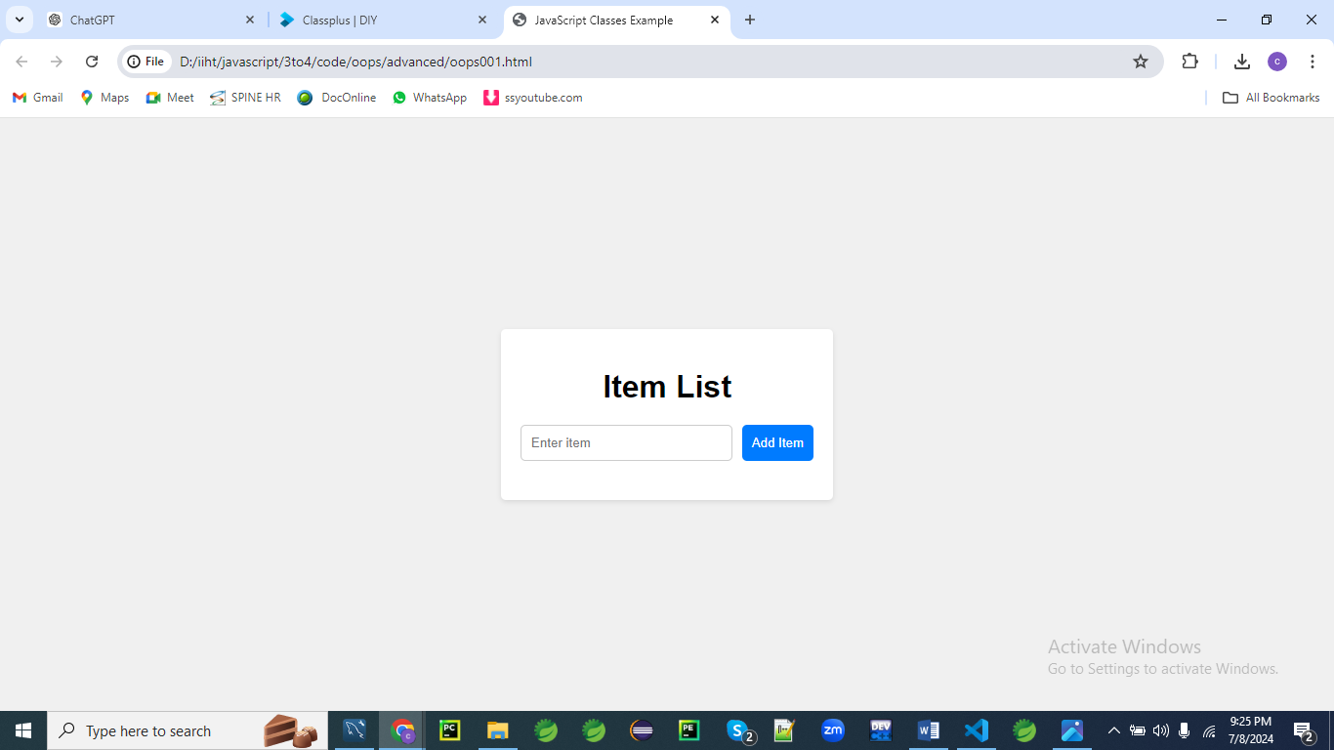

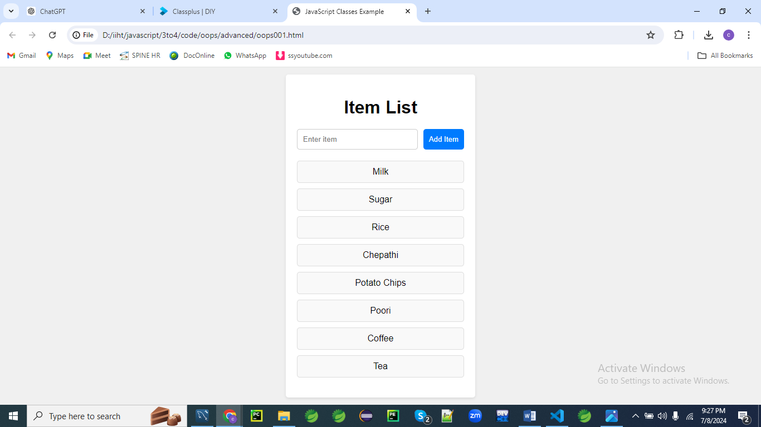

**HTML (oops001.html)**

<!DOCTYPE html>

<html lang="en">

<head>

<meta charset="UTF-8">

<meta name="viewport" content="width=device-width, initial-scale=1.0">

<title>JavaScript Classes Example</title>

<link rel="stylesheet" href="styles.css">

</head>

<body>

<div class="container">

<h1>Item List</h1>

<form id="itemForm">

<input type="text" id="itemInput" placeholder="Enter item" required>

<button type="submit">Add Item</button>

</form>

<ul id="itemList"></ul>

</div>

<script src="script.js"></script>

</body>

</html>

**CSS (styles001.css)**

body {

font-family: Arial, sans-serif;

background-color: #f0f0f0;

display: flex;

justify-content: center;

align-items: center;

height: 100vh;

margin: 0;

}

.container {

background-color: #fff;

padding: 20px;

border-radius: 5px;

box-shadow: 0 2px 5px rgba(0, 0, 0, 0.1);

width: 300px;

text-align: center;

}

h1 {

margin-bottom: 20px;

}

form {

display: flex;

justify-content: center;

margin-bottom: 20px;

}

input {

padding: 10px;

border: 1px solid #ccc;

border-radius: 5px;

flex: 1;

margin-right: 10px;

}

button {

padding: 10px;

border: none;

border-radius: 5px;

background-color: #007bff;

color: #fff;

cursor: pointer;

}

button:hover {

background-color: #0056b3;

}

ul {

list-style: none;

padding: 0;

}

li {

background-color: #f9f9f9;

padding: 10px;

border: 1px solid #ddd;

border-radius: 5px;

margin-bottom: 10px;

}

**JavaScript (script001.js)**

class ItemList {

constructor() {

this.items = [];

this.itemListElement = document.getElementById('itemList');

}

addItem(item) {

this.items.push(item);

this.render();

}

render() {

this.itemListElement.innerHTML = '';

this.items.forEach(item => {

const li = document.createElement('li');

li.textContent = item;

this.itemListElement.appendChild(li);

});

}

}

document.addEventListener('DOMContentLoaded', () => {

const itemList = new ItemList();

const itemForm = document.getElementById('itemForm');

const itemInput = document.getElementById('itemInput');

itemForm.addEventListener('submit', (event) => {

event.preventDefault();

const newItem = itemInput.value.trim();

if (newItem) {

itemList.addItem(newItem);

itemInput.value = '';

}

});

});

This program includes:

1. **HTML**: Defines the structure of the web page, including a form for entering items and a list to display them.
2. **CSS**: Styles the web page, making it look clean and centered.
3. **JavaScript**: Defines an ItemList class to manage the list of items and updates the DOM to reflect the current list of items.

To see this in action, create the three files (oops001.html, styles001.css, script001.js) with the content provided above, and open index.html in a web browser. You can then add items to the list using the form.

**Example 02**

Let's create a more complex example that involves a dynamic user interface, such as a simple shopping cart application. This example will include classes for products and the cart, as well as HTML and CSS for styling.

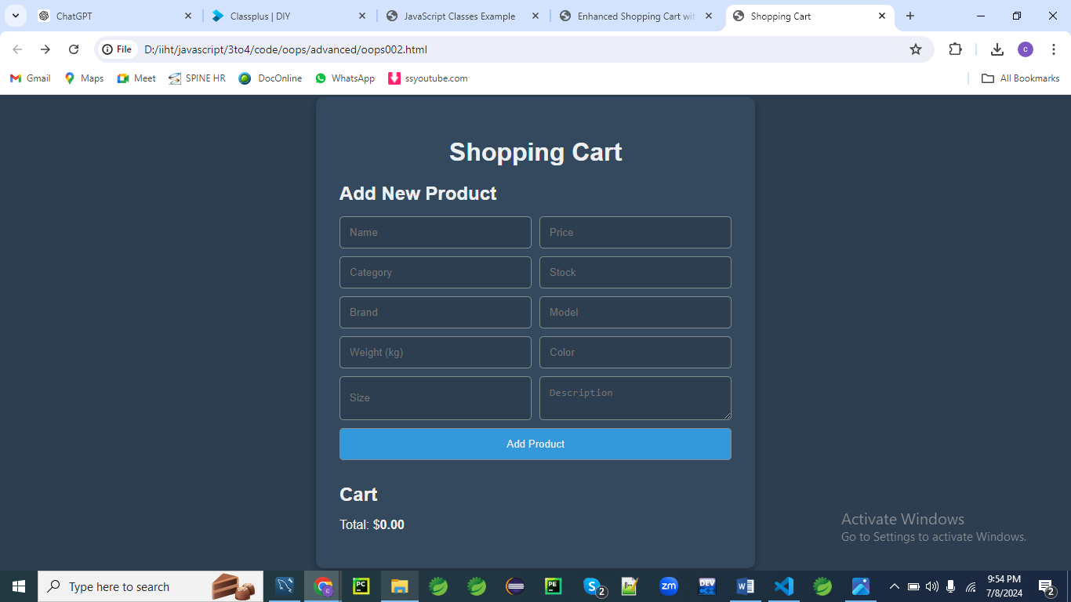

**Inputs**

**1.**

MacBook Pro

1999.46

Electronics

50

Apple

MacBook Pro 2023

1.59

Space Gray

13-inch

High-performance laptop with Retina display, M1 chip, and long battery life.

**2.**

iPhone 13 Pro

1099.00

Electronics

100

Apple

iPhone 13 Pro

0.204

Sierra Blue

6.1-inch

Advanced smartphone with Super Retina XDR display, A15 Bionic chip, and Pro camera system.

**3.**

Sony WH-1000XM4

349.99

Electronics

75

Sony

WH-1000XM4

0.25

Black

One Size

Premium wireless noise-canceling headphones with industry-leading noise cancellation and long battery life.

4.

Apple Watch Series 7

399.00

Electronics

30

Apple

Series 7

0.032

Midnight Aluminum

41mm

Advanced smartwatch with larger Always-On Retina display, blood oxygen sensor, and faster charging.

**5.**

Canon EOS R5

3899.00

Electronics

20

Canon

EOS R5

1.45

Black

One Size

High-resolution mirrorless camera with 8K video recording, 45MP full-frame sensor, and advanced autofocus system.

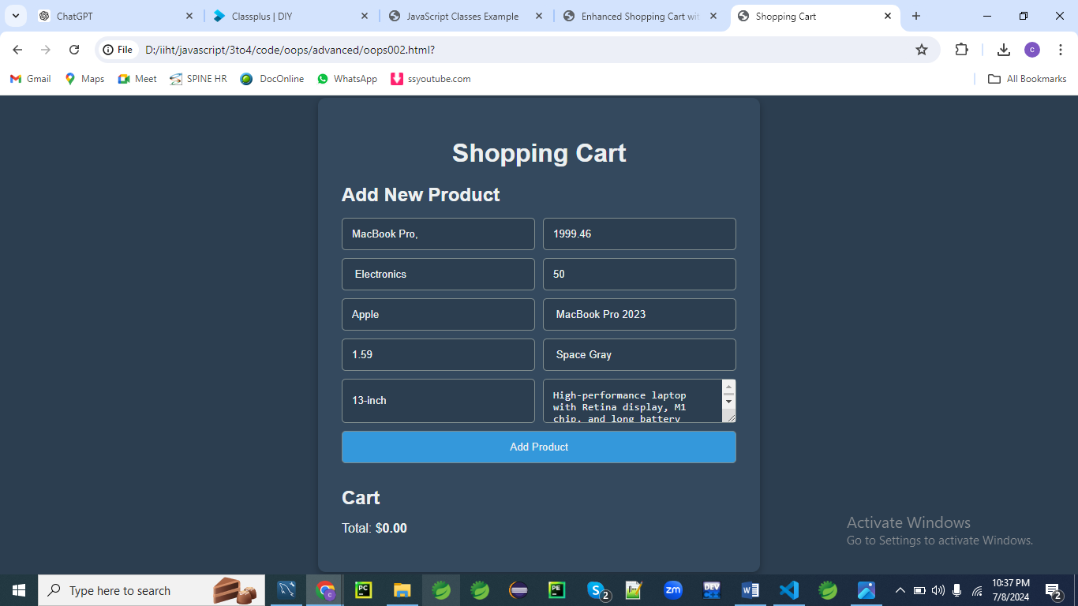

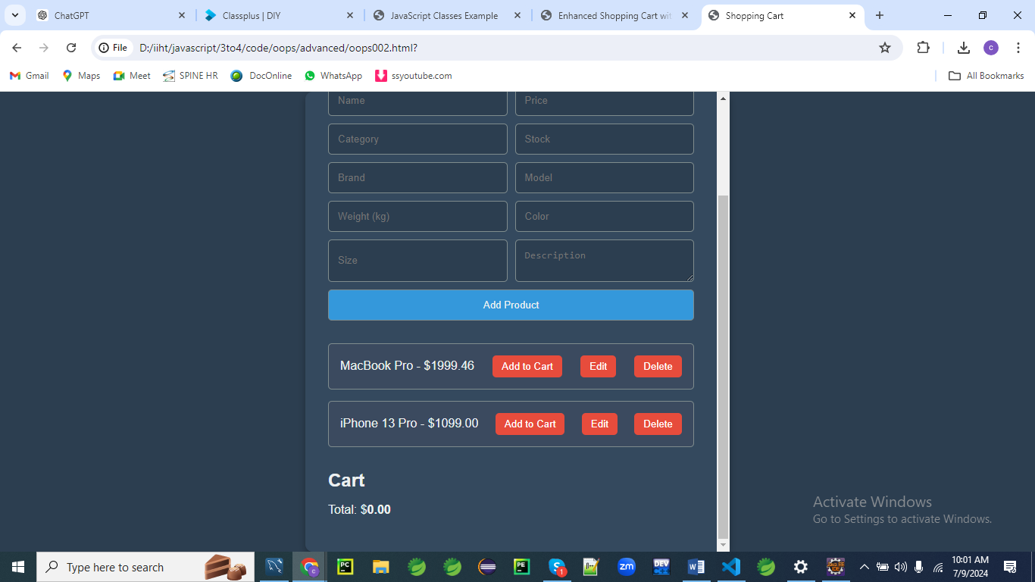

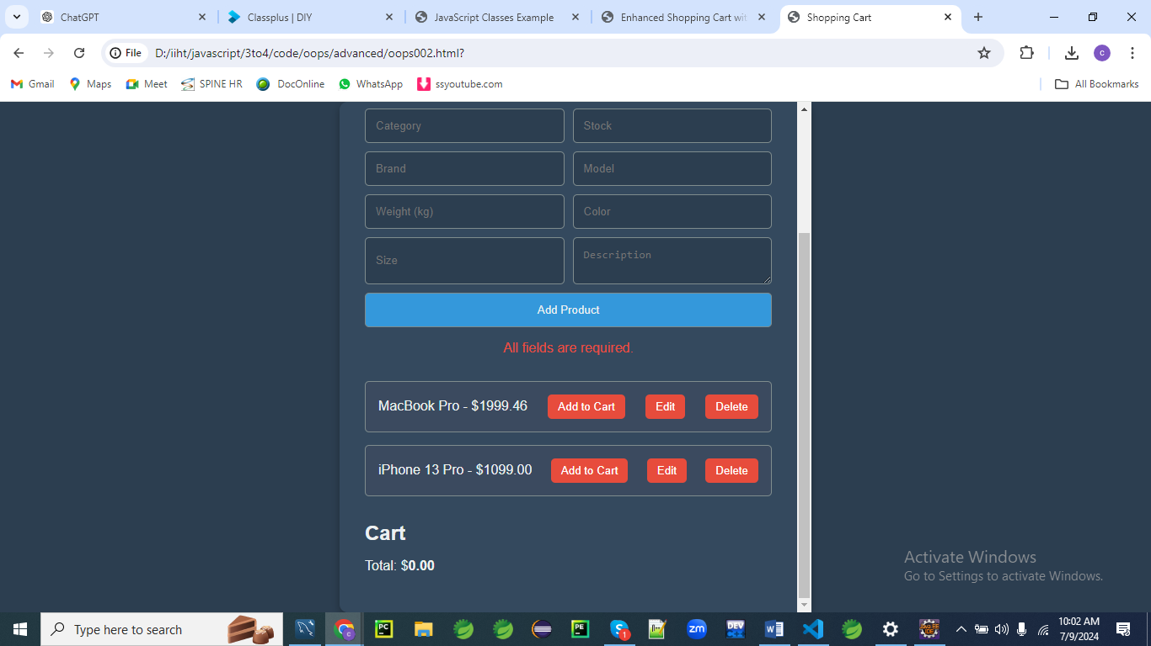

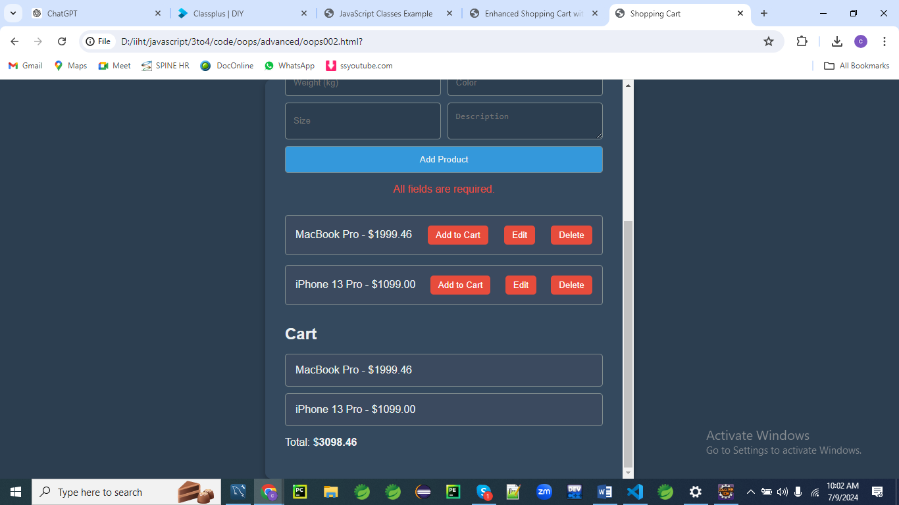

**HTML (oops002.html)**

<!DOCTYPE html>

<html lang="en">

<head>

    <meta charset="UTF-8">

    <meta name="viewport" content="width=device-width, initial-scale=1.0">

    <title>Shopping Cart</title>

    <link rel="stylesheet" href="styles002.css">

</head>

<body>

    <div class="container">

        <h1>Shopping Cart</h1>

        <div class="product-form">

            <h2 id="formTitle">Add New Product</h2>

            <form id="productForm">

                <input type="hidden" id="productId">

                <input type="text" id="productName" placeholder="Name" required>

                <input type="number" id="productPrice" placeholder="Price" step="any" required>

                <input type="text" id="productCategory" placeholder="Category" required>

                <input type="number" id="productStock" placeholder="Stock" required>

                <input type="text" id="productBrand" placeholder="Brand" required>

                <input type="text" id="productModel" placeholder="Model" required>

                <input type="number" id="productWeight" placeholder="Weight (kg)" step="any" required>

                <input type="text" id="productColor" placeholder="Color" required>

                <input type="text" id="productSize" placeholder="Size" required>

                <textarea id="productDescription" placeholder="Description" required></textarea>

                <button type="submit" id="submitButton">Add Product</button>

            </form>

            <p id="error-message" class="error-message"></p>

        </div>

        <div class="products" id="products"></div>

        <h2>Cart</h2>

        <ul id="cart"></ul>

        <p>Total: $<span id="total">0.00</span></p>

    </div>

    <script src="script002.js"></script>

</body>

</html>

**Explanation:**

1. **Document Type Declaration (<!DOCTYPE html>)**:
   * Specifies the document type and version of HTML being used.
2. **HTML Element (<html lang="en">)**:
   * The root element that contains the entire HTML document.
   * lang="en" attribute specifies the language of the document as English.
3. **Head Section (<head>)**:
   * Contains meta information about the HTML document and links to external resources.
   * **Meta Tags**:
     + <meta charset="UTF-8">: Specifies the character encoding for the document as UTF-8, ensuring proper display of characters.
     + <meta name="viewport" content="width=device-width, initial-scale=1.0">: Sets the viewport width to the device's width and sets the initial zoom level to 1.0, ensuring the webpage is responsive on different devices.
     + <title>Shopping Cart</title>: Sets the title of the webpage displayed in the browser tab.
     + <link rel="stylesheet" href="styles002.css">: Links an external CSS file (styles002.css) to style the HTML content.
4. **Body Section (<body>)**:
   * Contains the visible content of the HTML document.
   * **Container (<div class="container">)**:
     + Acts as a wrapper for the entire content of the shopping cart.
     + **Heading (<h1>Shopping Cart</h1>)**:
       - Displays the main title of the shopping cart page.
     + **Product Form (<div class="product-form">)**:
       - Contains a form (<form id="productForm">) to add new products to the shopping cart.
       - **Form Elements**:
         * Various input (<input>) and textarea (<textarea>) elements to enter product details such as name, price, category, stock, brand, model, weight, color, size, and description.
         * <input type="hidden" id="productId">: Hidden input field to store the product ID (typically used for editing products).
         * <button type="submit" id="submitButton">Add Product</button>: Submit button to add a new product to the shopping cart.
       - **Error Message (<p id="error-message" class="error-message"></p>)**:
         * Placeholder for displaying error messages related to form submission or validation.
     + **Products Section (<div class="products" id="products"></div>)**:
       - Placeholder where products added to the shopping cart are dynamically displayed.
     + **Cart Section**:
       - **Heading (<h2>Cart</h2>)**:
         * Displays a heading for the shopping cart section.
       - **Cart Items (<ul id="cart"></ul>)**:
         * Unordered list where items added to the cart are dynamically displayed as list items (<li>).
       - **Total Amount (<p>Total: $<span id="total">0.00</span></p>)**:
         * Displays the total amount of all items in the cart.
   * **Script (<script src="script002.js"></script>)**:
     + Links an external JavaScript file (script002.js) that contains scripts to add interactivity and functionality to the shopping cart, such as handling form submissions, updating cart items dynamically, calculating totals, and possibly interacting with a backend server for data storage and retrieval.

**Summary:**

This HTML structure forms the basis of a shopping cart web application. It includes forms for adding new products, sections for displaying products and the cart, and elements for displaying total amounts. The structure is designed to be styled and made interactive using CSS and JavaScript, allowing users to add, remove, and manage products in the shopping cart seamlessly.

**CSS (styles002.css)**

body {

    font-family: 'Roboto', sans-serif;

    background-color: #2c3e50;

    display: flex;

    justify-content: center;

    align-items: center;

    height: 100vh;

    margin: 0;

    color: #ecf0f1;

}

.container {

    background-color: #34495e;

    padding: 30px;

    border-radius: 10px;

    box-shadow: 0 4px 10px rgba(0, 0, 0, 0.3);

    width: 500px;

    max-height: 90vh;

    overflow-y: auto;

    text-align: left;

}

h1 {

    text-align: center;

    font-size: 2em;

    margin-bottom: 10px;

    color: #ecf0f1;

}

h2 {

    font-size: 1.5em;

    margin-bottom: 15px;

    color: #ecf0f1;

}

.product-form, .products, .cart {

    margin-bottom: 30px;

}

.product-form form {

    display: grid;

    grid-template-columns: 1fr 1fr;

    gap: 10px;

}

.product-form input, .product-form textarea, .product-form button {

    padding: 12px;

    border: 1px solid #7f8c8d;

    border-radius: 5px;

    background-color: #2c3e50;

    color: #ecf0f1;

    outline: none;

}

.product-form input:focus, .product-form textarea:focus {

    border-color: #3498db;

}

.product-form button {

    grid-column: span 2;

    background-color: #3498db;

    cursor: pointer;

}

.product-form button:hover {

    background-color: #2980b9;

}

.product, .cart-item {

    background-color: #3b4a5f;

    padding: 15px;

    border: 1px solid #7f8c8d;

    border-radius: 5px;

    margin-bottom: 15px;

    display: flex;

    justify-content: space-between;

    align-items: center;

}

.product button {

    margin-left: 10px;

    padding: 7px 12px;

    border: none;

    border-radius: 5px;

    background-color: #e74c3c;

    color: white;

    cursor: pointer;

}

.product button:hover {

    background-color: #c0392b;

}

.error-message {

    color: #e74c3c;

    text-align: center;

    grid-column: span 2;

}

#total {

    font-weight: bold;

}

#cart {

    list-style: none;

    padding: 0;

}

#cart li {

    margin-bottom: 10px;

}

**CSS Explanation:**

**/* Global Styles */**

**body {**

**font-family: 'Roboto', sans-serif;**

**background-color: #2c3e50;**

**display: flex;**

**justify-content: center;**

**align-items: center;**

**height: 100vh;**

**margin: 0;**

**color: #ecf0f1;**

**}**

* **Global Styles**:
  + body: Applies styles to the entire document body.
    - font-family: Sets the font family to 'Roboto', sans-serif.
    - background-color: Sets the background color to #2c3e50 (a shade of blue-grey).
    - display: Uses Flexbox to center items both horizontally and vertically.
    - justify-content: Centers content horizontally.
    - align-items: Centers content vertically.
    - height: Sets the height to 100vh (viewport height) to fill the entire screen.
    - margin: Sets margin to 0 to remove any default spacing.
    - color: Sets text color to #ecf0f1 (off-white or light grey).

**.container {**

**background-color: #34495e;**

**padding: 30px;**

**border-radius: 10px;**

**box-shadow: 0 4px 10px rgba(0, 0, 0, 0.3);**

**width: 500px;**

**max-height: 90vh;**

**overflow-y: auto;**

**text-align: left;**

**}**

* **Container Styles**:
  + .container: Styles the main container for the shopping cart.
    - background-color: Sets the background color to #34495e (a darker shade of blue-grey).
    - padding: Adds 30px of padding inside the container.
    - border-radius: Rounds the corners of the container with 10px border radius.
    - box-shadow: Adds a subtle shadow (0 4px 10px rgba(0, 0, 0, 0.3)) for depth effect.
    - width: Sets the width to 500px.
    - max-height: Limits the maximum height to 90vh (90% of viewport height).
    - overflow-y: Allows vertical scrolling (auto) inside the container if content exceeds viewport height.
    - text-align: Aligns text to the left within the container.

**/* Heading Styles */**

**h1 {**

**text-align: center;**

**font-size: 2em;**

**margin-bottom: 10px;**

**color: #ecf0f1;**

**}**

**h2 {**

**font-size: 1.5em;**

**margin-bottom: 15px;**

**color: #ecf0f1;**

**}**

* **Heading Styles**:
  + h1: Styles for main headings.
    - text-align: Centers the text horizontally.
    - font-size: Sets font size to 2em (equivalent to 32px).
    - margin-bottom: Adds 10px bottom margin.
    - color: Sets text color to #ecf0f1 (off-white or light grey).
  + h2: Styles for subheadings.
    - font-size: Sets font size to 1.5em (equivalent to 24px).
    - margin-bottom: Adds 15px bottom margin.
    - color: Sets text color to #ecf0f1 (off-white or light grey).

**/* Form and Layout Styles */**

**.product-form, .products, .cart {**

**margin-bottom: 30px;**

**}**

* **Form and Layout Styles**:
  + .product-form, .products, .cart: Adds 30px bottom margin to separate different sections (product form, products display, cart).

**.product-form form {**

**display: grid;**

**grid-template-columns: 1fr 1fr;**

**gap: 10px;**

**}**

* **Form Styles**:
  + .product-form form: Styles the form inside the product form section.
    - display: Uses CSS Grid layout.
    - grid-template-columns: Creates a grid with two equal columns (1fr 1fr).
    - gap: Sets 10px gap between grid items (inputs).

**.product-form input, .product-form textarea, .product-form button {**

**padding: 12px;**

**border: 1px solid #7f8c8d;**

**border-radius: 5px;**

**background-color: #2c3e50;**

**color: #ecf0f1;**

**outline: none;**

**}**

**.product-form input:focus, .product-form textarea:focus {**

**border-color: #3498db;**

**}**

**.product-form button {**

**grid-column: span 2;**

**background-color: #3498db;**

**cursor: pointer;**

**}**

**.product-form button:hover {**

**background-color: #2980b9;**

**}**

* **Form Element Styles**:
  + Styles input fields, textarea, and button inside the product form.
    - padding: Adds 12px padding inside input fields and textarea.
    - border: Sets a 1px solid border with color #7f8c8d.
    - border-radius: Rounds corners of inputs and textarea with 5px border radius.
    - background-color: Sets background color to #2c3e50 (a dark blue-grey).
    - color: Sets text color to #ecf0f1 (off-white or light grey).
    - outline: Removes default focus outline.
  + :focus pseudo-class: Changes border color to #3498db (light blue) when input or textarea is focused.
  + Button Styles:
    - grid-column: Spans button across both columns (span 2).
    - background-color: Sets background color to #3498db (light blue).
    - cursor: Changes cursor to pointer on hover.
  + Button Hover Effect:
    - Changes background color to #2980b9 (darker shade of blue) on hover.

**/* Product and Cart Item Styles */**

**.product, .cart-item {**

**background-color: #3b4a5f;**

**padding: 15px;**

**border: 1px solid #7f8c8d;**

**border-radius: 5px;**

**margin-bottom: 15px;**

**display: flex;**

**justify-content: space-between;**

**align-items: center;**

**}**

**.product button {**

**margin-left: 10px;**

**padding: 7px 12px;**

**border: none;**

**border-radius: 5px;**

**background-color: #e74c3c;**

**color: white;**

**cursor: pointer;**

**}**

**.product button:hover {**

**background-color: #c0392b;**

**}**

* **Product and Cart Item Styles**:
  + .product, .cart-item: Styles for individual products and cart items.
    - background-color: Sets background color to #3b4a5f (a darker blue-grey).
    - padding: Adds 15px padding inside the product and cart item boxes.
    - border: Sets a 1px solid border with color #7f8c8d.
    - border-radius: Rounds corners with 5px border radius.
    - margin-bottom: Adds 15px bottom margin between product and cart items.
    - display: Uses Flexbox.
    - justify-content: Spaces content evenly between the flex container.
    - align-items: Centers items vertically within the flex container.
  + .product button: Styles buttons inside product items.
    - margin-left: Adds 10px left margin.
    - padding: Sets 7px vertical padding and 12px horizontal padding inside the button.
    - border: Removes border (border: none).
    - border-radius: Rounds corners of the button with 5px border radius.
    - background-color: Sets background color to #e74c3c (red).
    - color: Sets text color to white.
    - cursor: Changes cursor to pointer.
  + Button Hover Effect:
    - Changes background color to #c0392b (darker red) on hover.

**/* Error Message Styles */**

**.error-message {**

**color: #e74c3c;**

**text-align: center;**

**grid-column: span 2;**

**}**

* **Error Message Styles**:
  + .error-message: Styles for error messages.
    - color: Sets text color to #e74c3c (red).
    - text-align: Centers text horizontally.
    - grid-column: Spans across two columns (span 2).

**/* Cart Total Styles */**

**#total {**

**font-weight: bold;**

**}**

* **Cart Total Styles**:
  + #total: Styles for the total amount display.
    - font-weight: Sets font weight to bold.

**/* Cart List Styles */**

**#cart {**

**list-style: none;**

**padding: 0;**

**}**

**#cart li {**

**margin-bottom: 10px;**

**}**

* **Cart List Styles**:
  + #cart: Styles for the cart list.
    - list-style: Removes default list styling (none).
    - padding: Sets padding to 0 (removes default padding).
  + #cart li: Styles for list items within the cart list.
    - margin-bottom: Adds 10px bottom margin between list items.

**Summary:**

The CSS provided styles a typical shopping cart interface. It uses Flexbox for layout and CSS Grid for form layout. Various styles are applied to ensure consistency, readability, and usability throughout the shopping cart application, from overall layout and typography to form elements, product displays, and error messages.

**JavaScript (script002.js)**

class Product {

    constructor(id, name, price, category, stock, brand, model, weight, color, size, description) {

        this.id = id;

        this.name = name;

        this.price = parseFloat(price);

        this.category = category;

        this.stock = parseInt(stock, 10);

        this.brand = brand;

        this.model = model;

        this.weight = parseFloat(weight);

        this.color = color;

        this.size = size;

        this.description = description;

    }

}

class ShoppingCart {

    constructor() {

        this.items = [];

        this.total = 0;

    }

    addItem(product) {

        this.items.push(product);

        this.calculateTotal();

        this.renderCart();

    }

    removeItem(productId) {

        this.items = this.items.filter(item => item.id !== productId);

        this.calculateTotal();

        this.renderCart();

    }

    calculateTotal() {

        this.total = this.items.reduce((sum, item) => sum + item.price, 0);

    }

    renderCart() {

        const cartElement = document.getElementById('cart');

        const totalElement = document.getElementById('total');

        cartElement.innerHTML = '';

        this.items.forEach(item => {

            const li = document.createElement('li');

            li.className = 'cart-item';

            li.textContent = `${item.name} - $${item.price.toFixed(2)}`;

            cartElement.appendChild(li);

        });

        totalElement.textContent = this.total.toFixed(2);

    }

}

document.addEventListener('DOMContentLoaded', () => {

    let products = [];

    const cart = new ShoppingCart();

    const productForm = document.getElementById('productForm');

    const errorMessage = document.getElementById('error-message');

    const formTitle = document.getElementById('formTitle');

    const submitButton = document.getElementById('submitButton');

    let editingProduct = null;

    productForm.addEventListener('submit', (event) => {

        event.preventDefault();

        const id = document.getElementById('productId').value;

        const name = document.getElementById('productName').value.trim();

        const price = document.getElementById('productPrice').value.trim();

        const category = document.getElementById('productCategory').value.trim();

        const stock = document.getElementById('productStock').value.trim();

        const brand = document.getElementById('productBrand').value.trim();

        const model = document.getElementById('productModel').value.trim();

        const weight = document.getElementById('productWeight').value.trim();

        const color = document.getElementById('productColor').value.trim();

        const size = document.getElementById('productSize').value.trim();

        const description = document.getElementById('productDescription').value.trim();

        if (!name || !price || !category || !stock || !brand || !model || !weight || !color || !size || !description) {

            errorMessage.textContent = 'All fields are required.';

            return;

        }

        if (isNaN(price) || isNaN(stock) || isNaN(weight)) {

            errorMessage.textContent = 'Price, Stock, and Weight must be valid numbers.';

            return;

        }

        if (editingProduct) {

            const index = products.findIndex(product => product.id === editingProduct.id);

            products[index] = new Product(editingProduct.id, name, price, category, stock, brand, model, weight, color, size, description);

            editingProduct = null;

            formTitle.textContent = 'Add New Product';

            submitButton.textContent = 'Add Product';

        } else {

            const newProduct = new Product(Date.now(), name, price, category, stock, brand, model, weight, color, size, description);

            products.push(newProduct);

        }

        renderProducts(products);

        errorMessage.textContent = '';

        productForm.reset();

    });

    function renderProducts(products) {

        const productsContainer = document.getElementById('products');

        productsContainer.innerHTML = '';

        products.forEach(product => {

            const productDiv = document.createElement('div');

            productDiv.className = 'product';

            const productInfo = document.createElement('span');

            productInfo.textContent = `${product.name} - $${product.price.toFixed(2)}`;

            const addButton = document.createElement('button');

            addButton.textContent = 'Add to Cart';

            addButton.addEventListener('click', () => {

                cart.addItem(product);

            });

            const editButton = document.createElement('button');

            editButton.textContent = 'Edit';

            editButton.addEventListener('click', () => {

                editProduct(product);

            });

            const deleteButton = document.createElement('button');

            deleteButton.textContent = 'Delete';

            deleteButton.addEventListener('click', () => {

                deleteProduct(product.id);

            });

            productDiv.appendChild(productInfo);

            productDiv.appendChild(addButton);

            productDiv.appendChild(editButton);

            productDiv.appendChild(deleteButton);

            productsContainer.appendChild(productDiv);

        });

    }

    function editProduct(product) {

        editingProduct = product;

        document.getElementById('productId').value = product.id;

        document.getElementById('productName').value = product.name;

        document.getElementById('productPrice').value = product.price;

        document.getElementById('productCategory').value = product.category;

        document.getElementById('productStock').value = product.stock;

        document.getElementById('productBrand').value = product.brand;

        document.getElementById('productModel').value = product.model;

        document.getElementById('productWeight').value = product.weight;

        document.getElementById('productColor').value = product.color;

        document.getElementById('productSize').value = product.size;

        document.getElementById('productDescription').value = product.description;

        formTitle.textContent = 'Edit Product';

        submitButton.textContent = 'Update Product';

    }

    function deleteProduct(id) {

        products = products.filter(product => product.id !== id);

        renderProducts(products);

    }

});

**JavaScript Explanation:**

**class Product {**

**constructor(id, name, price, category, stock, brand, model, weight, color, size, description) {**

**this.id = id;**

**this.name = name;**

**this.price = parseFloat(price);**

**this.category = category;**

**this.stock = parseInt(stock, 10);**

**this.brand = brand;**

**this.model = model;**

**this.weight = parseFloat(weight);**

**this.color = color;**

**this.size = size;**

**this.description = description;**

**}**

**}**

* **Product Class**:
  + Defines a class Product to represent a product.
  + The constructor method initializes the product with various properties (id, name, price, category, stock, brand, model, weight, color, size, description).
  + Uses type conversion functions like parseFloat and parseInt to ensure numeric values (price, stock, weight) are correctly parsed.

**class ShoppingCart {**

**constructor() {**

**this.items = [];**

**this.total = 0;**

**}**

**addItem(product) {**

**this.items.push(product);**

**this.calculateTotal();**

**this.renderCart();**

**}**

**removeItem(productId) {**

**this.items = this.items.filter(item => item.id !== productId);**

**this.calculateTotal();**

**this.renderCart();**

**}**

**calculateTotal() {**

**this.total = this.items.reduce((sum, item) => sum + item.price, 0);**

**}**

**renderCart() {**

**const cartElement = document.getElementById('cart');**

**const totalElement = document.getElementById('total');**

**cartElement.innerHTML = '';**

**this.items.forEach(item => {**

**const li = document.createElement('li');**

**li.className = 'cart-item';**

**li.textContent = `${item.name} - $${item.price.toFixed(2)}`;**

**cartElement.appendChild(li);**

**});**

**totalElement.textContent = this.total.toFixed(2);**

**}**

**}**

* **ShoppingCart Class**:
  + Defines a class ShoppingCart to manage a shopping cart.
  + constructor: Initializes an empty array items to store products and sets total to 0.
  + addItem(product): Adds a product to the items array, calculates the total price using calculateTotal(), and updates the cart display using renderCart().
  + removeItem(productId): Removes a product from items based on productId, recalculates the total using calculateTotal(), and updates the cart display using renderCart().
  + calculateTotal(): Computes the total price by summing up prices of all products in items.
  + renderCart(): Updates the cart display in the HTML:
    - Finds the cart element and total element in the DOM.
    - Clears existing cart content (cartElement.innerHTML = '').
    - Iterates through items, creates a <li> element for each product (cart-item class) with formatted name and price, and appends it to the cart.
    - Updates the total displayed in totalElement.

**document.addEventListener('DOMContentLoaded', () => {**

**let products = [];**

**const cart = new ShoppingCart();**

**const productForm = document.getElementById('productForm');**

**const errorMessage = document.getElementById('error-message');**

**const formTitle = document.getElementById('formTitle');**

**const submitButton = document.getElementById('submitButton');**

**let editingProduct = null;**

* **DOMContentLoaded Event Listener**:
  + Waits for the HTML document to be fully loaded (DOMContentLoaded event).
  + Initializes variables:
    - products: Array to store all products.
    - cart: Instance of ShoppingCart to manage the shopping cart.
    - productForm, errorMessage, formTitle, submitButton: References to various elements in the HTML form and error message.
    - editingProduct: Holds the currently edited product (or null if not editing).

**productForm.addEventListener('submit', (event) => {**

**event.preventDefault();**

**const id = document.getElementById('productId').value;**

**const name = document.getElementById('productName').value.trim();**

**const price = document.getElementById('productPrice').value.trim();**

**const category = document.getElementById('productCategory').value.trim();**

**const stock = document.getElementById('productStock').value.trim();**

**const brand = document.getElementById('productBrand').value.trim();**

**const model = document.getElementById('productModel').value.trim();**

**const weight = document.getElementById('productWeight').value.trim();**

**const color = document.getElementById('productColor').value.trim();**

**const size = document.getElementById('productSize').value.trim();**

**const description = document.getElementById('productDescription').value.trim();**

* **Form Submission Event Listener**:
  + Listens for the submit event on productForm.
  + Prevents the default form submission (event.preventDefault()).
  + Retrieves form input values:
    - id: Product ID (hidden field).
    - name, price, category, stock, brand, model, weight, color, size, description: Input values trimmed of leading and trailing whitespace.

**if (!name || !price || !category || !stock || !brand || !model || !weight || !color || !size || !description) {**

**errorMessage.textContent = 'All fields are required.';**

**return;**

**}**

**if (isNaN(price) || isNaN(stock) || isNaN(weight)) {**

**errorMessage.textContent = 'Price, Stock, and Weight must be valid numbers.';**

**return;**

**}**

* **Form Validation**:
  + Checks if any required field is empty.
  + Displays an error message in errorMessage if any field is empty and stops further execution (return).
  + Validates numeric fields (price, stock, weight) using isNaN() and displays an error if any is not a valid number.

**if (editingProduct) {**

**const index = products.findIndex(product => product.id === editingProduct.id);**

**products[index] = new Product(editingProduct.id, name, price, category, stock, brand, model, weight, color, size, description);**

**editingProduct = null;**

**formTitle.textContent = 'Add New Product';**

**submitButton.textContent = 'Add Product';**

**} else {**

**const newProduct = new Product(Date.now(), name, price, category, stock, brand, model, weight, color, size, description);**

**products.push(newProduct);**

**}**

* **Handling Product Editing and Adding**:
  + Checks if editingProduct is defined (i.e., editing mode).
  + If editing:
    - Finds the index of editingProduct in products.
    - Updates the product at that index with new values.
    - Resets editingProduct to null, updates form title (formTitle.textContent), and changes submit button text (submitButton.textContent).
  + If adding a new product:
    - Creates a new Product object with current timestamp as id.
    - Pushes the new product into products.

**renderProducts(products);**

**errorMessage.textContent = '';**

**productForm.reset();**

**});**

* **Rendering Products and Resetting Form**:
  + Calls renderProducts(products) to update the product list display.
  + Clears any previous error message (errorMessage.textContent = '').
  + Resets the form (productForm.reset()) to clear input fields after submission.

**function renderProducts(products) {**

**const productsContainer = document.getElementById('products');**

**productsContainer.innerHTML = '';**

**products.forEach(product => {**

**const productDiv = document.createElement('div');**

**productDiv.className = 'product';**

**const productInfo = document.createElement('span');**

**productInfo.textContent = `${product.name} - $${product.price.toFixed(2)}`;**

**const addButton = document.createElement('button');**

**addButton.textContent = 'Add to Cart';**

**addButton.addEventListener('click', () => {**

**cart.addItem(product);**

**});**

**const editButton = document.createElement('button');**

**editButton.textContent = 'Edit';**

**editButton.addEventListener('click', () => {**

**editProduct(product);**

**});**

**const deleteButton = document.createElement('button');**

**deleteButton.textContent = 'Delete';**

**deleteButton.addEventListener('click', () => {**

**deleteProduct(product.id);**

**});**

**productDiv.appendChild(productInfo);**

**productDiv.appendChild(addButton);**

**productDiv.appendChild(editButton);**

**productDiv.appendChild(deleteButton);**

**productsContainer.appendChild(productDiv);**

**});**

**}**

* **Rendering Products**:
  + Defines a function renderProducts(products) to display products in the HTML.
  + Finds productsContainer in the DOM.
  + Clears existing content (productsContainer.innerHTML = '').
  + Iterates through products array:
    - Creates a <div> for each product (productDiv with class product).
    - Creates a <span> (productInfo) to display product name and price.
    - Creates buttons (addButton, editButton, deleteButton) for adding to cart, editing, and deleting products.
    - Adds event listeners to buttons (addButton, editButton, deleteButton) to call respective functions (cart.addItem(product), editProduct(product), deleteProduct(product.id)).
    - Appends elements to productDiv and productsContainer.

**function editProduct(product) {**

**editingProduct = product;**

**document.getElementById('productId').value = product.id;**

**document.getElementById('productName').value = product.name;**

**document.getElementById('productPrice').value = product.price;**

**document.getElementById('productCategory').value = product.category;**

**document.getElementById('productStock').value = product.stock;**

**document.getElementById('productBrand').value = product.brand;**

**document.getElementById('productModel').value = product.model;**

**document.getElementById('productWeight').value = product.weight;**

**document.getElementById('productColor').value = product.color;**

**document.getElementById('productSize').value = product.size;**

**document.getElementById('productDescription').value = product.description;**

**formTitle.textContent = 'Edit Product';**

**submitButton.textContent = 'Update Product';**

**}**

* **Editing Product**:
  + Defines editProduct(product) function to populate form fields for editing.
  + Sets editingProduct to current product.
  + Sets form field values (document.getElementById(...).value) based on product properties.
  + Updates form title (formTitle.textContent) and submit button text (submitButton.textContent) for editing mode.

**function deleteProduct(id) {**

**products = products.filter(product => product.id !== id);**

**renderProducts(products);**

**}**

**});**

* **Deleting Product**:
  + Defines deleteProduct(id) function to remove a product from products array based on id.
  + Uses Array.filter() to create a new array excluding the product with matching id.
  + Calls renderProducts(products) to update the product list display after deletion.

**Summary:**

* The JavaScript code manages a shopping cart application.
* It uses classes (Product and ShoppingCart) to represent products and handle cart operations.
* Event listeners (submit, button clicks) manage user interactions with the form and product list.
* Functions (renderProducts, editProduct, deleteProduct) update the UI dynamically based on user actions.
* Error handling ensures required fields are filled and numeric inputs are valid.
* Overall, the code integrates with HTML and CSS to create a functional shopping cart interface.

**Explanation:**

1. **HTML**:
   * Includes hidden input for the product ID to facilitate editing.
   * A form with 10 fields for adding and editing products.
   * Sections for displaying products and the cart.
2. **CSS**:
   * Styles the web page for a better visual experience.
   * Includes styles for the form, products, cart, and error messages.
3. **JavaScript**:
   * Product class encapsulates product details, including a unique ID.
   * ShoppingCart class manages the cart items and total price.
   * Handles CRUD operations:
     + **Create**: Adding a new product to the list.
     + **Read**: Displaying the list of products.
     + **Update**: Editing an existing product.
     + **Delete**: Removing a product from the list.
   * Form validation ensures all fields are filled and numerical values are valid.
   * Event listeners dynamically update the product list and cart when actions are performed.

To see this in action, create the three files (index.html, styles.css, script.js) with the content provided above, and open index.html in a web browser. You can then add, edit, and delete products, and see the cart update dynamically.

**Example 03**

Here's another example involving CRUD operations and shopping cart functionality.

This time, we'll create a book library where users can add, edit, delete, and list books, and add them to a "reading list."

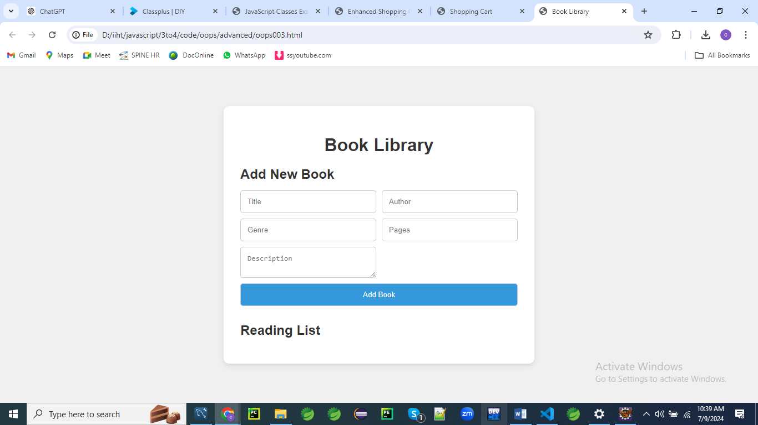

**Inputs**

**1.**

The Great Gatsby

F. Scott Fitzgerald

Fiction

180

A novel about the decline of the American Dream in the 1920s.

**2.**

To Kill a Mockingbird

Harper Lee

Fiction

281

A novel set in the American South during the 1930s, focusing on themes of racial injustice and moral growth.

**3.**

1984

George Orwell

Dystopian

328

A dystopian novel about a totalitarian regime that uses surveillance, censorship, and control to oppress its citizens.

**4.**

Moby-Dick

Herman Melville

Adventure

635

A novel about Captain Ahab's obsessive quest to kill the giant white whale, Moby-Dick.

**5.**

Pride and Prejudice

Jane Austen

Romance

279

A romantic novel that critiques the British landed gentry at the end of the 18th century.

**6.**

The Catcher in the Rye

J.D. Salinger

Fiction

214

A novel about teenage alienation and rebellion as narrated by the protagonist, Holden Caulfield.

**7.**

War and Peace

Leo Tolstoy

Historical Fiction

1225

A novel set during the Napoleonic Wars, focusing on the lives of five Russian aristocratic families.

**8.**

The Hobbit

J.R.R. Tolkien

Fantasy

310

A fantasy novel about the adventures of Bilbo Baggins, a hobbit who embarks on a quest to reclaim a stolen treasure.

**9.**

Brave New World

Aldous Huxley

Dystopian

268

A dystopian novel that explores the dangers of a technologically advanced society controlled by the state.

**10.**

The Catch-22

Joseph Heller

Satire

453

A satirical novel about the absurdities of war and the concept of a no-win situation.

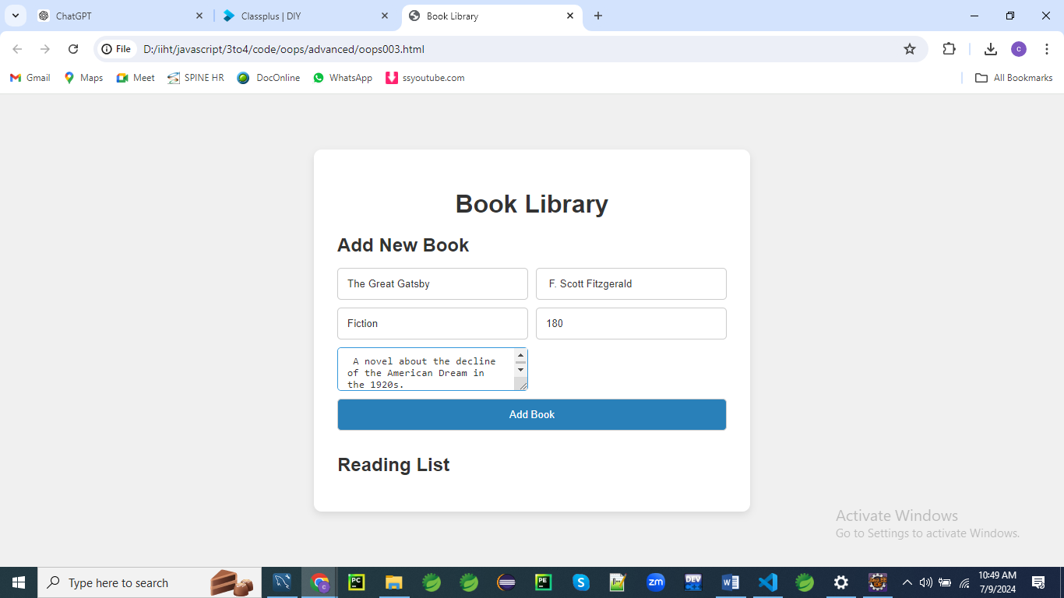

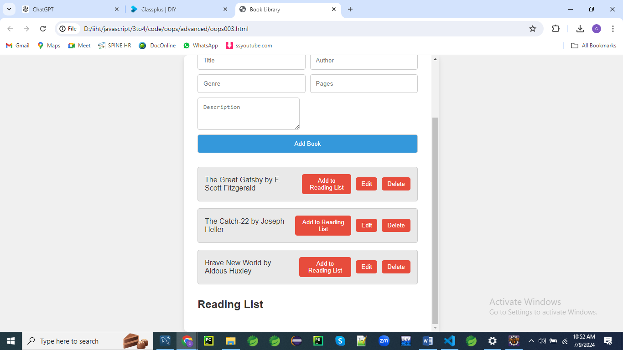

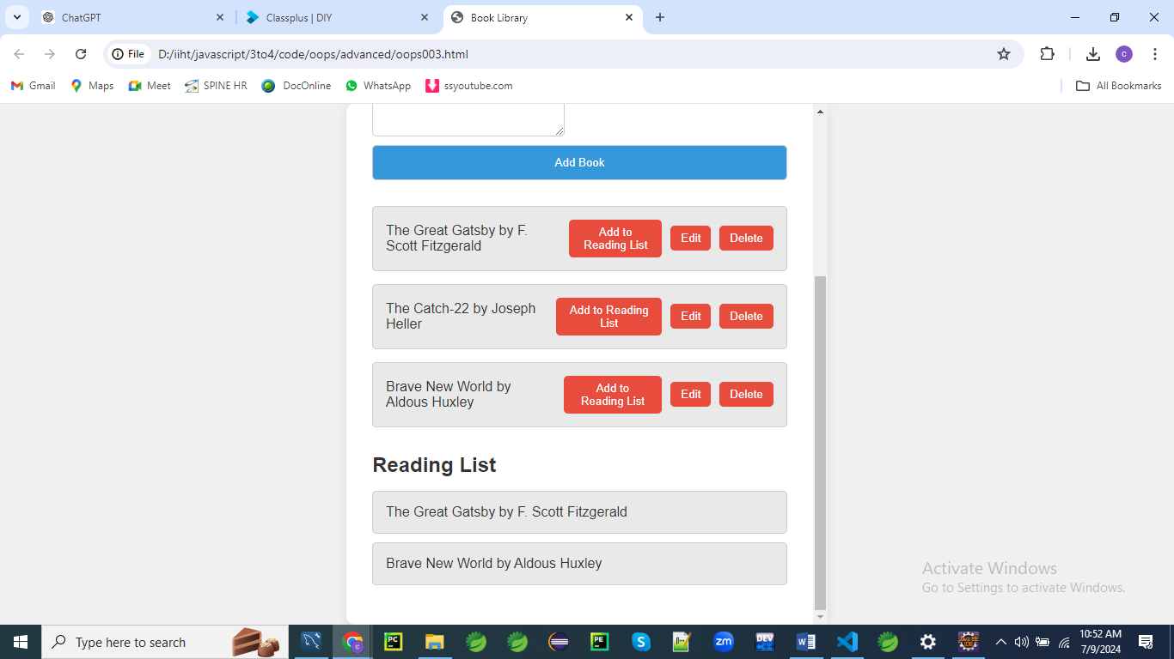

**HTML (oops003.html)**

<!DOCTYPE html>

<html lang="en">

<head>

<meta charset="UTF-8">

<meta name="viewport" content="width=device-width, initial-scale=1.0">

<title>Book Library</title>

<link rel="stylesheet" href="styles003.css">

</head>

<body>

<div class="container">

<h1>Book Library</h1>

<div class="book-form">

<h2 id="formTitle">Add New Book</h2>

<form id="bookForm">

<input type="hidden" id="bookId">

<input type="text" id="bookTitle" placeholder="Title" required>

<input type="text" id="bookAuthor" placeholder="Author" required>

<input type="text" id="bookGenre" placeholder="Genre" required>

<input type="number" id="bookPages" placeholder="Pages" required>

<textarea id="bookDescription" placeholder="Description" required></textarea>

<button type="submit" id="submitButton">Add Book</button>

</form>

<p id="error-message" class="error-message"></p>

</div>

<div class="books" id="books"></div>

<h2>Reading List</h2>

<ul id="readingList"></ul>

</div>

<script src="script003.js"></script>

</body>

</html>

**Explanation**

This HTML code is the skeleton of a web application for managing a book library.

It includes a form for adding books to the library, a section to display the list of books, and a section for a reading list.

Here's a detailed explanation of each part:

**HTML Structure**

**<head>**

* **Meta tags**:
  + <meta charset="UTF-8"> specifies the character encoding for the document as UTF-8.
  + <meta name="viewport" content="width=device-width, initial-scale=1.0"> ensures the page is responsive, adjusting to different screen sizes.
* **Title**: <title>Book Library</title> sets the title of the webpage.
* **Stylesheet**: <link rel="stylesheet" href="styles003.css"> links to an external CSS file for styling the page.

**<body>**

* **Container**: <div class="container"> wraps all the main content of the webpage.
  + **Header**: <h1>Book Library</h1> displays the main heading of the page.

**Book Form**

* + **Form Container**: <div class="book-form"> wraps the form elements.
    - **Form Title**: <h2 id="formTitle">Add New Book</h2> displays the form title.
    - **Form**: <form id="bookForm"> element with fields to input book details:
      * **Hidden Input**: <input type="hidden" id="bookId"> stores the book ID, useful for editing.
      * **Title Input**: <input type="text" id="bookTitle" placeholder="Title" required> for the book title.
      * **Author Input**: <input type="text" id="bookAuthor" placeholder="Author" required> for the author name.
      * **Genre Input**: <input type="text" id="bookGenre" placeholder="Genre" required> for the genre.
      * **Pages Input**: <input type="number" id="bookPages" placeholder="Pages" required> for the number of pages.
      * **Description Textarea**: <textarea id="bookDescription" placeholder="Description" required></textarea> for the book description.
      * **Submit Button**: <button type="submit" id="submitButton">Add Book</button> submits the form.
    - **Error Message**: <p id="error-message" class="error-message"></p> displays validation errors.

**Books List**

* + **Books Container**: <div class="books" id="books"></div> displays the list of added books.

**Reading List**

* + **Reading List Header**: <h2>Reading List</h2> heading for the reading list section.
  + **Reading List Container**: <ul id="readingList"></ul> an unordered list for the reading list.

**JavaScript**

* <script src="script003.js"></script> links to an external JavaScript file which will handle the form submission, validation, and other functionalities.

**Summary**

This code sets up the structure for a book library web application with:

1. A form to add new books with fields for title, author, genre, pages, and description.
2. A section to display the list of added books.
3. A reading list section to track books you want to read.

The corresponding CSS file (styles003.css) will handle the styling, and the JavaScript file (script003.js) will manage the dynamic behavior like form submission, validation, and updating the list of books.

**CSS (styles003.css)**

body {

font-family: 'Roboto', sans-serif;

background-color: #f0f0f0;

display: flex;

justify-content: center;

align-items: center;

height: 100vh;

margin: 0;

color: #333;

}

.container {

background-color: #fff;

padding: 30px;

border-radius: 10px;

box-shadow: 0 4px 10px rgba(0, 0, 0, 0.1);

width: 500px;

max-height: 90vh;

overflow-y: auto;

text-align: left;

}

h1 {

text-align: center;

font-size: 2em;

margin-bottom: 10px;

color: #333;

}

h2 {

font-size: 1.5em;

margin-bottom: 15px;

color: #333;

}

.book-form, .books, .reading-list {

margin-bottom: 30px;

}

.book-form form {

display: grid;

grid-template-columns: 1fr 1fr;

gap: 10px;

}

.book-form input, .book-form textarea, .book-form button {

padding: 12px;

border: 1px solid #ccc;

border-radius: 5px;

background-color: #fff;

color: #333;

outline: none;

}

.book-form input:focus, .book-form textarea:focus {

border-color: #3498db;

}

.book-form button {

grid-column: span 2;

background-color: #3498db;

cursor: pointer;

color: white;

}

.book-form button:hover {

background-color: #2980b9;

}

.book, .reading-list-item {

background-color: #e9e9e9;

padding: 15px;

border: 1px solid #ccc;

border-radius: 5px;

margin-bottom: 15px;

display: flex;

justify-content: space-between;

align-items: center;

}

.book button {

margin-left: 10px;

padding: 7px 12px;

border: none;

border-radius: 5px;

background-color: #e74c3c;

color: white;

cursor: pointer;

}

.book button:hover {

background-color: #c0392b;

}

.error-message {

color: #e74c3c;

text-align: center;

grid-column: span 2;

}

#readingList {

list-style: none;

padding: 0;

}

#readingList li {

margin-bottom: 10px;

}

**Explanation:**

This CSS stylesheet styles the HTML structure for the Book Library application. Here is a detailed explanation of each part:

**General Styling**

**body**

**body {**

**font-family: 'Roboto', sans-serif;**

**background-color: #f0f0f0;**

**display: flex;**

**justify-content: center;**

**align-items: center;**

**height: 100vh;**

**margin: 0;**

**color: #333;**

**}**

* **font-family**: Uses 'Roboto' font.
* **background-color**: Light gray background (#f0f0f0).
* **display**: Flexbox layout.
* **justify-content**: Centers content horizontally.
* **align-items**: Centers content vertically.
* **height**: Full viewport height.
* **margin**: No margin.
* **color**: Dark gray text color (#333).

**.container**

**.container {**

**background-color: #fff;**

**padding: 30px;**

**border-radius: 10px;**

**box-shadow: 0 4px 10px rgba(0, 0, 0, 0.1);**

**width: 500px;**

**max-height: 90vh;**

**overflow-y: auto;**

**text-align: left;**

**}**

* **background-color**: White background (#fff).
* **padding**: 30px padding around the content.
* **border-radius**: Rounded corners with 10px radius.
* **box-shadow**: Subtle shadow effect.
* **width**: 500px wide.
* **max-height**: 90% of the viewport height.
* **overflow-y**: Allows vertical scrolling if content overflows.
* **text-align**: Left-aligned text.

**Headings**

**h1 {**

**text-align: center;**

**font-size: 2em;**

**margin-bottom: 10px;**

**color: #333;**

**}**

**h2 {**

**font-size: 1.5em;**

**margin-bottom: 15px;**

**color: #333;**

**}**

* **h1**:
  + **text-align**: Center-aligned.
  + **font-size**: 2em font size.
  + **margin-bottom**: 10px bottom margin.
  + **color**: Dark gray text color (#333).
* **h2**:
  + **font-size**: 1.5em font size.
  + **margin-bottom**: 15px bottom margin.
  + **color**: Dark gray text color (#333).

**Form and Lists**

**.book-form, .books, .reading-list {**

**margin-bottom: 30px;**

**}**

* **margin-bottom**: 30px bottom margin for separation between elements.

**Form Layout**

**.book-form form {**

**display: grid;**

**grid-template-columns: 1fr 1fr;**

**gap: 10px;**

**}**

* **display**: Uses CSS Grid.
* **grid-template-columns**: Two equal columns.
* **gap**: 10px gap between grid items.

**Form Inputs and Button**

**.book-form input, .book-form textarea, .book-form button {**

**padding: 12px;**

**border: 1px solid #ccc;**

**border-radius: 5px;**

**background-color: #fff;**

**color: #333;**

**outline: none;**

**}**

**.book-form input:focus, .book-form textarea:focus {**

**border-color: #3498db;**

**}**

**.book-form button {**

**grid-column: span 2;**

**background-color: #3498db;**

**cursor: pointer;**

**color: white;**

**}**

**.book-form button:hover {**

**background-color: #2980b9;**

**}**

* **Inputs, Textarea, Button**:
  + **padding**: 12px padding.
  + **border**: Light gray border (#ccc).
  + **border-radius**: 5px rounded corners.
  + **background-color**: White background (#fff).
  + **color**: Dark gray text color (#333).
  + **outline**: No outline.
* **Input/textarea focus**:
  + **border-color**: Blue border (#3498db) when focused.
* **Button**:
  + **grid-column**: Spans both columns in the grid.
  + **background-color**: Blue background (#3498db).
  + **cursor**: Pointer cursor on hover.
  + **color**: White text color.
* **Button hover**:
  + **background-color**: Darker blue background (#2980b9).

**Book and Reading List Items**

**.book, .reading-list-item {**

**background-color: #e9e9e9;**

**padding: 15px;**

**border: 1px solid #ccc;**

**border-radius: 5px;**

**margin-bottom: 15px;**

**display: flex;**

**justify-content: space-between;**

**align-items: center;**

**}**

* **background-color**: Light gray background (#e9e9e9).
* **padding**: 15px padding.
* **border**: Light gray border (#ccc).
* **border-radius**: 5px rounded corners.
* **margin-bottom**: 15px bottom margin.
* **display**: Flexbox layout.
* **justify-content**: Space between elements.
* **align-items**: Center align items vertically.

**Book Button**

**.book button {**

**margin-left: 10px;**

**padding: 7px 12px;**

**border: none;**

**border-radius: 5px;**

**background-color: #e74c3c;**

**color: white;**

**cursor: pointer;**

**}**

**.book button:hover {**

**background-color: #c0392b;**

**}**

* **margin-left**: 10px left margin.
* **padding**: 7px 12px padding.
* **border**: No border.
* **border-radius**: 5px rounded corners.
* **background-color**: Red background (#e74c3c).
* **color**: White text color.
* **cursor**: Pointer cursor on hover.
* **hover background-color**: Darker red background (#c0392b).

**Error Message**

**.error-message {**

**color: #e74c3c;**

**text-align: center;**

**grid-column: span 2;**

**}**

* **color**: Red text color (#e74c3c).
* **text-align**: Center-aligned.
* **grid-column**: Spans both columns in the grid.

**Reading List**

**#readingList {**

**list-style: none;**

**padding: 0;**

**}**

**#readingList li {**

**margin-bottom: 10px;**

**}**

* **#readingList**:
  + **list-style**: No bullets or numbers.
  + **padding**: No padding.
* **#readingList li**:
  + **margin-bottom**: 10px bottom margin for spacing between items.

**JavaScript (script003.js)**

class Book {

constructor(id, title, author, genre, pages, description) {

this.id = id;

this.title = title;

this.author = author;

this.genre = genre;

this.pages = parseInt(pages, 10);

this.description = description;

}

}

class ReadingList {

constructor() {

this.items = [];

}

addItem(book) {

this.items.push(book);

this.renderReadingList();

}

removeItem(bookId) {

this.items = this.items.filter(item => item.id !== bookId);

this.renderReadingList();

}

renderReadingList() {

const readingListElement = document.getElementById('readingList');

readingListElement.innerHTML = '';

this.items.forEach(item => {

const li = document.createElement('li');

li.className = 'reading-list-item';

li.textContent = `${item.title} by ${item.author}`;

readingListElement.appendChild(li);

});

}

}

document.addEventListener('DOMContentLoaded', () => {

let books = [];

const readingList = new ReadingList();

const bookForm = document.getElementById('bookForm');

const errorMessage = document.getElementById('error-message');

const formTitle = document.getElementById('formTitle');

const submitButton = document.getElementById('submitButton');

let editingBook = null;

bookForm.addEventListener('submit', (event) => {

event.preventDefault();

const id = document.getElementById('bookId').value;

const title = document.getElementById('bookTitle').value.trim();

const author = document.getElementById('bookAuthor').value.trim();

const genre = document.getElementById('bookGenre').value.trim();

const pages = document.getElementById('bookPages').value.trim();

const description = document.getElementById('bookDescription').value.trim();

if (!title || !author || !genre || !pages || !description) {

errorMessage.textContent = 'All fields are required.';

return;

}

if (isNaN(pages)) {

errorMessage.textContent = 'Pages must be a valid number.';

return;

}

if (editingBook) {

const index = books.findIndex(book => book.id === editingBook.id);

books[index] = new Book(editingBook.id, title, author, genre, pages, description);

editingBook = null;

formTitle.textContent = 'Add New Book';

submitButton.textContent = 'Add Book';

} else {

const newBook = new Book(Date.now(), title, author, genre, pages, description);

books.push(newBook);

}

renderBooks(books);

errorMessage.textContent = '';

bookForm.reset();

});

function renderBooks(books) {

const booksContainer = document.getElementById('books');

booksContainer.innerHTML = '';

books.forEach(book => {

const bookDiv = document.createElement('div');

bookDiv.className = 'book';

const bookInfo = document.createElement('span');

bookInfo.textContent = `${book.title} by ${book.author}`;

const addButton = document.createElement('button');

addButton.textContent = 'Add to Reading List';

addButton.addEventListener('click', () => {

readingList.addItem(book);

});

const editButton = document.createElement('button');

editButton.textContent = 'Edit';

editButton.addEventListener('click', () => {

editBook(book);

});

const deleteButton = document.createElement('button');

deleteButton.textContent = 'Delete';

deleteButton.addEventListener('click', () => {

deleteBook(book.id);

});

bookDiv.appendChild(bookInfo);

bookDiv.appendChild(addButton);

bookDiv.appendChild(editButton);

bookDiv.appendChild(deleteButton);

booksContainer.appendChild(bookDiv);

});

}

function editBook(book) {

editingBook = book;

document.getElementById('bookId').value = book.id;

document.getElementById('bookTitle').value = book.title;

document.getElementById('bookAuthor').value = book.author;

document.getElementById('bookGenre').value = book.genre;

document.getElementById('bookPages').value = book.pages;

document.getElementById('bookDescription').value = book.description;

formTitle.textContent = 'Edit Book';

submitButton.textContent = 'Update Book';

}

function deleteBook(id) {

books = books.filter(book => book.id !== id);

renderBooks(books);

}

});

**Explanation**

The given code is a JavaScript implementation for a Book Library application.

It consists of two main classes: Book and ReadingList, along with event listeners and functions to handle form submission, book rendering, editing, deleting, and adding books to the reading list.

Below is a detailed explanation:

**Classes**

**Book Class**

Let's break down the Book class code line by line.

**Book Class Definition**

**class Book {**

**constructor(id, title, author, genre, pages, description) {**

**this.id = id;**

**this.title = title;**

**this.author = author;**

**this.genre = genre;**

**this.pages = parseInt(pages, 10);**

**this.description = description;**

**}**

**}**

* **class Book {**: Defines a new class called Book.

**Constructor Method**

**constructor(id, title, author, genre, pages, description) {**

* **constructor(id, title, author, genre, pages, description) {**: The constructor method is a special method for creating and initializing an object created with a class. It takes six parameters: id, title, author, genre, pages, and description.

**Property Initialization**

**this.id = id;**

* **this.id = id;**: Initializes the id property of the Book instance with the value passed as the id parameter.

**this.title = title;**

* **this.title = title;**: Initializes the title property of the Book instance with the value passed as the title parameter.

**this.author = author;**

* **this.author = author;**: Initializes the author property of the Book instance with the value passed as the author parameter.

**this.genre = genre;**

* **this.genre = genre;**: Initializes the genre property of the Book instance with the value passed as the genre parameter.

**this.pages = parseInt(pages, 10);**

* **this.pages = parseInt(pages, 10);**: Initializes the pages property of the Book instance with the integer value of the pages parameter. parseInt(pages, 10) ensures that the pages value is converted to an integer (base 10).

**this.description = description;**

* **this.description = description;**: Initializes the description property of the Book instance with the value passed as the description parameter.

**Closing the Constructor Method and Class**

**}**

**}**

* **}**: Closes the constructor method.
* **}**: Closes the Book class definition.

In summary, the Book class defines a blueprint for creating book objects with six properties: id, title, author, genre, pages, and description.

The constructor method initializes these properties using the values provided when a new Book instance is created.

**ReadingList Class**

Let's break down the ReadingList class code line by line.

**ReadingList Class Definition**

**class ReadingList {**

**constructor() {**

**this.items = [];**

**}**

* **class ReadingList {**: Defines a new class called ReadingList.
* **constructor() {**: The constructor method is a special method for creating and initializing an object created with a class.
  + **this.items = [];**: Initializes an empty array called items to store the books in the reading list.

**addItem Method**

**addItem(book) {**

**this.items.push(book);**

**this.renderReadingList();**

**}**

* **addItem(book) {**: Defines a method called addItem which takes a book object as an argument.
  + **this.items.push(book);**: Adds the book object to the items array.
  + **this.renderReadingList();**: Calls the renderReadingList method to update the displayed reading list.

**removeItem Method**

**removeItem(bookId) {**

**this.items = this.items.filter(item => item.id !== bookId);**

**this.renderReadingList();**

**}**

* **removeItem(bookId) {**: Defines a method called removeItem which takes a bookId as an argument.
  + **this.items = this.items.filter(item => item.id !== bookId);**: Filters out the item with the given bookId from the items array.
  + **this.renderReadingList();**: Calls the renderReadingList method to update the displayed reading list.

**renderReadingList Method**

**renderReadingList() {**

**const readingListElement = document.getElementById('readingList');**

**readingListElement.innerHTML = '';**

**this.items.forEach(item => {**

**const li = document.createElement('li');**

**li.className = 'reading-list-item';**

**li.textContent = `${item.title} by ${item.author}`;**

**readingListElement.appendChild(li);**

**});**

**}**

**}**

* **renderReadingList() {**: Defines a method called renderReadingList which updates the displayed reading list.
  + **const readingListElement = document.getElementById('readingList');**: Gets the reading list container element by its ID readingList.
  + **readingListElement.innerHTML = '';**: Clears the current content of the reading list container.
  + **this.items.forEach(item => {**: Iterates over each item in the items array.
    - **const li = document.createElement('li');**: Creates a new li (list item) element for each book.
    - **li.className = 'reading-list-item';**: Sets the class name of the li element to 'reading-list-item'.
    - **li.textContent = ${item.title} by ${item.author};**: Sets the text content of the li element to the book's title and author.
    - **readingListElement.appendChild(li);**: Appends the li element to the reading list container.

The ReadingList class encapsulates the functionality of managing a reading list.

It allows adding books, removing books by their ID, and rendering the updated reading list in the DOM.

**Event Listeners and Functions**

**DOMContentLoaded Event Listener**

Let's break down the code line by line.

**document.addEventListener('DOMContentLoaded', () => {**

* **document.addEventListener('DOMContentLoaded', () => {**: Adds an event listener to the DOMContentLoaded event, which fires when the initial HTML document has been completely loaded and parsed. This ensures that the script runs only after the HTML is fully loaded.

**Variable Declarations**

**let books = [];**

**const readingList = new ReadingList();**

**const bookForm = document.getElementById('bookForm');**

**const errorMessage = document.getElementById('error-message');**

**const formTitle = document.getElementById('formTitle');**

**const submitButton = document.getElementById('submitButton');**

**let editingBook = null;**

* **let books = [];**: Initializes an empty array to store book objects.
* **const readingList = new ReadingList();**: Creates a new instance of the ReadingList class.
* **const bookForm = document.getElementById('bookForm');**: Gets the form element by its ID bookForm.
* **const errorMessage = document.getElementById('error-message');**: Gets the error message element by its ID error-message.
* **const formTitle = document.getElementById('formTitle');**: Gets the form title element by its ID formTitle.
* **const submitButton = document.getElementById('submitButton');**: Gets the submit button element by its ID submitButton.
* **let editingBook = null;**: Initializes a variable to track the book being edited, if any.

**Form Submission Event Listener**

**bookForm.addEventListener('submit', (event) => {**

**event.preventDefault();**

* **bookForm.addEventListener('submit', (event) => {**: Adds a submit event listener to the bookForm.
* **event.preventDefault();**: Prevents the default form submission behavior to handle it with JavaScript.

**Get Form Values**

**const id = document.getElementById('bookId').value;**

**const title = document.getElementById('bookTitle').value.trim();**

**const author = document.getElementById('bookAuthor').value.trim();**

**const genre = document.getElementById('bookGenre').value.trim();**

**const pages = document.getElementById('bookPages').value.trim();**

**const description = document.getElementById('bookDescription').value.trim();**

* **const id = document.getElementById('bookId').value;**: Retrieves the value of the hidden bookId input field.
* **const title = document.getElementById('bookTitle').value.trim();**: Retrieves and trims the value of the bookTitle input field.
* **const author = document.getElementById('bookAuthor').value.trim();**: Retrieves and trims the value of the bookAuthor input field.
* **const genre = document.getElementById('bookGenre').value.trim();**: Retrieves and trims the value of the bookGenre input field.
* **const pages = document.getElementById('bookPages').value.trim();**: Retrieves and trims the value of the bookPages input field.
* **const description = document.getElementById('bookDescription').value.trim();**: Retrieves and trims the value of the bookDescription input field.

**Validate Form Values**

**if (!title || !author || !genre || !pages || !description) {**

**errorMessage.textContent = 'All fields are required.';**

**return;**

**}**

**if (isNaN(pages)) {**

**errorMessage.textContent = 'Pages must be a valid number.';**

**return;**

**}**

* **if (!title || !author || !genre || !pages || !description) {**: Checks if any of the fields are empty. If so, it sets an error message and returns early.
  + **errorMessage.textContent = 'All fields are required.';**: Sets the errorMessage element's text content to 'All fields are required.'.
  + **return;**: Exits the function early if the condition is met.
* **if (isNaN(pages)) {**: Checks if the pages value is not a valid number. If so, it sets an error message and returns early.
  + **errorMessage.textContent = 'Pages must be a valid number.';**: Sets the errorMessage element's text content to 'Pages must be a valid number.'.
  + **return;**: Exits the function early if the condition is met.

**Handle Editing Existing Book**

**if (editingBook) {**

**const index = books.findIndex(book => book.id === editingBook.id);**

**books[index] = new Book(editingBook.id, title, author, genre, pages, description);**

**editingBook = null;**

**formTitle.textContent = 'Add New Book';**

**submitButton.textContent = 'Add Book';**

**} else {**

* **if (editingBook) {**: Checks if an existing book is being edited (i.e., editingBook is not null).
  + **const index = books.findIndex(book => book.id === editingBook.id);**: Finds the index of the book being edited in the books array.
  + **books[index] = new Book(editingBook.id, title, author, genre, pages, description);**: Creates a new Book object with the updated values and replaces the old book in the books array.
  + **editingBook = null;**: Resets the editingBook variable to null, indicating that no book is currently being edited.
  + **formTitle.textContent = 'Add New Book';**: Resets the form title to 'Add New Book'.
  + **submitButton.textContent = 'Add Book';**: Resets the submit button text to 'Add Book'.

**Handle Adding New Book**

**const newBook = new Book(Date.now(), title, author, genre, pages, description);**

**books.push(newBook);**

**}**

* **const newBook = new Book(Date.now(), title, author, genre, pages, description);**: Creates a new Book object with a unique ID (generated using the current timestamp) and the form values.
* **books.push(newBook);**: Adds the new book to the books array.

**Render Updated Books List and Reset Form**

**renderBooks(books);**

**errorMessage.textContent = '';**

**bookForm.reset();**

**});**

* **renderBooks(books);**: Calls the renderBooks function to update the displayed list of books.
* **errorMessage.textContent = '';**: Clears any existing error messages.
* **bookForm.reset();**: Resets the form fields to their default values.

**Render Books Function**

**function renderBooks(books) {**

**const booksContainer = document.getElementById('books');**

**booksContainer.innerHTML = '';**

**books.forEach(book => {**

**const bookDiv = document.createElement('div');**

**bookDiv.className = 'book';**

**const bookInfo = document.createElement('span');**

**bookInfo.textContent = `${book.title} by ${book.author}`;**

**const addButton = document.createElement('button');**

**addButton.textContent = 'Add to Reading List';**

**addButton.addEventListener('click', () => {**

**readingList.addItem(book);**

**});**

**const editButton = document.createElement('button');**

**editButton.textContent = 'Edit';**

**editButton.addEventListener('click', () => {**

**editBook(book);**

**});**

**const deleteButton = document.createElement('button');**

**deleteButton.textContent = 'Delete';**

**deleteButton.addEventListener('click', () => {**

**deleteBook(book.id);**

**});**

**bookDiv.appendChild(bookInfo);**

**bookDiv.appendChild(addButton);**

**bookDiv.appendChild(editButton);**

**bookDiv.appendChild(deleteButton);**

**booksContainer.appendChild(bookDiv);**

**});**

**}**

* **function renderBooks(books) {**: Defines the renderBooks function, which takes the books array as an argument.
  + **const booksContainer = document.getElementById('books');**: Gets the books container element by its ID books.
  + **booksContainer.innerHTML = '';**: Clears the current content of the books container.
  + **books.forEach(book => {**: Iterates over each book in the books array.
    - **const bookDiv = document.createElement('div');**: Creates a new div element for each book.
    - **bookDiv.className = 'book';**: Sets the class name of the div to 'book'.
    - **const bookInfo = document.createElement('span');**: Creates a new span element for the book information.
    - **bookInfo.textContent = ${book.title} by ${book.author};**: Sets the text content of the span to the book's title and author.
    - **const addButton = document.createElement('button');**: Creates a new button element for adding the book to the reading list.
    - **addButton.textContent = 'Add to Reading List';**: Sets the button text to 'Add to Reading List'.
    - **addButton.addEventListener('click', () => { readingList.addItem(book); });**: Adds a click event listener to the button, which calls readingList.addItem(book) when clicked.
    - **const editButton = document.createElement('button');**: Creates a new button element for editing the book.
    - **editButton.textContent = 'Edit';**: Sets the button text to 'Edit'.
    - **editButton.addEventListener('click', () => { editBook(book); });**: Adds a click event listener to the button, which calls editBook(book) when clicked.
    - **const deleteButton = document.createElement('button');**: Creates a new button element for deleting the book.
    - **deleteButton.textContent = 'Delete';**: Sets the button text to 'Delete'.
    - **deleteButton.addEventListener('click', () => { deleteBook(book.id); });**: Adds a click event listener to the button, which calls deleteBook(book.id) when clicked.
    - **bookDiv.appendChild(bookInfo);**: Appends the bookInfo span to the bookDiv.
    - **bookDiv.appendChild(addButton);**: Appends the addButton button to the bookDiv.
    - **bookDiv.appendChild(editButton);**: Appends the editButton button to the bookDiv.
    - **bookDiv.appendChild(deleteButton);**: Appends the deleteButton button to the bookDiv.
    - **booksContainer.appendChild(bookDiv);**: Appends the bookDiv to the booksContainer.

**Edit Book Function**

**function editBook(book) {**

**editingBook = book;**

**document.getElementById('bookId').value = book.id;**

**document.getElementById('bookTitle').value = book.title;**

**document.getElementById('bookAuthor').value = book.author;**

**document.getElementById('bookGenre').value = book.genre;**

**document.getElementById('bookPages').value = book.pages;**

**document.getElementById('bookDescription').value = book.description;**

**formTitle.textContent = 'Edit Book';**

**submitButton.textContent = 'Update Book';**

**}**

* **function editBook(book) {**: Defines the editBook function, which takes a book object as an argument.
  + **editingBook = book;**: Sets the editingBook variable to the book being edited.
  + **document.getElementById('bookId').value = book.id;**: Sets the value of the bookId input field to the book's ID.
  + **document.getElementById('bookTitle').value = book.title;**: Sets the value of the bookTitle input field to the book's title.
  + **document.getElementById('bookAuthor').value = book.author;**: Sets the value of the bookAuthor input field to the book's author.
  + **document.getElementById('bookGenre').value = book.genre;**: Sets the value of the bookGenre input field to the book's genre.
  + **document.getElementById('bookPages').value = book.pages;**: Sets the value of the bookPages input field to the book's number of pages.
  + **document.getElementById('bookDescription').value = book.description;**: Sets the value of the bookDescription input field to the book's description.
  + **formTitle.textContent = 'Edit Book';**: Sets the form title to 'Edit Book'.
  + **submitButton.textContent = 'Update Book';**: Sets the submit button text to 'Update Book'.

**Delete Book Function**

**function deleteBook(id) {**

**books = books.filter(book => book.id !== id);**

**renderBooks(books);**

**}**

**});**

* **function deleteBook(id) {**: Defines the deleteBook function, which takes a book's ID as an argument.
  + **books = books.filter(book => book.id !== id);**: Filters out the book with the given ID from the books array.
  + **renderBooks(books);**: Calls the renderBooks function to update the displayed list of books.

**Close DOMContentLoaded Event Listener**

**});**

* **});**: Closes the DOMContentLoaded event listener callback function definition.

This code handles the functionality of a book management application, including adding, editing, and deleting books, as well as rendering the list of books and managing the reading list.

**Form Submission Handler**

**Add Event Listener to the Form**

**bookForm.addEventListener('submit', (event) => {**

* **bookForm.addEventListener('submit', (event) => {**: Adds a submit event listener to the bookForm element. When the form is submitted, the callback function is executed.

**Prevent Default Form Submission**

**event.preventDefault();**

* **event.preventDefault();**: Prevents the default form submission behavior, which would typically reload the page. This allows us to handle the form submission with JavaScript.

**Get Form Values**

**const id = document.getElementById('bookId').value;**

**const title = document.getElementById('bookTitle').value.trim();**

**const author = document.getElementById('bookAuthor').value.trim();**

**const genre = document.getElementById('bookGenre').value.trim();**

**const pages = document.getElementById('bookPages').value.trim();**

**const description = document.getElementById('bookDescription').value.trim();**

* **const id = document.getElementById('bookId').value;**: Retrieves the value of the hidden bookId input field.
* **const title = document.getElementById('bookTitle').value.trim();**: Retrieves and trims the value of the bookTitle input field.
* **const author = document.getElementById('bookAuthor').value.trim();**: Retrieves and trims the value of the bookAuthor input field.
* **const genre = document.getElementById('bookGenre').value.trim();**: Retrieves and trims the value of the bookGenre input field.
* **const pages = document.getElementById('bookPages').value.trim();**: Retrieves and trims the value of the bookPages input field.
* **const description = document.getElementById('bookDescription').value.trim();**: Retrieves and trims the value of the bookDescription input field.

**Validate Form Values**

**if (!title || !author || !genre || !pages || !description) {**

**errorMessage.textContent = 'All fields are required.';**

**return;**

**}**

**if (isNaN(pages)) {**

**errorMessage.textContent = 'Pages must be a valid number.';**

**return;**

**}**

* **if (!title || !author || !genre || !pages || !description) {**: Checks if any of the fields are empty. If so, it sets an error message and returns early.
  + **errorMessage.textContent = 'All fields are required.';**: Sets the errorMessage element's text content to 'All fields are required.'.
  + **return;**: Exits the function early if the condition is met.
* **if (isNaN(pages)) {**: Checks if the pages value is not a valid number. If so, it sets an error message and returns early.
  + **errorMessage.textContent = 'Pages must be a valid number.';**: Sets the errorMessage element's text content to 'Pages must be a valid number.'.
  + **return;**: Exits the function early if the condition is met.

**Handle Editing Existing Book**

**if (editingBook) {**

**const index = books.findIndex(book => book.id === editingBook.id);**

**books[index] = new Book(editingBook.id, title, author, genre, pages, description);**

**editingBook = null;**

**formTitle.textContent = 'Add New Book';**

**submitButton.textContent = 'Add Book';**

**} else {**

* **if (editingBook) {**: Checks if an existing book is being edited (i.e., editingBook is not null).
  + **const index = books.findIndex(book => book.id === editingBook.id);**: Finds the index of the book being edited in the books array.
  + **books[index] = new Book(editingBook.id, title, author, genre, pages, description);**: Creates a new Book object with the updated values and replaces the old book in the books array.
  + **editingBook = null;**: Resets the editingBook variable to null, indicating that no book is currently being edited.
  + **formTitle.textContent = 'Add New Book';**: Resets the form title to 'Add New Book'.
  + **submitButton.textContent = 'Add Book';**: Resets the submit button text to 'Add Book'.

**Handle Adding New Book**

**const newBook = new Book(Date.now(), title, author, genre, pages, description);**

**books.push(newBook);**

**}**

* **const newBook = new Book(Date.now(), title, author, genre, pages, description);**: Creates a new Book object with a unique ID (generated using the current timestamp) and the form values.
* **books.push(newBook);**: Adds the new book to the books array.

**Render Updated Books List and Reset Form**

**renderBooks(books);**

**errorMessage.textContent = '';**

**bookForm.reset();**

* **renderBooks(books);**: Calls the renderBooks function to update the displayed list of books.
* **errorMessage.textContent = '';**: Clears any existing error messages.
* **bookForm.reset();**: Resets the form fields to their default values.

**Close Event Listener**

**});**

* **});**: Closes the event listener callback function definition.

**Render Books Function**

**Function Definition**

**function renderBooks(books) {**

* Defines a function named renderBooks that takes one parameter, books, which is expected to be an array of book objects.

**Select the Books Container**

**const booksContainer = document.getElementById('books');**

**booksContainer.innerHTML = '';**

* **const booksContainer = document.getElementById('books');**: Selects the HTML element with the ID books and assigns it to the booksContainer variable.
* **booksContainer.innerHTML = '';**: Clears the contents of the booksContainer element by setting its inner HTML to an empty string. This ensures the container is empty before rendering the books.

**Loop Through Books**

**books.forEach(book => {**

* **books.forEach(book => {**: Iterates over each book in the books array using the forEach method. For each book, the following block of code is executed.

**Create Book Container**

**const bookDiv = document.createElement('div');**

**bookDiv.className = 'book';**

* **const bookDiv = document.createElement('div');**: Creates a new div element and assigns it to the bookDiv variable.
* **bookDiv.className = 'book';**: Adds a CSS class named book to the bookDiv element for styling purposes.

**Create and Append Book Information**

**const bookInfo = document.createElement('span');**

**bookInfo.textContent = `${book.title} by ${book.author}`;**

* **const bookInfo = document.createElement('span');**: Creates a new span element and assigns it to the bookInfo variable.
* **bookInfo.textContent = ${book.title} by ${book.author};**: Sets the text content of the bookInfo element to display the book's title and author.

**Create and Append Add Button**

**const addButton = document.createElement('button');**

**addButton.textContent = 'Add to Reading List';**

**addButton.addEventListener('click', () => {**

**readingList.addItem(book);**

**});**

* **const addButton = document.createElement('button');**: Creates a new button element and assigns it to the addButton variable.
* **addButton.textContent = 'Add to Reading List';**: Sets the text content of the addButton element to 'Add to Reading List'.
* **addButton.addEventListener('click', () => {**: Adds a click event listener to the addButton. When the button is clicked, the following block of code is executed:
  + **readingList.addItem(book);**: Calls the addItem method of the readingList object, passing the current book as an argument to add it to the reading list.

**Create and Append Edit Button**

**const editButton = document.createElement('button');**

**editButton.textContent = 'Edit';**

**editButton.addEventListener('click', () => {**

**editBook(book);**

**});**

* **const editButton = document.createElement('button');**: Creates a new button element and assigns it to the editButton variable.
* **editButton.textContent = 'Edit';**: Sets the text content of the editButton element to 'Edit'.
* **editButton.addEventListener('click', () => {**: Adds a click event listener to the editButton. When the button is clicked, the following block of code is executed:
  + **editBook(book);**: Calls the editBook function, passing the current book as an argument to populate the form with the book's data for editing.

**Create and Append Delete Button**

**const deleteButton = document.createElement('button');**

**deleteButton.textContent = 'Delete';**

**deleteButton.addEventListener('click', () => {**

**deleteBook(book.id);**

**});**

* **const deleteButton = document.createElement('button');**: Creates a new button element and assigns it to the deleteButton variable.
* **deleteButton.textContent = 'Delete';**: Sets the text content of the deleteButton element to 'Delete'.
* **deleteButton.addEventListener('click', () => {**: Adds a click event listener to the deleteButton. When the button is clicked, the following block of code is executed:
  + **deleteBook(book.id);**: Calls the deleteBook function, passing the current book's ID as an argument to remove the book from the list.

**Append Elements to Book Container**

**bookDiv.appendChild(bookInfo);**

**bookDiv.appendChild(addButton);**

**bookDiv.appendChild(editButton);**

**bookDiv.appendChild(deleteButton);**

* **bookDiv.appendChild(bookInfo);**: Appends the bookInfo element to the bookDiv container.
* **bookDiv.appendChild(addButton);**: Appends the addButton element to the bookDiv container.
* **bookDiv.appendChild(editButton);**: Appends the editButton element to the bookDiv container.
* **bookDiv.appendChild(deleteButton);**: Appends the deleteButton element to the bookDiv container.

**Append Book Container to Books Container**

**booksContainer.appendChild(bookDiv);**

* **booksContainer.appendChild(bookDiv);**: Appends the bookDiv container, which now includes all the book's details and buttons, to the booksContainer element.

**Closing Function and Loop**

**});**

**}**

* **});**: Closes the forEach loop that iterates over each book in the books array.
* **}**: Closes the renderBooks function definition

**Edit Book Function**

**function editBook(book) {**

**editingBook = book;**

**document.getElementById('bookId').value = book.id;**

**document.getElementById('bookTitle').value = book.title;**

**document.getElementById('bookAuthor').value = book.author;**

**document.getElementById('bookGenre').value = book.genre;**

**document.getElementById('bookPages').value = book.pages;**

**document.getElementById('bookDescription').value = book.description;**

**formTitle.textContent = 'Edit Book';**

**submitButton.textContent = 'Update Book';**

**}**

* **Populates form with book data**.
* **Updates form title and button text** for editing.

**Delete Book Function**

**function deleteBook(id) {**

**books = books.filter(book => book.id !== id);**

**renderBooks(books);**

**}**

* **Deletes book by ID** and re-renders the book list.

**Inheritance in javascript**

Inheritance in JavaScript is a concept where one class (or constructor function) can inherit properties and methods from another class.

This allows for code reuse and the creation of a hierarchical relationship between classes, where a "child" class can extend the functionality of a "parent" class.

There are two ways we can do inheritance in javascript

1. Prototypal Inheritance

2. Classical Inheritance with ES6 Classes

**Prototypal Inheritance**

Before ES6, JavaScript used a prototype-based inheritance model.

This model can still be used and is fundamental to understanding JavaScript's inheritance.

// Parent constructor function

function **Animal**(name) {

this.name = name;

}

Animal.prototype.speak = function() {

console.log(`${this.name} makes a noise.`);

};

// Child constructor function

function Dog(name, breed) {

Animal.call(this, name); // Call the parent constructor

this.breed = breed;

}

// Inherit from Animal

Dog.prototype = Object.create(Animal.prototype);

Dog.prototype.constructor = Dog;

Dog.prototype.bark = function() {

console.log(`${this.name} barks.`);

};

// Create an instance of Dog

const dog = new Dog('Rex', 'Labrador');

dog.speak(); // Output: Rex makes a noise.

dog.bark(); // Output: Rex barks.

**Explanation:**

Let's go through the provided JavaScript program line by line to understand what each part does:

// Parent constructor function

**function Animal(name) {**

**this.name = name;**

**}**

Here, a constructor function Animal is defined with a single parameter name.

When an instance of Animal is created with new Animal('SomeName'), it sets the name property of the instance to 'SomeName'.

**Animal.prototype.speak = function(){**

**console.log(`${this.name} makes a noise.`)**

**};**

This adds a method speak to the prototype of Animal.

Any instance created from Animal (like new Animal('SomeName')) will have access to this method.

When called, it logs a message indicating that the animal makes a noise based on its name.

The line

**Animal.prototype.speak = function(){**

**console.log(${this.name} makes a noise.)**

**};**

in JavaScript is adding a method named speak to the prototype of the Animal constructor function.

Let's break down what each part of this line does:

1. **Animal.prototype**:
   1. Animal is a constructor function in JavaScript.
   2. Every function in JavaScript has a property called **prototype**, which initially is just an empty object.
   3. This prototype object is used to attach properties and methods that will be inherited by instances created with new Animal().
2. **speak**:
   1. This is the name of the method being added to Animal.prototype.
   2. speak is a function that takes no arguments.
3. **function(){ ... }**: This defines an anonymous function that will be executed when speak is called.
4. **console.log(${this.name} makes a noise.)**:
   1. Inside the function, console.log() is used to output a message to the console. ${this.name} accesses the name property of the current object (this).
   2. In the context of Animal.prototype.speak, this refers to the instance of Animal that calls the speak method.

Therefore, when you create an instance of Animal and call speak on it, such as:

**let animal = new Animal('Lion');**

**animal.speak();**

It will log "Lion makes a noise." to the console.

Here's what happens step by step:

* new Animal('Lion') creates a new object with its name property set to 'Lion'.
* animal.speak() calls the speak method defined on Animal.prototype.
* Inside speak(), this.name refers to 'Lion', so console.log(${this.name} makes a noise.) prints "Lion makes a noise." to the console.

In essence, Animal.prototype.speak allows all instances of Animal (and any subclasses that inherit from Animal) to have a speak method that outputs a message indicating the animal's name followed by "makes a noise."

This approach is a fundamental aspect of prototype-based inheritance in JavaScript, enabling efficient sharing of methods across multiple instances of objects.

**function Dog(name, breed) {**

**Animal.call(this, name); // Call the parent constructor**

**this.breed = breed;**

**}**

Here, Dog is a constructor function that inherits from Animal.

It uses call(this, name) to call the Animal constructor with the current this context (which will refer to the new Dog instance), and passes name as an argument.

This initializes the name property of the Dog instance using the Animal constructor.

Additionally, Dog constructor takes a breed parameter and sets it as a property on the Dog instance.

**Dog.prototype = Object.create(Animal.prototype);**

**Dog.prototype.constructor = Dog;**

This sets up inheritance for Dog from Animal.

It creates a new object that inherits Animal.prototype using Object.create.

This new object becomes the prototype for Dog.prototype.

Setting Dog.prototype.constructor ensures that instances of Dog correctly point back to Dog as their constructor (since it was overwritten when setting Dog.prototype).

**Dog.prototype.bark = function() {**

**console.log(`${this.name} barks.`);**

**};**

This adds a new method bark to Dog.prototype.

Instances of Dog (like dog created later) will have access to this method.

When called, it logs a message indicating that the dog named this.name barks.

// Create an instance of Dog

**const dog = new Dog('Rex', 'Labrador');**

Here, an instance of Dog is created with the name 'Rex' and breed 'Labrador'.

This calls the Dog constructor with 'Rex' and 'Labrador' as arguments.

Inside Dog constructor, Animal.call(this, name) initializes this.name to 'Rex', and this.breed to 'Labrador'.

**dog.speak(); // Output: Rex makes a noise.**

**dog.bark(); // Output: Rex barks.**

Finally, dog.speak() calls the speak method inherited from Animal, which logs "Rex makes a noise.".

dog.bark() calls the bark method defined on Dog.prototype, which logs "Rex barks.".

In summary, this program demonstrates classical inheritance in JavaScript using constructor functions and prototypes.

It defines an Animal superclass with a speak method, and a Dog subclass that extends Animal.

Instances of Dog inherit properties and methods from Animal, and Dog adds its own method bark.

**Explanation**

1. **Parent Constructor Function (Animal)**:
   * function Animal(name) { ... }: Defines a constructor function called Animal.
   * Animal.prototype.speak = function() { ... }: Adds a method to the Animal prototype.
2. **Child Constructor Function (Dog)**:
   * function Dog(name, breed) { ... }: Defines a constructor function called Dog.
   * Animal.call(this, name);: Calls the Animal constructor function to initialize name in the Dog instance.
   * Dog.prototype = Object.create(Animal.prototype);: Sets up the prototype chain so that Dog inherits from Animal.
   * Dog.prototype.constructor = Dog;: Corrects the constructor property to point to Dog.
   * Dog.prototype.bark = function() { ... }: Adds a method to the Dog prototype.
3. **Creating an Instance**:
   * const dog = new Dog('Rex', 'Labrador');: Creates a new instance of the Dog constructor function.
   * dog.speak();: Calls the speak method from the Animal prototype.
   * dog.bark();: Calls the bark method from the Dog prototype.

**Classical Inheritance with ES6 Classes**

In ES6, JavaScript introduced the class syntax, which includes a more familiar way to handle inheritance through the extends keyword.

**Example of Inheritance in JavaScript**

// Parent class

class Person {

constructor(name, age) {

this.name = name;

this.age = age;

}

greet() {

console.log(`Hello, my name is ${this.name} and I am ${this.age} years old.`);

}

}

// Child class that inherits from Person

class Student **extends** Person {

constructor(name, age, grade) {

super(name, age); // Call the parent class constructor

this.grade = grade;

}

study() {

console.log(`${this.name} is studying.`);

}

}

// Create an instance of the Student class

const student = new Student('Alice', 20, 'A');

// Use methods from both the parent and child class

student.greet(); // Output: Hello, my name is Alice and I am 20 years old.

student.study(); // Output: Alice is studying.

**Explanation**

1. **Parent Class (Person)**:
   * class Person { ... }: Defines a class called Person.
   * constructor(name, age) { ... }: The constructor method initializes the name and age properties.
   * greet() { ... }: A method that logs a greeting message to the console.
2. **Child Class (Student)**:
   * class Student extends Person { ... }: Defines a class called Student that extends the Person class, meaning it inherits properties and methods from Person.
   * constructor(name, age, grade) { ... }: The constructor method initializes name and age by calling the parent class constructor using super(name, age), and also initializes the grade property specific to Student.
   * study() { ... }: A method that logs a studying message to the console.
3. **Creating an Instance**:
   * const student = new Student('Alice', 20, 'A');: Creates a new instance of the Student class.
   * student.greet();: Calls the greet method from the parent Person class.
   * student.study();: Calls the study method from the Student class.

**Example 01**

Let's create a comprehensive JavaScript program that demonstrates inheritance using constructor functions and prototypes.

We'll define a parent class Shape and two child classes Circle and Rectangle to illustrate inheritance and method overriding.

**Prototypal**

// Parent class: Shape

function Shape(color) {

this.color = color;

}

// Method in parent class

Shape.prototype.getColor = function() {

return this.color;

};

// Child class: Circle

function Circle(radius, color) {

Shape.call(this, color); // Call parent constructor with color

this.radius = radius;

}

// Inherit from Shape

Circle.prototype = Object.create(Shape.prototype);

Circle.prototype.constructor = Circle;

// Method in child class (override getColor)

Circle.prototype.getArea = function() {

return Math.PI * this.radius * this.radius;

};

// Child class: Rectangle

function Rectangle(width, height, color) {

Shape.call(this, color); // Call parent constructor with color

this.width = width;

this.height = height;

}

// Inherit from Shape

Rectangle.prototype = Object.create(Shape.prototype);

Rectangle.prototype.constructor = Rectangle;

// Method in child class (override getColor)

Rectangle.prototype.getArea = function() {

return this.width * this.height;

};

// Usage

const circle = new Circle(5, 'red');

const rectangle = new Rectangle(4, 6, 'blue');

console.log(circle.getColor()); // Output: red

console.log(circle.getArea()); // Output: 78.53981633974483 (approx.)

console.log(rectangle.getColor()); // Output: blue

console.log(rectangle.getArea()); // Output: 24

**Explanation:**

1. **Parent Class (Shape)**:
   * Shape is a constructor function that accepts a color parameter and assigns it to this.color.
   * It has a prototype method getColor that returns the color of the shape.
2. **Child Class (Circle)**:
   * Circle is defined using a constructor function that accepts radius and color.
   * It calls the parent constructor Shape.call(this, color); to set the color property inherited from Shape.
   * Circle.prototype is set to a new object created from Shape.prototype (Object.create(Shape.prototype)), establishing the inheritance link.
   * Circle.prototype.constructor is set back to Circle to maintain correct constructor references.
   * Circle defines its own method getArea, which calculates and returns the area of the circle based on its radius.
3. **Child Class (Rectangle)**:
   * Rectangle is defined similarly to Circle, but it accepts width, height, and color.
   * It also calls the parent constructor Shape.call(this, color); to set the color property inherited from Shape.
   * Rectangle.prototype is set up to inherit from Shape.prototype just like Circle.
   * Rectangle.prototype.constructor is set to Rectangle.
   * Rectangle defines its own method getArea, which calculates and returns the area of the rectangle based on its width and height.
4. **Inheritance and Method Overriding**:
   * Both Circle and Rectangle inherit the getColor method from Shape.
   * They override the getArea method defined in Shape with their own implementations, specific to calculating the area based on their respective shapes (Circle and Rectangle).
5. **Usage**:
   * Instances of Circle and Rectangle (circle and rectangle) are created with specific dimensions and colors.
   * Methods like getColor and overridden getArea are called on these instances to demonstrate inheritance and method overriding in action.

**Summary:**

This program illustrates inheritance in JavaScript using constructor functions and prototypes. It shows how child classes (Circle and Rectangle) inherit properties and methods from a parent class (Shape), and how child classes can override parent methods to provide their own functionality. This approach allows for efficient code reuse and abstraction in object-oriented programming in JavaScript.

**Classical Inheritance with ES6 Classes**

Let's rewrite the same program using ES6 classes to demonstrate inheritance:

// Parent class: Shape

class Shape {

constructor(color) {

this.color = color;

}

getColor() {

return this.color;

}

}

// Child class: Circle

class Circle extends Shape {

constructor(radius, color) {

super(color); // Call parent constructor with color

this.radius = radius;

}

getArea() {

return Math.PI * this.radius * this.radius;

}

}

// Child class: Rectangle

class Rectangle extends Shape {

constructor(width, height, color) {

super(color); // Call parent constructor with color

this.width = width;

this.height = height;

}

getArea() {

return this.width * this.height;

}

}

// Usage

const circle = new Circle(5, 'red');

const rectangle = new Rectangle(4, 6, 'blue');

console.log(circle.getColor()); // Output: red

console.log(circle.getArea()); // Output: 78.53981633974483 (approx.)

console.log(rectangle.getColor()); // Output: blue

console.log(rectangle.getArea()); // Output: 24

**Explanation:**

1. **Parent Class (Shape)**:
   * Shape is defined as an ES6 class with a constructor that initializes a color property.
   * It has a method getColor defined within the class.
2. **Child Class (Circle)**:
   * Circle extends Shape using the extends keyword, inheriting both the constructor and methods from Shape.
   * The super keyword is used to call the parent class constructor with the color parameter.
   * Circle defines its own method getArea for calculating the area of the circle.
3. **Child Class (Rectangle)**:
   * Rectangle similarly extends Shape and uses super to call the parent constructor.
   * It defines its own method getArea for calculating the area of the rectangle.
4. **Usage**:
   * Instances of Circle and Rectangle (circle and rectangle) are created using the new keyword with specific dimensions and colors.
   * Methods like getColor and getArea are called on these instances to demonstrate inheritance and method overriding in action.

**Summary:**

This version of the program uses ES6 class syntax to achieve the same functionality as the previous versions using constructor functions and prototypes. ES6 classes provide a more concise and familiar syntax for defining classes and handling inheritance in JavaScript, making the code cleaner and more readable while retaining the same underlying principles of object-oriented programming and inheritance.

Top of Form

Bottom of Form

**Program 02**

Let's create a larger example that demonstrates inheritance with a more complex scenario involving different types of vehicles. We'll have a base class Vehicle and subclasses Car, Motorcycle, and Truck. Each subclass will have specific methods and properties, and we'll use an HTML form to interact with instances of these classes.

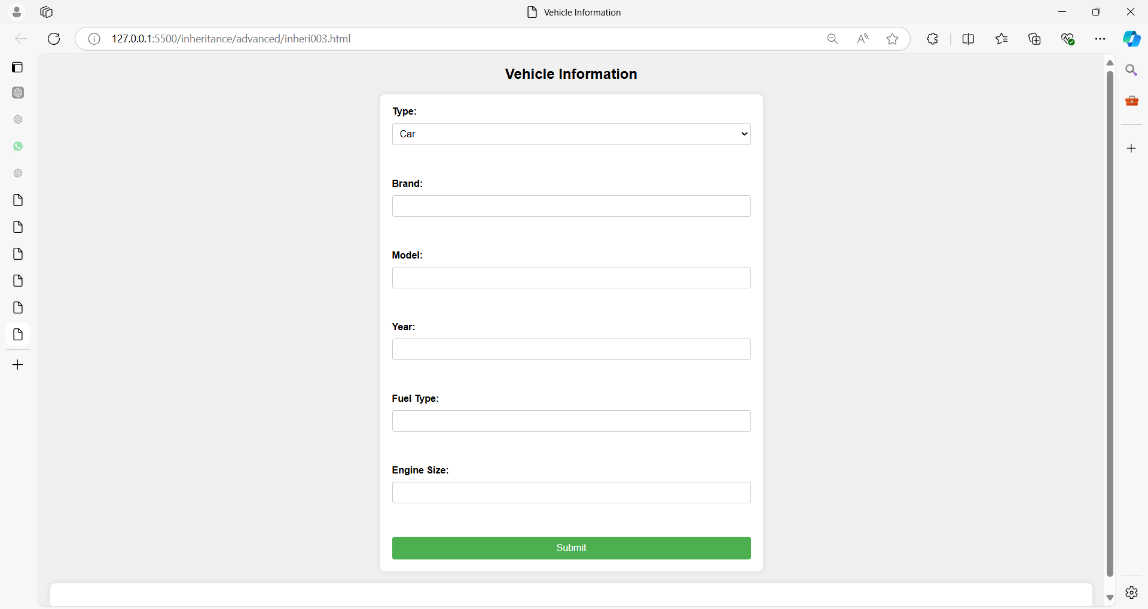

**HTML (index.html):**

<!DOCTYPE html>

<html lang="en">

<head>

<meta charset="UTF-8">

<meta name="viewport" content="width=device-width, initial-scale=1.0">

<title>Vehicle Information</title>

<link rel="stylesheet" href="styles001.css">

</head>

<body>

<h2>Vehicle Information</h2>

<form id="vehicleForm">

<label for="type">Type:</label>

<select id="type" name="type" required>

<option value="car">Car</option>

<option value="motorcycle">Motorcycle</option>

<option value="truck">Truck</option>

</select><br><br>

<label for="brand">Brand:</label>

<input type="text" id="brand" name="brand" required><br><br>

<label for="model">Model:</label>

<input type="text" id="model" name="model" required><br><br>

<label for="year">Year:</label>

<input type="number" id="year" name="year" min="1900" max="2099" required><br><br>

<label for="fuel">Fuel Type:</label>

<input type="text" id="fuel" name="fuel" required><br><br>

<label for="engine">Engine Size:</label>

<input type="text" id="engine" name="engine" required><br><br>

<button type="submit">Submit</button>

</form>

<div id="result"></div>

<script src="script001.js"></script>

</body>

</html>

**CSS (styles003.css):**

body {

font-family: Arial, sans-serif;

background-color: #f0f0f0;

margin: 20px;

padding: 0;

}

h2 {

text-align: center;

margin-bottom: 20px;

}

#vehicleForm {

max-width: 600px;

margin: 0 auto;

background-color: #fff;

padding: 20px;

border-radius: 8px;

box-shadow: 0 0 10px rgba(0, 0, 0, 0.1);

}

form {

display: grid;

gap: 10px;

}

label {

font-weight: bold;

}

input[type="text"],

input[type="number"],

select {

width: 100%;

padding: 8px;

font-size: 16px;

border: 1px solid #ccc;

border-radius: 4px;

box-sizing: border-box;

}

button[type="submit"] {

width: 100%;

padding: 10px;

background-color: #4CAF50;

color: white;

border: none;

border-radius: 4px;

cursor: pointer;

font-size: 16px;

}

button[type="submit"]:hover {

background-color: #45a049;

}

#result {

margin-top: 20px;

padding: 20px;

background-color: #fff;

border-radius: 8px;

box-shadow: 0 0 10px rgba(0, 0, 0, 0.1);

}

#result h3 {

margin-top: 0;

color: #333;

}

#result p {

margin: 5px 0;

font-size: 16px;

line-height: 1.5;

}

**Explanation:**

1. **Body Styling**:
   * Sets the overall font family and a light gray background color for the entire page.
2. **Form (#vehicleForm)**:
   * Centers the form horizontally (max-width and margin: 0 auto).
   * Provides a white background, padding, rounded corners (border-radius), and a subtle box shadow for a card-like appearance.
   * Ensures a grid layout for form elements (form { display: grid; gap: 10px; }) with evenly spaced gaps (gap: 10px;).
3. **Form Elements Styling**:
   * Enhances the appearance of labels (label { font-weight: bold; }).
   * Standardizes input fields (input[type="text"], input[type="number"], select) with consistent padding, font size, border, and border-radius.
4. **Submit Button Styling**:
   * Defines a green background color for the submit button (button[type="submit"]), with white text, rounded corners, and no border.
   * Adds a hover effect (button[type="submit"]:hover) to darken the background color slightly when hovered.
5. **Result Display (#result)**:
   * Styles the result display area (#result) with padding, white background, rounded corners, and a box shadow for clarity.
   * Ensures the result heading (#result h3) has no top margin (margin-top: 0;) and uses a darker color for better contrast.
   * Sets a comfortable margin (margin: 5px 0;) and font size for paragraphs (#result p) within the result area.

**Usage:**

* Save the CSS code in a file named styles.css.
* Link this stylesheet in your index.html file within the <head> section: <link rel="stylesheet" href="styles.css">.
* Ensure the structure of your HTML (index.html), JavaScript (app.js), and CSS (styles.css) files are correctly referenced and placed in the same directory.

This CSS stylesheet enhances the visual appeal and user experience of the vehicle information form and results display, providing a clean and modern look while maintaining responsiveness and accessibility. Adjustments can be made based on specific design preferences or additional styling requirements.

**JavaScript (script003.js):**

// Parent class: Vehicle

class Vehicle {

constructor(type, brand, model, year, fuel, engine) {

this.type = type;

this.brand = brand;

this.model = model;

this.year = year;

this.fuel = fuel;

this.engine = engine;

}

// Method in parent class

getDetails() {

return `${this.year} ${this.brand} ${this.model}`;

}

// Method in parent class

start() {

return `${this.brand} ${this.model} started.`;

}

// Method in parent class

stop() {

return `${this.brand} ${this.model} stopped.`;

}

}

// Child class: Car

class Car extends Vehicle {

constructor(brand, model, year, fuel, engine, doors) {

super('Car', brand, model, year, fuel, engine);

this.doors = doors;

}

// Method in child class

getDetails() {

return `${super.getDetails()}, ${this.engine}L, ${this.doors} doors`;

}

// Method in child class

drive() {

return `${this.brand} ${this.model} is driving smoothly.`;

}

}

// Child class: Motorcycle

class Motorcycle extends Vehicle {

constructor(brand, model, year, fuel, engine) {

super('Motorcycle', brand, model, year, fuel, engine);

}

// Method in child class

getDetails() {

return `${super.getDetails()}, ${this.engine}cc`;

}

// Method in child class

wheelie() {

return `${this.brand} ${this.model} popped a wheelie!`;

}

}

// Child class: Truck

class Truck extends Vehicle {

constructor(brand, model, year, fuel, engine, capacity) {

super('Truck', brand, model, year, fuel, engine);

this.capacity = capacity;

}

// Method in child class

getDetails() {

return `${super.getDetails()}, ${this.engine}L, ${this.capacity} ton capacity`;

}

// Method in child class

haul() {

return `${this.brand} ${this.model} is hauling a heavy load.`;

}

}

// Form submission handler

document.getElementById('vehicleForm').addEventListener('submit', function(event) {

event.preventDefault();

const type = document.getElementById('type').value;

const brand = document.getElementById('brand').value;

const model = document.getElementById('model').value;

const year = document.getElementById('year').value;

const fuel = document.getElementById('fuel').value;

const engine = document.getElementById('engine').value;

let vehicle;

if (type === 'car') {

const doors = parseInt(prompt('Enter number of doors:'));

vehicle = new Car(brand, model, year, fuel, engine, doors);

} else if (type === 'motorcycle') {

vehicle = new Motorcycle(brand, model, year, fuel, engine);

} else if (type === 'truck') {

const capacity = parseFloat(prompt('Enter hauling capacity in tons:'));

vehicle = new Truck(brand, model, year, fuel, engine, capacity);

}

// Output result

const resultDiv = document.getElementById('result');

resultDiv.innerHTML = `

<h3>Vehicle Details:</h3>

<p>Type: ${vehicle.type}</p>

<p>Details: ${vehicle.getDetails()}</p>

<p>Fuel Type: ${vehicle.fuel}</p>

<p>Engine: ${vehicle.engine}</p>

<p>${vehicle.start()}</p>

`;

});

**Explanation:**

1. **HTML (index.html)**:
   * The HTML contains a form (vehicleForm) with input fields for selecting Type (Car, Motorcycle, Truck), Brand, Model, Year, Fuel Type, and Engine Size.
   * It has a submit button to trigger form submission.
2. **JavaScript (script001.js)**:
   * **Parent Class (Vehicle)**:
     + Vehicle is defined as an ES6 class with a constructor that initializes properties such as type, brand, model, year, fuel, and engine.
     + It has methods getDetails() (returns basic details about the vehicle), start() (simulates starting the vehicle), and stop() (simulates stopping the vehicle).
   * **Child Classes (Car, Motorcycle, Truck)**:
     + Each child class (Car, Motorcycle, Truck) extends Vehicle using extends.
     + They inherit properties from Vehicle and add their specific properties (doors for Car, capacity for Truck) and methods (drive() for Car, wheelie() for Motorcycle, haul() for Truck).
     + They override the getDetails() method to include their specific details.
   * **Form Submission Handler**:
     + Event listener (submit) is attached to the form (vehicleForm).
     + When the form is submitted, it prevents the default action.
     + It retrieves the form input values (type, brand, model, year, fuel, engine).
     + Depending on the selected type (car, motorcycle, truck), it creates an instance of the corresponding class (Car, Motorcycle, Truck) with additional prompts for specific details (doors for Car, capacity for Truck).
     + It then displays the vehicle details and a simulated start message in the result div.

**Usage:**

* Select a Type (Car, Motorcycle, Truck) and enter corresponding details (Brand, Model, Year, Fuel Type, Engine Size).
* Click on "Submit".
* The vehicle details including its type-specific details and a simulated start message will be displayed below the form.

This example demonstrates the use of inheritance with ES6 classes in JavaScript to model different types of vehicles and their behaviors. The form allows interactive creation of vehicle instances with specific attributes, showing how inheritance simplifies code organization and promotes code reuse in object-oriented programming.

**What are closures in javascript?**

In JavaScript, **closures** are a fundamental concept that allows functions to remember the **lexical scope** in which they were defined, even when the function is executed outside that lexical scope.

A closure occurs when a function is defined inside another function (the outer function), and has access to variables that are declared and defined in the outer function, even after the outer function has finished executing.

Here’s a breakdown of key points about closures in JavaScript:

1. **Definition Scope**:
   1. In JavaScript, each function has its own lexical scope, which means it has access to variables defined in its parent functions.
2. **Closure Formation**:
   1. When a function is defined within another function and it accesses variables from the outer function's scope, a closure is formed.
   2. This closure allows the inner function to access those variables even after the outer function has completed execution.
3. **Accessing Outer Variables**:
   1. Closures have access to the outer function’s variable scope chain, including the variables and parameters of the outer function and any variables from its parent functions.
4. **Use Cases**:
   1. Closures are often used for data encapsulation, creating private variables and methods, and maintaining state in functional programming paradigms where functions are treated as first-class citizens.
5. **Memory Management**:
   1. Closures can lead to retaining memory longer than expected if not managed carefully, as they keep references to their outer function's variables.

**Here’s are simple examples to illustrate closures in JavaScript:**

**Example 01**

function outerFunction(outerVariable) {

// Inner function defined inside outerFunction

function innerFunction(innerVariable) {

console.log(outerVariable + innerVariable);

}

// Return the inner function from the outer function

return innerFunction;

}

// Create a closure by calling outerFunction

let closure = outerFunction(3);

// Call the closure, it still has access to outerVariable

closure(5); // Output: 8

In this example:

* **outerFunction** defines **outerVariable** and **innerFunction**.
* **innerFunction** accesses **outerVariable** even after **outerFunction** has finished executing.
* closure retains the scope of **outerFunction** and can still access **outerVariable**.

Understanding closures is crucial for effective JavaScript programming, especially when dealing with asynchronous operations, callbacks, and maintaining state in functional programming paradigms.

**Example 02**

Imagine you have a function makeCounter that generates and returns a counter function.

Each time you call makeCounter, it creates a new counter that starts from a specified initial value.

Here’s how you can implement it using closures:

**function makeCounter(initialValue) {**

// Local variable to store the current count

let counter = initialValue;

// Inner function (closure) that will be returned

**function increment() {**

// Increment the counter variable

counter++;

console.log(counter);

}

// Return the inner function increment

return increment;

}

// Create two counters with different initial values

let counter1 = makeCounter(0);

let counter2 = makeCounter(10);

// Call counter1 multiple times

counter1(); // Output: 1

counter1(); // Output: 2

// Call counter2 multiple times

counter2(); // Output: 11

counter2(); // Output: 12

**In this example:**

1. **makeCounter Function**: This function takes an initialValue parameter and defines a local variable counter to store the current count.
2. **increment Function (Closure)**: Inside makeCounter, there is an inner function increment that increments the counter variable and logs its value to the console.
3. **Closure Formation**: When makeCounter is called with an initial value (makeCounter(0) and makeCounter(10)), it returns a reference to the increment function. Each time makeCounter is called, it creates a new closure where counter is accessible and can be modified by the increment function.
4. **Usage of Closures**: counter1 and counter2 are two independent counters created by calling makeCounter with different initial values. They each have their own counter variable, which is accessible and modifiable only by their respective increment function.
5. **Persistent State**: The closures (increment functions) retain access to the counter variable even after makeCounter has finished executing. This allows counter1 and counter2 to maintain their own separate counts without interference.

Closures are powerful because they allow functions to retain access to variables from the scope in which they were created, even when those functions are called outside that scope.

They are commonly used for creating private variables and methods, implementing function factories, and managing state in JavaScript applications.

**Example 03**

**Bank Account Management System**

Imagine we want to create a system where we can create multiple bank accounts, deposit and withdraw money from these accounts, and check the balance.

Each account should have its own balance and operations should be secure and isolated to each account.

function **createAccount**(accountName, initialBalance) {

// Private variables accessible only inside createAccount function

let accountHolder = accountName;

let balance = initialBalance;

// Inner functions (closures) that have access to private variables

function deposit(amount) {

if (amount > 0) {

balance += amount;

console.log(`${accountHolder}'s account: Deposit of ${amount}. New balance is ${balance}`);

}

else {

console.log(`Invalid deposit amount for ${accountHolder}'s account`);

}

}

function withdraw(amount) {

if (amount > 0 && amount <= balance) {

balance -= amount;

console.log(`${accountHolder}'s account: Withdrawal of ${amount}. New balance is ${balance}`);

}

else {

console.log(`Insufficient funds for ${accountHolder}'s account or invalid withdrawal amount`);

}

}

function checkBalance() {

console.log(`${accountHolder}'s account: Current balance is ${balance}`);

}

// Return an object with methods that can interact with the account

return {

deposit,

withdraw,

checkBalance

};

}

// Create two bank accounts

let account1 = createAccount('Alice', 500);

let account2 = createAccount('Bob', 1000);

// Perform operations on account1

account1.checkBalance(); // Output: Alice's account: Current balance is 500

account1.deposit(200); // Output: Alice's account: Deposit of 200. New balance is 700

account1.withdraw(300); // Output: Alice's account: Withdrawal of 300. New balance is 400

account1.checkBalance(); // Output: Alice's account: Current balance is 400

// Perform operations on account2

account2.checkBalance(); // Output: Bob's account: Current balance is 1000

account2.withdraw(1200); // Output: Insufficient funds for Bob's account or invalid withdrawal amount

account2.deposit(500); // Output: Bob's account: Deposit of 500. New balance is 1500

account2.checkBalance(); // Output: Bob's account: Current balance is 1500

**Explanation:**

1. **createAccount Function**: This function creates a new bank account with an initial balance and returns an object with methods (deposit, withdraw, checkBalance) that interact with the account.
2. **Private Variables**: accountHolder and balance are private variables that are only accessible within the scope of createAccount due to closures. Each time createAccount is called, a new set of private variables is created, ensuring isolation between different accounts.
3. **Inner Functions (Closures)**: deposit, withdraw, and checkBalance are inner functions that have access to the private variables (accountHolder and balance). They can modify the balance based on deposit and withdrawal operations, and retrieve the current balance.
4. **Usage of Closures**: When createAccount is called to create account1 and account2, each account gets its own set of private variables (accountHolder and balance). The methods (deposit, withdraw, checkBalance) operate on these private variables through closures, ensuring that operations on one account do not affect another.
5. **Method Calls**: account1 and account2 demonstrate how methods can be called to perform operations on their respective accounts, displaying appropriate messages and updating balances accordingly.

This example illustrates how closures are used to create encapsulated and secure environments for managing state and operations in JavaScript applications.

Each bank account maintains its own state (balance) and operations (deposit, withdraw) are performed securely within the scope of closures.

**Example 04**

**Task Manager Example**

function **TaskManager**() {

let tasks = []; // Private array to store tasks

// Inner functions (closures) that interact with private data

function addTask(task) {

tasks.push(task);

console.log(`Task "${task}" added successfully`);

}

function completeTask(task) {

let index = tasks.indexOf(task);

if (index !== -1) {

tasks.splice(index, 1);

console.log(`Task "${task}" completed and removed`);

} else {

console.log(`Task "${task}" not found`);

}

}

function listTasks() {

return tasks.slice(); // Return a copy of tasks array

}

// Public methods exposed through the TaskManager object

return {

addTask,

completeTask,

listTasks

};

}

// Create a TaskManager instance

let taskManager = TaskManager();

// Example usage of the TaskManager methods

taskManager.addTask('Task 1'); // Output: Task "Task 1" added successfully

taskManager.addTask('Task 2'); // Output: Task "Task 2" added successfully

console.log(taskManager.listTasks()); // Output: ["Task 1", "Task 2"]

taskManager.completeTask('Task 1'); // Output: Task "Task 1" completed and removed

console.log(taskManager.listTasks()); // Output: ["Task 2"]

taskManager.completeTask('Task 3'); // Output: Task "Task 3" not found

**Explanation:**

1. **TaskManager Function**: This function creates a task manager instance with private data (tasks array) and methods (addTask, completeTask, listTasks) that interact with this private data.
2. **Inner Functions (Closures)**:
   * addTask(task): Adds a task to the tasks array synchronously.
   * completeTask(task): Completes and removes a task from the tasks array synchronously.
   * listTasks(): Returns a copy of the tasks array synchronously.

Each of these functions is a closure that has access to the tasks array due to the lexical scope chain.

1. **Synchronous Operations**: Operations (addTask, completeTask, listTasks) are performed synchronously without delays (setTimeout). Tasks are added, completed, and listed immediately.
2. **TaskManager Instance**: taskManager is an instance of TaskManager created to manage tasks.
3. **Example Usage**:
   * Calls addTask twice to add tasks synchronously (Task 1, Task 2).
   * Calls listTasks to list all tasks synchronously.
   * Calls completeTask to complete and remove Task 1 synchronously.
   * Calls listTasks again to list remaining tasks (Task 2).
   * Attempts to complete a non-existent task (Task 3) and logs an appropriate message.

This example demonstrates how closures in JavaScript can encapsulate data (tasks array) and operations (addTask, completeTask, listTasks) while handling synchronous operations effectively.

Closures maintain the state of tasks across method calls, ensuring that operations are performed securely and without interference between tasks.

Top of Form

**Example 05**

Let's create a more involved example using closures to simulate a basic shopping cart functionality.

In this example, we'll manage items, their quantities, calculate totals, and provide methods to add, remove, and list items in the cart.

**Shopping Cart Example**

function ShoppingCart() {

let cartItems = []; // Private array to store cart items

// Inner functions (closures) that interact with private data

function addItem(item, price, quantity = 1) {

let index = findItemIndex(item);

if (index !== -1) {

// Item already exists in cart, update quantity

cartItems[index].quantity += quantity;

console.log(`Added ${quantity} more "${item}" to the cart`);

} else {

// Add new item to cart

cartItems.push({ item, price, quantity });

console.log(`Added "${item}" to the cart`);

}

}

function removeItem(item) {

let index = findItemIndex(item);

if (index !== -1) {

cartItems.splice(index, 1);

console.log(`Removed "${item}" from the cart`);

} else {

console.log(`"${item}" not found in the cart`);

}

}

function updateQuantity(item, quantity) {

let index = findItemIndex(item);

if (index !== -1) {

cartItems[index].quantity = quantity;

console.log(`Updated quantity of "${item}" to ${quantity}`);

} else {

console.log(`"${item}" not found in the cart`);

}

}

function listItems() {

return cartItems.map(item => ({

item: item.item,

price: item.price,

quantity: item.quantity,

total: item.price * item.quantity

}));

}

function findItemIndex(item) {

return cartItems.findIndex(i => i.item === item);

}

function getTotal() {

let total = cartItems.reduce((acc, item) => acc + item.price * item.quantity, 0);

return total.toFixed(2); // Return total formatted to 2 decimal places

}

// Public methods exposed through the ShoppingCart object

return {

addItem,

removeItem,

updateQuantity,

listItems,

getTotal

};

}

// Create a ShoppingCart instance

let cart = ShoppingCart();

// Example usage of the ShoppingCart methods

cart.addItem('Shirt', 25); // Output: Added "Shirt" to the cart

cart.addItem('Pants', 40, 2); // Output: Added 2 more "Pants" to the cart

console.log(cart.listItems());

// Output: [{ item: "Shirt", price: 25, quantity: 1, total: 25 }, { item: "Pants", price: 40, quantity: 2, total: 80 }]

cart.updateQuantity('Pants', 3); // Output: Updated quantity of "Pants" to 3

console.log(cart.getTotal()); // Output: 145.00

cart.removeItem('Shoes'); // Output: "Shoes" not found in the cart

cart.removeItem('Shirt'); // Output: Removed "Shirt" from the cart

console.log(cart.listItems());

// Output: [{ item: "Pants", price: 40, quantity: 3, total: 120 }]

**Explanation:**

1. **ShoppingCart Function**: This function creates a shopping cart instance with private data (cartItems array) and methods (addItem, removeItem, updateQuantity, listItems, getTotal) that interact with this private data.
2. **Inner Functions (Closures)**:
   * addItem(item, price, quantity): Adds an item to the cart with an optional quantity.
   * removeItem(item): Removes an item from the cart.
   * updateQuantity(item, quantity): Updates the quantity of an item in the cart.
   * listItems(): Returns an array of objects representing items in the cart with their details (item, price, quantity, total).
   * getTotal(): Calculates and returns the total price of all items in the cart.

Each of these functions is a closure that has access to the cartItems array due to the lexical scope chain.

1. **Usage of Closures**: Closures ensure that each method (addItem, removeItem, updateQuantity, listItems, getTotal) maintains access to the cartItems array and can manipulate it securely.
2. **ShoppingCart Instance**: cart is an instance of ShoppingCart created to manage items in the cart.
3. **Example Usage**:
   * Calls addItem to add items (Shirt and Pants) with specified prices and quantities.
   * Calls listItems to list all items in the cart.
   * Calls updateQuantity to change the quantity of an item (Pants).
   * Calls getTotal to calculate and log the total price of all items in the cart.
   * Calls removeItem to remove items (Shoes and Shirt) from the cart.
   * Logs the updated list of items in the cart after removals.

This example demonstrates how closures in JavaScript can encapsulate data (cartItems array) and operations (addItem, removeItem, updateQuantity, listItems, getTotal) while managing shopping cart functionality effectively. Closures ensure that operations on the shopping cart are secure and isolated, maintaining the integrity of the cart's state across method calls.

**Example 06:**

Let's dive into a more comprehensive example that involves creating a simple blogging platform. In this example, we'll implement functionality for managing users, posts, comments, and interactions between them using closures in JavaScript.

**Blogging Platform Example**

function BloggingPlatform() {

let users = []; // Private array to store users

let posts = []; // Private array to store posts

// Inner functions (closures) that interact with private data

function registerUser(username, email) {

let newUser = { username, email, id: generateUserId() };

users.push(newUser);

console.log(`User ${username} registered with email ${email}`);

return newUser.id;

}

function createPost(userId, title, content) {

let author = findUserById(userId);

if (!author) {

console.log(`User with ID ${userId} not found`);

return;

}

let newPost = { id: generatePostId(), author, title, content, comments: [] };

posts.push(newPost);

console.log(`Post "${title}" created by ${author.username}`);

return newPost.id;

}

function addComment(postId, userId, text) {

let post = findPostById(postId);

if (!post) {

console.log(`Post with ID ${postId} not found`);

return;

}

let commenter = findUserById(userId);

if (!commenter) {

console.log(`User with ID ${userId} not found`);

return;

}

let newComment = { id: generateCommentId(), commenter, text };

post.comments.push(newComment);

console.log(`Comment added to post "${post.title}" by ${commenter.username}`);

return newComment.id;

}

function listUsers() {

return users.map(user => ({ username: user.username, email: user.email }));

}

function listPosts() {

return posts.map(post => ({

title: post.title,

author: post.author.username,

comments: post.comments.map(comment => ({

commenter: comment.commenter.username,

text: comment.text

}))

}));

}

function findUserById(userId) {

return users.find(user => user.id === userId);

}

function findPostById(postId) {

return posts.find(post => post.id === postId);

}

function generateUserId() {

return users.length > 0 ? users[users.length - 1].id + 1 : 1;

}

function generatePostId() {

return posts.length > 0 ? posts[posts.length - 1].id + 1 : 1;

}

function generateCommentId() {

let maxId = 0;

posts.forEach(post => {

post.comments.forEach(comment => {

if (comment.id > maxId) {

maxId = comment.id;

}

});

});

return maxId + 1;

}

// Public methods exposed through the BloggingPlatform object

return {

registerUser,

createPost,

addComment,

listUsers,

listPosts

};

}

// Create a BloggingPlatform instance

let bloggingPlatform = BloggingPlatform();

// Example usage of the BloggingPlatform methods

let userId1 = bloggingPlatform.registerUser('alice123', 'alice@example.com'); // Output: User alice123 registered with email alice@example.com

let userId2 = bloggingPlatform.registerUser('bob456', 'bob@example.com'); // Output: User bob456 registered with email bob@example.com

let postId1 = bloggingPlatform.createPost(userId1, 'First Post', 'Hello world!'); // Output: Post "First Post" created by alice123

let postId2 = bloggingPlatform.createPost(userId2, 'Second Post', 'This is my second post.'); // Output: Post "Second Post" created by bob456

bloggingPlatform.addComment(postId1, userId2, 'Great first post, Alice!'); // Output: Comment added to post "First Post" by bob456

bloggingPlatform.addComment(postId2, userId1, 'Nice second post, Bob!'); // Output: Comment added to post "Second Post" by alice123

console.log(bloggingPlatform.listUsers());

/*

Output:

[

{ username: 'alice123', email: 'alice@example.com' },

{ username: 'bob456', email: 'bob@example.com' }

]

*/

console.log(bloggingPlatform.listPosts());

/*

Output:

[

{

title: 'First Post',

author: 'alice123',

comments: [

{ commenter: 'bob456', text: 'Great first post, Alice!' }

]

},

{

title: 'Second Post',

author: 'bob456',

comments: [

{ commenter: 'alice123', text: 'Nice second post, Bob!' }

]

}

]

*/

**Explanation:**

1. **BloggingPlatform Function**: This function creates a blogging platform instance with private data (users and posts arrays) and methods (registerUser, createPost, addComment, listUsers, listPosts) that interact with this private data.
2. **Inner Functions (Closures)**:
   * registerUser(username, email): Registers a new user with a unique ID and stores their username and email in the users array.
   * createPost(userId, title, content): Creates a new post authored by a user identified by userId and stores it in the posts array.
   * addComment(postId, userId, text): Adds a comment to a post identified by postId by a user identified by userId and stores it within the post's comments array.
   * listUsers(): Returns an array of objects containing usernames and emails of all registered users.
   * listPosts(): Returns an array of objects containing post titles, authors, and comments (commenter username and text) for each post.

Each of these functions is a closure that has access to the users and posts arrays due to the lexical scope chain.

1. **Usage of Closures**: Closures ensure that each method (registerUser, createPost, addComment, listUsers, listPosts) maintains access to the users and posts arrays and can manipulate them securely.
2. **BloggingPlatform Instance**: bloggingPlatform is an instance of BloggingPlatform created to manage users, posts, and comments within the blogging platform.
3. **Example Usage**:
   * Calls registerUser to register two users (alice123 and bob456) with their usernames and emails.
   * Calls createPost to create two posts authored by alice123 and bob456.
   * Calls addComment to add comments to the created posts by different users.
   * Calls listUsers and listPosts to list all registered users and their details, and all posts with their details and comments.

This example demonstrates how closures in JavaScript can encapsulate data (users and posts arrays) and operations (registerUser, createPost, addComment, listUsers, listPosts) while managing a blogging platform effectively. Closures ensure that operations on users, posts, and comments are secure and isolated, maintaining the integrity of the platform's state across method calls.

**Example 07:**

Here's a **real-time "To-Do List with Category Filters" web application** that demonstrates the **concept of JavaScript closures** in action.

Closures are used here to **encapsulate task-related operations** inside a function while still allowing access to variables from the outer lexical environment.

**Features:**

* Add tasks with categories
* Filter tasks by category
* Closures used for each task's delete and complete functionality
* Includes **CSS3** styling
* Fully working **JavaScript** code

**index.html**

<!DOCTYPE html>

<html lang="en">

<head>

<meta charset="UTF-8">

<title>To-Do List with Closures</title>

<link rel="stylesheet" href="style.css">

</head>

<body>

<div class="app">

<h1>To-Do List</h1>

<form id="taskForm">

<input type="text" id="taskInput" placeholder="Enter task" required>

<select id="categoryInput">

<option value="Work">Work</option>

<option value="Personal">Personal</option>

<option value="Urgent">Urgent</option>

</select>

<button type="submit">Add Task</button>

</form>

<div class="filter-section">

<label>Filter by Category:</label>

<select id="filterCategory">

<option value="All">All</option>

<option value="Work">Work</option>

<option value="Personal">Personal</option>

<option value="Urgent">Urgent</option>

</select>

</div>

<ul id="taskList"></ul>

</div>

<script src="script.js"></script>

</body>

</html>

**style.css**

body {

font-family: 'Segoe UI', sans-serif;

background: linear-gradient(to right, #74ebd5, #acb6e5);

margin: 0;

padding: 0;

display: flex;

justify-content: center;

align-items: flex-start;

height: 100vh;

}

.app {

background-color: white;

padding: 30px;

margin-top: 50px;

border-radius: 15px;

box-shadow: 0 0 10px rgba(0,0,0,0.2);

width: 400px;

}

h1 {

text-align: center;

color: #333;

}

form {

display: flex;

gap: 10px;

margin-bottom: 20px;

}

input, select, button {

padding: 10px;

border-radius: 5px;

border: 1px solid #ccc;

flex: 1;

}

button {

background-color: #28a745;

color: white;

cursor: pointer;

}

button:hover {

background-color: #218838;

}

.filter-section {

margin-bottom: 20px;

text-align: center;

}

ul {

list-style: none;

padding: 0;

}

li {

background-color: #f4f4f4;

margin-bottom: 10px;

padding: 15px;

border-radius: 5px;

position: relative;

}

.task-actions {

position: absolute;

right: 10px;

top: 15px;

}

.task-actions button {

margin-left: 5px;

padding: 5px 10px;

border: none;

border-radius: 3px;

}

.complete {

background-color: #007bff;

color: white;

}

.delete {

background-color: #dc3545;

color: white;

}

.completed {

text-decoration: line-through;

color: gray;

}

**script.js (Closure Concept)**

document.addEventListener('DOMContentLoaded', function () {

const taskForm = document.getElementById('taskForm');

const taskInput = document.getElementById('taskInput');

const categoryInput = document.getElementById('categoryInput');

const taskList = document.getElementById('taskList');

const filterCategory = document.getElementById('filterCategory');

let tasks = [];

// Add Task

taskForm.addEventListener('submit', function (e) {

e.preventDefault();

const taskText = taskInput.value.trim();

const taskCategory = categoryInput.value;

if (taskText !== '') {

const taskObj = {

text: taskText,

category: taskCategory,

completed: false

};

tasks.push(taskObj);

taskInput.value = '';

renderTasks();

}

});

// Filter Tasks

filterCategory.addEventListener('change', renderTasks);

function renderTasks() {

taskList.innerHTML = '';

const selectedCategory = filterCategory.value;

tasks.forEach((task, index) => {

if (selectedCategory === 'All' || task.category === selectedCategory) {

const li = document.createElement('li');

li.className = task.completed ? 'completed' : '';

li.textContent = `${task.text} [${task.category}]`;

const actionDiv = document.createElement('div');

actionDiv.className = 'task-actions';

// Closure Example: deleteTask and toggleComplete are closures

function createDeleteHandler(taskIndex) {

return function () {

tasks.splice(taskIndex, 1);

renderTasks();

};

}

function createToggleCompleteHandler(taskIndex) {

return function () {

tasks[taskIndex].completed = !tasks[taskIndex].completed;

renderTasks();

};

}

const completeBtn = document.createElement('button');

completeBtn.textContent = '✔';

completeBtn.className = 'complete';

completeBtn.onclick = createToggleCompleteHandler(index); // Closure

const deleteBtn = document.createElement('button');

deleteBtn.textContent = '✘';

deleteBtn.className = 'delete';

deleteBtn.onclick = createDeleteHandler(index); // Closure

actionDiv.appendChild(completeBtn);

actionDiv.appendChild(deleteBtn);

li.appendChild(actionDiv);

taskList.appendChild(li);

}

});

}

});

**How Closure Works Here**

**Key Functions:**

function createDeleteHandler(taskIndex) {

return function () {

tasks.splice(taskIndex, 1);

renderTasks();

};

}

* This function **returns a function** that “remembers” the value of taskIndex at the time it was created.
* Even after the outer function is done running, the returned function still has access to taskIndex — this is a **closure**.

**Same goes for:**

function createToggleCompleteHandler(taskIndex) {

return function () {

tasks[taskIndex].completed = !tasks[taskIndex].completed;

renderTasks();

};

}

**Benefits of Using Closure:**

* Prevents global variable pollution
* Allows encapsulation of state (like taskIndex)
* Makes code modular and reusable

**What is JSON in javascript?**

JSON (**JavaScript Object Notation**) is a lightweight data interchange format that is easy for humans to read and write and easy for machines to parse and generate.

It is used primarily to transmit data between a server and a web application, serving as an alternative to XML.

**Key Characteristics of JSON**

1. **Human-Readable**: JSON is written in a text format that is easy to read and understand.
2. **Language-Independent**: Although it originated from JavaScript, JSON is language-independent and is supported by many programming languages.
3. **Lightweight**: JSON uses a minimal format, making it efficient to use over networks.

**JSON Syntax**

JSON syntax is derived from JavaScript object notation syntax, but it's text-only.

Here are the primary components:

1. **Objects**: Objects are collections of key/value pairs.
2. **Arrays**: Arrays are ordered lists of values.
3. **Values**: Values can be strings, numbers, objects, arrays, true, false, or null.

**Example of a JSON Object**

{

"name": "John Doe",

"age": 30,

"isStudent": false,

"courses": ["Math", "Science", "History"],

"address": {

"street": "123 Main St",

"city": "Anytown",

"state": "CA"

}

}

**Using JSON in JavaScript**

In JavaScript, you can easily convert data to and from JSON using the JSON object.

**Converting JavaScript Objects to JSON (Serialization)**

You can convert a JavaScript object to a JSON string using the JSON.stringify() method.

const person = {

name: "John Doe",

age: 30,

isStudent: false,

courses: ["Math", "Science", "History"],

address: {

street: "123 Main St",

city: "Anytown",

state: "CA"

}

};

const jsonString = JSON.stringify(person);

console.log(jsonString);

**Converting JSON to JavaScript Objects (Deserialization)**

You can convert a JSON string back to a JavaScript object using the JSON.parse() method.

const jsonString = '{"name":"John Doe","age":30,"isStudent":false,"courses":["Math","Science","History"],"address":{"street":"123 Main St","city":"Anytown","state":"CA"}}';

const person = JSON.parse(jsonString);

console.log(person);

**Advantages of JSON**

1. **Simplicity**: JSON has a straightforward structure with minimal syntax.
2. **Efficiency**: JSON's lightweight format reduces the amount of data transmitted.
3. **Interoperability**: JSON is language-independent and supported by many programming languages, making it a universal data format.
4. **Ease of Use**: JSON methods (JSON.stringify and JSON.parse) make it easy to work with JSON in JavaScript.

**Use Cases**

* **APIs**: JSON is commonly used to exchange data between a server and a client in web APIs.
* **Configuration Files**: JSON is often used for configuration files because of its readability.
* **Data Storage**: Some NoSQL databases (like MongoDB) use a JSON-like format for storing data.

In summary, JSON is an essential part of modern web development, providing a simple and effective way to exchange data between servers and web applications.

**Example 1: Parsing JSON Data**

Suppose you have a JSON string that you received from a server, and you want to convert it into a JavaScript object.

const jsonString = '{"name": "Alice", "age": 25, "city": "Wonderland"}';

// Parse the JSON string into a JavaScript object

const user = JSON.parse(jsonString);

console.log(user.name); // Output: Alice

console.log(user.age); // Output: 25

console.log(user.city); // Output: Wonderland

**Example 2: Stringifying JavaScript Objects**

You can convert a JavaScript object into a JSON string to send it to a server or store it.

const product = {

id: 1,

name: "Laptop",

price: 999.99,

inStock: true

};

// Convert the JavaScript object to a JSON string

const jsonString = JSON.stringify(product);

console.log(jsonString);

// Output: {"id":1,"name":"Laptop","price":999.99,"inStock":true}

**Example 3: Manipulating JSON Data**

Suppose you have a JSON object and you want to manipulate its data.

const jsonString = '{"name": "Alice", "age": 25, "city": "Wonderland"}';

const user = JSON.parse(jsonString);

// Update the user's age

user.age = 26;

// Add a new property

user.country = "Fantasy Land";

// Convert the updated object back to a JSON string

const updatedJsonString = JSON.stringify(user);

console.log(updatedJsonString);

// Output: {"name":"Alice","age":26,"city":"Wonderland","country":"Fantasy Land"}

**Example 4: Fetching and Processing JSON Data from an API**

Here's an example of fetching JSON data from an API and processing it.

<!DOCTYPE html>

<html>

<head>

<title>Fetch JSON Data</title>

</head>

<body>

<div id="userData"></div>

<script>

// URL of the API

const apiUrl = 'https://jsonplaceholder.typicode.com/users/1';

// Fetch data from the API

fetch(apiUrl)

.then(response => response.json()) // Parse JSON data from the response

.then(user => {

// Process the JSON data

const userDataDiv = document.getElementById('userData');

userDataDiv.innerHTML = `

<h2>User Information</h2>

<p>Name: ${user.name}</p>

<p>Email: ${user.email}</p>

<p>City: ${user.address.city}</p>

`;

})

.catch(error => console.error('Error fetching data:', error));

</script>

</body>

</html>

**Example 5: Storing and Retrieving JSON Data from Local Storage**

You can store JSON data in the browser's local storage and retrieve it later.

const settings = {

theme: "dark",

notifications: true,

autoSave: false

};

// Store settings in local storage

localStorage.setItem('userSettings', JSON.stringify(settings));

// Retrieve settings from local storage

const savedSettings = JSON.parse(localStorage.getItem('userSettings'));

console.log(savedSettings);

// Output: {theme: "dark", notifications: true, autoSave: false}

**Example 6: Handling Complex JSON Data**

Sometimes, JSON data can have nested structures, and you need to process these nested structures.

const jsonString = `

{

"name": "Alice",

"age": 25,

"address": {

"street": "123 Main St",

"city": "Wonderland",

"zipcode": "12345"

},

"phones": ["123-456-7890", "987-654-3210"]

}

`;

const user = JSON.parse(jsonString);

// Access nested data

console.log(user.address.city); // Output: Wonderland

console.log(user.phones[0]); // Output: 123-456-7890

// Update nested data

user.address.zipcode = "54321";

user.phones.push("111-222-3333");

// Convert the updated object back to a JSON string

const updatedJsonString = JSON.stringify(user, null, 2);

console.log(updatedJsonString);

/*

Output:

{

"name": "Alice",

"age": 25,

"address": {

"street": "123 Main St",

"city": "Wonderland",

"zipcode": "54321"

},

"phones": [

"123-456-7890",

"987-654-3210",

"111-222-3333"

]

}

*/

These examples cover a range of common tasks involving JSON in JavaScript, including parsing, stringifying, manipulating data, working with APIs, and using local storage.

**Example 07:**

Let's create a more extensive example that combines HTML forms, CSS3 styling, and JavaScript functionality.

This example will be a **User Registration and Login System** that stores user data in local storage.

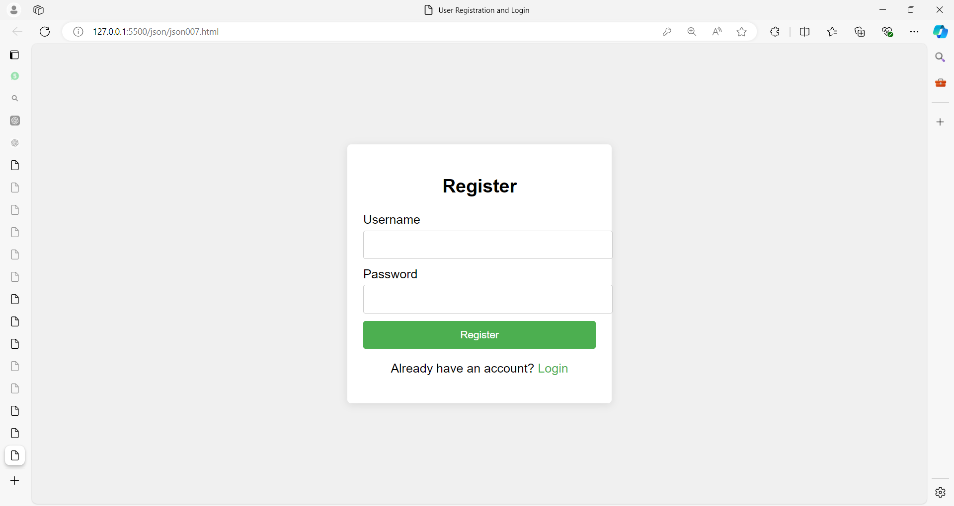

**User Registration and Login System with JSON**

**HTML**

<!DOCTYPE html>

<html lang="en">

<head>

<meta charset="UTF-8">

<meta name="viewport" content="width=device-width, initial-scale=1.0">

<title>User Registration and Login</title>

<link rel="stylesheet" href="styles.css">

</head>

<body>

<div class="container">

<div id="formContainer">

<form id="registrationForm" class="form">

<h2>Register</h2>

<label for="regUsername">Username</label>

<input type="text" id="regUsername" required>

<label for="regPassword">Password</label>

<input type="password" id="regPassword" required>

<button type="submit">Register</button>

<p>Already have an account? <a href="#" id="showLoginForm">Login</a></p>

</form>

<form id="loginForm" class="form hidden">

<h2>Login</h2>

<label for="loginUsername">Username</label>

<input type="text" id="loginUsername" required>

<label for="loginPassword">Password</label>

<input type="password" id="loginPassword" required>

<button type="submit">Login</button>

<p>Don't have an account? <a href="#" id="showRegistrationForm">Register</a></p>

</form>

</div>

<div id="welcomeContainer" class="hidden">

<h2>Welcome, <span id="welcomeUser"></span>!</h2>

<button id="logoutButton">Logout</button>

</div>

</div>

<script src="script.js"></script>

</body>

</html>

**CSS (styles.css)**

body {

font-family: Arial, sans-serif;

background-color: #f0f0f0;

display: flex;

justify-content: center;

align-items: center;

height: 100vh;

margin: 0;

}

.container {

background-color: #fff;

padding: 20px;

border-radius: 5px;

box-shadow: 0 2px 10px rgba(0, 0, 0, 0.1);

width: 300px;

}

h2 {

text-align: center;

margin-bottom: 20px;

}

label {

display: block;

margin-bottom: 5px;

}

input {

width: 100%;

padding: 10px;

margin-bottom: 10px;

border: 1px solid #ccc;

border-radius: 3px;

}

button {

width: 100%;

padding: 10px;

background-color: #4CAF50;

color: #fff;

border: none;

border-radius: 3px;

cursor: pointer;

}

button:hover {

background-color: #45a049;

}

.hidden {

display: none;

}

p {

text-align: center;

}

a {

color: #4CAF50;

text-decoration: none;

}

a:hover {

text-decoration: underline;

}

**JavaScript (script.js)**

document.addEventListener('DOMContentLoaded', () => {

const registrationForm = document.getElementById('registrationForm');

const loginForm = document.getElementById('loginForm');

const formContainer = document.getElementById('formContainer');

const welcomeContainer = document.getElementById('welcomeContainer');

const welcomeUser = document.getElementById('welcomeUser');

const logoutButton = document.getElementById('logoutButton');

const getUsers = () => JSON.parse(localStorage.getItem('users')) || {};

const saveUsers = (users) => localStorage.setItem('users', JSON.stringify(users));

document.getElementById('showLoginForm').addEventListener('click', (e) => {

e.preventDefault();

registrationForm.classList.add('hidden');

loginForm.classList.remove('hidden');

});

document.getElementById('showRegistrationForm').addEventListener('click', (e) => {

e.preventDefault();

loginForm.classList.add('hidden');

registrationForm.classList.remove('hidden');

});

registrationForm.addEventListener('submit', (e) => {

e.preventDefault();

const username = document.getElementById('regUsername').value.trim();

const password = document.getElementById('regPassword').value.trim();

if (username && password) {

const users = getUsers();

if (users[username]) {

alert('Username already exists.');

} else {

users[username] = { password };

saveUsers(users);

alert('Registration successful!');

registrationForm.reset();

registrationForm.classList.add('hidden');

loginForm.classList.remove('hidden');

}

}

else {

alert('Please fill out all fields.');

}

});

loginForm.addEventListener('submit', (e) => {

e.preventDefault();

const username = document.getElementById('loginUsername').value.trim();

const password = document.getElementById('loginPassword').value.trim();

const users = getUsers();

if (users[username] && users[username].password === password) {

formContainer.classList.add('hidden');

welcomeContainer.classList.remove('hidden');

welcomeUser.textContent = username;

} else {

alert('Invalid username or password.');

}

});

logoutButton.addEventListener('click', () => {

formContainer.classList.remove('hidden');

welcomeContainer.classList.add('hidden');

});

});

**Explanation**

* **HTML Structure**: Contains two forms for registration and login, and a welcome message container.
* **CSS Styling**: Basic styling for forms, buttons, and containers, including a hidden class for toggling visibility.
* **JavaScript Logic**:
  + **getUsers Function**: Retrieves the users from local storage and parses them from JSON.
  + **saveUsers Function**: Converts the users object to JSON and stores it in local storage.
  + **Registration Form**: Adds a new user to the JSON object if the username does not already exist.
  + **Login Form**: Validates user credentials against the stored JSON object.
  + **Logout Button**: Shows the registration/login forms and hides the welcome message.

This example demonstrates how to use JSON for storing and managing user data, providing a more structured approach than using individual key-value pairs in local storage.

**Example 08:**

Let's build another comprehensive example using JSON. This time, we'll create a **To-Do List Application** where users can add, edit, and delete tasks. The tasks will be stored as JSON objects in local storage.

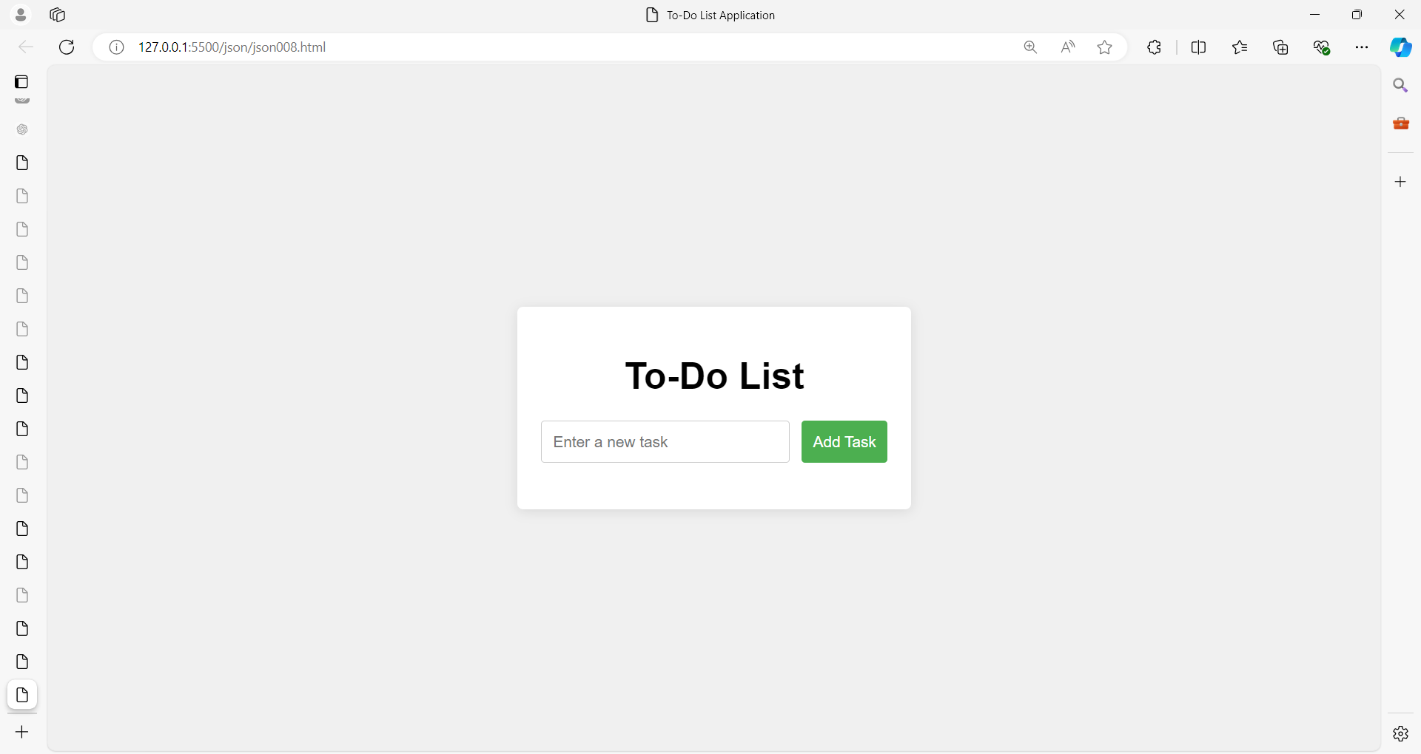

**To-Do List Application with JSON**

**HTML**

<!DOCTYPE html>

<html lang="en">

<head>

<meta charset="UTF-8">

<meta name="viewport" content="width=device-width, initial-scale=1.0">

<title>To-Do List Application</title>

<link rel="stylesheet" href="styles.css">

</head>

<body>

<div class="container">

<h1>To-Do List</h1>

<form id="taskForm">

<input type="text" id="taskInput" placeholder="Enter a new task" required>

<button type="submit">Add Task</button>

</form>

<ul id="taskList"></ul>

</div>

<script src="script.js"></script>

</body>

</html>

**CSS (styles008.css)**

body {

font-family: Arial, sans-serif;

background-color: #f0f0f0;

display: flex;

justify-content: center;

align-items: center;

height: 100vh;

margin: 0;

}

.container {

background-color: #fff;

padding: 20px;

border-radius: 5px;

box-shadow: 0 2px 10px rgba(0, 0, 0, 0.1);

width: 300px;

}

h1 {

text-align: center;

margin-bottom: 20px;

}

form {

display: flex;

gap: 10px;

margin-bottom: 20px;

}

input {

flex: 1;

padding: 10px;

border: 1px solid #ccc;

border-radius: 3px;

}

button {

padding: 10px;

background-color: #4CAF50;

color: #fff;

border: none;

border-radius: 3px;

cursor: pointer;

}

button:hover {

background-color: #45a049;

}

ul {

list-style-type: none;

padding: 0;

}

li {

display: flex;

justify-content: space-between;

align-items: center;

padding: 10px;

border-bottom: 1px solid #ccc;

}

button.edit, button.delete {

background-color: #f0ad4e;

color: #fff;

border: none;

border-radius: 3px;

cursor: pointer;

padding: 5px;

}

button.edit:hover {

background-color: #ec971f;

}

button.delete {

background-color: #d9534f;

}

button.delete:hover {

background-color: #c9302c;

}

**JavaScript (script.js)**

document.addEventListener('DOMContentLoaded', () => {

const taskForm = document.getElementById('taskForm');

const taskInput = document.getElementById('taskInput');

const taskList = document.getElementById('taskList');

const getTasks = () => JSON.parse(localStorage.getItem('tasks')) || [];

const saveTasks = (tasks) => localStorage.setItem('tasks', JSON.stringify(tasks));

const renderTasks = () => {

const tasks = getTasks();

taskList.innerHTML = '';

tasks.forEach((task, index) => {

const li = document.createElement('li');

li.innerHTML = `

<span>${task.text}</span>

<div>

<button class="edit" data-index="${index}">Edit</button>

<button class="delete" data-index="${index}">Delete</button>

</div>

`;

taskList.appendChild(li);

});

};

taskForm.addEventListener('submit', (e) => {

e.preventDefault();

const taskText = taskInput.value.trim();

if (taskText) {

const tasks = getTasks();

tasks.push({ text: taskText });

saveTasks(tasks);

taskInput.value = '';

renderTasks();

}

});

taskList.addEventListener('click', (e) => {

const index = e.target.dataset.index;

const tasks = getTasks();

if (e.target.classList.contains('delete')) {

tasks.splice(index, 1);

saveTasks(tasks);

renderTasks();

}

if (e.target.classList.contains('edit')) {

const newText = prompt('Edit task:', tasks[index].text);

if (newText) {

tasks[index].text = newText;

saveTasks(tasks);

renderTasks();

}

}

});

// Initial render

renderTasks();

});

**Explanation**

* **HTML Structure**: Contains a form for adding tasks and an unordered list to display tasks.
* **CSS Styling**: Provides basic styling for the task list, buttons, and form elements.
* **JavaScript Logic**:
  + **getTasks Function**: Retrieves tasks from local storage and parses them from JSON.
  + **saveTasks Function**: Converts the tasks array to JSON and stores it in local storage.
  + **renderTasks Function**: Updates the task list UI based on the current tasks in local storage.
  + **Form Handling**: Adds new tasks to local storage and updates the UI.
  + **Task List Handling**: Supports editing and deleting tasks by modifying the JSON data in local storage and updating the UI.

This example demonstrates how to use JSON to manage a list of tasks, providing a practical application of JSON in a to-do list context.

**Asynchronous Operations in javascript**

**Asynchronous** operations in JavaScript allow the execution of tasks independently of the main program flow.

This is especially useful when dealing with tasks that may take some time to complete, such as fetching data from a server, file operations, or other time-consuming tasks.

There are several key concepts and patterns for handling asynchronous operations in JavaScript:

**1. Callbacks**

The most basic way to handle asynchronous operations is through callbacks.

A callback is a function passed as an argument to another function that will be invoked after the asynchronous task is completed.

**Example:**

function fetchData(callback) {

setTimeout(() => {

console.log("Data fetched");

callback("Some data");

}, 2000); // Simulates a delay of 2 seconds

}

fetchData(function(data) {

console.log("Callback: ", data);

});

Here, fetchData simulates a delay (using setTimeout) before calling the callback function with some data.

**2. Promises**

Promises provide a cleaner and more flexible way to handle asynchronous operations compared to callbacks.

A Promise represents the eventual completion (or failure) of an asynchronous operation.

**States of a Promise:**

* **Pending**: The operation is still ongoing.
* **Fulfilled**: The operation was successful.
* **Rejected**: The operation failed.

**Example:**

function fetchData() {

return new Promise((resolve, reject) => {

setTimeout(() => {

const success = true; // Simulating success or failure

if (success) {

resolve("Data fetched successfully");

} else {

reject("Failed to fetch data");

}

}, 2000);

});

}

fetchData()

.then((data) => {

console.log("Promise Resolved: ", data);

})

.catch((error) => {

console.error("Promise Rejected: ", error);

});

**3. async and await**

The **async** and **await** keywords provide a way to write asynchronous code that looks more like synchronous code.

async functions always return a **promise**, and await pauses the execution of the function until the promise is resolved or rejected.

**Example:**

**async** function fetchData() {

try {

const data = **await** new Promise((resolve, reject) => {

setTimeout(() => {

resolve("Data fetched successfully");

}, 2000);

});

console.log("Async/Await: ", data);

} catch (error) {

console.error("Error: ", error);

}

}

fetchData();

In the **provided program**, **async** and **await** are used to handle asynchronous code in a way that looks more like synchronous code.

Let’s break down how they work:

**async Keyword:**

* The function **fetchData** is declared with the async keyword.
* This tells JavaScript that the function will contain asynchronous code.
* When a function is marked as **async**, it automatically returns a Promise.
* If the function has no explicit return value, it returns a promise that resolves to undefined.

**await Keyword:**

* Inside the **fetchData** function, **await** is used before the new Promise object.
* The **await** keyword makes JavaScript pause the execution of the **fetchData** function until the Promise is resolved (or rejected).
* It allows you to wait for the asynchronous operation (in this case, the Promise inside the setTimeout) to complete before moving to the next line of code.
* Once the promise is resolved, the result is stored in the data variable and logged to the console.

**Step-by-Step Explanation of the Program:**

1. **Declaring an async Function:**
   * The function fetchData() is marked **async**, meaning it will return a Promise.
   * The **async** keyword is necessary to use await within the function.
2. **Creating a New Promise:**
   * Inside the function, a new Promise is created, which simulates a delay using setTimeout.
   * The promise will resolve after 2 seconds with the string "Data fetched successfully".
   * The promise can either:
     + **Resolve**: When the asynchronous operation is successful (i.e., after 2 seconds, the promise resolves with "Data fetched successfully").
     + **Reject**: If there was an error during the asynchronous operation (not used in this case, but possible in other scenarios).
3. **Using await to Wait for the Promise:**
   * The **await** keyword pauses the function execution until the promise is resolved.
   * After 2 seconds, the promise resolves, and the result ("Data fetched successfully") is stored in the data variable.
   * Execution then continues, and the result is logged to the console: Async/Await: Data fetched successfully.
4. **Error Handling with try...catch:**
   * The try...catch block is used to handle any errors that might occur while waiting for the promise.
   * If the promise is rejected, or if any other error occurs during execution, the catch block will log the error to the console. In this case, no errors are thrown, so the catch block is not used.

**Code Execution Flow:**

1. **Call fetchData():** The function is called, and it returns a promise immediately.
2. **Inside fetchData()**:
   * The function encounters the await keyword, which pauses its execution.
   * JavaScript waits for the promise to resolve (after 2 seconds).
3. **After Promise Resolution**:
   * The data variable is assigned the resolved value of the promise: "Data fetched successfully".
   * The console logs: Async/Await: Data fetched successfully.
4. **Error Handling**:
   * If any errors were encountered in the asynchronous operation, they would be caught by the catch block (though none occur in this case).

**Why Use async/await:**

* **Readability**: async/await makes the code easier to read compared to using .then() and .catch() chains for handling promises.
* **Error Handling**: With async/await, you can use standard try...catch blocks for error handling, which is more intuitive than handling errors in promise chains.

**4. Using Fetch API with Promises**

A common real-world scenario for asynchronous operations is fetching data from an API. The fetch() API is used to make network requests, which returns a promise.

**Example:**

async function getData() {

try {

const response = await fetch('https://jsonplaceholder.typicode.com/posts');

if (!response.ok) {

throw new Error("Network response was not ok");

}

const data = await response.json(); // Convert the response to JSON

console.log(data);

} catch (error) {

console.error("Fetch error: ", error);

}

}

getData();

The given code demonstrates how to use async/await to handle fetching data from an API using the fetch() function in JavaScript. Let's break down the code step-by-step to explain its functionality:

**1. async function declaration:**

**async function getData() {**

* The function getData() is declared with the async keyword. This makes the function asynchronous, meaning it will return a Promise and allows the use of the await keyword inside it to handle asynchronous operations.

**2. Fetching Data from an API:**

**const response = await fetch('https://jsonplaceholder.typicode.com/posts');**

* The fetch() function is used to send a request to the specified URL (https://jsonplaceholder.typicode.com/posts) to get a list of posts from the JSONPlaceholder API.
* fetch() is an asynchronous operation, which returns a promise.
* The await keyword pauses the execution of the getData function until the promise from fetch() resolves (i.e., until the response is received).
* The resolved value is stored in the response variable, which contains the HTTP response object.

**3. Checking the Response Status:**

**if (!response.ok) {**

**throw new Error("Network response was not ok");**

**}**

* The response.ok property is checked to determine whether the HTTP request was successful (i.e., if the response status is in the 200-299 range).
* If the response is not OK (e.g., status 404 or 500), an error is thrown using throw new Error("Network response was not ok"). This will skip the rest of the code in the try block and go straight to the catch block.

**4. Parsing the JSON Response:**

**const data = await response.json();**

* If the request was successful, the response.json() method is called to convert the raw response body into a JavaScript object or array (since the response is in JSON format).
* response.json() returns a promise because reading and parsing the response body is also an asynchronous operation.
* The await keyword is used again to wait for the json() method to complete, and the parsed data is stored in the data variable.

**5. Logging the Data:**

**console.log(data);**

* Once the data has been fetched and parsed into a JavaScript object/array, it is logged to the console.

**6. Error Handling with try...catch:**

**} catch (error) {**

**console.error("Fetch error: ", error);**

**}**

* The try...catch block is used to handle any errors that might occur during the fetching or parsing of the data.
* If an error is thrown anywhere in the try block (e.g., the network request fails or the response status is not OK), the control jumps to the catch block.
* Inside the catch block, the error is caught and logged to the console with the message: "Fetch error: ".

**7. Calling the getData Function:**

**getData();**

* The getData() function is called, which starts the process of fetching the data from the API.

**Code Execution Flow:**

1. **Function Call**: getData() is called.
2. **Fetching Data**: The fetch() function is called, and JavaScript waits for the promise returned by fetch() to resolve using await.
3. **Response Check**: Once the response is received, the response.ok property is checked. If the request was successful, the program proceeds. If not, an error is thrown.
4. **Parsing the Response**: The response is parsed as JSON using await response.json().
5. **Data Logging**: After parsing, the data is logged to the console.
6. **Error Handling**: If an error occurs at any point (network failure, invalid response, etc.), the catch block catches the error and logs it.

**Why Use async/await Here?**

* **Improved Readability**: The use of async/await makes the asynchronous code look like synchronous code, making it easier to read and understand.
* **Error Handling**: Using a try...catch block allows you to handle errors in a centralized, clean way without chaining .then() and .catch() methods.
* **Non-blocking**: Although it looks synchronous, the execution of other parts of the program is not blocked while waiting for the fetch operation to complete. This is a key feature of asynchronous programming.

**Example of Output (from API):**

If successful, the data will look like:

[

{

"userId": 1,

"id": 1,

"title": "sunt aut facere repellat provident occaecati excepturi optio reprehenderit",

"body": "quia et suscipit..."

},

{

"userId": 1,

"id": 2,

"title": "qui est esse",

"body": "est rerum tempore vitae..."

},

...

]

If there's an error (e.g., the network request fails), you will see something like:

**Fetch error: Error: Network response was not ok**

**5. Error Handling in Asynchronous Code**

Handling errors is an important aspect of asynchronous operations. When using promises, errors are handled using .catch(), and when using async/await, errors are typically caught using try/catch.

**Example with async/await:**

async function fetchData() {

try {

const result = await fetch('https://jsonplaceholder.typicode.com/invalid-url');

if (!result.ok) {

throw new Error('Fetch failed');

}

const data = await result.json();

console.log(data);

} catch (error) {

console.error('Error:', error);

}

}

fetchData();

**Use Cases for Asynchronous Operations:**

* **API Calls**: Fetching or submitting data to a server.
* **Timers**: Delayed operations using setTimeout or setInterval.
* **File Operations**: Reading or writing files in environments like Node.js.
* **UI Operations**: Tasks that should not block the user interface, such as loading indicators or animations.

**What is a Promise in javascript?**

A **Promise** in JavaScript is an object that represents the eventual completion (or failure) of an asynchronous operation and its resulting value.

Promises allow you to write asynchronous code in a more synchronous and readable manner, helping to avoid callback hell, which is a situation where callbacks are nested within callbacks.

**Key Concepts of a Promise:**

1. **Pending:** The initial state, neither fulfilled nor rejected.
2. **Fulfilled:** The operation completed successfully, and the promise has a value.
3. **Rejected:** The operation failed, and the promise has a reason for the failure.

**Basic Structure of a Promise:**

let promise = new Promise((resolve, reject) => {

// Asynchronous operation

let success = true; // Simulating success or failure

if (success) {

resolve("Operation was successful");

} else {

reject("Operation failed");

}

});

**Using Promises:**

You can use the .then(), .catch(), and .finally() methods to handle the result of a promise.

promise

.then((result) => {

console.log(result); // This will run if the promise is fulfilled

})

.catch((error) => {

console.log(error); // This will run if the promise is rejected

})

.finally(() => {

console.log("This will run regardless of the promise being fulfilled or rejected");

});

**Example with an Asynchronous Operation:**

function fetchData() {

return new Promise((resolve, reject) => {

setTimeout(() => {

let dataReceived = true; // Simulate success or failure

if (dataReceived) {

resolve("Data fetched successfully");

} else {

reject("Failed to fetch data");

}

}, 2000);

});

}

fetchData()

.then((data) => console.log(data))

.catch((error) => console.error(error));

In this example, after 2 seconds, the promise either resolves with a success message or rejects with an error message.

**Chaining Promises:**

Promises can be chained together, where the output of one .then() becomes the input to the next.

fetchData()

.then((data) => {

console.log(data);

return "Next operation";

})

.then((nextData) => console.log(nextData))

.catch((error) => console.error(error));

**Conclusion:**

Promises are a powerful way to handle asynchronous operations in JavaScript, allowing for cleaner, more manageable code compared to traditional callback-based approaches.

**Example 1: Basic Promise Example**

let promise = new Promise((resolve, reject) => {

let isSuccessful = true; // Simulate a condition

if (isSuccessful) {

resolve("The operation was successful!");

} else {

reject("The operation failed.");

}

});

promise

.then((message) => {

console.log(message); // This runs if the promise is fulfilled

})

.catch((error) => {

console.error(error); // This runs if the promise is rejected

});

**Explanation:**

* **Promise Constructor:** We create a new promise using the **new Promise() constructor**. Inside the constructor, we have a function with two parameters: resolve and reject. These parameters are functions that are used to indicate the outcome of the promise.
* **Resolve:** If the operation is successful, we call resolve(), passing in the success message. This makes the promise "fulfilled."
* **Reject:** If the operation fails, we call reject(), passing in the error message. This makes the promise "rejected."
* **Then:** The .then() method is used to handle the success case, where the message from resolve() is received.
* **Catch:** The .catch() method is used to handle the failure case, where the error from reject() is received.

**Example 2: Chaining Promises**

function fetchData() {

return new Promise((resolve, reject) => {

setTimeout(() => {

resolve("Data fetched successfully!");

}, 1000);

});

}

function processData(data) {

return new Promise((resolve, reject) => {

setTimeout(() => {

resolve(`${data} Data processed successfully!`);

}, 1000);

});

}

fetchData()

.then((data) => {

console.log(data);

return processData(data); // Chain another promise

})

.then((processedData) => {

console.log(processedData);

})

.catch((error) => {

console.error(error);

});

**Explanation:**

* **fetchData Function:** This function returns a promise that simulates fetching data asynchronously using setTimeout. After 1 second, it resolves with a success message.
* **processData Function:** This function takes the fetched data and returns another promise that simulates processing the data asynchronously. It also uses setTimeout to delay the operation by 1 second.
* **Chaining:** The first .then() receives the result of fetchData(). It logs the data and then returns a new promise from processData(data). This allows the next .then() to handle the result of processData.
* **Catch:** If any of the promises in the chain fail, the .catch() block will handle the error.

**Example 3: Handling Multiple Promises with Promise.all**

function fetchUserData() {

return new Promise((resolve, reject) => {

setTimeout(() => resolve("User data fetched"), 1000);

});

}

function fetchOrders() {

return new Promise((resolve, reject) => {

setTimeout(() => resolve("Orders fetched"), 1500);

});

}

function fetchSettings() {

return new Promise((resolve, reject) => {

setTimeout(() => resolve("Settings fetched"), 500);

});

}

Promise.all([fetchUserData(), fetchOrders(), fetchSettings()])

.then((results) => {

console.log(results); // Logs an array with all results: ["User data fetched", "Orders fetched", "Settings fetched"]

})

.catch((error) => {

console.error("One of the promises failed:", error);

});

**Explanation:**

* **fetchUserData, fetchOrders, fetchSettings:** These functions each return a promise that simulates an asynchronous operation with different durations.
* **Promise.all:** Promise.all takes an array of promises and returns a new promise. This promise is fulfilled when all the included promises are fulfilled, or it is rejected if any of the included promises are rejected.
* **Then:** The .then() method receives an array containing the results of each promise in the same order as they were passed in.
* **Catch:** If any of the promises fail, the .catch() block will handle the error. This ensures that if one operation fails, the entire process is marked as failed.

**Example 4: Using Promise.race**

function delay(ms) {

return new Promise((resolve, reject) => {

setTimeout(() => resolve(`Finished after ${ms}ms`), ms);

});

}

Promise.race([delay(1000), delay(2000), delay(3000)])

.then((result) => {

console.log(result); // Logs: "Finished after 1000ms"

})

.catch((error) => {

console.error(error);

});

**Explanation:**

* **delay Function:** This function returns a promise that resolves after a given number of milliseconds.
* **Promise.race:** Promise.race returns a promise that fulfills or rejects as soon as one of the promises in the array fulfills or rejects. In this example, the promise with the shortest delay (1000ms) fulfills first, so its result is returned.
* **Then:** The .then() method logs the result of the first promise to resolve.
* **Catch:** If any of the promises reject before one fulfills, the .catch() block would handle the error.

**Example 5: Using Promises with fetch API**

fetch('https://jsonplaceholder.typicode.com/posts/1')

.then(response => {

if (!response.ok) {

throw new Error('Network response was not ok');

}

return response.json(); // Parse JSON from the response

})

.then(data => {

console.log('Fetched Post:', data);

})

.catch(error => {

console.error('Fetching error:', error);

});

**Explanation:**

* **fetch:** The fetch function is used to make HTTP requests and returns a promise.
* **Response Handling:** The first .then() checks if the response was successful. If not, it throws an error, which will be caught by .catch(). If successful, it parses the JSON data from the response.
* **Data Handling:** The second .then() receives the parsed JSON data and logs it.
* **Error Handling:** The .catch() block handles any errors that occurred during the fetch or the processing of the response.

These examples illustrate how Promises in JavaScript can be used for handling asynchronous operations, chaining tasks, and dealing with multiple asynchronous tasks efficiently.

**What is webstorage in javascript?**

Web storage in JavaScript provides a way to store data locally within the user's browser.

It offers a more secure and efficient alternative to cookies.

There are two main types of web storage:

1. **Local Storage**: This type of storage allows you to store data with no expiration date. The data will persist even after the browser is closed and reopened. It is typically used for storing data that should be available across sessions.
2. **Session Storage**: This type of storage allows you to store data for the duration of the page session. The data is deleted when the page session ends, which means it only persists while the browser is open and the page is not refreshed or closed.

**Features of Web Storage**

* **Capacity**: Web storage can hold more data compared to cookies (typically around 5MB per origin for local storage).
* **Accessibility**: Data stored in web storage is only accessible within the domain that created it, enhancing security.
* **Ease of Use**: It provides a simple API for storing, retrieving, and removing data.

**Using Web Storage**

**Local Storage**

// Store data

localStorage.setItem('key', 'value');

// Retrieve data

let value = localStorage.getItem('key');

// Remove data

localStorage.removeItem('key');

// Clear all data

localStorage.clear();

**Session Storage**

// Store data

sessionStorage.setItem('key', 'value');

// Retrieve data

let value = sessionStorage.getItem('key');

// Remove data

sessionStorage.removeItem('key');

// Clear all data

sessionStorage.clear();

**Use Cases**

* **Local Storage**: Storing user preferences, settings, and other data that needs to persist across sessions.
* **Session Storage**: Storing temporary data like session tokens, form data during a multi-step form process, and other session-specific information.

Web storage is widely supported across modern browsers, making it a reliable choice for client-side storage.

**The difference between Local Storage and Session Storage**

Local Storage and Session Storage are both part of the Web Storage API in JavaScript, providing ways to store data on the client-side. Here are the key differences between them:

**1. Persistence**

* **Local Storage**: Data stored in local storage persists indefinitely unless explicitly deleted. It remains available even after the browser is closed and reopened.
* **Session Storage**: Data stored in session storage is only available for the duration of the page session. It is cleared when the page is closed or the browser is refreshed.

**2. Scope**

* **Local Storage**: Data is shared across all tabs and windows with the same origin (protocol, host, and port).
* **Session Storage**: Data is scoped to the specific tab or window where it was created. Each tab or window has its own separate session storage.

**3. Use Cases**

* **Local Storage**: Suitable for data that needs to persist across sessions, such as user preferences, settings, and long-term caching.
* **Session Storage**: Suitable for temporary data that is only needed for the duration of the page session, such as session-specific information, temporary form data, and session tokens.

**4. Storage Capacity**

* Both local storage and session storage typically have a capacity limit of around 5MB per origin, though this can vary slightly between browsers.

**Summary**

* **Local Storage**: Best for persistent, long-term data.
* **Session Storage**: Best for temporary, session-specific data.
* Understanding these differences helps in choosing the appropriate storage method based on the requirements of the web application.

Here are some examples demonstrating the use of local storage and session storage in JavaScript.

**Example 01**

**Local Storage Example**

**Use Case: Storing User Preferences**

Imagine a scenario where you want to save a user's theme preference (light or dark) so that it persists across sessions.

<!DOCTYPE html>

<html>

<head>

<title>Local Storage Example</title>

</head>

<body>

<button id="toggleTheme">Toggle Theme</button>

 <div id="theme-name"/>

<script>

// Check if there's a saved theme in local storage

let theme = localStorage.getItem('theme') || 'light';

//document.body.className = theme;

// Function to toggle the theme

function toggleTheme() {

if (theme === 'light') {

theme = 'dark';

} else {

theme = 'light';

}

//document.body.className = theme;

localStorage.setItem('theme', theme); // Save the theme in local storage

document.getElementById("theme-name").innerText=theme;

}

// Attach the toggle function to the button

document.getElementById('toggleTheme').addEventListener('click', toggleTheme);

</script>

</body>

</html>

In this example:

* The user's theme preference is stored in local storage.
* When the page loads, it checks the stored theme and applies it.
* The user can toggle the theme using a button, and the preference is saved in local storage.

**Example 02**

**Session Storage Example**

**Use Case: Temporary Form Data**

Imagine a scenario where you have a multi-step form and you want to save the form data temporarily between steps.

<!DOCTYPE html>

<html>

<head>

<title>Session Storage Example</title>

</head>

<body>

<form id="multiStepForm">

<input type="text" id="step1Input" placeholder="Step 1 Data">

<button type="button" id="saveStep1">Save Step 1</button>

</form>

<script>

// Check if there's saved data in session storage

let step1Data = sessionStorage.getItem('step1Data');

if (step1Data) {

document.getElementById('step1Input').value = step1Data;

}

// Function to save step 1 data in session storage

function saveStep1() {

let step1Input = document.getElementById('step1Input').value;

sessionStorage.setItem('step1Data', step1Input);

alert('Step 1 data saved!');

}

// Attach the save function to the button

document.getElementById('saveStep1').addEventListener('click', saveStep1);

</script>

</body>

</html>

In this example:

* The form data for step 1 is saved in session storage.
* When the user returns to the form, the data is pre-filled if it exists in session storage.
* This ensures that the data is only available during the current session and will be cleared once the session ends.

**Example 03: User Authentication Status**

**Remembering User Login Status**

Imagine a scenario where you want to remember if a user is logged in. If the user selects "Remember Me," the login status should persist across sessions using local storage. If not, the status should only persist for the current session using session storage.

<!DOCTYPE html>

<html>

<head>

<title>Login Example</title>

</head>

<body>

<div id="loginForm">

<input type="text" id="username" placeholder="Username">

<input type="password" id="password" placeholder="Password">

<label>

<input type="checkbox" id="rememberMe"> Remember Me

</label>

<button id="loginButton">Login</button>

</div>

<div id="welcomeMessage" style="display: none;">

Welcome back, <span id="user"></span>!

<button id="logoutButton">Logout</button>

</div>

<script>

// Check if the user is logged in

let user = localStorage.getItem('user') || sessionStorage.getItem('user');

if (user) {

document.getElementById('user').innerText = user;

document.getElementById('loginForm').style.display = 'none';

document.getElementById('welcomeMessage').style.display = 'block';

}

// Function to handle login

function login() {

let username = document.getElementById('username').value;

let rememberMe = document.getElementById('rememberMe').checked;

if (rememberMe) {

localStorage.setItem('user', username);

} else {

sessionStorage.setItem('user', username);

}

document.getElementById('user').innerText = username;

document.getElementById('loginForm').style.display = 'none';

document.getElementById('welcomeMessage').style.display = 'block';

}

// Function to handle logout

function logout() {

localStorage.removeItem('user');

sessionStorage.removeItem('user');

document.getElementById('loginForm').style.display = 'block';

document.getElementById('welcomeMessage').style.display = 'none';

}

// Attach functions to buttons

document.getElementById('loginButton').addEventListener('click', login);

document.getElementById('logoutButton').addEventListener('click', logout);

</script>

</body>

</html>

In this example:

* The login status is checked using both local storage and session storage.
* If the user is already logged in, the welcome message is displayed.
* When the user logs in, the username is stored in either local storage or session storage based on the "Remember Me" checkbox.
* When the user logs out, the login status is cleared from both local storage and session storage.

**Example 04:**

Here is a comprehensive example that includes an HTML form with CSS styling, and uses both local storage and session storage to manage user data. This example demonstrates a user registration and login system.

**User Registration and Login System**

**HTML and CSS**

<!DOCTYPE html>

<html>

<head>

<title>User Registration and Login</title>

<style>

body {

font-family: Arial, sans-serif;

background-color: #f2f2f2;

display: flex;

justify-content: center;

align-items: center;

height: 100vh;

}

.container {

background-color: #fff;

padding: 20px;

border-radius: 5px;

box-shadow: 0 2px 10px rgba(0, 0, 0, 0.1);

width: 300px;

}

.container h2 {

margin-bottom: 20px;

text-align: center;

}

.container input {

width: calc(100% - 20px);

padding: 10px;

margin: 10px 0;

border: 1px solid #ccc;

border-radius: 3px;

}

.container button {

width: calc(100% - 20px);

padding: 10px;

background-color: #4CAF50;

color: #fff;

border: none;

border-radius: 3px;

cursor: pointer;

margin: 10px 0;

}

.container button:hover {

background-color: #45a049;

}

.container .link {

text-align: center;

margin-top: 20px;

}

.container .link a {

color: #4CAF50;

text-decoration: none;

}

</style>

</head>

<body>

<div class="container" id="registerForm">

<h2>Register</h2>

<input type="text" id="regUsername" placeholder="Username">

<input type="password" id="regPassword" placeholder="Password">

<button id="registerButton">Register</button>

<div class="link">

<a href="#" id="toLogin">Already have an account? Login</a>

</div>

</div>

<div class="container" id="loginForm" style="display: none;">

<h2>Login</h2>

<input type="text" id="loginUsername" placeholder="Username">

<input type="password" id="loginPassword" placeholder="Password">

<label>

<input type="checkbox" id="rememberMe"> Remember Me

</label>

<button id="loginButton">Login</button>

<div class="link">

<a href="#" id="toRegister">Don't have an account? Register</a>

</div>

</div>

<div class="container" id="welcomeMessage" style="display: none;">

<h2>Welcome, <span id="user"></span>!</h2>

<button id="logoutButton">Logout</button>

</div>

<script>

// Helper function to show/hide forms

function showForm(formId) {

document.getElementById('registerForm').style.display = 'none';

document.getElementById('loginForm').style.display = 'none';

document.getElementById('welcomeMessage').style.display = 'none';

document.getElementById(formId).style.display = 'block';

}

// Switch between register and login forms

document.getElementById('toLogin').addEventListener('click', () => showForm('loginForm'));

document.getElementById('toRegister').addEventListener('click', () => showForm('registerForm'));

// Check if the user is logged in

let user = localStorage.getItem('user') || sessionStorage.getItem('user');

if (user) {

document.getElementById('user').innerText = user;

showForm('welcomeMessage');

} else {

showForm('loginForm');

}

// Function to handle registration

function register() {

let username = document.getElementById('regUsername').value;

let password = document.getElementById('regPassword').value;

if (username && password) {

localStorage.setItem('username', username);

localStorage.setItem('password', password);

alert('Registration successful! Please log in.');

showForm('loginForm');

} else {

alert('Please fill in both fields.');

}

}

// Function to handle login

function login() {

let username = document.getElementById('loginUsername').value;

let password = document.getElementById('loginPassword').value;

let rememberMe = document.getElementById('rememberMe').checked;

let storedUsername = localStorage.getItem('username');

let storedPassword = localStorage.getItem('password');

if (username === storedUsername && password === storedPassword) {

if (rememberMe) {

localStorage.setItem('user', username);

} else {

sessionStorage.setItem('user', username);

}

document.getElementById('user').innerText = username;

showForm('welcomeMessage');

} else {

alert('Invalid username or password.');

}

}

// Function to handle logout

function logout() {

localStorage.removeItem('user');

sessionStorage.removeItem('user');

showForm('loginForm');

}

// Attach functions to buttons

document.getElementById('registerButton').addEventListener('click', register);

document.getElementById('loginButton').addEventListener('click', login);

document.getElementById('logoutButton').addEventListener('click', logout);

</script>

</body>

</html>

**Explanation**

* **HTML Structure**: The HTML structure contains three main sections: a registration form, a login form, and a welcome message.
* **CSS Styling**: Basic CSS is used to style the forms, buttons, and container to make it look clean and presentable.
* **JavaScript Logic**:
  + **Helper Function**: A helper function showForm is used to switch between the registration, login, and welcome message sections.
  + **Form Switching**: Event listeners are set up to switch between the registration and login forms.
  + **User Authentication**: On page load, the script checks if a user is already logged in by checking local storage or session storage. If a user is logged in, it shows the welcome message.
  + **Registration**: When the register button is clicked, the username and password are saved in local storage, and the user is prompted to log in.
  + **Login**: When the login button is clicked, the script verifies the username and password. If valid, it either saves the username in local storage or session storage based on the "Remember Me" checkbox and shows the welcome message.
  + **Logout**: When the logout button is clicked, the user data is removed from both local storage and session storage, and the login form is displayed again.

This comprehensive example demonstrates the use of local storage and session storage to manage user authentication and persistence in a web application.

**Example 05**

Here's a more comprehensive example that simulates a small task management application. This application will allow users to add, edit, and delete tasks, and it will use local storage to persist the tasks across sessions. The example includes HTML, CSS, and JavaScript.

**Task Management Application**

<!DOCTYPE html>

<html>

<head>

<title>Task Management Application</title>

<style>

body {

font-family: Arial, sans-serif;

background-color: #f0f0f0;

display: flex;

justify-content: center;

align-items: center;

height: 100vh;

margin: 0;

}

.container {

background-color: #fff;

padding: 20px;

border-radius: 5px;

box-shadow: 0 2px 10px rgba(0, 0, 0, 0.1);

width: 400px;

}

h2 {

text-align: center;

margin-bottom: 20px;

}

.task-input {

display: flex;

margin-bottom: 20px;

}

.task-input input {

flex: 1;

padding: 10px;

border: 1px solid #ccc;

border-radius: 3px;

margin-right: 10px;

}

.task-input button {

padding: 10px;

background-color: #4CAF50;

color: #fff;

border: none;

border-radius: 3px;

cursor: pointer;

}

.task-input button:hover {

background-color: #45a049;

}

.tasks {

list-style-type: none;

padding: 0;

}

.tasks li {

background-color: #f9f9f9;

padding: 10px;

border: 1px solid #ccc;

border-radius: 3px;

margin-bottom: 10px;

display: flex;

justify-content: space-between;

align-items: center;

}

.tasks li .edit {

background-color: #FFA500;

}

.tasks li .edit:hover {

background-color: #e59400;

}

.tasks li .delete {

background-color: #FF6347;

}

.tasks li .delete:hover {

background-color: #e54e3b;

}

</style>

</head>

<body>

<div class="container">

<h2>Task Manager</h2>

<div class="task-input">

<input type="text" id="taskInput" placeholder="Enter a new task">

<button id="addTaskButton">Add Task</button>

</div>

<ul class="tasks" id="taskList"></ul>

</div>

<script>

// Initialize task list from local storage

let tasks = JSON.parse(localStorage.getItem('tasks')) || [];

// Function to render tasks

function renderTasks() {

const taskList = document.getElementById('taskList');

taskList.innerHTML = '';

tasks.forEach((task, index) => {

const taskItem = document.createElement('li');

taskItem.innerHTML = `

<span>${task}</span>

<button class="edit" onclick="editTask(${index})">Edit</button>

<button class="delete" onclick="deleteTask(${index})">Delete</button>

`;

taskList.appendChild(taskItem);

});

}

// Function to add a new task

function addTask() {

const taskInput = document.getElementById('taskInput');

const task = taskInput.value.trim();

if (task) {

tasks.push(task);

localStorage.setItem('tasks', JSON.stringify(tasks));

renderTasks();

taskInput.value = '';

}

}

// Function to edit a task

function editTask(index) {

const newTask = prompt('Edit task:', tasks[index]);

if (newTask !== null) {

tasks[index] = newTask.trim();

localStorage.setItem('tasks', JSON.stringify(tasks));

renderTasks();

}

}

// Function to delete a task

function deleteTask(index) {

tasks.splice(index, 1);

localStorage.setItem('tasks', JSON.stringify(tasks));

renderTasks();

}

// Event listener for adding tasks

document.getElementById('addTaskButton').addEventListener('click', addTask);

// Render initial tasks

renderTasks();

</script>

</body>

</html>

**Explanation**

* **HTML Structure**: The HTML structure contains a container with an input field and a button for adding tasks, and an unordered list for displaying the tasks.
* **CSS Styling**: Basic CSS is used to style the container, input field, buttons, and the task list.
* **JavaScript Logic**:
  + **Initialization**: The tasks array is initialized from local storage, or as an empty array if there are no tasks saved.
  + **Render Tasks**: The renderTasks function iterates over the tasks array and creates list items for each task, including Edit and Delete buttons.
  + **Add Task**: The addTask function retrieves the value from the input field, adds it to the tasks array, saves the array to local storage, and re-renders the task list.
  + **Edit Task**: The editTask function prompts the user to edit a task. If the user provides a new value, it updates the task in the tasks array, saves it to local storage, and re-renders the task list.
  + **Delete Task**: The deleteTask function removes a task from the tasks array, saves the updated array to local storage, and re-renders the task list.

This example demonstrates a simple task management application where tasks can be added, edited, and deleted, with all changes being persisted across sessions using local storage.

**Example 06**

Let's create a more comprehensive application: a **Simple Note-Taking Application**. This application will allow users to create, edit, delete, and search notes. Each note will have a title and content. We'll use local storage to persist notes, and we'll add some CSS for styling.

**Simple Note-Taking Application**

**HTML**

<!DOCTYPE html>

<html lang="en">

<head>

<meta charset="UTF-8">

<meta name="viewport" content="width=device-width, initial-scale=1.0">

<title>Note-Taking Application</title>

<link rel="stylesheet" href="styles.css">

</head>

<body>

<div class="container">

<h1>Note-Taking Application</h1>

<div class="note-input">

<input type="text" id="noteTitle" placeholder="Title">

<textarea id="noteContent" placeholder="Content"></textarea>

<button id="addNoteButton">Add Note</button>

</div>

<div class="search">

<input type="text" id="searchInput" placeholder="Search notes...">

</div>

<div id="notesContainer"></div>

</div>

<script src="script.js"></script>

</body>

</html>

**CSS (styles.css)**

body {

font-family: Arial, sans-serif;

background-color: #f0f0f0;

display: flex;

justify-content: center;

align-items: flex-start;

height: 100vh;

margin: 0;

padding-top: 20px;

}

.container {

background-color: #fff;

padding: 20px;

border-radius: 5px;

box-shadow: 0 2px 10px rgba(0, 0, 0, 0.1);

width: 80%;

max-width: 800px;

}

h1 {

text-align: center;

}

.note-input,

.search {

display: flex;

flex-direction: column;

margin-bottom: 20px;

}

.note-input input,

.note-input textarea,

.search input {

width: 100%;

padding: 10px;

margin-bottom: 10px;

border: 1px solid #ccc;

border-radius: 3px;

}

.note-input button {

padding: 10px;

background-color: #4CAF50;

color: #fff;

border: none;

border-radius: 3px;

cursor: pointer;

}

.note-input button:hover {

background-color: #45a049;

}

.notes {

display: flex;

flex-wrap: wrap;

gap: 20px;

}

.note {

background-color: #f9f9f9;

padding: 20px;

border: 1px solid #ccc;

border-radius: 3px;

width: calc(33% - 20px);

box-sizing: border-box;

position: relative;

}

.note h2 {

margin: 0 0 10px 0;

}

.note p {

margin: 0 0 20px 0;

}

.note button {

position: absolute;

top: 10px;

right: 10px;

background-color: #FF6347;

color: #fff;

border: none;

border-radius: 3px;

cursor: pointer;

}

.note button:hover {

background-color: #e54e3b;

}

**JavaScript (script.js)**

// Initialize notes from local storage

let notes = JSON.parse(localStorage.getItem('notes')) || [];

// Function to render notes

function renderNotes(filter = '') {

const notesContainer = document.getElementById('notesContainer');

notesContainer.innerHTML = '';

const filteredNotes = notes.filter(note => note.title.includes(filter) || note.content.includes(filter));

filteredNotes.forEach((note, index) => {

const noteElement = document.createElement('div');

noteElement.className = 'note';

noteElement.innerHTML = `

<h2>${note.title}</h2>

<p>${note.content}</p>

<button onclick="deleteNote(${index})">Delete</button>

`;

notesContainer.appendChild(noteElement);

});

}

// Function to add a new note

function addNote() {

const noteTitle = document.getElementById('noteTitle').value.trim();

const noteContent = document.getElementById('noteContent').value.trim();

if (noteTitle && noteContent) {

notes.push({ title: noteTitle, content: noteContent });

localStorage.setItem('notes', JSON.stringify(notes));

renderNotes();

document.getElementById('noteTitle').value = '';

document.getElementById('noteContent').value = '';

}

}

// Function to delete a note

function deleteNote(index) {

notes.splice(index, 1);

localStorage.setItem('notes', JSON.stringify(notes));

renderNotes();

}

// Event listener for adding notes

document.getElementById('addNoteButton').addEventListener('click', addNote);

// Event listener for searching notes

document.getElementById('searchInput').addEventListener('input', (e) => {

renderNotes(e.target.value);

});

// Render initial notes

renderNotes();

**Explanation**

* **HTML Structure**: The HTML contains a main container with an input section for adding notes, a search bar, and a container for displaying notes.
* **CSS Styling**: The CSS styles the main container, input fields, buttons, and notes to make the application visually appealing.
* **JavaScript Logic**:
  + **Initialization**: The notes array is initialized from local storage, or as an empty array if there are no notes saved.
  + **Render Notes**: The renderNotes function renders the notes based on an optional filter. It updates the notes container with filtered notes.
  + **Add Note**: The addNote function retrieves the title and content from the input fields, adds a new note to the notes array, saves it to local storage, and re-renders the notes.
  + **Delete Note**: The deleteNote function removes a note from the notes array, saves the updated array to local storage, and re-renders the notes.
  + **Search Notes**: An event listener is added to the search input to filter and display notes based on the search query.

This application allows users to manage their notes efficiently, with the added ability to search through notes, ensuring a user-friendly and functional note-taking experience.

Bottom of Form